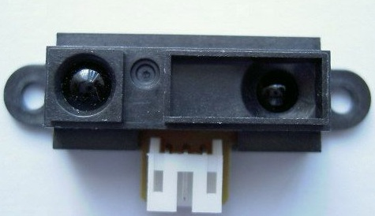

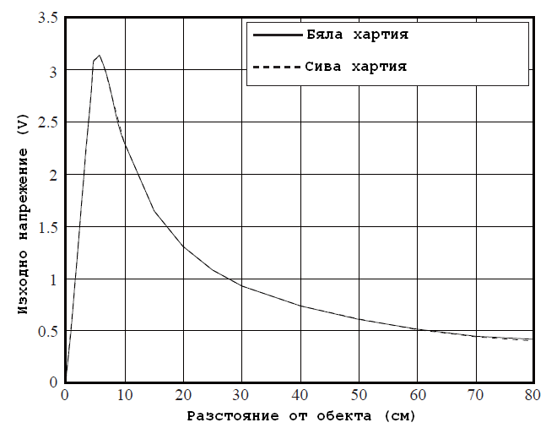

double vv[15] = {2.240,1.580,1.260,1.030,0.880,0.775,0.690,0.640,0.590,0.545,0.50,0.485,0.465,0.435,0.420};

/* ######################## начало датчик за разстояние ######################### */
double distance_sensor(int sensor_number)
{ // AN7
double sensor_table[15] = {2.240,1.680,1.340,1.120,0.960,0.840,0.760,0.690,0.640,0.600,0.560,0.485,0.465,0.435,0.420};
// 10 15 20 25 30 35 40 45 50 55 60 65 70 75 80
//2.240,1.580,1.260,1.030,0.880,0.775,0.690,0.640,0.590,0.545,0.500,0.485,0.465,0.435,0.420
// 9
int i, temporary_data = 0;
double voltage, real_distance;
if (sensor_number==1)
ADCON0 = 0x01;
else
ADCON0 = 0x05;
for(i = 0; i < 20; i++)
{
ADCON0bits.GO = 1; // стартиране на конвертирането
while(ADCON0bits.GO == 1); // изчакване края на конвертирането
temporary_data += 256*ADRESH + ADRESL; //прочитане на резултата от конвертирането
}
voltage = temporary_data / 20 / 1024.0 * 5.0;
i = 0;
while((voltage < sensor_table[i]) && (i < 15))
i++;
if (i==0)
real_distance = 9;
else
if (i==14)
real_distance = 81;
else
real_distance = 5 * ((voltage - sensor_table[i-1]) / (sensor_table[i] - sensor_table[i-1]) + 1 + i);
// формулата за изчисляване чрез апроксимацията
return real_distance;
//return (int)(real_distance + 0.5);
}
/* ###################### край датчик за разстояние ########################### */

