Contain
1. Main definitions and terms
1.1. Introduction
1.2. Used names and short names (ABREVIATION )
1.3. Integrated Development Environment – (IDE)
1.4. Files, created in Environment of Microsoft Visual C++
1. 5 Programming model in Windows
2. Resources
2. Work with screen resources
2.3. Dialog Elements / Dialog Controls /
3. SPECIFICITY OF programming in Windows
4. Object oriented programming in Windows environment
4.1. Objects nature and model
4.2. Events - messages
5. Objects polymorphism and object inheritance in Windows environment
5.1 Object programming in Windows environment
5.2. Inhering features in Windows
5.3. Polymorphism in Windows
6. Resource management in Windows environment.
6.1 Resources management
6.2. Distribution resources management
7. Operative memory management
8. Microsoft Foundation Class Library
8.1. Listing for example
8.2. Messages processing
8.3. Base classes of library MFC
9. Integrated development environment MS Visual C++
9.1. Instrumental devices
9.2. New conceptions in Windows
9.3 Dynamic Link Library (DLL)
9.4. Type of the data in Windows
10. An application creation
10.1. Algorithm for creation of WINDOWS application
10.2. File for description of the module *.DEF
10.3. Programs interaction in Windows environment
11. Structure of WIN32-application.
Simple example program for window management
11.1. Main rules and restrictions in programming under WINDOWS
11.2. Structure of Windows – applications
11.3 Processing of the application messages
11.4. Listing of simple application
12. Windows management in the environment of Windows Management of windows
12. 1. Types of windows
12.2. Windows work area
12. 3. Context of the devices. (GDI).
12.3. Processing of the messages (events) from key-board, timer and mouse
12.4. Processing of the messages (events) from the dialogue box and dialogue elements

MS Visual C++
1. Main definitions and terms
1.1. Introduction
Purpose: Learning technologies for program providing /program systems/, applications in Windows and С++. These applications have 3 - layers architecture: user’s dialog, business logics, and DataBases (DB).
User’s dialog includes: events management; windows management; resources – memory and insert devices; resources in Windows; data exchange between the applications – DLL, COM (Component Object Model ), ATL (Active Template Library), DB - ODBC.
Main /basic/ conceptions in Windows:
- transferability of the executable applications;
- object orientation of programming of applications.

1.2. Used names and short names (ABREVIATION )
Active Template Library (ATL)
Microsoft Foundation Classes Library (MFC)
Application Programming Interface (API) dynamic library with functions that realize all necessary system actions;
Graphic Device Interface (GDI) the sub-multitude of API, interface and graphic devices
Component Object Model (COM)
Run Time Libraries (RTL)
Object Linking Embedding (OLE) – Linking and objects building in.
Dynamic Link Libraries (DLL)
Microsoft Foundation Class Library (MFC)
Microsoft Developer Network (MSDN)

1.3. Integrated Development Environment – (IDE)
MS Visual C++
The environment for program development Microsoft Visual C++ Integrated development environment MS Visual C++ (Integrated Development Environment – (IDE)) еis intended for creation of applications – programs that are provided with everything necessary for their work. In Microsoft Visual C++ the applications often are developed on the base of Microsoft Foundation Class Library (MFC) – library of base class objects of the firm Microsoft, although there is also an ability for creating other types of programs. Such applications present an aggregate of objects, which are the application itself and its components: documents, type of the documents, dialogs, etc.
Each application interacts with Windows by Application Programming Interface (API). API contains several hundreds of functions that realize all necessary system actions, such as memory separation, windows creation, display on a screen, etc. The API functions are contained in dynamic libraries Dynamic Link Libraries (DLL), which are loaded in the memory only in this moment when there is an address to them. One of the sub-multitudes of API is Graphic Device Interface (GDI) – interface of graphic devices. The purpose of GDI is to provide the appliance independence of the graphic. The fact that the appliances can be executed on different computers is due to GDI.
The interface of Microsoft Visual C++ 6.0 includes suitable devices for creation and editing of all types of resources. Such a powerful device for skeleton application is AppWizard and also the device for application classes’ creation and management is ClassWizard.
The creation a simple application contains interface with standard windows it can be done with instrument AppWizard. It allows simplifying the issues for program creation than using of MFC. When this instrument is used, it appears a sequence from dialog windows. In these windows, AppWizard sets questions to programmer. During the dialog process, the user defines project kind and characteristics. Defining the base classes from the library MFC for the project AppWizard builds all needed derivate classes. After that the programmer definites features and behaviors of these classes. The project unites class descriptions, resource descriptions etc.
The knowledge library Microsoft Developer Network (MSDN) can help with the inestimable help during the program development.

The environment provides the following instrumental devices:
Integrated Development Environment – (IDE) MS Visual C++ presents :
- Text editor - for source code creation;
- Tools for discovery of programming errors - debugger;
- Compiler and Linker;
- help system - Microsoft Developer Network (MSDN);
- Tools for program /code/ optimization;
- ClassWizard a device for application classes creation and management ;
- AppWizard (AFC) a device for skeleton applications creation and editing
- libraries: Object Link Embedding (OLE), Runtime Libraries (RTL); Active Template Library (ATL); *.dll (Dynamic Link Library)

1.4. Files, created in Environment of Microsoft Visual C++
The environment uses the following folders and files:
With the creation of a new project, a folder with the same name as that of the project is created. The folder contains a folder with the name Debug and can contain the following types of files:
*.dsw – Project Workspace ;
*.dps – Project File ;
*.cpp – C++ source file – a file with primary code /source/ of the programs;
*.h, – header file – a file with primary code of the used libraries;
resource.h – contains the name of the resources ;
*.rc - Resource Template – a file with a template of the resources;
ReadMe.txt -Text Document ;
*.asp – ASP File- Active Server Pages;
*.ico ; smal.ico – Icon File – images of icons;
*.ncb – NCB File
*.html – HTML Documents;
*.cur - cursor image;
*.exe - respectively executable transferable program – application;
*.dll - Application, and dynamic program library.

1. 5 Programming model in Windows
When Windows starts an application, it calls its function WinMain. The most important task of WinMain is creation the main window application. It must have its own code for massage processing. The main difference between an application for MS-Dos and for Windows is way of processing of user’s input information. Windows processes this input data by Windows messages. The most of Windows messages are definite and concern all applications. In Windows there is an abstract middle level - graphical device interface (GDI). Windows gives printer drivers and video drivers. The functions of GDI turn to a data structure called - device context. Windows associates this structure and produces input-output instructions. During the programming of Windows application a part of data are hold in resource file *.REC using some definite formats. The linker summarizes codes of resource file and the *.OBJ file generated by compiler of C++ and creates a new program.
In Windows, there is DLL (Dynamic Link Library). They can load and are linked during application execution. Some application can share one DLL it saves a memory and a disk space. DLL can be compiled separately so the programs can be modified easy. The user can create his own DLL.
The process of building (compiling an lining) of a Visual C++ application is illustrated on the next scheme (Fig. 1.).
Resource Compilation
Developer Studio
Executable (EXE) file
Code compilation
Compiler
OBJ files
Runtime header files
MFC header files
Windows header files
Source files
Linker
Windows, runtime and MFC libraries
Resource.h

Resource File (RES)
Resource Compiler

Resource script file (RC)

Resource
Fig. 1. Process of application building

Developer Studio is IDE (Integrated Development Environment). It shares by Visual C++, Visual Basic, Visual and some other products. IDE has two editors: AppWizard and ClassWizard. AppWizard is code generator that creates working skeleton of application. It has characteristics, class names, and file names with source code by dialog windows. ClassWizard is program (realized as DLL), which spend routine work for writing of classes in Visual C++. It can generate new classes, virtual or new functions for massage processing.
С/ С++ compiler processes С and С++ source codes and produce *.OBJ files. resource compiler read ASCII file with description of resources *.RC file created by resource editors and write like binary resource file *.RES.
The linker reads OBJ and RES files created by С /С++ compiler and resource compiler. The linker LIB files for including of MFC code, runtime library and Windows code and creates EXE file of project. For tracing of data processing in an application, it uses tracing program (Debugger).

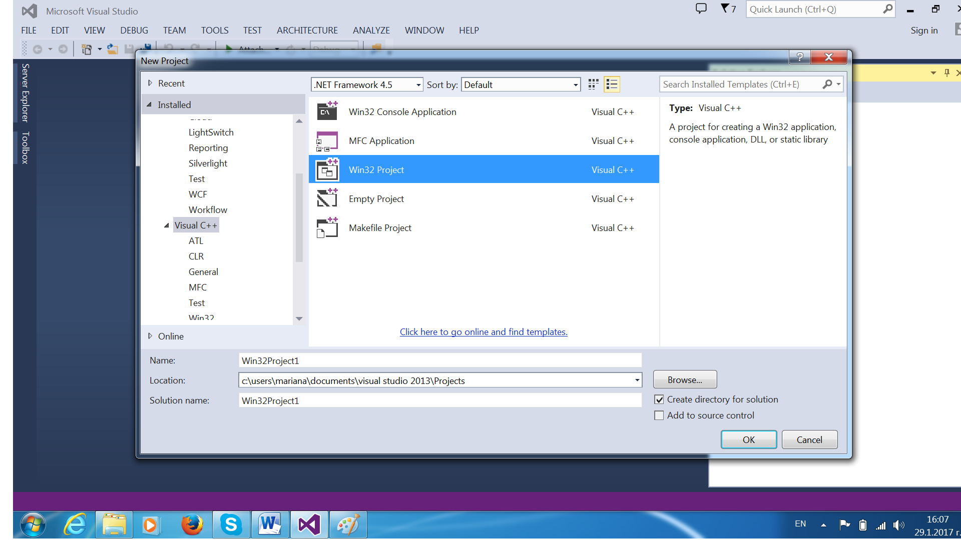
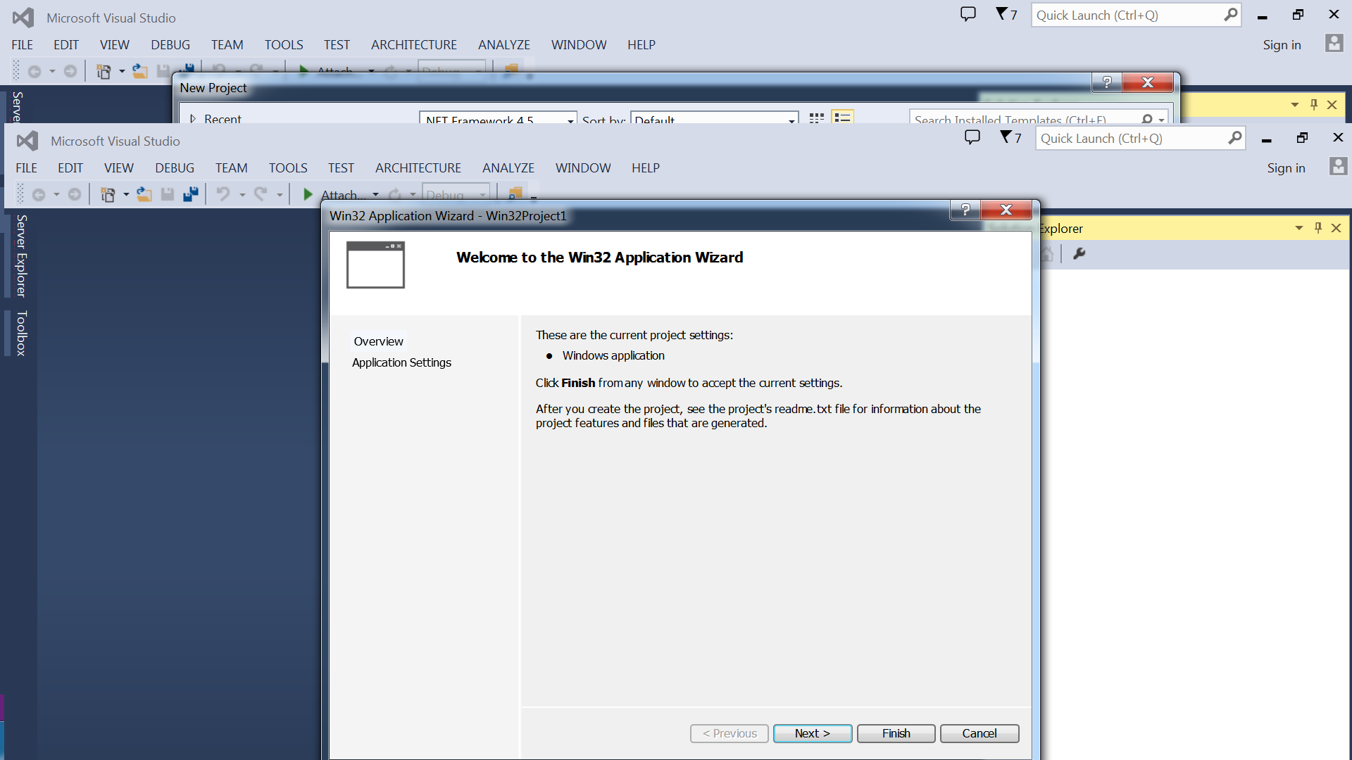

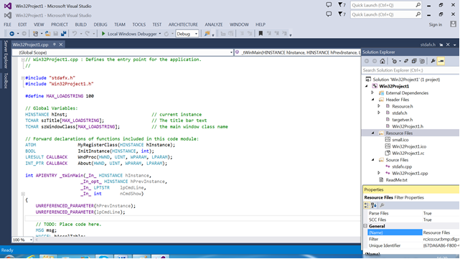

2. Resources

MS Visual C++ gives suitable devices for creation and editing resources of all types. When applications are created AppWizard automatically completes a program by a standard composition of resources. They are in the component Resources (ResourceView) of the Workspace (Fig.2. а/.) The resource are ten: Menu; Accelerators; Dialogboxes; Fonts; Cursors; Icons; HTML – WEB page; Bitmaps – images.
The resources are part of executive applications, but they aren’t located in data segments. They are described in individually in resource files with resource language and loads in memory only when it is necessary.
The resources are described individually in script file *. RC (Resource Script) by the resource language. These files can contain rows with #include directives for including resource from different directories and sub directories. Some of these resources include specific objects like bit-map objects of image (BMP), icon (ICO), symbol string with error massages. The editor adds the corresponding to resources and controls #define constants in resource.h.

2.1. Work with screen resources

2.1. 1. The addition of a new resource comes by following the instructions:
Position the cursor on the folder with the name of the application resources -win32 resource and press the right button. The menu for choosing the function for resources editing falls. We choose a function Insert by pressing the left button. The menu Insert resource falls (Fig.2.б/ ) in order the type of the new resource to be chosen.
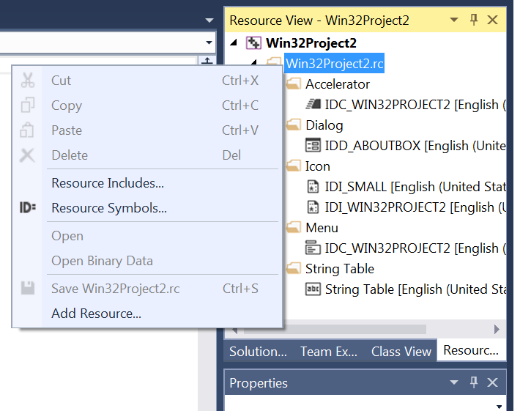
2.1. 2. Creation and editing different types of resources of one application

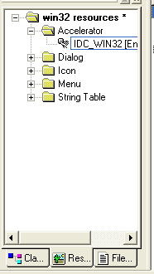
Resource View
Accelerator
Dialog
Icon
Menu
String Table
Fig.2.a. The resources of the exemplary program win32 (Resource View )

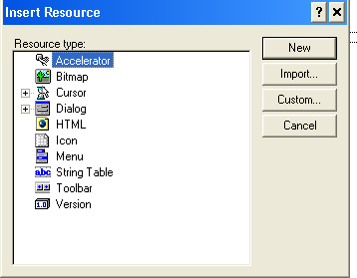
Fig.. 2 b. Addition of a resource.

Editing of different resources kinds:
- Accelerators - Tables with combinations of keys
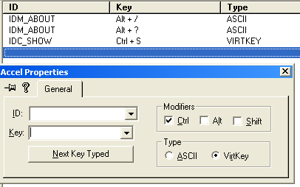

- Dialog-boxes
The creation and editing dialogue boxes uses devices grouped in the section Controls and Dialog Properties.
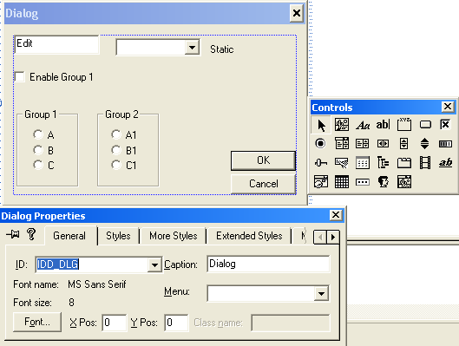
Fig. 3. Resource editing – a dialogue window
The creation and edition of dialog boxes uses tools which are grouping in section Controls and Dialog Properties.
- Icons –(Fig.4.) For the creation and edition of icons it uses tools which are grouping in section Colors and Graphics.
- Menu –(Fig.5.)
- String Table – Table with texts
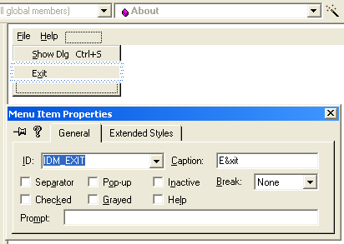
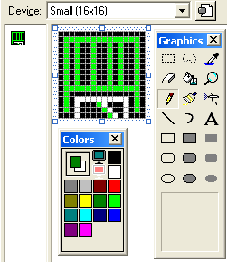
Fig. 5 Editing of the resource - menu

Fig. 4. Editing of a resource - icon
.

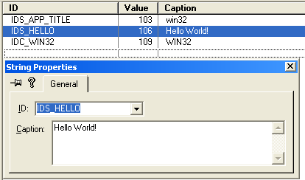
Fig.6. Editing the resource – table with texts

- ToolBar – (Fig.7) Tool band
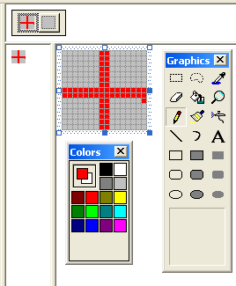
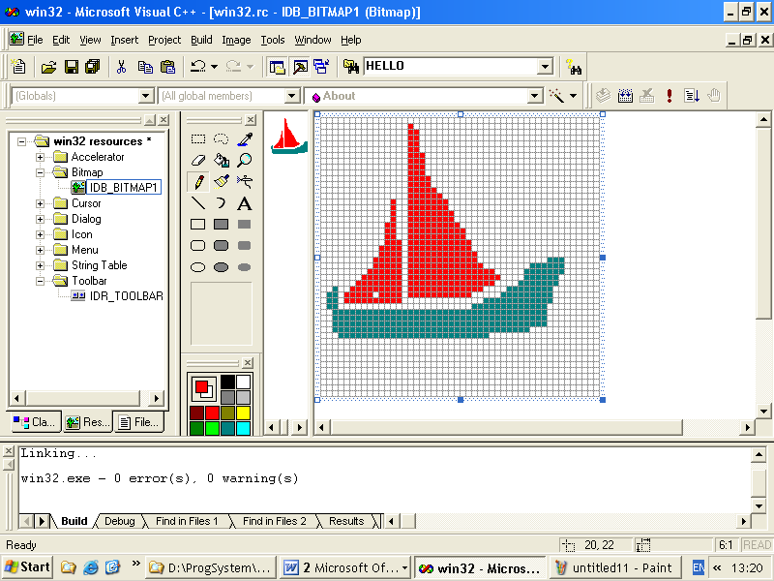
Fig. 7. Editing the resource Toolbar

Fig. 8. Editing the resource image

- BitMap - Bite images (Fig. 8). For the creation and edition of icons it uses tools which are grouping in section Colors and Graphics.
- Cursor – Cursors for the mouse
Besides the traditional devices for change of the color, choice of the way and the size of depiction, there exists also ability to determine a point from the cursor (pixel), HotSpot that will determine the position of the mouse. The succession for this is as follows: Press the button HotSpot and after that by the left button of the mouse indicate the point that will determine the position of the cursor. The АРI function SetCursor() may be used for setting the cursor, where the OS renovates the cursor every time there is a movement of the mouse. During this the image of the cursor is changed by the target one at the window class registration. One of the ways for control of the cursor shape is processing the message WM_SETCURSOR. The cursor shape is set also in the methods CPainterView::OnMouseMove().

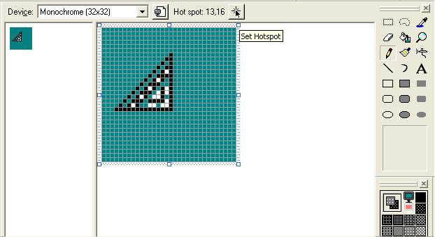
Set Hotspot
Fig. 9. Creation or editing a cursor

- Version – information for the program version
- HTML – It’s created using a text edition and section tools. създава се използвайки текстово редактиране и средствата на секцията
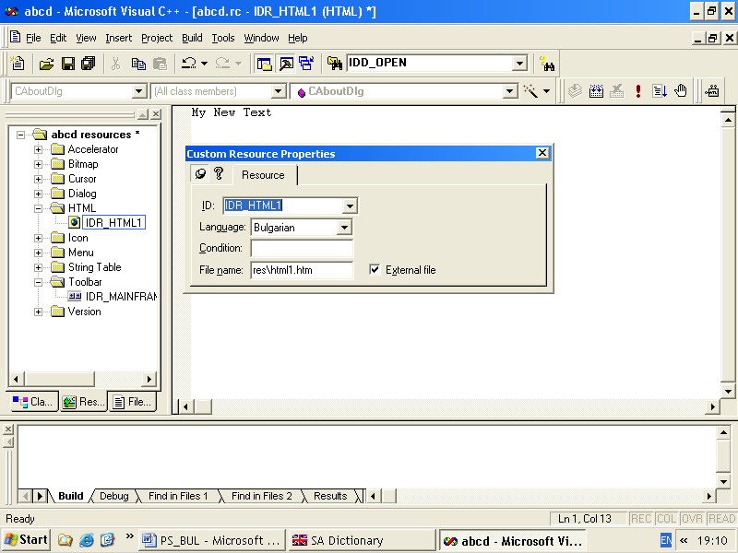
Fig.10 Creation or edition of HTML page.

They are described in individually in resource files *.RC ->*.RES with resource language. The resources are set in program code by its identifiers in way that is shown below:

The way of forming of identifiers
ID{ 1 symbol according to type of resource: M (menu)/ D (dialog)/ I(icon) / A (accelerator) / (string table)/…. }_username
Example: IDM_FILE_READ – an identifier function from menu; IDD_ABOUTBOX - an identifier of dialogue window, IDМ_WIN32_8 an identifier function from menu, IDI_SMALL an identifier of small icon.

2.3. Dialog Elements / Dialog Controls /
Most often used controls have the following Description of the abilities of the tools:
- Select – allows to click on something and to change or transfer it;
- Picture – allows to show an image;

Controls

Фиг. 11. Лента с инструменти (Controls) на диалоговите елементи
1 2 3 4 5 6 7
8 9 10 11 12 13 14
15 16 17 18 19 20 21
22 23 24 25 26

- Static Text – allows inserting a text that will appear in the dialogue window. The user cannot change this text. Use of inscriptions.
- Edit Box – allows to add controls for editing to the dialogue window in order text to be inserted;
- Group Box – allows an empty space to be located around some controls and to form a group;
- Button – allows to add buttons to a dialogue window;
- Check Box – allows control fields to be added to the dialogue window. They allow determining if there is a mark before the element or not. More than one elements of the group may be marked.
- Radio Button – allows radio buttons to be added to the dialogue window. they allow to choose which element to be marked. They are used when in a moment only one element of the group may be chosen.
- Combo Box – allows adding a falling list to a dialogue window. The falling fields are combination of controls for editing and list fields. A value may be chosen ore inserted.
- List Box – allows adding a list field to a dialogue window. The list fields give to the user a composition of abilities for choice.
- Horizontal Scroll Box – instrument
- Vertical Scroll Box - instrument
- Spin Bar – instrument for scrolling
- Progress bar – instrument for illustration of process.
--------------------------------
- Slider
- Hot Key
- List Control
- Tree Control
- Tab Control
- Animate – instrument for animation
- Rich Edit
----------------------------------------
- Data Time Piker
- Month Calendar
- IP Address
- Custom Control
- Extended Combo box

Методи за управление на диалози.

1. Активиране на диалог, указан с идентификатора на диалоговата му кутия и програмата, която го обработва, дъщерен прозорец на дадената инстанция.
DialogBox( hInst, MAKEINTRESOURCE(IDD_ABOUTBOX), hWnd, About );
2. Затваряне на диалога.

EndDialog(hDlg, LOWORD(wParam));

Пример:
... case IDM_NA:
DialogBox(hInst, (LPCTSTR)IDD_OUR, hWnd, (DLGPROC)FirstOurProg);
break;

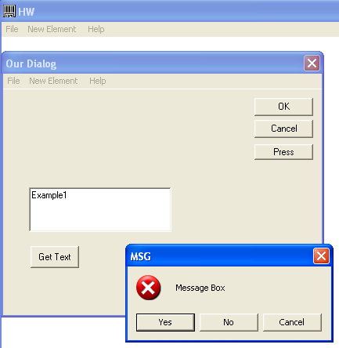

3 Създаване на диалог от тип съобщение

int MessageBox(hDlg, "Message","Title of box", Buttons| Standard Windows)

- Buttons : {MB_OK, MB_OKCANCEL, MB_YESNO, MB_YESNOCANCEL, MB_RETRYCANCEL, MB_ICONEXCLAMATION }
- Standard Windows: { MB_ICONERROR,MB_ICONSTOP, MB_ICONINFORMATION, MB_ICONQUESTION }
for example - MessageBox(hDlg,"Message Box","MSG",MB_YESNOCANCEL | MB_ICONERROR ));
MessageBox(hDlg,"No","MSG",MB_OK);
int x; x = MessageBox(hDlg, "Liub4oslav","Popivanoslav", MB_YESNOCANCEL | MB_ICONQUESTION );

Примери:
.... switch(MessageBox(hDlg,"Message Box","MSG",MB_YESNOCANCEL | MB_ICONERROR ))
{
case IDYES: MessageBox(hDlg,"Yes","MSG",MB_OK); break;
case IDNO: MessageBox(hDlg,"No","MSG",MB_OK); break;
case IDCANCEL: MessageBox(hDlg,"Cancel","MSG",MB_OK); break;
}

4. Четене на текст от едит контрол.

GetDlgItemText(hDlg, Control Identification ,text variable , text size )

Пример
char buf[100]; GetDlgItemText(hDlg,IDC_EDIT1,buf,100);

5. Запис на текстова променлива или константа в едит контрол

SetDlgItemText(hDlg, Control Identification ,"some text")-

Пример - SetDlgItemText(hDlg, IDC_EDIT1,"Example1");

Общ пример Lab2_D1.cpp

#include "stdafx.h"
#include "Lab2_D1.h"
#define MAX_LOADSTRING 100
// Global Variables:
HINSTANCE hInst; // current instance
TCHAR szTitle[MAX_LOADSTRING]; // The title bar text
TCHAR szWindowClass[MAX_LOADSTRING]; // the main window class name

// Forward declarations of functions included in this code module:
ATOM MyRegisterClass(HINSTANCE hInstance);
BOOL InitInstance(HINSTANCE, int);
LRESULT CALLBACK WndProc(HWND, UINT, WPARAM, LPARAM);
INT_PTR CALLBACK About(HWND, UINT, WPARAM, LPARAM);
INT_PTR CALLBACK FirstOurProg(HWND, UINT, WPARAM, LPARAM);

int APIENTRY _tWinMain(_In_ HINSTANCE hInstance,
_In_opt_ HINSTANCE hPrevInstance,
_In_ LPTSTR lpCmdLine,
_In_ int nCmdShow)
{
UNREFERENCED_PARAMETER(hPrevInstance);
UNREFERENCED_PARAMETER(lpCmdLine);

// TODO: Place code here.
MSG msg;
HACCEL hAccelTable;

// Initialize global strings
LoadString(hInstance, IDS_APP_TITLE, szTitle, MAX_LOADSTRING);
LoadString(hInstance, IDC_LAB2_D1, szWindowClass, MAX_LOADSTRING);
MyRegisterClass(hInstance);

// Perform application initialization:
if (!InitInstance (hInstance, nCmdShow))
{
return FALSE;
}
hAccelTable = LoadAccelerators(hInstance, MAKEINTRESOURCE(IDC_LAB2_D1));
// Main message loop:
while (GetMessage(&msg, NULL, 0, 0))
{
if (!TranslateAccelerator(msg.hwnd, hAccelTable, &msg))
{
TranslateMessage(&msg);
DispatchMessage(&msg);
}
}

return (int) msg.wParam;
}
//
// FUNCTION: MyRegisterClass()
//
// PURPOSE: Registers the window class.
//
ATOM MyRegisterClass(HINSTANCE hInstance)
{
WNDCLASSEX wcex;
wcex.cbSize = sizeof(WNDCLASSEX);
wcex.style = CS_HREDRAW | CS_VREDRAW;
wcex.lpfnWndProc = WndProc;
wcex.cbClsExtra = 0;
wcex.cbWndExtra = 0;
wcex.hInstance = hInstance;
wcex.hIcon = LoadIcon(hInstance, MAKEINTRESOURCE(IDI_LAB2_D1));
wcex.hCursor = LoadCursor(NULL, IDC_ARROW);
wcex.hbrBackground = (HBRUSH)(COLOR_WINDOW+1);
wcex.lpszMenuName = MAKEINTRESOURCE(IDC_LAB2_D1);
wcex.lpszClassName = szWindowClass;
wcex.hIconSm = LoadIcon(wcex.hInstance, MAKEINTRESOURCE(IDI_SMALL));

return RegisterClassEx(&wcex);
}
//
// FUNCTION: InitInstance(HINSTANCE, int)
//
// PURPOSE: Saves instance handle and creates main window
//
// COMMENTS:
//
// In this function, we save the instance handle in a global variable and
// create and display the main program window.
//
BOOL InitInstance(HINSTANCE hInstance, int nCmdShow)
{
HWND hWnd;
hInst = hInstance; // Store instance handle in our global variable
hWnd = CreateWindow(szWindowClass, szTitle, WS_OVERLAPPEDWINDOW,
CW_USEDEFAULT, 0, CW_USEDEFAULT, 0, NULL, NULL, hInstance, NULL);
if (!hWnd)
{
return FALSE;
}
ShowWindow(hWnd, nCmdShow);
UpdateWindow(hWnd);
return TRUE;
}
//
// FUNCTION: WndProc(HWND, UINT, WPARAM, LPARAM)
//
// PURPOSE: Processes messages for the main window.
//
// WM_COMMAND - process the application menu
// WM_PAINT - Paint the main window
// WM_DESTROY - post a quit message and return/
LRESULT CALLBACK WndProc(HWND hWnd, UINT message, WPARAM wParam, LPARAM lParam)
{
int wmId, wmEvent;
PAINTSTRUCT ps;
HDC hdc;

switch (message)
{
case WM_COMMAND:
wmId = LOWORD(wParam);
wmEvent = HIWORD(wParam);
// Parse the menu selections:
switch (wmId)
{
case IDM_ABOUT:
DialogBox(hInst, MAKEINTRESOURCE(IDD_ABOUTBOX), hWnd, About);
break;

case IDM_NA:
DialogBox(hInst, MAKEINTRESOURCE(IDD_NEWDIALOG1), hWnd, FirstOurProg);
break;

case IDM_EXIT:
DestroyWindow(hWnd);
break;
default:
return DefWindowProc(hWnd, message, wParam, lParam);
}
break;
case WM_PAINT:
hdc = BeginPaint(hWnd, &ps);
// TODO: Add any drawing code here...
EndPaint(hWnd, &ps);
break;
case WM_DESTROY:
PostQuitMessage(0);
break;
default:
return DefWindowProc(hWnd, message, wParam, lParam);
}
return 0;
}
// Message handler for about box.
INT_PTR CALLBACK About(HWND hDlg, UINT message, WPARAM wParam, LPARAM lParam)
{
UNREFERENCED_PARAMETER(lParam);
switch (message)
{
case WM_INITDIALOG:
return (INT_PTR)TRUE;

case WM_COMMAND:
if (LOWORD(wParam) == IDOK || LOWORD(wParam) == IDCANCEL)
{
EndDialog(hDlg, LOWORD(wParam));
return (INT_PTR)TRUE;
}
break;
}
return (INT_PTR)FALSE;}

INT_PTR CALLBACK FirstOurProg(HWND hDlg, UINT message, WPARAM wParam, LPARAM lParam)
{
UNREFERENCED_PARAMETER(lParam);
switch (message)
{
case WM_INITDIALOG:
SetDlgItemText(hDlg,IDC_EDIT1,"Example1");
return TRUE;
case WM_COMMAND:
if (LOWORD(wParam) == IDOK || LOWORD(wParam) == IDCANCEL)
{
EndDialog(hDlg, LOWORD(wParam));
return TRUE;
}
else if(LOWORD(wParam)== IDC_PRESS)
{
switch(MessageBox(hDlg,"Message Box","MSG", MB_YESNOCANCEL | MB_ICONERROR ))
{
case IDYES: MessageBox(hDlg,"Yes","MSG",MB_OK); break;
case IDNO: MessageBox(hDlg,"No","MSG",MB_OK); break;
case IDCANCEL: MessageBox(hDlg,"Cancel","MSG",MB_OK);
break;} }

else if(LOWORD(wParam)== IDC_GET)
{
char buf[100];
GetDlgItemText(hDlg,IDC_EDIT1,buf,100);
MessageBox(hDlg, buf, "MSG",MB_OK);
} break; }
return FALSE;
}

3. SPECIFICITY OF programming in Windows
The operation system Win32 - we envisage the 32- degree varieties of Windows, gives us such possibilities, for which we could only dream 10 years ago. The main difference from the preceding ones is the narrowing multi-application and the ability for direct addressment of Operation Memory (OM) to 4G bites. The narrowing multi-application means that the system decides by itself to which of the programs to give up the processor. Any program after some time of work is taken out of the system automatically and the control is delivered to another application. This organization allows an illusion for simultaneous implementation of several programs and does not allow the computer resources to be engaged by some wrong application and in this way the system is protected from “hanging”. The second peculiarity of Win32 is the 32-degree addressment in the complete virtual space, i.e. any application /program of Win32/ can dispose with 4 GB. OM no matter how applications are started. Moreover the particular applications cannot damage the data of the others as each application selects its own address space. The programmers can feel comfortable as they receive such a great memory resource. Besides the mentioned peculiarities the existence of the following may be noticed:
- support on process and tread level;
- ability for synchronisation of the treads;
- existence of files that are designable in the memory;
- presence of a mechanism of data exchange between the processes.
In Win32 any executed program is named a process. If a program is started twice these are two processes. Every process has as a minimum one tread of execution. The term “tread” may be determined as a logic direction of program execution. If the program can be compared with a river, the treads may be compared with its branches. These treads may flow in parallel. For example: when the program has to execute some prolonged operation it is expedient that it should be separated in a single tread while in the same time the main program tread may continue associate with the user. All treads in a process are executed in one addressed space and have a common code, resources and global variables. For example a process with some windows, which keep their own, treads is execution of Wndows Explrer.
A synchronization of treads is applied in order a couple of treads of the same process to be not able to hinder in the use of common resources. It may be used in cases when one tread has to await the operation of another tread or to use a resource that can serve only one of them. As the treads are executed in narrowing multi-application the function of their synchronization is executed by the operation environment. For the control of the treads in Windows special flags upon which is based the action of some mechanisms, are used: semaphores, mutex, event, critical section.
Each process has the ability for direct indexing up to 4 GB but much more practical is the programs to work with virtual addresses but not with physical ones. A special mechanism of connection of the operative memory with the hard disk is used for the ability OS to give a big memory capacity for the applications. This mechanism is named paging /irrelevant memory organization/. In this organization, each process logical address space is divided on separated blocks named Pages. The pages may be disposed as in the operative memory, as also in a hard disc. The OS optimizes the separate ОS in such a way that the processes can receive a rapid access to the data used too often. The virtual memory dispatcher remarks the pages not used for a long time and sends them to the hard disc.
Evidently, a similar mechanisms used in creation of files that are designed in the memory /memory-mapped files/, named also reflected files. The designed file as if depicts a file of the disc in the address diapason of the memory. This allows execution of operations with files just in the same way as if the work is done in the memory. The OS organizes alone the data exchange between the memory and the disc. The data separation is made in the following way: two or more processes create in their virtual memory projections of one and the same physical area memory – object “projected” file. When a process records data in its “projection” file , the changes immediately appear also in the created in other processes “projections”. For the organization of this interaction all processes must use one and the same name for the object “projected” file.
In Win32 each process has its address space and that is why the applications executed simultaneously cannot damage accidentally the data of the others. However, a necessity of information exchange between the processes appears too often. For this purpose in Win32 special methods are provided that allow a common access to some data to be obtained. They all are based on the mechanism of the “projected” file. Such a mechanism is the creation of a mail slot – a special structure in the memory that imitates a hard disc file. The applications may put their data in a “box” and read them from it. When all applications working with the “box” finish, the mail slot separates from the memory. Another method of this type is in the organization of a communication highway – “pipe” that connects the processes. An application having an access to one end of the “pipe” may be connected to another one that has an access to its other end and to send data for it. The pipe may give the applications unilateral or bilateral access. When unilateral access, one application can record data in the pipe and another one can read; when bilateral access, both applications can implement operations reading/record. There is ability a pipe to be organized that commutates several processes simultaneously.
Main /basic/ conceptions in Windows:
- transferability of the executable applications;
- object orientation of programming of applications.

Operation system features
Operation environment MS-DOS +Windows has the following features:
- transferability of applications;
- operative memory and resources management;
- simultaneous work of many applications;
- multi-windows interface.

Architecture of Windows environment
The architecture of the environment, its basic interacting components are presented in a general plan on Fig. 1 and in details – on Fig. 12.
Hardware
Application
Windows
MS

-DOS
Fig. 11. General plan of operation environment

On the schema are shown:
- The main hardware drivers;
- Resources of MS- DOS used: File system INT21; MS-DOS’s file system drivers ; BIOS function for discs and diskettes management; BIOS function for print management ( parallel interface).
- Windows drivers multitude specific for each concrete device
- Windows basic functions Windows operation system resources
- gdi.exe for display and mouse management;
- user.exe for management of all other devices, key-board and mouse;
- kernel.exe for files and OM management.
Windows
Windows-drivers
Hardware
Display
Print
display.drv
printer.drv
Timer
Sound
RS-232
….
.
.

Keyboard
Mouse

O.memory
D. memory
systim.drv
sound.drv
comm.drv
….
.
.

keyboard.drv
mouse.drv
BIOS
Drivers
File system
GDI.EXE
USER.EXE
KERNEL.EXE
MS-DOS
Windows
Application
Fig. 12.Operation environment – schema in details
Interface
hardware
Interface drivers
Interface
Windows

The operation memory is fragmented. Applications are transferable in the operative memory. Fig. 13. shows exemplary schema of OM distribution.
Executed applications can load from different entry addresses and they are changed during executions. For this purpose, it uses temporary file - swap file.

Fig. 13. Exemplary schema of OM distribution.
File
SWAP
OM fragmentation
Applications transferability
Windows
Методи за работа с менюта
1. Зареждане на описание на меню на зададен прозорец.
HMENU hMenu = GetMenu(hWnd);
GetMenu – връща в структура от тип HMENU описанието на менюто на зададения идентификатор на прозорец hWnd;

2. Зареждане на ресурсното меню описание в структура
HMENU hMenu = LoadMenu(hInst, MAKEINTRESOURCE(IDR_POP));
Зарежда зададено със идентификатора си ресурс меню IDR_POP, в структура от тип HMENU.

3. Извличане на подменю от структура
HMENU hSubMenu = GetSubMenu(hMenu, nPos); -
Извлича под-менюто от задаено описание hMenu според зададено ниво nPos
HMENU hSubMenu = GetSubMenu(hMenu, 0); -

4. Показване меню за бърз достъп на определено място неговото активиране чрез проследяване избора на елементи на от него.

TrackPopupMenu(hMenu,Flags, x,y, Reserved, hWnd,prcRect);

Flags, – указва центрирането и вида на менюто или при кой натиснат бутон на мишката се появява, x, y – координати на горния ляв ъгъл, прозореца в който се появява, prcRect се игнорира.
TPM_LEFTBUTTON | The user can select menu items with only the left mouse button.
TPM_RIGHTBUTTON | The user can select menu items with both the left and right mouse buttons.

TrackPopupMenu(hSubMenu, TPM_RIGHTBUTTON, 500, 300, hWnd, NULL);
показва и активира указаното описание с начало (500,300) менюто при натискане на десен бутон.

5. Деактивиране на указано меню
DestroyMenu(hMenu);

6. Връщане на флаговете за свойства на отделни елементи от на менюто.

UINT GetMenuState(hMenu,Id, Flags);

В UINT променлива се връща съдържанието на флага за конкретен елемент, зададен с идентификатор ID от описанието на менюто в структурата hMenu, и начина на задаване на идентификатор на елемент в менюто, зададен чрез Flags Стойности за Flags MF_BYPOSITION по подразбиране и MF_BYCOMMAND.
Възможни резултати:
MF_CHECKED, MF_UNCHECKED, MF_DISABLED, MF_ENABLED, MF_GRAYED, MF_SEPARATOR и др

Примери
UINT res = GetMenuState(hMenu, IDM_C1, MF_BYCOMMAND);
UINT res = GetMenuState(hMenu, IDM_DI1, MF_BYCOMMAND);
7. Функции за промяна на свойствата на конкретен елемент от меню
7.1. Промяна на свойството (Check/UnCheck) за чекнато листо или премахването на чекването

CheckMenuItem(hMenu, ID, Flags|Check)

Променя свойсвото на листо с ID от меню hMenu, с указано с Параметър Check.
Възможните тойности на Check са: MF_UNCHECKED, MF_CHECKED. Начинът на задаване на идентификатор на елемент в менюто е зададен чрез Flags Стойности за Flags MF_BYPOSITION по подразбиране и MF_BYCOMMAND.
Пример
CheckMenuItem(hMenu, IDM_CHECK, MF_BYCOMMAND | MF_CHECKED)
CheckMenuItem(hMenu, IDM_CHECK, MF_BYCOMMAND | MF_UNCHECKED);

7.2. Промяна на свойството (Enable/ Disable) за чекнато листо или премахването на чекването

EnableMenuItem (hMenu, ID, Flags|Enable)
Променя свойсвото на листо с ID от меню hMenu, с указано с Параметър Check.
Възможните тойности на Enable са: MF_ENABLED, MF_DISABLED, MF_GRAYED. Начинът на задаване на елемент в менюто е задаен чрез Flags Стойности за Flags MF_BYPOSITION по подразбиране и MF_BYCOMMAND.
Примери
EnableMenuItem(hMenu, IDM_DISABLE, MF_BYCOMMAND | MF_ENABLED);
EnableMenuItem(hMenu, IDM_DISABLE, MF_BYCOMMAND | MF_GRAYED);

8 . Добавяне на нов елемент в указано меню
InsertMenuItem(hMenu,Item,ByPosition,MENUITEMINFO lpmii);
Към зададено меню hMenu, преди елемент с идентификатор Item се добавя елемент описан с MENUITEMINFO lpmii. ByPosition определя как се задава Item. Ако ByPosition=FALSE Item се задава с идентификатор ID, в противен случай със позиция в менюто.
При добавяне на нов елемент в меню се използва относително зададен идентификатор .
Проверка дали съществува, описан в Resource.h.
If (GetMenuState(hMenu, IDM_ADD + 4, MF_BYCOMMAND) == -1)
// отсъства такъв номер в resource.h

За добавянето се използва структура описваща свойствата на елемента в менюто от типа
MENUITEMINFO mii;
ZeroMemory(&mii, sizeof(mii));
mii.cbSize = sizeof(mii);
mii.fMask = MIIM_ID | MIIM_TYPE | MIIM_STATE;
mii.wID = IDM_ADD + 4;
mii.fType = MFT_STRING; //
mii.dwTypeData = TEXT("Delete &me"); // надпис на листото
mii.fState = MFS_ENABLED; // свойство достъпност
Пример
InsertMenuItem(hMenu, IDM_ADD, FALSE, &mii);

9. Премахване на елемент с указания идентификатор в зададено меню
DeleteMenu(hMenu, ID, Flags);
В меню hMenu се изтрива елемент с ID. Начинът на задаване на идентификатор на елемент в менюто е зададен чрез Flags Стойности за Flags MF_BYPOSITION по подразбиране и MF_BYCOMMAND.

Пример
HMENU hMenu = GetMenu(hWnd);
DeleteMenu(hMenu, IDM_D3, MF_BYCOMMAND);

Цялостен пример:
LRESULT CALLBACK WndProc(HWND hWnd, UINT message, WPARAM wParam, LPARAM lParam)
{
int wmId, wmEvent;
PAINTSTRUCT ps;
HDC hdc;
LoadString(hInst, IDS_HELLO, szHello, MAX_LOADSTRING);
switch (message)
{
case WM_COMMAND:
wmId = LOWORD(wParam);
wmEvent = HIWORD(wParam);
switch (wmId)
{
case IDM_OPEN:
MessageBox(hWnd, _T("Open"), _T("Info"), MB_OK | MB_ICONINFORMATION);
break;
case IDM_CHECK:
HMENU hMenu = GetMenu(hWnd);
UINT res = GetMenuState(hMenu, IDM_CHECK, MF_BYCOMMAND);
if(res & MF_CHECKED)
CheckMenuItem(hMenu, IDM_CHECK, MF_BYCOMMAND | MF_UNCHECKED);
else
CheckMenuItem(hMenu, IDM_CHECK, MF_BYCOMMAND | MF_CHECKED);
break;
case IDM_DISABLE:
HMENU hMenu = GetMenu(hWnd);
EnableMenuItem(hMenu, IDM_DISABLE, MF_BYCOMMAND | MF_GRAYED);
break;
case IDM_ENABLE:
HMENU hMenu = GetMenu(hWnd);
res = GetMenuState(hMenu, IDM_DISABLE, MF_BYCOMMAND);
if(res & MF_GRAYED)
EnableMenuItem(hMenu, IDM_DISABLE, MF_BYCOMMAND | MF_ENABLED);
else
EnableMenuItem(hMenu, IDM_DISABLE, MF_BYCOMMAND | MF_GRAYED);
break;
case IDM_ADD:
HMENU hMenu = GetMenu(hWnd);
if(GetMenuState(hMenu, IDM_ADD + 1, MF_BYCOMMAND) == -1) // or disable
{
MENUITEMINFO mii;
ZeroMemory(&mii, sizeof(mii));
mii.cbSize = sizeof(mii);
mii.fMask = MIIM_ID | MIIM_TYPE | MIIM_STATE;
mii.wID = IDM_ADD + 1;
mii.fType = MFT_STRING;
mii.dwTypeData = TEXT("Delete &me");
mii.fState = MFS_ENABLED;
InsertMenuItem(hMenu, IDM_ADD, FALSE, &mii);
}
break;
case IDM_ADD + 1:
HMENU hMenu = GetMenu(hWnd);
DeleteMenu(hMenu, IDM_ADD + 1, MF_BYCOMMAND);
break;
case IDM_DO:
MessageBox(hWnd, _T("Do Something else"), _T("Title Message"), MB_OK);
break;
case IDM_ABOUT:
DialogBox(hInst, (LPCTSTR)IDD_ABOUTBOX, hWnd, (DLGPROC)About);
break;
case IDM_EXIT:
DestroyWindow(hWnd);
break;
default:
return DefWindowProc(hWnd, message, wParam, lParam);
}
break;
case WM_RBUTTONDOWN:
HMENU hMenu = LoadMenu(hInst, MAKEINTRESOURCE(IDR_POP));
HMENU hSubMenu = GetSubMenu(hMenu, 0);
POINT pt = {LOWORD(lParam), HIWORD(lParam)};
ClientToScreen(hWnd, &pt);
TrackPopupMenu(hSubMenu, TPM_RIGHTBUTTON, pt.x, pt.y, 0, hWnd, NULL);
DestroyMenu(hMenu);
break;
case WM_PAINT:
hdc = BeginPaint(hWnd, &ps);
RECT rt;
GetClientRect(hWnd, &rt);
EndPaint(hWnd, &ps);
break;
case WM_DESTROY:
PostQuitMessage(0);
break;
default:
return DefWindowProc(hWnd, message, wParam, lParam);
}
return 0;
}

4. Object oriented programming in Windows environment
The object oriented programming is the main conception in Windows
4.1. Objects nature and model
Classic algorithm
Data
Objects multitude
А
В
C
D
E

X

Y

Z

Object 1
X
А
В
Object 2
Y
C
D
Object 3
Z
E
Fig. 14. Illustrates the object model of data processing

Fig. 14. Illustrates Windows object orientation. Program functions are marked by А, B, C, D, E, and by X, Y, Z – structures of data. Object 1 includes structures of data X and the program functions A and B. Objects structurization by algorithm is illustrated in the left side of the figure, and in the right side – the structurization by data. Data is accessible by the functions only. This is named “capsulation” of objects.

Messages between objects are accomplished as follows:
- commands to objects containing data are executed;
- commands determine the sequence of functions execution;
- objects exchange information by messages only.

The mechanism of messages exchange between objects is illustrated on Fig. 15.
Fig. 15. Exchange of messages between objects
Messages dispatcher
Object 1
X
А
Object 2
Y
FIFO
Messages from the hardware /key-board, mouse/ mousemousemouseишка/
Insert points
Main functions
В
D
C
Data
SendMessage()
Methods – internal functions

Objects in Windows:
- Object presenting data structure: coordinates, colour, type, size, … of window);
- Main function that serves the messages incoming to the object.
  - The function is attached to the object that is initialized (aroused)
  - All functions have a general header: message code; standard parameters
  - The function structure is of the type: switch on the message code
  - The function analyses each message and reacts to some of them ( change of size, contents or attributes of a window)
- Subordinate functions to which the main function accosts (functions of application)
- Standard functions of Windows that are used by the main or the subordinate functions (TextOut, BitBlt,)

4.2. Events - messages
The message is an unique 32-bits complete meaning. In the file WINDOWS.H for each messages standard names as WM_COMMAND, WM_INITDIALOG, WM_DESTROY, WM_CHAR, WM_PAINT, WM_MOVE, WM_SIZE, WM_LBUTTONDOWN etc. are determined. Messages are too often accompanied by parameters having additional information (cursor coordinates, pressed key code, etc.). Every time the event that concerns the program appears, OS sends a corresponding message to it.

Messages structure. Types of messages.
Structure:
16 bits – receiver code; 16 bits message code; 16 bits data; 32 bits data. Example ≡object1.method2(d1,d2)
The receiver code is in fact a number or index of 0-2¹⁷ that identifies every object. The code is an equivalent number of an engaged block for the object in the operative memory. In fact this is a reference to an object. Object manipulator. The message code is the message number and this number corresponds to the internal function - method. Data 16b. and 32b are data accompanying the message.
Example: If we press the left button of the mouse the following message will be formed:
receiver: window object (active window); message code: WM_LBUTTONDOWN – this is 16b. number, data 1: coding from the key-board; data 2: major 16b. Х, minor 16b. Y mouse coordinates. (Coordinates we can obtain by:
int x = LOWORD(lParam); int y = HIWORD(lParam);

The main serving function for each object has one and the same format:
long WinApi(WndProc(hWnd, hPen, UINT message, Word, wParam, long, lParam)
{{
hWnd – windows, hPen - pens, hBrush - brushes, hFont - prints, hMenu - memory, hBitmap – screen image.
Messages exchange. Messages processing and sending. Synchronization. Messages dispatcher.
Figure 16 presents the diagram for messages exchange in Windows. The components are marked by letters enclosed in a square and the processing is presented by а serial numbers enclosed in a circles.
Symbols of the main components:
а – main program of the application;
b – processing cycle – message extraction WM_CHAR ;
c – main function of the application window;
d – WM_CHAR message from the key-board driver to the main function;
e – application window (active window – focus);
f – calling of the function TextOut (GDI – function)
Processing:
numbers from 1 to 9 present the main cycle of message processing WM_CHAR:
1 – address from the key-board to the key-board driver;
2 – message (Reseiver=WM_CHAR of the active window (WM_CHAR – messages from key-board));
WndProc(
switch
c
2
keyboard.drv
key-board
R

R
screen
display.drv
e
8
1
9
WinMain
a
b
10
12
11
GDI.EXE
USER.EXE
Another Application
Queue of system messages
Queue of application messages
3
4
5
6
7
f
d
APPLICATION
WINDOWS
Fig. 16. Diagram of messages exchange

3 – distribution of the queues;
4, 5 – messages extraction WM_CHAR;
6 – Windows calls WndProc;
7- WndProc outputs text by TextOut;
8 – address to the display driver;
9 – from the display driver to the screen;
10 – startт of appliance – Management is transferred to WinMain;
11 – Functions to (RegisterClass, CreateWindow, …) for initial setting;
12 – finishing the application when receiving the message WM_QUIT.

Методи за управление на диалогови контроли

Работа с числови данни в диалоговите елементи

1. Четене на цяло число въведено от контрола edit box
BOOL *LPt=NULL; BOOL SIG=TRUE;
int GetDlgItemInt(hDlg, edit box identification ,LPt, SIG) – връща цяло число, което се въвежда в контрола;
Пример: BOOL *LPt=NULL; BOOL SIG=TRUE;
g1=GetDlgItemInt(hDlg,IDC_EDIT1,LPt, SIG);

2. Записване на цяло число в контрола edit box
SetDlgItemInt(hDlg, edit box identification, INumber,TRUE);
Примери: SetDlgItemInt(hDlg,IDC_EDIT4, g1,TRUE);

Преобразуващи функции:да се добави
получаване на реално число, което е въведено като текст в edit box:
char *stopstring; double variable=strtod(char var[10],&stopstring);
float val=atof(“10.2”); int val1=atoi(“777”); long val2=atol(“989”);
получаване на символен низ, който е получен от реална стойност.
float d; char txt[10]; sprintf(txt, “%10.2f”,d); ]; sprintf_s(txt, “%10.2f”,d);/
gcvt(d,10,Text);

Примери:
char t1[10]; GetDlgItemText(hDlg,IDC_EDIT1,t1,10);
x1=strtod(t1,&stopstring); gcvt(x1,10,t11);

MessageBox(hDlg, t11,"OK", MB_OK);
SetDlgItemText(hDlg,IDC_EDIT3,t11);

3. Изпращане на съобщения към контрол
Слеващата функция изпраща съобщения към различните видове диалогови елементи, което се изразява в различни действия, в зависимост от типа на елемента и параметрите които и се подават. Общия и формат изглежда така:

int SendDlgItemMessage(hDlg,ID_of_DialogControl, Processing_Way, Index,(LPARAM) "Some text in Dialog Control")
Функцията връща номера на реда в списъчните контроли към които тя изпраща съобщение. Ако стойността е по-малка от 0 то контролът е празен.
Параметри:
- hDlg –описател на обекта;
- ID_of_DialogControl – идентификатор на диалоговия елемент;
- Processing_Way – Параметър, които казва как се изпраща съобщението. Зависи от типа на диалоговия елемент по следния начин:
    - за list box възможните стандартни константи за този параметър започват с LB: LB_GETTEXT, LB_SETTEXT, LB_RESETCONTENT, LB_INSERTSTRING, LB_SELECTSTRING, LB_FINDSTRING, LB_GETCURSEL, LB_SETCURSEL, LB_DELETESTRING.
LB_GETTEXT – за четене на текст от контрола с указан номер на реда
LB_SETTEXT – за запис на текст в контрола с указан номер на реда
LB_RESETCONTENT – за изпразване от текст на контрола
LB_INSERTSTRING – за вмъкване на текст
LB_ADDSTRING – за добавяне на текст
LB_SELECTSTRING – за избор на ред от лист контрола
LB_FINDSTRING – за търсене на текст в контрола
LB_GETCURSEL – за връщане на номера на реда в контрола, в който е курсора
LB_SETCURSEL – за установяване на курсора на указан ред в контрола
LB_DELETESTRING – за изтриване на ред в контрола
    - за combo box стандартни константи започват с възможните стандартни константи за този параметър започват с CB: CB_SETTEXT, LB_ISERTSTRING, CB_ADDSTRING, CB_SELECTSTRING, CB_GETCURSEL, CB_SETCURSEL, CB_GETLBTEXT, CB_FINDSTRING, CB_DELETESTRING
CB_GETLBTEXT – за четене на текст от контрола с указан номер на реда
CB_SETTEXT – за запис на текст в контрола с указан номер на реда
CB_RESETCONTENT – за изпразване от текст на контрола
CB_INSERTSTRING – за вмъкване на текст
CB_ADDSTRING – за добавяне на текст
CB_SELECTSTRING – за избор на ред от лист контрола
CB_FINDSTRING – за търсене на текст в контрола
CB_GETCURSEL – за връщане на номера на реда в контрола, в който е курсора
CB_SETCURSEL – за установяване на курсора на указан ред в контрола
CB_DELETESTRING – за изтриване на ред в контрола

    - за radio and check boxes възможните стандартни константи за този параметър започват с BM: BM_SETCHECK, BM_GETCHECK;
BM_SETCHECK – за поставяне на отметка
BM_GETCHECK – за връщане на резултат за отметка

    - за edit box възможните стандартни константи за този параметър започват с WM: WM_GETTEXT, WM_SETTEXT.
WM_GETTEXT – за четене на текст от контрола
WM_SETTEXT. – за запис на текст в контрола

Пример - SendDlgItemMessage(hDlg,IDC_LIST1,LB_GETTEXT,lbIndex,(LPARAM)data);

- Параметър Index :
a/ Указва позицията на изпращания текст в случай на list или combo boxes.
b/ Установява отметка или премахва в случай на radio and check boxes, използвайки константите : BST_CHECKED, BST_UNCHECKED.
c/ Установява дължината на текста в случай на edit box като напр. (LPARAM) "Some text in Dialog Control" –за изпращания текст"Some text in Dialog Control" .

Примери:
// combo box
string val[10]=”{“text1”, “text2”, “text3”, text4”}
for (int i=0; i<4; i++)
c_index=SendDlgItemMessage(hDlg,IDC_COMBO1,CB_ADDSTRING,0,(LPARAM) ;val[i].c_str());
SendDlgItemMessage(hDlg,IDC_COMBO1,CB_RESETCONTENT,0,-1);

i=SendDlgItemMessage(hDlg,IDC_COMBO1,CB_FINDSTRING,0,(LPARAM)data)
if (i>-1))
{….// текста data e намерен в к.б. и номерът му е i…} else (…// data липсва в к.б.}

cbIndex=SendDlgItemMessage(hDlg,IDC_COMBO1,CB_GETCURSEL,0,0);

SendDlgItemMessage(hDlg,IDC_COMBO1,CB_GETLBTEXT,cbIndex,(LPARAM)data);
__________________
case WM_COMMAND:
if(mID==IDCANCEL)
EndDialog(hDlg,mID);
else if(mID==IDC_BUTTON3)
{
if(!(IsDlgButtonChecked(hDlg,IDC_CHECK1)+IsDlgButtonChecked(hDlg,IDC_CHECK2)))
MessageBox(hDlg,"no checked added","asd",MB_OK);
else
GetDlgItemText(hDlg,IDC_ToAdd,data,sizeof(data));
if(IsDlgButtonChecked(hDlg,IDC_CHECK1)&&!(SendDlgItemMessage(hDlg,IDC_COMBO1,CB_FINDSTRING,0,(LPARAM)data)>-1))
{
c_index=SendDlgItemMessage(hDlg,IDC_COMBO1,CB_ADDSTRING,0,(LPARAM)data);
SendDlgItemMessage(hDlg,IDC_COMBO1,CB_SETCURSEL,c_index,0);
MessageBox(hDlg,"added in combo box","asd",MB_OK);
}

// list box
l_index=SendDlgItemMessage(hDlg,IDC_LIST1,LB_ADDSTRING,0,(LPARAM)"List row 1");
SendDlgItemMessage(hDlg,IDC_COMBO1,CB_SELECTSTRING,-1,(LPARAM) "Row 2 in Combo Box");
SendDlgItemMessage(hDlg,IDC_LIST1,LB_SETCURSEL,0,0);
I= SendDlgItemMessage(hDlg,IDC_LIST1,LB_FINDSTRING,0,(LPARAM)data);
SendDlgItemMessage(hDlg,IDC_LIST1,LB_GETTEXT,lbIndex,(LPARAM)data);
// check box
I= SendDlgItemMessage(hDlg,IDC_CHECK1, BM_GETCHECK,0,0);

4. Проверка и смяна статуса на елемента като отметнат или не.
4.1.Получаване на стойност съобразно това дали елемента е отметната или не
IsDlgButtonChecked(hDlg, ID)
връща лог. стойност за указания с ID check box или radio box. в зависимост от това дали е избран или не.
Пример: IsDlgButtonChecked(hDlg, ID_ZNAK)

4.2. Смяна статуса на елемента като отметнат или не
ChechDlgButton(hDlg, ID, (BST_CHECKED or BST_UNCHECKED) )
Функцията сменя статуса на указания в ID контрол в указания като трети параметър.
Функцията освен това връща състоянието преди функцията да бъде извикана. Ако не върне 0 функцията е била недостъпна преди извикването. Ако върне 0 е била достъпна.
Пример: ChechDlgButton(hDlg, ID_C, BST_CHECKED

5. Objects polymorphism and object inheritance in Windows environment

5.1 Object programming in Windows environment
The main concepts and principals object oriented programming (ООP) are: object, class, capsulation (closing), inheritance and polymorphism.
The class appears as a generalization of the concept for data type and sets features and behavior of the class objects, named also specimens of the class. Every object belongs to some class. The class may be presented as an union of data and procedures, intended for their processing. The class data are named also variables of the class, and the procedures – methods of the class.
Capsulation of objects. is data processing by the functions only. In С++ the class variables are named data-member of the class (data member), and the method – function-member of the class (member function). The variables determine the features or the condition of the object. The methods determine objects behavior.
Inhering of features and behavior from parent class
Let class A is determined, then a new class B may be determined that inheres the features and behavior of the objects of class A. This means that variables and methods from class A will be determined in class B. The class B appears as an ancestral from class А. And class A is parental (basic) regarding В. In a derivative class new features and behavior may be set determining new variables and methods. The basic class methods may be re-determined. The re-determination (overloading) of class A methods – this is determination in class B of a method with name that has already appeared as a name of some method from class A. The basic class method may be announced as virtual (with attribute virtual). Then in re-determining the method in a derivative class the number of method parameters and their types must be stored. The virtual method provides ability for writing polymorphic functions, whose arguments may have different types (classes) in different addresses to the functions and, however, they will execute actions that are specific for the type of the really transferred argument. For example, let class A is a determined virtual method VirtualMethod(), that sends the message “I am a method of class A”. Let us re-determine the method in the class in such a way that it should send message “I am method-member of class B”. Then a re-determination of the mode is following:

// Determination of class А
class A
{
public:
// Class А virtual method
virtua void VirtualMethod() {Sends a message “I am a method of class А”}
}
// Determination of class В
class B: public A
{
public:
// Class B virtual method
virtua void VirtualMethod() {Sends a message “I am method of class B”}
}
// Polymorphic function. !!!! As an argument it receives a pointer
// towards class А that is basic for В
void ShowMessage(A* x)
{
// Calling the object method VirtualMethod() x
x->VirtualMethod();
}
// Creation of Object А of the class А
A ObjectA;
// Creation of Object B of the class B
B ObjectB;
// We call a polymorphic function with an argument – pointer towards an object of class А
// A message “I am a method of class А” will be drawn out
ShowMessage(&ObjectA)
// We call polymorphic function with argument –pointer towards object of class В
// A message “I am a method of class B” will be drawn out
ShowMessage(&ObjectВ)

The class B may be basic for the next class and so on. All derivative classes are named inheritors and the classes they have come from are named ancestors.
The determination of the classes (interface of classes) may be found in the title files *.h, and the class function realization may be found in the homonymous file with an extent *.cpp. This organization structurizes the outgoing text, facilitates data management and allows dividing the program modules compilation.

5.2. Inhering features in Windows
Inherence is a feature of the objects ordered in an hierarchy that allows by hierarchy of classes the common features to be taken to a higher level in the hierarchy. Inherence in Operation systems has a dynamic character.
Objects hierarchic structure is characterized by:
The ordering of the objects in a hierarchic level where each object has 1 predecessor if it is not a root and has inheritors if it is not a life. The main principal of the inherence is that all inheritors inherit the data and serving functions of the predecessor. All inheritors appear as instances (concretization) of the predecessor. All predecessors appear as generalizations of their inheritors. Predecessors are purely abstract classes and contain empty methods. The methods of the inheritor may overlap the methods of the predecessor. The polymorphism is a feature of objects to realize a certain abstract functionality in their own specific way and imposes the use of standardized methods. For example: Installing and deleting of objects.
Ref=new_class_Name leads to instance in heap.
Example 1
ship
cargo ship
tanker
Position
typedef struct{
int x;
int y;
} Position;
Point
typedef struct{
Position:koord;
int: color;
} Point;
Line
typedef struct{
Point: P1;
Point: P2;
char:LineType;
} Line;

Example 2

The inherence in Windows takes place by registration of class of windows when creating the window is executed during the execution of application.
Example 3 Rеgister Class (object with features for certain type of windows)
……………..
CreateWindows(private features)
5.3. Polymorphism in Windows
Polymorphism is the object feature to realize certain abstract functionality in their own specific way. These functions are polymorphic of the abstract functionality and are its concretizations. That means:
- Management standardization of multitude of objects;
- Insert of nomenclature of the methods;
- Unification of objects.
In OM this may be achieved by overlapping of abstract objects and methods; in JAVA a synthetic interface construction is supported.
Polymorphism in methods
Example for abstract functionality – Abstract method like Move(Id,x,y) – transfers of visual object in a window to a new position with new coordinates. Its corresponding polymorphic functions (Polymorphic methods) overlap: transfer of vector object (line, square); transfer of a screen object – bitmap; photo; transfer of text object – string;
Polymorphism is realized by programming of specific (subordinate) functions, that are activated by the different main object functions for processing one and the same message: For example: the message WM_PAINT causes re-drawing of all windows to which it is sent, and on different windows different graphic or text objects may be depicted. WM_PAINT is generated, for example, when the size of some windows of the screen is changed.
A fitting example for overlapping of class methods is shown below. In this example one function for drawing a vector object is definite by two ways. In base class „Shape” function-method is definite only as (virtual void Draw(HDC hdc)). In two inheritor (class Line, class Rect) this function is re-definite in two different ways for drawing of a line and a rectangle.
enum shpType
{
line, rect
};
//
class Shape
{
public:
POINTS begin;
POINTS end;

Shape() {};
~Shape() {};

Shape(const Shape& s)
{
begin = s.begin;
end = s.end;
}

Shape& operator=(const Shape& s)
{
begin = s.begin;
end = s.end;
return *this;
}

virtual void Draw(HDC hdc) { assert(FALSE); };
};

class Line : public Shape
{
public:
virtual void Draw(HDC hdc)
{
MoveToEx(hdc, begin.x, begin.y, (LPPOINT) NULL);
LineTo(hdc, end.x, end.y);
}
};

class Rect : public Shape
{
public:
virtual void Draw(HDC hdc)
{
Rectangle(hdc, begin.x, begin.y, end.x, end.y);
}
};

Polymorphism in messages:
The most used standard messages:
- WM_INITDIALOG – once when creating a windows; first data initialization; files opening; operative memory occupation; objects instance.
- WM_CLOSE – when closing the process;
- WM_QUIT – closes the application;
- WM_CHAR – messages from key-board (pressed key)
- WM_LBUTTONDOWN(UP) messages from the mouse for pressed left button
- WM_Rbuttondown(up) messages from the mouse for pressed right button
- WM_mousemove messages from the mouse for object transfer (dragging, re-drawing).
- WM_SIZE – messages when there is a change of window’s size.
WM_PAINT – message that causes re-drawing of all windows to which it is sent, and on different windows different graphic or text objects may be depicted. WM_PAINT is generated, for example, when the size of some windows of the screen is changed.
Example: The following messages may be in a window: Preparation WM_INITDIALOG, drawing out of an image WM_PAINT,
- WM_PAINT – massages that is sent when the main window is drawn by UpdateWindow;
- WM_DESTROY – messages for destroying of main windows children;
- WM_COMMAND – messages from the menu or dialog-box.
- WM_CREATE messages for object creation;
For example in a window, there are the next messages: Preparation of the dialog-box contain with WM_INITDIALOG, outputting of a the main window image with WM_PAINT, commands from the menu or dialog-box with WM_COMMAND and closing of application with WM_DESTROY.

Методи за работа с ProgressBar контрол и таймери

1. Функция, изпращаща съобщения към диалогов елемент ProgressBar

SendDlgItemMessage(hDlg,ID_of_DialogControl, Processing_Way, Index,(LPARAM) "Some text in Dialog Control")
Processing_Way - възможните стандартни константи за този параметър започват с PBM: PBM_SETRANGE, PBM_GETRANGE, PBM_DELTAPOS, PBM_SETSTEP, PBM_SETPOS, PBM_STEPIT, PBM_GETPOS, PBM_GETSTEP, PBM_SETBARCOLOR, PBM_SETBKCOLOR;
PBM_SETRANGE – задава диапазона (мин. и макс. ) на които съответства началото и края на прогрес бара.
PBM_GETRANGE – връща диапазона, съответстващ на началото и края на бара
PBM_DELTAPOS – премества текущата позиция в п.б. на зададеното отстояние
PBM_SETPOS - премества текущата позиция в п.б. на зададена позиция
PBM_SETSTEP – задава стъпка за преместване
PBM_GETSTEP – връща стъпката за преместване на курсора
PBM_STEPIT – мести текущата позиция една стъпка
PBM_SETBARCOLOR задава цвят на бара (от 0 до COLORREF)
PBM_SETBKCOLOR – задава цвят на фона на п.б (от 0 до COLORREF)
COLORREF SetBarColor( COLORREF clrBar);

Примери:
SendDlgItemMessage(hDlg, IDC_PROGBAR, PBM_SETRANGE, 0, MAKELPARAM(0, 1000));
SendDlgItemMessage(hDlg, IDC_PROGBAR, PBM_DELTAPOS, 100, 0);
r= SendDlgItemMessage(hDlg, IDC_PROGBAR, PBM_GETPOS, 0, 0)
step = -20;
SendDlgItemMessage(hDlg, IDC_PROGBAR, PBM_SETSTEP, step,0);
SendDlgItemMessage(hDlg, IDC_PROGBAR, PBM_STEPIT,0,0);

2. Методи за работа с таймери
2.1. Създаване на таймери и установяване на стартовата стойност и стъпката за промяна

SetTimer (hWnd, nIDEvent, uElapse, Timerproc);
nIDEvent –идентификатор на таймера
uElapse – Време на изчакване в милисекунди до издаване на съобщениение
TimerProc Указател към функция, която за да бъде извикана, когато времето за изчакване стойност изтече.
Пример:
# include <commctrl.h>
#define TIMER1 500 // дефиниция на името на таймера
SetTimer(hDlg, TIMER1, 20, NULL)

Приложението може да обработва съобщението WM_TIMER чрез включване като случай при обработката на съобщенията или чрез определяне на функция за обратно извикване на TimerProc, указана при създаването на таймера. Когато се зададе функцията TimerProc, подразбиращата се процедурата, обработваща прозореца извиква функцията когато се обработва WM_TIMER. Следователно, трябва да се изпраща съобщения в извикващия поток, дори когато се използва TimerProc вместо обработка WM_TIMER.
Параметърът wParam на съобщение WM_TIMER съдържа стойността на параметъра за nIDEvent. Това може да се използва за да се различат отделните таймери в случай, че се ползват повече от един в приложението.
Идентификаторът на таймер, nIDEvent, е специфичен за асоциране с прозореца. Друг прозорец може да има свой собствен таймер, който има същия идентификатор като този собственост на друг прозорец, но таймерите са различни.
Идентификаторът на таймер, nIDEvent, е специфичен за свързаните с прозореца.

2.2. Спиране работата на указан таймер
KillTimer(hWnd, nIDEvent) – спиране на таймер nIDEvent, асоцииран с hWnd
Пример: KillTimer(hDlg, TIMER1) – спира TIMER1.

4. Връщане идентификатора (хендела) на обекта в прозотрец hDlg, в който е указания с control ID контрол.
HWND GetDlgItem(hDlg, control ID);

5. Установяване на състояние на достъпност или недостъпност на прозорец
EnableWindow(hWnd, bEnable);

hWnd – handle на прозореца , който ще сменя състоянието си
bEnable е променлива (bool), указваща как ще се смени статуса на прозореца
6. Показване на прозорец или контрол
ShowWindow((hWnd, bEnable);
hWnd – handle на прозореца , който ще сменя състоянивто си
bEnable е променлива (bool), указваща как ще се смени статуса на прозореца
Примери:
CheckDlgButton(hDlg, IDC_A, BST_CHECKED); // => CheckRadioButton(...)
{UINT state = IsDlgButtonChecked(hDlg, IDC_CHECK_CTRL);
EnableWindow(GetDlgItem(hDlg, IDC_B), state); // прави контрола достъпен ако state=TRUE
Бутон с идентификатор IDC_A - има свойството visible=false
if (strcmp(psw,”password”)==0)
ShowWindow(GetDlgItem(hDlg, IDC_A), TRUE); // прави видим бутона IDC_A

6. Координати на мишката
int LOWORD(lParam) – връща x- координата на на позицията на мишката of mouse;int y = HIWORD(lParam) връща the y- координата на на позицията на мишката;

Структура на WIN32-приложение.
Примерна програма за управление на прозорец

Основни правила и ограничения при програмиране под WINDOWS
- Да не се използват стандартни функции за извод към екрана като: printf, scamf, getchar, putchar.
- Да не се работи пряко с ОП или периферните устройства (клавиатура, мишка, таймер, дисплай).
- Да не се присвоява процесора само към една задача. Така се избягват зациклиянията.
- Да не се използват библиотечни функции за работа с паралелния или серийния интерфейс като с файлове. Да се използват функциите за комуникация на WINDOWS.
- Да не се използват стандартни функции за работа с паметта malloc, calloc, realloc, free. Те се заменят автоматично от функции на WINDOWS.
- Стандартните функции за работа с файлове са допустими, но използването на Windows- функциите за работа с файлове е препоръчително (имат по-големи възможности).

Структура на Windows – приложения
Работата в Windows-програмите се основава на обработка на съобщения, които постъпват от потребителя, ОС и други програми. Структурата на приложението непременно включва в себе си главната функция WinMain, еднакво устроена за всички приложения. С нея започва изпълнението на всички Windows – програми. WinMain трябва да изпълни следните действия:
- Да определи и регистрира клас –прозорец в Windows.
- Да създаде и изобрази прозорец, определен от данните на класа.
- Да организира цикъл за обработка на съобщенията.
При определяне на класа на прозореца се указва специална функция на прозореца, която трябва да реагира на постъпващите в прозореца съобщения. Всяко приложение има своя опашка от съобщения, която създава Windows и помества там всички съобщения, адресирани към прозореца на приложението. След създаването и изобразяването на прозореца се организира основния цикъл за обработка на съобщенията, в който съобщенията преминават предварителна обработка и се връщат в Windows обратно. След това Windows извиква функцията на прозореца в програмата с опашката от съобщения в качеството на аргументи. Анализирайки съобщенията, функцията на прозореца инициира съответните операции. Съобщенията, чиято обработка не е предвидена от функцията на прозореца, се предават на Windows, която изпълнява обработка по „подразбиране”.
Обща структура на просто приложение е представено на Фиг.24
По-долу е приведена минимална програма за Windows.

WinMain
Заглавен оператор
Инициализация
Цикъл за обработка на съобщенията
Създаване на основен прозорец
Изобразяване на основен прозорец
ПРИЛОЖЕНИЕ

WndProc
Заглавен оператор
Разклонения по съобщения
Фиг. 24. Обща структура на просто приложение
Главна програма
Параметри на приложението
Регистрация (обявяване) на класа на прозорците на приложението
Създаване на основния прозорец на приложението (връзка с WndProc)
Изобразяване на основния прозорец и обновяване на работната му площ
Цикъл за извличане и диспечиране на съобщенията (до WM_QUIT)
Постъпващи съобщения към главната функция на прозореца (чрез под-програмно извикване)
Разклонителна структура за анализ и обработка на съобщения
Процес на обработка на съобщенията
Като правило, програмите, написани за Windows, използват прозорци за организация на интерфейса и основно се използва механизмът за обмяна на съобщения. Съобщенията могат да се предават на прозоречната процедура веднага, а може да се поставят и в опашката от съобщения. При стартиране на приложение Windows създава за него опашка на съобщенията. Такава опашка се създава за всеки поток (thread), или най-малко една опашка за всеки процес. При всяко действие с прозореца (изменение на размерите и др.) Windows поставя съответното съобщение в опашката. Форматът на съообщението съответства на структурата MSG.

Структура MSG:
typedef struct tagMSG
{
HWND hwnd;
UINT message;
WPARAM wParam;
LPARAM lParam;
DWORD time;
POINT pt;
} MSG;
- hwnd – хендъл на прозореца на получателя на съобщението;
- message - код на съобщението;
- wParam - параметър на съобщението;
- lParam – допълнителен параметър на съобщението;
- time – времето на изпращане на съобщението;
- pt – координатите на курсора на мишката в момент на отправяне на съобщението.

Хендъл на прозорец - число идентифициращо прозореца. Всеки прозорец в Windows има своя свой хендъл. Практически във всички функции на API се изисква да се укаже хендъл на прозореца.
Съобщенията, поставени в опашката на съобщения, трябва да се извличат и обработват правилно. За целта е предвиден цикъл за обработка на съобщенията.
Схематично процеса на обработка на съобщенията на приложението е представена с структурата на Фиг. 25.
Всички програми за Windows трябва да включват библиотечния файл WINDOWS.H. Този файл съдържа прототипи на API – функциите, а така също определянето на различи типове данни, макроси и константи. Функцията на главния прозорец, използвана в програмата се нарича : WinProc(), която е обявена като функция на обратното извикване т.к. тя се извиква от ОС за обработка на съобщенията.
Изпълнението на приложението започва с извикването на WinMain().Тя първо определя класа на прозореца по пътя на запълването на полетата на структурата WNDCLASSEX. С помощта на дадената структура програмата указва на WINDOWS функцията и стилa на прозореца. Регистрацията на класа на прозореца се изпълнява с помощта на API функцията RegisterClassEx.

Application

WinMain()
RegisterClass
CreateWindow()
ShowWindow() UpdateWindow()

WndProc()
while(GetMessage(&msg))
{…..
TranslateMessage(&msg)
DispatchMessage(&msg)

}

Windows

Massages of Windows

User’s massages
Опашка от съобщения of Windows

Съобщения от приложението

Фиг. 25. Схема на процеса на обработка на съобщенията на приложението

Следва създаването на прозореца с помощта на API функцията CreateWindow() , параметрите на която определят външния вид на прозореца. В края на функцията WinMain() е разположен цикъла на съобщенията. Той е задължителна част от всяко приложение. Докато приложението се изпълнява, то непрекъснато получава съобщения и ги извлича от опашката с помощта на API функцията GetMessage(). Съобщенията постъпват чрез параметър на функцията от тип структура MSG. Ако опашката е празна, то извикването на GetMessage() предава управлението на WINDOWS. При завършване на работа с програмата функцията GetMessage() връща нула. След като съобщението е прочетено, то се предава към API функцията TranslateMessage(&msg) и DispatchMessage(). WINDOWS съхранява съобщението до тогава, докато не го предаде на програмата в качеството на параметър на функцията на прозореца. Когато цикълът на съобщенията завърши, WinMain() също завършва своето изпълнение и предава на ОС значението на кода на завършването. Този начин на обработка на съобщенията дава възможност за:
- филтриране на получените съобщения, задавайки нужните параметри на функцията GetMessage();
- да се транслират виртуалните кодове на клавишите в клавиатурни съобщения с помощта на функцията TranslateMessage(&msg);
- да се транслират кодовете на натискане на «горещи» клавиши в съобщения на командите с помощта на функцията TranslateAccelerator(hwnd, hAccel, &msg).

Цикъл за обработка на съобщенията:
MSG msg;
while(GetMessage(&msg,0,0,0))
{
TranslateMessage(&msg);
DispatchMessage(&msg);
}

Функция GetMessage():
BOOL GetMessage(
LPMSG lpMsg,
HWND hWnd,
UINT wMsgFilterMin,
UINT wMsgFilterMax);
Функцията GetMessage() извлича поредното съобщение от опашката на съобщения и го поставя в структурата lpMsg типа MSG.Ако липсва в опашката съобщение то текущия поток се привежда в състояние на очакване и ОС предава управението на друг поток.
Връща значенията: Ако функцията извлича съобщение различно от WM_QUIT, то функция връща неенулево значение.
Ако функцията извлича съобщението WM_QUIT, то тя връща 0.
Ако има грешка, то тя връща -1.
- lpMsg - указател на структурата, където ще се постави съобщението;
- hWnd - хендъл на прозореца, за който се извлича съобщението, ако се укаже 0 то функцията GetMessage() ще извлече съобщения за всички прозорци;
- wMsgFilterMin –долната граница на диапазона на извличане, например, ако се укаже 10, то ще се извличат съобщения с кодове започващи от 10, ако се укаже 0 то тази граница отсъства.;
- wMsgFilterMax – горна граница на диапазона на изличаните съобщения, например ако е 300, то ще се извличат съобщения с кодове до 300, ако е зададено 0 то тази граница отсъства.

Функция TranslateMessage():
BOOL TranslateMessage(CONST MSG *lpMsg);
Функцията TranslateMessage() транслира съобщения от клавиатурата. Тя превежда съобщенията на виртуалните клавиши (Virtual-key) в символни съобщения.

Функция DispatchMessage():
LONG DispatchMessage(CONST MSG *lpmsg);
Функцията DispatchMessage() изпраща съобщение в прозоречната процедура. По същество тази функция извиква прозоречната процедура.

Прозоречна процедура
Прозоречната процедура е функция за обработка на събития (съобщения). Тя извиква ОС Windows и получава параметри: хендъл на прозореца - hWnd, код на съобщението - msg и два параметъра lParam и wParam. Процедурата може да има всякакво име, но обикновено е WndProc.
/* Прототип */
LRESULT CALLBACK WndProc(
HWND hWnd,
UINT msg,
WPARAM wParam,
LPARAM lParam );
Прозоречната процедура трябва да умее да обработва всички съобщения, но в Windows такива съобщения са няколко хиляди. Всичко се свежда до обработката само на тези съобщения, които са необходими на конкретното приложение, а всички останали ще се обработват по подразбиране с функцията - DefWindowProc();

/* Пример за прозоречна процедура */
LRESULT CALLBACK WndProc(HWND hWnd, UINT msg, WPARAM wParam, LPARAM lParam)
{....... switch(msg)
{

case WM_DESTROY:
// да се постави съообщението WM_QUIT в опашката на съобщенията
PostQuitMessage(0);
break;

default:
// прозоречна роцедура по подразбиране
return DefWindowProc(hWnd,msg,wParam,lParam);
}
return 0;}
Тази процедура обработва само едно съобщение - WM_DESTROY, а всички други се обработват от процедурата по подразбиране. Съобщението WM_DESTROY се изпраща при опит да се затвори прозореца.
Процедурата обработва съобщенията за прозорци от определени класове.

Класове на прозорците, регистрация на нов клас
Прозоречният клас е този, на чиято основа се създават прозорци. На базата на един прозоречен клас могат да се създават няколко прозореца. В ОС Windows има пре-определени класове прозорци. За да се създаде прозорец на основата на даден клас, то той трябва да се регистрира в системата с функцията RegisterClass() или RegisterClassEx().
Необходимо да се запъни структурата WNDCLASSEX.

Структура WNDCLASSEX:
typedef struct _WNDCLASSEX {
UINT cbSize;
UINT style;
WNDPROC lpfnWndProc;
int cbClsExtra;
int cbWndExtra;
HANDLE hInstance;
HICON hIcon;
HCURSOR hCursor;
HBRUSH hbrBackground;
LPCTSTR lpszMenuName;
LPCTSTR lpszClassName;
HICON hIconSm;
} WNDCLASSEX;
- cbSize - размер на структурата WNDCLASSEX;
- style – битови флагове , определящи стила на прозореца ;
- lpfnWndProc - адрес на прозоречната процедура;
- cbClsExtra - размер за допълнителна памет на класа;
- cbWndExtra - размер на доп. памет;
- hInstance - хендъл на екземпляра на приложението, на което принадлежи прозоречната процедура;
- hIcon - хендъл на икона (32x32 пиксела);
- hCursor хендъл на курсора на прозореца по подразбиране;
- hbrBackground хендъл на цвета по подразбиране;
- lpszMenuName – менюто на прозореца (името на ресурса);
- lpszClassName – име на класса;
- hIconSm – хендъл на малката икона (16x16 пикселей).
След запълване на структурата WNDCLASSEX, класът трябва да се регистрира в системата. Това става с помощта на RegisterClassEx();
WNDCLASSEX wc;
// попълване на структурата WNDCLASS
// ....
// Регистриране на нов клас
RegisterClassEx(&wc);

Създаване на прозорец
Това става с функцията CreateWindow() или CreateWindowEx().
В случай на успех на функцията CreateWindow() тя връща хендъл на новия създаден прозорец, в противен случай връща NULL.
HWND CreateWindow(
LPCTSTR lpClassName,
LPCTSTR lpWindowName,
DWORD dwStyle,
int x,
int y,
int nWidth,
int nHeight,
HWND hWndParent,
HMENU hMenu,
HANDLE hInstance,
LPVOID lpParam );
- lpClassName – името на регистрирания клас на прозореца;
- lpWindowName – заглавието на прозореца;
- dwStyle –стил на прозореца (комбинация от флагове);
- x - начално положение по X;
- y - начално положение по Y;
- nWidth - ширина на прозореца;
- nHeight – височина на прозореца ;
- hWndParent - хендъл на прозореца на родителя ;
- hMenu - хендъл на менюто на прозореца;
- hInstance хендъл на екземпляра на приложението, създаващ прозореца;
- lpParam - указател на параметрите за WM_CREATE.
След създаването на прозореца е необходимо той да се изобрази на екрана. За показване на екрана се извиква функцията ShowWindow().
ShowWindow(hWnd, SW_SHOW);

Шаблон на програма за windows
#include <windows.h>
// Обявяване на прозоречната процедура
LRESULT CALLBACK WndProc(HWND hWnd,UINT msg,
WPARAM wParam,LPARAM lParam);
int WINAPI WinMain(HINSTANCE hInstance,
HINSTANCE hPrevInstance,
LPSTR lpCmdLine, int iCmdShow)
{
const char szClassName[]="MyApp"; // Име на прозоречния клас
WNDCLASSEX wc;
MSG msg;
HWND hWnd;

// Запълване на полетата на структурата wc
wc.cbSize=sizeof(wc); // Размер на структурата wc
wc.cbClsExtra=0; // допълнителна памет за класа
wc.cbWndExtra=0; // допълнителна памет за прозореца
wc.hbrBackground=CreateSolidBrush(RGB(135,163,187)); // Цвят на фона
wc.hCursor=LoadCursor(0,IDC_ARROW); // Вид на курсора на мишката
wc.hIcon=LoadIcon(hInstance,IDI_APPLICATION); // Икона
wc.hIconSm=LoadIcon(hInstance,IDI_APPLICATION); // Малка икона
wc.hInstance=hInstance; // хендъл на екземпляра на приложението wc.lpfnWndProc=WndProc; // Име на прозоречната процедура
wc.lpszClassName=szClassName; // Име на прозоречния клас
wc.lpszMenuName=NULL; // Име на менюто
wc.style=CS_HREDRAW | CS_VREDRAW; // Стил на прозореца

// Регистрация на нов прозоречен клас
if(!RegisterClassEx(&wc))
{
MessageBox(NULL,"Не е възможно да се регистрира клас","Грешка",MB_OK | MB_ICONSTOP);
return -1;}
// Създаване на прозорец
hWnd=CreateWindow( szClassName, // Име на проречния клас
"Прозорец", // Заглавие на прозореца
WS_OVERLAPPEDWINDOW, // Стил на прозореца.
CW_USEDEFAULT, // Координата x
CW_USEDEFAULT, // Координата y
CW_USEDEFAULT, // Ширина на прозореца
CW_USEDEFAULT, //Височина на прозореца
0, // хендъл на родителския прозорец
NULL, // хендъл на менюто
hInstance, // хендъл на екземпляра на приложението
NULL); // Допълнителни параметри

if(hWnd==NULL)
{
MessageBox(NULL,"Не може да се създаде нов прозорец ","Грешка",MB_OK | MB_ICONSTOP);
return -1;
}

ShowWindow(hWnd,SW_SHOW); // Показване на прозореца
UpdateWindow(hWnd); // Прозоречната процедура изпраща съобщението WM_PAINT

// Цикъл за обработка на съобщенията
while (GetMessage(&msg,0,0,0))
{
TranslateMessage(&msg); // за съобщения от клавиатурата
DispatchMessage(&msg); // Стартиране на прозоречната процедура
}
return 0;
}
// Прозоречна процедура
LRESULT CALLBACK WndProc(HWND hWnd,
UINT msg,
WPARAM wParam,
LPARAM lParam)
{
HDC hDC;
PAINTSTRUCT ps;
switch(msg)
{
case WM_PAINT:
{ hDC=BeginPaint(hWnd,&ps);
// Нещо се рисува
EndPaint(hWnd,&ps);
}
break;
case WM_DESTROY:
PostQuitMessage(0);
break;
default:
return DefWindowProc(hWnd,msg,wParam,lParam);
}
return 0;}

Примерен програмен код, съответстващ на структура на просто приложение:

Листинг на минимално приложение
# include <windows.h>
# include “sample.h”
// Прототип на функция на прозорец
LRESULT, CALLBACK WndProc (
HWND hvnd, // указател на прозореца
UINT uint, // идентификатор на съобщения
WPARAM wparam, // параметри на съобщенията
LPARAM lparam);// координати на мишката
char szWindowName[]=”myClass”; // име на класа на прозореца

// Функция WinMain ①
int WINAPI WinMain(
HINSTANCE hInstance, // Дескриптор на екземпляра на приложението
HINSTANCE hPrevInstance, // NULL
LPSTR lpCmdLine, // указател на ред с аргументи
int nCmdShow) // Способ за визуализация

{
// Initialization ②
if(!Init(hInstance)) return NULL;
// указател на на главния прозорец на програмата
HWND hwnd;
// Структура- буфер за съхранение на съобщенията
MSG msg;
// Структура за определяне на класа на прозореца
WNDCLASSEX wc1;
wc1.hInstance-hThisInst; //Дескриптор на приложнието
wc1.lpszClassName = szWindowName; // Име на класа на прозореца
wc1.style=0; // Стил по подразбиране
wc1.lpfnWnfProc=(WNDPROC) WndProc; // обработваща функция
wc1.hIcon=LoadIcon(NULL, IDI_APPLICATION); // Икона
wc1.hCursor=LoadCursor(NULL, IDC_ARROW); // Курсор
wc1.lpzMenueName=NULL; // Без меню
wc1.cbClsExtra=0; // Без доп. информация
wc1.cbWndExtra=0; // Без доп. информация
wc1.hbrBackground=(HBRUSH)GetStockObject(WHILE_BRUSH); // Фон

//Регистрация на класа на прозореца
IF (!RegisterClassEx(&wc1)) RETURN 0;

//Създаване на прозореца ③
hwnd=CreateWindow (
szWindowName, // Име на класа на прозореца
“Minimal Program”, // Заглавие
WS_OVERRLAPPEDWINDOW, // Стил
CW_USERDEFAULT, // Координати х, y
CW_USERDEFAULT, // горен ляв ъгъл
CW_USERDEFAULT, //ширина
CW_USERDEFAULT, // височина
HWND_DESKTOP, // родителски прозорец
NULL, /дескриптор на меню
hInstance, //дескриптор на приложение
NULL); // без доп. информация

// Изобразяване на прозореца ④
ShowWindow (hwnd, nCmdShow)

// Прерисуване на прозореца ⑤
UpdateWindow(hwnd)

// Цикъл на обработка извличане на съобщенията ⑥
while (GetMessage())
&msg, // Буфер за съобщения
NULL, // Да се получават съобщения от всички прозорци на приложението
0,0)) // Диапазон на получаванните съобщения-всички
{
// връщане на управлението на Windows
TranslateMessage(&msg);
DispatchMessage(&msg);
}
return msg.wParam; // Значение, връщано на програмата
}
// Функция на прозореца извиквана от ОС за обработка на съобщенята ⑦

LRESULT CALLBACK WndProc (
HWND hwnd, // Дескриптор на прозорец
UINT message, // Идентификатор на съобщения
WPARAM wParam.// Параметри
LPARAM lParam)
{ int wmId, wmEvent;
PAINTSTRUCT ps;
HDC hdc;
switch (message) // многократен разклонител за действия с използването на lParam, WParam
{
// case WM_COMMAND:--------: // ⑧ Обработка на съобщение

wmId = LOWORD(wParam);
wmEvent = HIWORD(wParam);
switch (wmId)
{
case IDM_ABOUT:
DialogBox(hInst, MAKEINTRESOURCE(IDD_ABOUTBOX), hWnd, About); break;
case IDM_EXIT:
DestroyWindow(hWnd); break;
default:
return DefWindowProc(hWnd, message, wParam, lParam);
}
break;

// ---------
case WM_PAINT: // рисуване или обновяване на прозореца
hdc = BeginPaint(hWnd, &ps);
// TODO: Add any drawing code here...
EndPaint(hWnd, &ps);
break;
case WM_DESTROY: // ⑨ Затваряне на прозореца . WM_QUITкъм WINDOWS
PostQuitMessage(0);
break;
default: // ⑩ Предаване на обработваните съобщения към WINDOWS обратно за обработка по подразбиране
return DefWindowProc(hwnd, message, wParam, lParam);
}
return 0;
};

7. Resource management in Windows environment
7.1 Resources management
Resources for the applications under Windows are hardware and software resources of the computer. Hardware resources are: display, printer, key-board, mouse, RS232, timer, sound card, operative memory, disc memory, processor.
Multi-program work under Windows
- Many applications can be started simultaneously under Windows;
- The control is switched over between them according to event in a program way;
  - From the user (ALT-TAB), by menu, by mouse’s focus transfer;
  - programming by functions of Windows;
- Switching over the applications is not done by time sling after a signal of the timer.

6.2. Distribution resources management
Distribution of the resources is realized by the functions of Windows. The resources are occupied and released by them.
Exceptional complete occupation of the resources (mutual switch off for a certain period (sound generator, processor, printer, key-board RS232).
Dividing of the resources (mutual switch off of part of the resources display, mouse, timer, OP, disc memory).
Parallel use of the resources (file system): files by SHARE.EXE queue of (spooler) the printer.
Display management – it is executed by windows. Main element – focus of a window – only one of all open windows has a focus.
The presentation of a picture in the memory cells is coded in a special way. In the most junior cell of the memory information for the cell with coordinates (0,0) is stored.
Address space

Windows

…………

Application
Picture memory
Video Controller
display
Fig. 7. Display management
VC
Memory

GDI offers hardware – independent color interface. The program gives “absolute” color code, GDI associates it with suitable color or combination from color if video – card.
Color Models
For color coding of display pixels (logical points) are used different color models. The most used are a few:
- Monochromatic model describes the pixels in 1bit for two colors black and white.

Gray scale model has only one component in scope from 0 to 255 for color from black to white (Fig. 18.)
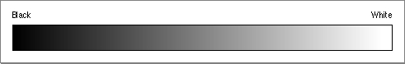
Фиг. 18.

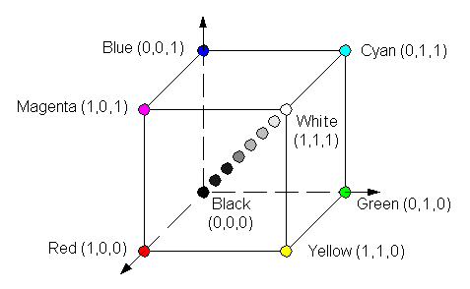
Model RGB (Red-Green-Blue) (Fig.19.) is three-dimensional with main colors red green, and blue. Every component sets by number in scope from 0 to 255.
Fig. 19
Blue (0, 0, 1)
Cyan (0, 1, 1)
Magenta (1, 0, 1)
White (1, 1, 1)
Black (0, 0, 0)
Red (1, 0, 0)
Yellow (1, 1, 0)
Green (0, 1, 0)

Other extant models are:
- Model CMYК (Can, Magenta, Yellow);
- Model HSV(Hue, Saturation, Value),
- Model HLS, (Hue, Luminance, Saturation)
- Model HIS (Hue, Intensity, Saturation) .
There are different variants for coding the colors in the pixels (points) of the display:
1 bit/ point for monochromatic image (black and white) image;
4 bits/ point for image of 16 colors;
8 bits, 1 bite/ point for image of 256 colors;
2 bites/ point for ≈ 65000 colors and
4 bites/ point for ≈ 4. 10^{6 colors}.
It is possible for each point of the memory only one number of its color to be coded or by 3 numbers from 0 - 255 to be coded the intensity of three basic colors of the RGB color model. There is a function for synthesizing of color by 3 components RGB(R,G,B) in Windows. In examples of Visual C++ the colors of objects set by 3 components on scope (0÷255 in decimal number system or 0÷0xFF in sixteen number system).
- Examples with color setting using RGB(R,G,B) in decimal number system: gray - RGB(127,127,127) , red - RGB(255,0,0), white -RGB(255,255,255), yellow - RGB(255,255, 0), brown - RGB(255,200,100); pink - RGB(255,102, 228).
- Examples with color setting using RGB(R,G,B) in decimal number system: yellow - RGB(0xFF,0xFF,0x00); pink - RGB(0xFF,0x66, 0xEF).
The serving function of each window attends with its regeneration in real time (UpdateWindow(hWnd)).

7. Operative memory management
In MS-Dos: All segment addresses of the executable files are permanent after their insert in OM therefore are not transferable. The executable file cannot be larger than the free part of OP. However, work with physical addresses allowed.
In Windows: There is a new mechanism for memory management here that allows:
- ability for transfer of segments in the memory;
- tightening of the occupied memory after its releasing, obtaining maximum free spaces;
- ability for particular charging of great applications *.ЕХЕ;
- ability for temporary storage of no active segments in system file (swap –file);
- ability for secondary memory organization and use of extended memory;
The process has its own 4-GB virtual address space. The program receives access to every bite of address space by one single 32-bits linear address. The memory space includes:
- EXE instance of program;
- non –system DLL , which program loads;
- Global program data ( read-only and read/write);
- Program stack ;
- Dynamic loaded memory including heaps of Windows and С runtime libreary (CRT);
- Memory mapped files;
- Memory blacks shared between separated processes;
- Local memory of executing treads;
- Special blocks of system memory including virtual memory tables;
- Kernel and Windows executive and DLL library,which are part of Windows.
Each process has the ability for direct indexing up to 4 GB but much more practical is the programs to work with virtual addresses but not with physical ones. A special mechanism of connection of the operative memory with the hard disk is used for the ability OS to give a big memory capacity for the applications. This mechanism is named paging /irrelevant memory organization/. In this organization, each process logical address space is divided on separated blocks named Pages. The pages may be disposed as in the operative memory, as also in a hard disc. The OS optimizes the separate ОS in such a way that the processes can receive a rapid access to the data used too often. The virtual memory dispatcher remarks the pages not used for a long time and sends them to the hard disc.
Phisical memory
Page table
holds entries for 1024 virtual memory pages

32-bits linear page address

On directory per process directory
Page table directory
holds 1024 page table entries
CR3 register holds
directory page entries

Windows loads CR3 for every current process
Bits 31-22
4096 bites
Page - 4096 bites
Offset in page
Bits 11-0
Фиг.19 Управление на виртуалната памет при Win32 (за Intel)
Bits 31-22

Microprocessor chip of Intel associates a 32-bits virtual address with a page and moving in the frame of this page using two levels. It is shown on the Fig. 19. The pages can be noted like “read only” or “read/write”. Every process has its own table group. The register CR3 of Intel chip contains a pointer to directory page-entries to directory page. When the OS switches the processes and updates CR3. In the page tables has bits “present bits”, which show whether corresponding pages are in RAM memory or not. If it’s necessary access to the page that is not in memory it’s generated an interruption and OS verifies the internal tables, reads page from disk, loads it in RAM and refreshes the page table. It’s happened like it’s loaded physical address and sets “present” bit. The virtual memory manager notes the long ago used pages and sends they to hard disk. If some process does not need from some page, it is down loaded to disk and the free memory is used for loading a new page of other process.
The virtual memory manager has ability for temporary storage of no active segments in system file - swap file; If two process use one and the same EXE file it’s associated with address from address space of everyone process. Two process share global data.
Heap is a memory area of some processes. When the program needs memory block, it calls the function HeapAlloc for allocating of a heap and when need to release the occupied memory it calls the function HeapFree.
Other opportunity for memory management that is used is creation of files that are designed in the memory /memory-mapped files/, named also reflected files. The designed file as if depicts a file of the disc in the address diapason of the memory. This allows execution of operations with files just in the same way as if the work is done in the memory. The OS organizes alone the data exchange between the memory and the disc.
Example diagrams of OM distribution in three different moments marked by а/ b / и c/ from the execution of 4 applicationsот A, B, C, D is presented on Fig. 20. In the first moment, а/ 3 applications are active; in the second moment only application А is active and there is a new application C. Application D has finished and application B is a non active application. Here is shone how the maximum free space is united. If the maximum free space is not enough, a record in a file for a temporary storage is made. In the third moment the OM distribution after the finish of work of applications A and C is shone.
In order these abilities of the operation system to be realized it is necessary to specify the information – which segments are transferable and which can be stored in a file temporary (pointed in *. DEF file). The work is with virtual addresses by descriptors instead of physical addresses.
A
B
A
D
A
a/
A
A
A
C
b/
B
c/
Fig. 1.8. Illustration of memory management mechanism in three consecutive moments а/ в/ с/.
8. Microsoft Foundation Class Library
MFC library is a basic composition of classes written in language С++ and are intended for programming under Windows. The library is a hierarchy of classes on many levels with about 200 members and provides the creation of applications on the basis of the object-oriented approach. The merits of MFC are in the fact that the use of its classes allows a great amount of routine work to be avoided. A capsulation of the functions API by MFC simplifies the programming significantly. The library provided interface doze not depends in practice from the details that realize it. That’s why the programs written on the base of MFC can be adapted easily for new versions of Windows. MFC gives the skeleton on which base a program under Windows may be created. As all applications have fixed structure, determined by WinMain(), so the applications created on the base of MFC are firmly set. The classes’ names of the MFC – library begin with „C” and the names of the variables of the class - with „m_”. In the simplest case a program written by use of MFC, contains 2 classes: The class intended for application creation and the class intended for window creation. The first one (CApp) is obtained from the class CWinApp of the MFC library, and the second (CMainWin) - from CFrameWnd. The kernel of the MFC – applications is the global object theApp of the class CApp, is responsible for the creation of all other objects and the queue of messages processing.
The creation of MFC – program includes the following actions:
- From CFrameWnd a class to be obtained that determines a window - class CMainWin .
- From CWinApp a class to be obtained that determines the application – CАpp.
- A card of messages to be created.
- The function InitInstance() of the class CWinApp. to be re-determined.
- A specimen of the class determining the application – the object theApp to be created.
8.1. Listing for example
Minimum program created on the base of the class MFC libraries.#include <afxwin.h>
// Determination of the main classes
// Class for the main window
class CMainWin: public CFrameWnd
{
public:
CMainWin();
DECLARE_MESSAGE_MAP()
};
// Constructor for a window
CMainWin:: CMainWin()
{
Create(NULL, “Base MFC application”
}
// Class for application creation
class CApp: public CWinApp
{
public: BOOL initInstance();
};
// Function for application initialization
:BOOL CApp:: initInstance()
{
// Creation of the object – main window
m_pMainWnd=new CMainWin;
// Window depicting
m_pMainWnd->ShowWindow(m_nCmdShow);
// Window re-drawing
m_pMainWnd->UpdateWindow(); }
// Card of applications messages
BEGIN_MESSAGE_MAP(CMainWin, CFrameWnd)
END_MESSAGE_MAP()
//////////////////////
// Start of application execution
// Creation of a global object – application
cApp theApp;

The text of the program includes the file AFXWIN.H, that contains description of the classes of the MFC library and other library files. The application is executed when a specimen is created of the class CАpp – the object theApp. The obtained class CMainWin contains 2 members: constructor CMainWin() and macros DECLARE_MESSAGE_MAP(), in which a card for messages processing for the class CMainWin is announced. The pair of commands BEGIN_MESSAAGE_MAP(CMainWin, CFrameWnd) and END_MESSAGE_MAP() enclose the main window’s messages card and among them must be the calling of the function for processing of the incoming messages. In the example messages are not processed.
8.2. Messages processing
The message is unique 32-bits integer. In the file WINDOWS.H standard names like WM_CHAR, WM_PAINT, WM_MOVE, WM_SIZE, WMLBUTTONDOWN etc. are determined for all messages. Messages are often accompanied by parameters that carry additional information (cursor coordinates, pressed key code, etc.). Every time the relative to the program event occurs, OS sends a corresponding message. It is not necessary to describe the reaction to every message. For messages that do not have a special processing, in MFC – program are processed in a standard way.
MFC contains re-determination of functions – processing the messages, that may be used in the program. For the organization of the messages processing it is necessary the following actions to be executed:
- Messages macro-commands to be included in the program messages card;
- A message processor to be included in the class description – function prototype.
The macro-commands provide calling of the functions – processors of the standard messages in Windows. The macro-commands names consist of the prefix ON_, the name of the message and a pair of round brackets. For example: ON_WM_LBUTTONDOWN(),ON_WM_LBUTTONUP(), ON_WM_PAINT. A special macro-command ON_COMMAND() is provided, intended for messages that enter after calling points from menu and message determined by the programmer. This macro-command has two arguments: ON_COMMAND(ID, METHODNAME), where the first argument – identifier of the point from the menu or the message determined by the programmer, and the second is the name of the function – processor of the message.
The message macro-command is in card of the window messages. The messages card is a special mechanism that connects the messages identifier with the corresponding processor. One application may has several messages cards. The belonging of the card to some window is determined by the parameter of the macros BEGIN_MESSAGE_MAP():
BEGIN_MESSAGE_MAP(class of the window-possessor, basic class)
// macro-commands of messages
END_MESSAGE_MAP()
The name of the function – processor consist of the prefix ON_and the name of the message (without WM_). For example OnButtonDown(). A prototype the function – processor of messages must be put into window’s class description before the macros DECLARE_MESSAGE_MAP(). For the description a specifier of the type afx_msg is used. As an example let us add to the previous program processing of the message WM_LBUTTONDOWN. After the user presses the left button in the area of the window , a message WM_LBUTTONDOWN is sent to the application. When the message is received, the program displays a message for the event that occurred and coordinates of the points.
To execute this the following actions are done:
- Modification of the message processing card
// card of the messages
BEGIN_MESSAGE_MAP(CMainWin, CFrameWnd)
// macro-command of the message
ON_WM_LBUTTONDOWN()
END_MESSAGE_MAP()
- Including a prototype of the function - processor in a window class description
class CMainWin: public CFrameWnd
{
public:
CMainWin();
// Prototype of the function - processor
// “pressed left button”
afx_msg void OnLButtonDown (UINT, nFlags, CPoint point);
DECLARE_MESSAGE_MAP()
};
- The realization of the function – processor inserts the program
void CMainWin::OnButtonLButtonDown(UINT nFlags, CPoint point)
{
// CString – MFC class for work with strings
CString Str;
Str.Format(“Press left button in point x=%d, y=%d, point.x, point.y);
// MessageBox – method of the class Cwnd – basic for CFrameWnd and CMainWin)
// Arguments: (Str) message text, Title of the window and flag,
// determining window’s stile.
MessageBox(Str, “There is a message”, MB_OK|MB_ICONINFORMATION);
// Standard processor
CFrameWnd::OnButtonDown(nFlags, point);
}
8.3. Base classes of library MFC
CView, CEditView, CFormView, CListView, CHtmlView, CRichView, CScrollView, CTreeView.
9. Integrated development environment MS Visual C++

9.1. Instrumental devices.
The environment for program development Microsoft Visual C++ Integrated development environment MS Visual C++ (Integrated Development Environment – (IDE)) еis intended for creation of applications – programs that are provided with everything necessary for their work. In Microsoft Visual C++ the applications often are developed on the base of Microsoft Foundation Class Library (MFC) – library of base class objects of the firm Microsoft, although there is also an ability for creating other types of programs. Such applications present an aggregate of objects which are the application itself and its components: documents, type of the documents, dialogs, etc.
Each application interacts with Windows by Application Programming Interface (API). API contains several hundreds of functions that realize all necessary system actions, such as memory separation, windows creation, display on a screen, etc. The API functions are contained in dynamic libraries Dynamic Link Libraries (DLL), that are loaded in the memory only in this moment when there is an address to them. One of the sub-multitudes of API is Graphic Device Interface (GDI) – interface of graphic devices. The purpose of GDI is to provide the appliance independence of the graphic. The fact that the appliances can be executed on different computers is due to GDI.
The interface of Microsoft Visual C++ 6.0 includes suitable devices for creation and editing of all types of resources. Such a powerful device for skeleton application is AppWizard and also the device for application classes creation and management is ClassWizard.
The library of knowledge Microsoft Developer Network (MSDN) may give an estimable help in program development. In this library may be found information not only for API and MFC, but many examples too.

9.2. New conceptions in Windows
New executive format: ххх.ЕХЕ
NEW EXECUTABLE FORMAT
This is referred to :
- applications: *.ЕХЕ
- dynamic libraries *.DLL
- some binary files: type stiles
- drivers for the particular devices
Additional information in the new format:
- section (Entry Table) of the inlet points: name, numbers, inlet address of all exportable functions (if it is ЕХЕ there is only a main program – WinMain) that may be calleed from Wndows);
- section of all importable functions: functions, defined in other modules;
- export and import functions are described in the file: *.DEF (name and number)

9.3 Dynamic Link Library (DLL)
The dynamic library is a module for work in the environment of Windows, that exports library functions as:
- the library functions are accessible for every active application and may be used in parallel (in case of static data);
- the access to the export functions of the module is realized in real time when addressing to the functions;
- the library body is not a part of the applications but is an ordinary common for more applications;
- the name and the serial number of the library functions of the environment itself are recorded in *LIBW.LIB (Напр. GetMessage има номер 108)
- in user’s DLL modules ХХХ .LIB is also created with the name and number of the functions.

9.4. Type of the data in Windows
In the Windows – programs types of programs determined in library files (for example Window.h) are used. Often used types:
- HANDLE – 32 degree integer as a descriptor (number identifier of several resources);
- HWND – 32 degree integer, descriptor of a window;
- BYTE – 8 degree signless symbolic meaning;
- WORD – 16 degree, signless integer;
- DWORD, UINT – 32 degree signless integer;
- LONG – 32 degree signless integer;
- BOOL – integer used for marking truth (1True) or lie(0 False)
- LPSTR -32 degree pointer of order of symbols.
Besides these there are also many other types marking descriptors of different resources, pointers, structures. The differences between them lies mainly in what they mark. In the programs all traditional types of data may also be used.
Hungarian record
There is a convention for including the type of the variables as a prefix to their name. It is proposed by Charles Symonay /a Hungarian/. It allows a better control of variables types. The Hungarian record is illustrated in the table:
Prefix | Type | Description | Example
c | char | 8 bits | cSymbol
by | BYTE | Unsigned char | byCode
n | short, int | 16 bits | nCounter
x | short | X co-ordinate | xParam
y | short | Y co-ordinate | yParam
i | int | 16 bits | iCount
b | BOOL | Int | bFlag
w | WORD | Unsigned integer | wParam
h | HANDLE | Unsigned integer | hInstance
l | LONG | 32 bits | lParam
dw | DWORD | Unsigned long | dwBufsize
fn | function | function | fnWndProc
s |  | string | sName
sz |  | String+0 | szName
p | * | index | pP1
lp | for * | Long index | lpPtr
np | Near * | Short index | npStr

10. An application creation

The diagram presenting the process of creation of a realizable application is illustrated on Fig. 21.
*. DLL
LINK
*. EXE
*. LIB
*. PRJ
*. DLG
*.MNU
*. BMP
*.ICO
*.CUR
Resource
Work Shop
*. OBJ
*. C
*.CPP
*. H
*. RES
*. RC
RC
compiler
C, C++
compiler
*. OBJ
*. ASM
*. DEF
MASM
Фиг. 21. The scheme of application creation .

Insert by editor or dialogue

The following files are included in the diagram:
*.ASM - a program module written in Assembler
*.C (*.CPP) – A program module written in С or С++
*.Н - files for including (Windows.h)
*.RC – description of the resources
*.DLG, *.MNU – resources for dialogue boxes, menus
*.BMP,*.ICO,*.CUR resources for Bitmaps, icons, cursors
*.OBJ – object modules
*.RES – object modules for the resources
*.LIB – library module ( LIBW, LIBCEW)
*.EXE – WINDOWS -application
*.DLL – dynamic library
*.PRJ, *.dsp – project file
*.DEF – module describer
These files are organized in projects *.dsp, that are a part of working space *.dsw.

10.1. Algorithm for creation of WINDOWS application
- Writing and inserting of functions “WinMain” and “WndProc” in languages C or C++ and disclosing of the definitions in files *.H.
- Creation of resources (*.DLG, *MNU, *.BMP, *.CUR, *.ICO) by Resource Workshop and including them in the files *.RC.
- Writing and inserting of the file for description of the module *.def
- Compilation of all program modules (*. С, *.СРР)
- Compilation of the resources *.RC.
- Connection of the object modules *.OBJ, resources *.RC and libraries *.LIB in executable module (*.EXE или *.DLL)

10.2. File for description of the module *.DEF
NAME sample ; application name
DESCRIPTION ‘Wndows Application’ ; text description
EXETYPE WINDOWS ; Type of ЕХЕ
STUB ‘Winstub.exe’ ; name of program that is started in MS-DOS
CADE MOVEABL ; transferable segment
DATA MOVEABLE MULTIPLE ; Transferable segment for multiple use
HEAPSIZE 1024 ; Size of the dynamic area
STACUSIZE 4096 ; size of the stack
EXPORT WndProc@1
About@2

10.3. Programs interaction in Windows environment
The programs interaction in Windows environment is illustrated by example from Fig. 22. The example scheme is presented with two applications. One of them is segmented. During the execution, applications interact with Operation System and Dynamics Link Library. The input or output connections are noted by arrows.

EXE2
EXE1
EXE1’
EXE1’’
DLL
DLL
DLL3
DLL1
DLL2
GDI
KERNEL
USER
WINDOWS
EXE programs
dynamic libraries
Фиг. 22. The programs interaction at execution

Illustration of the interaction of executable modules by export and import functions is given on Diagram 23.

F1

F1

F2

F3

F3

F2

.....
G1

G2

G2
Call F3

G1
Call F1
Call F2

.....
F1
…….
F2
F3
export functions
import functions
import functions

инпортни
функции
Fig. 23.Mechanism of interaction between executable modules

11. Structure of WIN32-application
Simple example program for window management

11.1. Main rules and restrictions in programming under WINDOWS
- Standard functions for screen interface like : printf, scamf, getchar, putchar must not be used
- There must not be worked directly with OM or the peripheral devices (key-board, mouse, timer, display)
- The processor must not be appropriated to only one problem. Thus encircling are avoided.
- Library functions must not be used for work with the parallel or serial interface as with files. The functions for communication of WINDOWS to be used.
- Standard functions like malloc, calloc, realloc, free must not be used for work with the memory. They are automatically changed by functions of WINDOWS.
- Standard functions are admissible for work with files but the use of Windows- functions is advisable (they have greater abilities).

11.2. Structure of Windows – applications
The work with Windows – programs is based on processing of the messages that come in from the user, OS and other programs. The application structure includes by all means the main function WinMain, equally arranged for all applications. The execution of all Windows – programs begin with it. WinMain must execute the following actions:
- To determine and register a class-window in Windows.
- To create and depict a window determined by the data of the class.
- To organize a cycle for messages processing.
When determining the class of the window a special function of the window is pointed that has to register the entering the process messages. Each application has its queue of messages that creates Windows and there inserts all messages addressed to the application window. After the creation and depiction of the window the main cycle for messages processing is organized and the messages in it have a previous processing and return back in Windows again. After that Windows calls the function of the window program with a queue of messages as arguments. Analyzing the messages the window function initiates the corresponding operations. The messages which’s processing is not foreseen by the window function are delivered to Windows, that executes processing by “understanding”.
A general structure of a simple application is illustrated on Fig.24
A minimum program for Windows is envisaged lower.

WinMain
Title operator
Initialization
Cycle for messages processing
A main window creation
Main window image
APPLICATION

WndProc
Title operator
brunching on messages
Fig. 24. General structure of a simple application
- Main program
- Application parameters
-Registration (announcing) of the application windows classes
- Application main window creation
- Main window depicting and renovation of its work area
- Cycle for messages extraction and dispatching (up to WM_QUIT)
- Messages entering to the main function of the window (by program calling)
- Brunching structure for messages analysis and processing
11.3 Processing of the application messages
Schematically the processing of the application messages in this structure is illustrated on Fig. 25.
Application

WinMain()
RegisterClass
CreateWindow

WinProc()
while(GetMessage(msg))
{
DispatchMessage(msg)

}

Windows

Messages of Windows

User’s messages
Queue of messages messagesindows

Application messages приложението

Fig. 25. Diagram of the processing of the application messages

All Windows programs have to include the library file WINDOWS.H. This file includes the prototype of the API – functions, and also the determination of different types of data, macroses and constants. The window function used in the program is named: WindProc(), which is announced as a function of the reverse calling i.e. it is called from the OS for messages processing. The execution starts with calling of WinMain(). At first it determines the window class by the way of filling up the fields of the structure WNDCLASSEX. With the help of the given structure the program points also the window style to the WINDOWS function. The registration of the window class is executed with the help of the API function RegisterClassEx. Follows the window creation with the help of the API function CreateWindow(), whose parameters determine the window appearance. The cycle of messages is situated at the end of the function WinMain(). It is an obligatory part of each application. As long as the application is executed it receives messages continuously and extracts them from the queue with the help of the API function GetMessage(). The messages enter by the function parameter of the type MSG structure. If the queue is empty, the GetMessage() calling gives the management to WINDOWS. At the end of the work with the program the function GetMessage() gives back zero. After the message is read it is transferred to the API function DispatchMessage(). WINDOWS stores the message until it gives it to the program as a parameter of the window function. When the cycle of the messages ends, WinMain() finishes its execution too and gives the meaning of the finish code to the OS. This way of messages processing gives the ability for:
- filtering the received messages by setting the necessary parameters of the function GetMessage();
- translation of the virtual codes of the keys into key-board messages with the help of the function TranslateMessage(&msg);
- translation of the codes of pressing «hot» keys into messages of the commands with the help of the function TranslateAccelerator(hwnd, hAccel, &msg).

11.4. Listing of simple application.
The programming code of simple application is presented below:
// Minimum program
# include <windows.h>
# include “sample.h”
//Prototype of window function
LRESULT, CALLBACK WinFunction (
HWND hvnd, // pointer of the window
UINT uint, // messages identifier
WPARAM wparam, // parameters
LPARAM lparam);// messages
// name of the window class
char szWindowName[]=”myClass”;

// Function WinMain ①
int WINAPI WinMain(
HINSTANCE hInstance, // Descriptor of application specimen
HINSTANCE hPrevInstance, // NULL
LPSTR lpCmdLine, // pointer of row with arguments
int nCmdShow) // Approach for visualization

{
// Initialization ②
if(!Init(hInstance)) return NULL;
// pointer to the main program window
HWND hwnd;
// Structure – buffer messages store
MSG msg;
// Structure for the window class determination
WNDCLASSEX wc1;
wc1.hInstance-hThisInst; //Application descriptor
wc1.lpszClassName = szWindowName; // Name of the window class
wc1.lpfnWndProc=WinFun ction // function of window
wc1.style=0; // Style by understanding
wc1.hIcon=LoadIcon(NULL, IDI_APPLICATION); // Icon
wc1.hCursor=LoadCursor(NULL, IDC_ARROW); // Cursor
wc1.lpzMenueName=NULL; // Without menu
wc1.cbClsExtra=0; // Without additional information
wc1.cbWndExtra=0; // Without additional information
wc1.hbrBackground=(HBRUSH)GetStockObject(WHILE_BRUSH); // Background

//Registration of the window class
IF (!RegisterClassEx(&wc1)) RETURN 0;

//Window creation ③
hwnd=CreateWindow (

szWindowName, // Name of the window class
“Minimal Program”, // Title
WS_OVERRLAPPEDWINDOW, // Style
CW_USERDEFAULT, // Coordinates х, y
CW_USERDEFAULT, // top left angle
CW_USERDEFAULT, // width
CW_USERDEFAULT, // Height
HWND_DESKTOP, // parent window
NULL, /menu descriptor
hInstance, //application descriptor
NULL); // without additional information

// Window depicting ④
ShowWindow (hwnd, nCmdShow)

// Redrawing of the window ⑤
UpdateWindow(hwnd)

// Cycle of messages processing and extraction ⑥
while (GetMessage(
&msg, // Buffer for messages
NULL, // Messages of all application windows to be received
0,0)) // Diapason of all messages received
{
// return of management to Windows
TranslateMessage(&msg);
DispatchMessage(&msg);
}
return msg.wParam; // Meaning, return of the program
}
// Window function called by OS for messages processing ⑦
LRESULT CALLBACK WinFunction (
HWND hwnd, // Window descriptor
UINT message, // Messages identifier
WPARAM wParam.// Parameters
LPARAM lParam)
{
switch (message) // multiple bruncher for actions using lParam, WParam
{
// case --------: // ⑧ Processing of a message
//Function(0);
// break;
// ---------
case WM_DESTROY: // ⑨ Closing the window. WM_QUITкъм WINDOWS
PostQuitMessage(0);
break;
default: // ⑩Transfer of the processed messages back to WINDOWS
return DefWindowProc(hwnd, message, wParam, lParam);
}
return 0;
};

Detailed description of the functions and their parameters
- ① Main program
hInstance – Descriptor of the active application copy;
hPrevInstace – Descriptor of the last active copy of the application ; if it is 0 it is the unique one;
- if(!Init(hPrevInstance)) return NULL; if releasing of more copies is possible;
- if(!Init(hInstance)) return NULL; Initializes only when a first copy is the global resources creation (classof the windows);
lpCmdLine – long pointer to the command row, analysis and parameters of the application;
nCmdShow – primary depicting of the application.
- ② Initialization
BOOL Init(Instance) // class of windows announcing
HANDLE hInstance; // descriptor of the running copy
{
HANDLE hMem; // descriptor of dynamic block memory
PWNDCLASS BWndClass; // pointer to the window class
BOOL bResult // result of the class announcing
hMem=LocalAlloc(LPTR, sizeof(WNDCLASS); // query for memory
pWndClass= (PWNDCLASS) LocalLock(hMem) // fixing of the block and receiving of the physical address;
pWndClass->style = NULL; // window property;
pWndClass->lpfnWndProc =WndProc; // main serving function
pWndClass->hInstance = hInstance; // descriptor of the copy
pWndClass->hIcon =LoadIcon(NULL,IDI_APPLICATION); // icon
pWndClass->hCursor = LoadCursor(nuul,idc_arrow); //cursor
pWndClass->hbrBackground = GetStockObject(WHITE_BRUSH); // base
pWndClass->lpszMenuName = (LPSTR) NULL; // if there is a menu
pWndClass->lpszClassName = (LPsTR) “sample”; // global name of the class
bRes = RegisterClass(pWndClass);
LocalUnlock(hMem);
LocalFree(hMem);
return bRes;
}
- Every application displays information in a window. The screen is a dividable resource.
- Each window is an instance of an appointed class.
- Each class has to be announced preliminary, before the creation of a window of this class.
- The class determines the general characteristics of the windows inheritors: type of the cursor, color of the base,…
- Class announcing: A Windows structure filling up with parameters. Addressing the Register Class function. Use of the Dynamic memory of the class.
- NULL : Windows sets understandable values (defaults)
- lpfnWndProc – pointer for dynamic connection of the main serving function of the object window.
- LoadIcon, LoadCursor may load icons or cursors that are created beforehand as resources
- ③ Window creation
hWnd = CreateWindow ( // returns descriptor of the created window
“sample”, // class name
“Sample Application” // window title
WS_OVERLAPPEDWINDOW, // window type (ws_... from Windows.h)
100, 80 // X,Y left top angle coordinates
300, 200, // window sizes (WS_USERDEFAULT)
null, // DESCRIPTOR OF THE PARENT WINDOW
NULL // menu descriptor
hInstance, // additional pointer
NULL );
IF (!HwND) return NULL // in ability for window creation
- ④ Window depicting ⑤ window renovation

hwnd // descriptor of the created window
nCmdShow // points how to be depicted – normally or as an icon
UpdateWindow(hwnd) – generates the message WM_PAINT. WM_PAINT is interpreted in the main function of the object window and provokes window contents redrawing.
- ⑥ Cycle for messages extraction and processing
This cycle executes the main task of WinMain
GetMessage - extracts the message and records it in the structure msg
DispatchMessage - Windows transfers it to the corresponding main processing function of the window.
TranslateMessage - Transformation of the messages from the key-board into the standard ANS
WM_QUIT- NULL returns and the application finishes. detached from the processing function of the main window. PostQuitMessage
- ⑦ Cycle for messages extraction and processing
- ⑧ Processes different messages (WM_ например WM_PAINT)
- ⑨ Closes the main window and end of the application (WM_DESTROY)
- ⑩ The messages that are not interpreted by the current function are transferred for processing back to.

Title file. „sample.h”
int Pascal WinMain(HANDLE, HANDLE, LPSTR, int);
BOOL Init(HANDLE);
long FAR PASCAL WndProc(HWND, usigned, WORD, long);
Descriptor of the module “sample.def”
NAME sample
DESCRIPTION “sample Windows Application”
STUB “WINSTUB.EXE”
CODE PRELOAD MOVEABLE DISCARDABLE
DATA PRELOAD MOVEABLE MULTIPLE
HEAPSIZE 1024
STACKSIZE 6000
EXPORTS WndProc @1

Image of the window
Empty white window (200х300), with a title band, cursor (IDI_ARROW) and an icon (IDI_APPLICATION).

Листинг на минимално приложение
# include <windows.h>
# include “sample.h”
// Прототип на функция на прозорец
LRESULT, CALLBACK WndProc (
HWND hvnd, // указател на прозореца
UINT uint, // идентификатор на съобщения
WPARAM wparam, // параметри на съобщенията
LPARAM lparam);// координати на мишката
char szWindowName[]=”myClass”; // име на класа на прозореца

// Функция WinMain ①
int WINAPI WinMain(
HINSTANCE hInstance, // Дескриптор на екземпляра на приложението
HINSTANCE hPrevInstance, // NULL
LPSTR lpCmdLine, // указател на ред с аргументи
int nCmdShow) // Способ за визуализация

{
// Initialization ②
if(!Init(hInstance)) return NULL;
// указател на на главния прозорец на програмата
HWND hwnd;
// Структура- буфер за съхранение на съобщенията
MSG msg;
// Структура за определяне на класа на прозореца
WNDCLASSEX wc1;
wc1.hInstance-hThisInst; //Дескриптор на приложнието
wc1.lpszClassName = szWindowName; // Име на класа на прозореца
wc1.style=0; // Стил по подразбиране
wc1.lpfnWnfProc=(WNDPROC) WndProc; // обработваща функция
wc1.hIcon=LoadIcon(NULL, IDI_APPLICATION); // Икона
wc1.hCursor=LoadCursor(NULL, IDC_ARROW); // Курсор
wc1.lpzMenueName=NULL; // Без меню
wc1.cbClsExtra=0; // Без доп. информация
wc1.cbWndExtra=0; // Без доп. информация
wc1.hbrBackground=(HBRUSH)GetStockObject(WHILE_BRUSH); // Фон

//Регистрация на класа на прозореца
IF (!RegisterClassEx(&wc1)) RETURN 0;

//Създаване на прозореца ③
hwnd=CreateWindow (
szWindowName, // Име на класа на прозореца
“Minimal Program”, // Заглавие
WS_OVERRLAPPEDWINDOW, // Стил
CW_USERDEFAULT, // Координати х, y
CW_USERDEFAULT, // горен ляв ъгъл
CW_USERDEFAULT, //ширина
CW_USERDEFAULT, // височина
HWND_DESKTOP, // родителски прозорец
NULL, /дескриптор на меню
hInstance, //дескриптор на приложение
NULL); // без доп. информация

// Изобразяване на прозореца ④
ShowWindow (hwnd, nCmdShow)

// Прерисуване на прозореца ⑤
UpdateWindow(hwnd)

// Цикъл на обработка извличане на съобщенията ⑥
while (GetMessage())
&msg, // Буфер за съобщения
NULL, // Да се получават съобщения от всички прозорци на приложението
0,0)) // Диапазон на получаванните съобщения-всички
{
// връщане на управлението на Windows
TranslateMessage(&msg);
DispatchMessage(&msg);
}
return msg.wParam; // Значение, връщано на програмата
}
// Функция на прозореца извиквана от ОС за обработка на съобщенята ⑦

LRESULT CALLBACK WndProc (
HWND hwnd, // Дескриптор на прозорец
UINT message, // Идентификатор на съобщения
WPARAM wParam.// Параметри
LPARAM lParam)
{ int wmId, wmEvent;
PAINTSTRUCT ps;
HDC hdc;
switch (message) // многократен разклонител за действия с използването на lParam, WParam
{
// case WM_COMMAND:--------: // ⑧ Обработка на съобщение

wmId = LOWORD(wParam);
wmEvent = HIWORD(wParam);
switch (wmId)
{
case IDM_ABOUT:
DialogBox(hInst, MAKEINTRESOURCE(IDD_ABOUTBOX), hWnd, About); break;
case IDM_EXIT:
DestroyWindow(hWnd); break;
default:
return DefWindowProc(hWnd, message, wParam, lParam);
}
break;

// ---------
case WM_PAINT: // рисуване или обновяване на прозореца
hdc = BeginPaint(hWnd, &ps);
// TODO: Add any drawing code here...
EndPaint(hWnd, &ps);
break;
case WM_DESTROY: // ⑨ Затваряне на прозореца . WM_QUITкъм WINDOWS
PostQuitMessage(0);
break;
default: // ⑩ Предаване на обработваните съобщения към WINDOWS обратно за обработка по подразбиране
return DefWindowProc(hwnd, message, wParam, lParam);
}
return 0;};
12. Windows management

12. 1. Types of windows
Every window has mainframe window that contains view window. The mainframe window contains Title and Menu bar. Child windows are Toolbar window, Toolbar window, Status bar window (Fig. 26. а/). The application environment controls the interaction between frame and view windows as it orientates messages from first to second.

Title bar
Menu bar
Toolbar window
View window
Status bar window
Child windows
Fig. 26. а/ Child windows in mainframe window
Main -frame windows

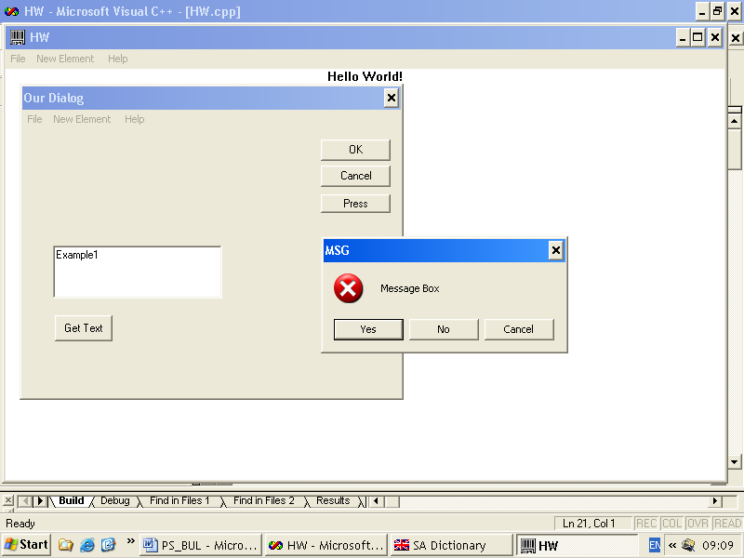
auxiliary window
main window
child window
Fig .26. The illustration of different kinds of windows

It is set in the title parameter of CREATE_WINDOW: 32-bits determinant ->WINDOWS.H

There are 3 types of windows existing:
- WS_OVERLAPED: main type, concealing window that screens the others if active (received the focus);
- WS_POPUP – auxiliary window, it is depicted always on the top, it is used as a dialogue window, panel window;
- WS_ CHILD – child window, subordinate to the parent window.
Windows elements

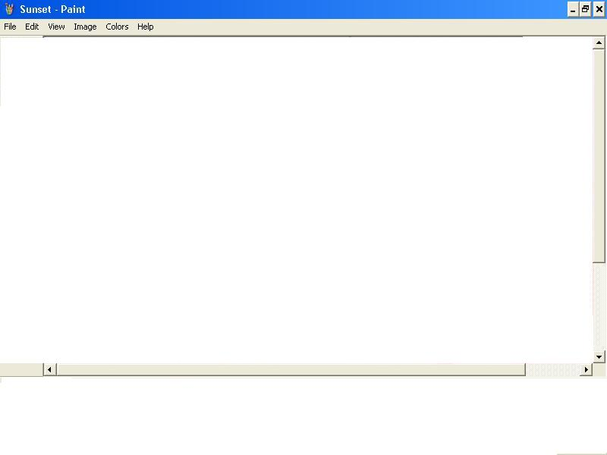
The elements of main window diagram are presented on Fig. 27.
horizontal elevator
vertical elevator
buttons for minimization, maximization, closing
title band

Fig. 27 .Main window diagram

Features of the windows
They are set in a 32-bits determinant, that is defined in WINDOWS.H.
WS_SYSMENU|WS_VSCROLL|…..
Distribution:
16-21 bits, describing the window elements: WS_MAXIMIZEROX, WS_MINIMIZEBOX, WS_THICKFRAME, WS_SYSMENU, WS_HSCROLL, WS_VSCROLL;
22-23 bits the type of the frame (00, 01, 10, 11) WS_DLGFRAME, WS_BORDER, WS_CAPTION;
24 bit - WS_MAXIMIZE maximum depiction;
25 bit WS_CLIPCHILDREN
26 bit WS_CLIPSIBLINGS
27 bit WS_DISABLED
28-29 bits WS_VISIBLE, WS_MINIMAZE
30-31 bits determine the type of the window WS_OVERLAPED, WS_CHILD, WS_POPUP.

Auxiliary windows (WS_POPUP).
Used for temporary information drawing or temporary dialogue (messages, dialogue, “Yes”, “No”)
Particularities:
- every window has its own main processing function;
- they have no title of the window but they have a frame;
- they have usually a fixed size but it is not obligatory;
- they may have or not a parent window: if not they are independent overlapping windows, and if they have it doze not mean that they are child windows. If the parent window is minimized the auxiliary window remains always on the top of the images.
Child windows (WS_CHILD)
They are used as dialogue elements: text field, field for editing, button, list box and the remaining resources of the dialogue boxes.
Particularities:
- closely connected with the parent window;
- do not go outside the size of the parent window;
- their coordinates are relative with respect of the top left corner of the work field of the parent window;
- at transference of the parent window, the child windows are moving with it;
- child windows can never be active;
- child windows do not have usually main serving functions;
- the messages coming from them are given through the parameter wParam to the serving function of the parent window at the message WM_COMMAND and switch on wParam.

The program code connected with windows from Fig. 26 follows below:
// Foward declarations of functions included in this code module:
ATOM MyRegisterClass(HINSTANCE hInstance);
BOOL InitInstance(HINSTANCE, int);
LRESULT CALLBACK WndProc(HWND, UINT, WPARAM, LPARAM);
LRESULT CALLBACK About(HWND, UINT, WPARAM, LPARAM);
LRESULT CALLBACK FirstOurProg(HWND, UINT, WPARAM, LPARAM);
int APIENTRY WinMain(HINSTANCE hInstance, HINSTANCE hPrevInstance,
LPSTR lpCmdLine,int nCmdShow)
////////……….
LRESULT CALLBACK WndProc(HWND hWnd, UINT message, WPARAM wParam, LPARAM lParam)
switch (message)
{
case WM_COMMAND:
wmId = LOWORD(wParam);
wmEvent = HIWORD(wParam);
switch (wmId) // Parse the menu selections:
{
////////…………….
case IDM_NA:
DialogBox(hInst, (LPCTSTR)IDD_OUR, hWnd, (DLGPROC)FirstOurProg);
break;
/////////………
LRESULT CALLBACK FirstOurProg (HWND hDlg, UINT message, WPARAM wParam, LPARAM lParam)
{
switch (message)
{
case WM_INITDIALOG:
SetDlgItemText(hDlg,IDC_EDIT1,"Example1");
return TRUE;
case WM_COMMAND:
if (LOWORD(wParam) == IDOK || LOWORD(wParam) == IDCANCEL)
{
EndDialog(hDlg, LOWORD(wParam));
return TRUE;
}
else if(LOWORD(wParam)== IDC_PRESS)
{
switch(MessageBox(hDlg,"MessageBox","MSG",MB_YESNOCANCEL | MB_ICONERROR ))
{
case IDYES: MessageBox(hDlg,"Yes","MSG",MB_OK); break;
case IDNO: MessageBox(hDlg,"No","MSG",MB_OK); break;
case IDCANCEL: MessageBox(hDlg,"Cancel","MSG",MB_OK); break;
}
}
else if(LOWORD(wParam)== IDC_GET)
{
char buf[100];
GetDlgItemText(hDlg,IDC_EDIT1,buf,100);
MessageBox(hDlg, buf, "MSG",MB_OK);
}
break;
}
return FALSE;
}

12.2. Windows work area
The applications output information in the windows work area. The screen is dividable between the applications resource.
Peculiarities:
- The applications do not work with a fixed size of the windows (The window size is determined from the user).
- The applications do not know the exact moment of drawing out on the screen in the window. The drawing out is executed asynchronously by messages. The program fragment that displays in the window must be able to out put every time.
- If concealed from another window the work area is not stored in the memory or file. If a closed area is detected, the image is redrawn again (renovated).
- The renovation is managed by the message WM_PAINT for the whole window or for a part of it.
WM_PAINT is not sent generally to every main serving function of the drawn windows because a great number of redundant redrawing will appear.
The OS determines automatically only visible parts and supports for every window “PAINT STRUCTURE” that contains the area coordinates for renovation „invalid rectangle”, that is automatically supported and changes currently.
WM_PAINT moves to the messages queue with a low priority: when „invalid rectangle” is not empty and there is no other message in the queue. The user’s actions have a greater priority. The delayed renovation is achieved by the functions: InvalidateRectangle(hwnd, &rect, True/False)
WM_PAINT is transferred directly to the serving function if a direct innovation is necessary, for example, at primary drawing. Function UpdateWindow(…..) is used.
An example of message processing WM_PAINTin simple application:
// Foward declarations of functions included in this code module:
ATOM MyRegisterClass(HINSTANCE hInstance);
BOOL InitInstance(HINSTANCE, int);
LRESULT CALLBACK WndProc(HWND, UINT, WPARAM, LPARAM);
//………….
int APIENTRY WinMain(HINSTANCE hInstance, HINSTANCE hPrevInstance,
LPSTR lpCmdLine,int nCmdShow)
LRESULT CALLBACK WndProc(HWND hWnd, UINT message, WPARAM wParam, LPARAM lParam)
switch (message)
{
case WM_COMMAND:
////////…………….
case WM_PAINT:
hdc = BeginPaint(hWnd, &ps);
// TODO: Add any drawing code here...
RECT rt;
GetClientRect(hWnd, &rt);
DrawText(hdc, szHello, strlen(szHello), &rt, DT_CENTER);
EndPaint(hWnd, &ps);
break;
////////…………….

12. 3. Context of the devices. (GDI).
When an information is drawn out to the screen, the printer, etc. it is not drawn directly to the hardware but an universal interface given by Windows-GDI is used GDI (graphical device interface).
The context of the devices (Device Context DC) includes a data structure describing specific parameters of the devices and is created for every window.
Windows gives printer drivers and video drivers. The functions of GDI turn to a data structure called - device context. Windows associates this structure and produces input-output instructions. DLL (Dynamic Link Library) is load and linked during application execution. Some application can share one DLL it saves a memory and a disk space.
The application calls GDI functions by data structure - device context. Windows associates this structure with physical device and produce input/output instructions. GDI allows the applications share the display. Every time when the program draws on the display or printer, it uses GDI functions. That are functions which draw points, lines, rectangles, polygons, bitmap and text. Device context represents physical device. Every С++ object with type “device context” is associated by 32-bit manipulator ( handle ) (type HDC ).
The “current” condition of device context includes:
- Added GDI objects for drawing like pens, brushes and fonts;
- Regime of comparing that defines the scale of objects;
- Details like parameters of text justifying and object filling.
GDI
display.drv
DC3
DC2
DC1
1
2
3
driver
dynamic memory
Fig. 28.Schematic illustration of windows drawing
APPLICATION
GDI interface

The process of information outputting to display is presented on Fig. 28.
When drawing out to the screen (printer):
① Creation of device context.
② Operation for drawing in the work area.
③ Release from the context.
There are two methods for drawing in the window that are illustrated below:
а) PAINTSTRUCT pc
HDC hdc
………
////////………
case WM_PAINT:
hDC=BeginPaint(hwnd, &pc);

///……… графични функции

EndPaint(hwnd, &pc);
break;

b) HDC hdc
//////………
case WM_DRAW:
hDC=GetDC(hwnd);

///……… графични функции

ReleaseDC(hwnd, hdc);
break;

About hDC we can receive information for the device specificity:
GetTextMetrix(hdc, &tm), where tm is the size of the symbols, i.e. default font:
xChar=tm.tmAvecharWidth;
yChar=tm.tmHeight;
or to execute the graphic functions:
TextOut(hDC.xChar.iYPos.szText.strlen(szText));
For example: TextOut(hdc, 150, 100, bla, strlen(bla));

12.3. Processing of the messages (events) from key-board, timer and mouse.
Key-board management
The key-board driver is keyboard.drv, kbdr.drv
Export functions: enable, disable – ToScii, AnsiToOlm, OlmToAnsi
There are generally 8 messages existing for events in the key-board. It is not necessary to react to all of them. The main message is WM_COMMAND, that includes the final result when working with dialogue elements, i.e. the chosen option from the menu.
Focus for insertion
The key-board is a dividable resource and is managed by the application focus. A message from the key-board receives that application which the focus has at the moment (which window the focus has at the moment). Active is the window that has a focus or if its child window has the focus. Processing window function receives messages WM_SETFOCUS/WM_KILLFOKUS respectively receives/looses the focus.
interruption (pressing, release) of a key

USER.EXE
procedure for interruptions processing
message

queue

getMessage
DispatchMessage

Fig. 16.Diagram of the interruption processing

Messages from the key-board
- System and non system keys, system (ALT_TAB, ALT_ESC).
- The corresponding messages for pressing system keys are: WM_SYSKEYDOWN, WM_SYSKEYUP, and for non system keys are: WM_KEYDOWN, WM_KEYUP.
- Information for the pressed key: in lParam encoding of the symbol.
- Virtual key code: in lParam . The names of the virtual keys in WINDOWS.h , i.e. VK_RETURN, VK_HOME, VK_0, VK_A,…..
- Must not be worked directly with ASCII table but with virtual key codes.

12.4. Modal dialog and controls of Windows
Processing of the messages (events) from the dialogue box and dialogue elements
Almost every one Windows application uses a dialog window for communication with the user. It can be a simple message window with one button “ОK” or a more complicated form for data inserting. There are two dialog types: modal and modeless. With modal dialog like “File Open” the user can’t work on the other place in the same application while the dialog is opened. With modeless dialog the user can work on other place in the same application while dialog is staying on the screen. For example it can look the dialog “Find and Replace”. The most used dialogs are modal. The user action (choice from menu) outputs the dialog on the screen. After that the user inserts data and closes the dialog.
The dialogue boxes are windows with processing functions. The windows are hierarchically connected and one parent window may contain several child windows. The dialogue elements are child windows of auxiliary windows.
An example with dialogue elements is illustrated on Fig.30. 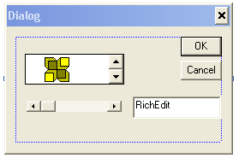
parent window
/dialogue box/
child windows
Fig. 30. Example with dialogue elements
The messages from the child windows are gathered in the message WM_COMMAND. There are pre-defined standard classes child windows like dialogue elements in WINDOWS. For example: “button”, “edit”, “scroolbar”, “listbox”, …. They are created in a simplified way by CreateWindow and pointing the standard class.

The dialogue elements are:
  - Simple like buttons, switches, group frame, text frame;
  - Complicated like elevators, field for editing, list window for choice, combined windows.

Dialogue elements are created as follows:
- a class is registered;
- a child window is created;
- the messages to the child window are processed;
- a result is sent to the parent window by SendMessage->WM_COMMAND
The messages from the chaild windows are gathered in the message WM_COMMAND. (WM_COMMAND: wParam – index of the chaild window (the dialogue element); lParam – specific information. messages dispatch to the parent window:
SendMessage (hListWnd, LBADDSTRING,0,(LONG)szString)
LB_ADDSTRING, LB_RESETCONTENS, LB_DELETESTRING
Receiving the choice:
nIndex=(WORD)SentMessage(hListWnd, LB_GETCURSEL,0,OL)

Language for resources defining
These are data that join at the end of the executing file. The data is stored on a disc and is loaded in the memory if necessary. The standard resources are data of different type.
Types of resources (redefined in, ObjectWindows OWL – additionally more powerful resources (objects):
- Menu (menu);
- Tables with combination of keys (accelerators);
- Dialogue boxes;
- Шрифтове (fonts);
- Курсори за мишката (cursors);
- Икони (icons);
- Information for the program version;
- HTML – WEB page;
- Байтови изображения (bitmaps).
The resources are a part of the executed program but they are not located in the data segments. They are loaded in the memory only when it is necessary. The resources are described separately in a resource file with the help of a language for resources description.

The resources are described in the files *.RC ->*.RES where a language for resources description is used. An example for resource description of “menu” follows below.
- Описание на МЕНЮ (*.MNU)
Demonstration MENU
sub-menu “File”
BEGIN
POPUP “&File”
BEGIN
The conrction with processing function.
Send in the variable of WM_COMMAND
or in *.h file
MENUITEM “&NEW”, IDM_NEW
MENUITEM “&Open”,IDM_OPEN
- -
END
POPUP “&EDIT”
BEGIN
- - -
END
END
- Описание на диалогова кутия (*.DLF)
About Box DIALOG 22, 17 144, 75
STYLE WS_POPUP|WS_DLGFRAME
BEGIN CTEXT “MicroSoft Windows”, - 1, 0, 5, 144, 8
- - - DEFPUSHBUTTON “OK” IDOK, 53,59,32,14, WS_GROUP
END
- Description of MENU (*.MNU)
Demonstration MENU
BEGIN
POPUP “&File”
BEGIN
MENUITEM “&NEW”, IDM_NEW
MENUITEM “&Open”,IDM_OPEN
- -
END
POPUP “&EDIT”
BEGIN
- - -
END
END
- Description of dialogue box (*.DLF)
About Box DIALOG 22, 17 144, 75
STYLE WS_POPUP|WS_DLGFRAME
BEGIN
CTEXT “MicroSoft Windows”, - 1, 0, 5, 144, 8
- - -
DEFPUSHBUTTON “OK” IDOK, 53,59,32,14, WS_GROUP
END
- Use of AppWizard

APPENDIX

CWindow Class Members

Alert Methods | Data Members
Attribute Methods | Icon Methods
Caret Methods | Menu Methods
Clipboard Methods | Message Methods
Construction, Destruction, and Initialization | Process and Thread Methods
Window Tree Access Methods | Scrolling Methods
Coordinate Mapping Methods | Timer Methods
Dialog Box Item Methods | Update and Painting Methods
Drag-Drop Methods | Window Access Methods
Font Methods | Window Size and Position Methods
Help Methods | Window State Methods

Hot Key Methods | Window Text Methods
Operators

Alert Methods
FlashWindow | Flashes the window once.
MessageBox | Displays a message box.

Attribute Methods
GetExStyle | Retrieves the extended window styles.
GetStyle | Retrieves the window styles.
GetWindowLong | Retrieves a 32-bit value at a specified offset into the extra window memory.
GetWindowWord | Retrieves a 16-bit value at a specified offset into the extra window memory.
ModifyStyle | Modifies the window styles.
ModifyStyleEx | Modifies the extended window styles.
SetWindowLong | Sets a 32-bit value at a specified offset into the extra window memory.
SetWindowWord | Sets a 16-bit value at a specified offset into the extra window memory.

Caret Methods
CreateCaret | Creates a new shape for the system caret.
CreateGrayCaret | Creates a gray rectangle for the system caret.
CreateSolidCaret | Creates a solid rectangle for the system caret.
HideCaret | Hides the system caret.
ShowCaret | Displays the system caret.

Clipboard Methods
ChangeClipboardChain | Removes the window from the chain of Clipboard viewers.
OpenClipboard | Opens the Clipboard.
SetClipboardViewer | Adds the window to the Clipboard viewer chain.

Construction, Destruction, and Initialization
Create | Creates a window.
Attach | Attaches a window to the CWindow object.
CWindow | Constructor.
DestroyWindow | Destroys the window associated with the CWindow object.
Detach | Detaches the window from the CWindow object.

Coordinate Mapping Methods
ClientToScreen | Converts client coordinates to screen coordinates.
MapWindowPoints | Converts a set of points from the window’s coordinate space to the coordinate space of another window.
ScreenToClient | Converts screen coordinates to client coordinates.

Dialog Box Item Methods
CheckDlgButton | Changes the check state of the specified button.
CheckRadioButton | Checks the specified radio button.
DlgDirList | Fills a list box with the names of all files matching a specified path or filename.
DlgDirListComboBox | Fills a combo box with the names of all files matching a specified path or filename.
DlgDirSelect | Retrieves the current selection from a list box.
DlgDirSelectComboBox | Retrieves the current selection from a combo box.
GetDlgItemInt | Translates a control’s text to an integer.
GetDlgItemText | Retrieves a control’s text.
GetNextDlgGroupItem | Retrieves the previous or next control within a group of controls.
GetNextDlgTabItem | Retrieves the previous or next control having the WS_TABSTOP style.
GotoDlgCtrl | Sets the keyboard focus to a control in the dialog box.
IsDialogMessage | Determines whether a message is intended for the specified dialog box.
IsDlgButtonChecked | Determines the check state of the button.
NextDlgCtrl | Sets the keyboard focus to the next control in the dialog box.
PrevDlgCtrl | Sets the keyboard focus to the previous control in the dialog box.
SendDlgItemMessage | Sends a message to a control.
SetDlgItemInt | Changes a control’s text to the string representation of an integer value.
GetDlgControl | Retrieves the IUnknown of the specified control.
SetDlgItemText | Changes a control’s text.

Drag-Drop Methods
DragAcceptFiles | Registers whether the window accepts dragged files.

Font Methods
GetFont | Retrieves the window’s current font.
SetFont | Changes the window’s current font.

Help Methods
GetWindowContextHelpId | Retrieves the window’s help context identifier.
SetWindowContextHelpId | Sets the window’s help context identifier.
WinHelp | Starts Windows Help.

Hot Key Methods
GetHotKey | Determines the hot key associated with the window.
SetHotKey | Associates a hot key with the window.

Icon Methods
GetIcon | Retrieves the window’s large or small icon.
SetIcon | Changes the window’s large or small icon.

Menu Methods
DrawMenuBar | Redraws the window’s menu bar.
GetMenu | Retrieves the window’s menu.
GetSystemMenu | Creates a copy of the system menu for modification.
HiliteMenuItem | Highlights or removes the highlight from a top-level menu item.
SetMenu | Changes the window’s current menu.

Message Methods
PostMessage | Places a message in the message queue associated with the thread that created the window. Returns without waiting for the thread to process the message.
SendMessage | Sends a message to the window and does not return until the window procedure has processed the message.
SendNotifyMessage | Sends a message to the window. If the window was created by the calling thread, SendNotifyMessage does not return until the window procedure has processed the message. Otherwise, it returns immediately.

Process and Thread Methods
GetWindowThreadID | Retrieves the identifier of the thread that created the specified window.
GetWindowProcessID | Retieves the identifier of the process that created the window.

Scrolling Methods
EnableScrollBar | Enables or disables the scroll bar arrows.
GetScrollInfo | Retrieves the parameters of a scroll bar.
GetScrollPos | Retrieves the position of the scroll box.
GetScrollRange | Retrieves the scroll bar range.
ScrollWindow | Scrolls the specified client area.
ScrollWindowEx | Scrolls the specified client area with additional features.
SetScrollInfo | Sets the parameters of a scroll bar.
SetScrollPos | Changes the position of the scroll box.
SetScrollRange | Changes the scroll bar range.
ShowScrollBar | Shows or hides a scroll bar.

Timer Methods
KillTimer | Destroys a timer event.
SetTimer | Creates a timer event.

Update and Painting Methods
BeginPaint | Prepares the window for painting.
EndPaint | Marks the end of painting.
GetDC | Retrieves a device context for the client area.
GetDCEx | Retrieves a device context for the client area and allows clipping options.
GetUpdateRect | Retrieves the coordinates of the smallest rectangle that completely encloses the update region.
GetUpdateRgn | Retrieves the update region and copies it into a specified region.
GetWindowDC | Retrieves a device context for the entire window.
Invalidate | Invalidates the entire client area.
InvalidateRect | Invalidates the client area within the specified rectangle.
InvalidateRgn | Invalidates the client area within the specified region.
IsWindowVisible | Determines the window’s visibility state.
LockWindowUpdate | Disables or enables drawing in the window.
Print | Requests that the window be drawn in a specified device context.
PrintClient | Requests that the window’s client area be drawn in a specified device context.
RedrawWindow | Updates a specified rectangle or region in the client area.
ReleaseDC | Releases a device context.
SetRedraw | Sets or clears the redraw flag.
ShowOwnedPopups | Shows or hides the pop-up windows owned by the window.
ShowWindow | Sets the window’s show state.
ShowWindowAsync | Sets the show state of a window created by a different thread.
UpdateWindow | Updates the client area.
ValidateRect | Validates the client area within the specified rectangle.
ValidateRgn | Validates the client area within the specified region.

Window Access Methods
ChildWindowFromPoint | Retrieves the child window containing the specified point.
ChildWindowFromPointEx | Retrieves a particular type of child window containing the specified point.
GetLastActivePopup | Retrieves the most recently active pop-up window.
GetParent | Retrieves the immediate parent window.
GetTopLevelParent | Retrieves the top-level parent or owner window.
GetTopLevelWindow | Retrieves the top-level owner window.
GetTopWindow | Retrieves the top-level child window.
GetWindow | Retrieves the specified window.
IsChild | Determines whether the specified window is a child window.
SetParent | Changes the parent window.

Window Size and Position Methods
ArrangeIconicWindows | Arranges all minimized child windows.
BringWindowToTop | Brings the window to the top of the Z order.
CenterWindow | Centers the window against a given window.
DeferWindowPos | Updates the specified multiple-window-position structure for the specified window.
GetClientRect | Retrieves the coordinates of the client area.
GetWindowPlacement | Retrieves the show state and positions.
GetWindowRect | Retrieves the window’s bounding dimensions.
GetWindowRgn | Obtains a copy of the window region of a window.
IsIconic | Determines whether the window is minimized.
IsZoomed | Determines whether the window is maximized.
MoveWindow | Changes the window’s size and position.
ResizeClient | Resizes the window.
SetWindowPlacement | Sets the show state and positions.
SetWindowPos | Sets the size, position, and Z order.
SetWindowRgn | Sets the window region of a window.

Window State Methods
EnableWindow | Enables or disables input.
IsWindow | Determines whether the specified window handle identifies an existing window.
IsWindowEnabled | Determines whether the window is enabled for input.
IsWindowUnicode | Determines whether the specified window is a native Unicode window.
SetActiveWindow | Activates the window.
SetCapture | Sends all subsequent mouse input to the window.
SetFocus | Sets the input focus to the window.

Window Text Methods
GetWindowText | Retrieves the window’s text.
GetWindowTextLength | Retrieves the length of the window’s text.
SetWindowText | Changes the window’s text.

Window Tree Access Methods
GetDescendantWindow | Retrieves the specified descendant window.
GetDlgCtrlID | Retrieves the window’s identifier (for child windows only).
GetDlgItem | Retrieves the specified child window.
SendMessageToDescendants | Sends a message to the specified descendant windows.
SetDlgCtrlID | Changes the window’s identifier.
Operators
operator HWND | Converts the CWindow object to an HWND.
operator = | Assigns an HWND to the CWindow object.
Data Members
m_hWnd | The handle to the window associated with the CWindow object.
Microsoft Visual C++

Тема1. (4ч.) Особености на програмирането под Windows. Обектно програмиране в средата на Windows. Обекти. Обработка и изпращане на съобщения. Синхронизация. Строеж на средата Windows. Прозорци. Атрибути. Типове съобщения. Диспечер на съобщенията. Основни функции на Windows.

Тема 2. (3ч.) Object programming in Windows environment Обекти полиморфия и наследяване на обекти в средата на Windows. Управление на ресурсите във в средата на Windows. Управление на Оперативната памет. Управление на разделяемите ресурси..

Theme 3. (3ч.) Instrumental devices. Compiler. Dynamic libraries. Devices for connection between the appliances in the Windows environment. Structure of WIN32-application. Simple example program for window management.
Theme 4.(4ч.) Windows management in the environment of Windows. Work area. Context of the devices. (GDI). Processing of the messages (events) from the key-board, timer and mouse. Work with menus. Serving function. Drawing a vector graphic, filling up areas, business graphic.
Тема 5. (2ч.) Ресурси:диалогови кутии, диалогови елементи. Език за дефиниране на ресурси. Управление на диалогови елементи в Win-32 приложения. Съобщения, функции за управление на диалогови елементи (инициализация, постановяване и получаване на стойности).
Тема 6. (3ч.) Интерактивна графика и управление на визуални елементи. Drag&Drop с мишката, маркиране и влачене на графични елементи. Примерна програма за визуална работа в работната област на графичен прозорец.
Тема 7. (3ч.) Достъп до файловата система. Типове файлове. Файлове и стриймове. Форматиране и конвертиране на стриймове и низове. Последователен и директен достъп до елементите на файлове.
Тема 8. (3ч.) Работа с по-сложни контроли в Windows: списъчен (табличен) контрол и дървовиден контрол.
Тема 9. (4ч.) Създаване на динамични библиотеки (DLL) в Windows. Импорти и експорти. Примерен опростен DLL и клиентска програма за достъп до DLL.
Тема 10. (4ч.) MFC и ActiveX контроли. Примерна програма, която включва ActiveX контрол. . Компонентен обектен модел (COM), същност, COM-интерфейси. Регистрация на COM модули. Работа с MFC – Wizard за създаване на СОМ обекти.
Тема 11. (3ч.) Компонентен обектен модел (COM), същност, COM-интерфейси. Регистрация на COM модули. Работа с MFC – Wizard за създаване на СОМ обекти.
Тема 12. (3ч.) Запознаване с Active Tamplate Library (ATL COM) Работа с при създаване на ATL–клиентска и ATL–сървърна част.
Тема 13. (3ч.) Управление на бази от данни. ODBC-интерфейс. Wizard за проектиране на приложение с достъп до БД. Извадки (Record Set) от базата. Примерно приложение за достъп до база от данни на MS-ACCESS.

