**Optimize Beer Route Selection: A Toronto Brewery Case Study**

Trevor S. – May 2020

1. **Introduction / Business Problem**

A Toronto-based beer brewery recently started bottling its beer. Instead of using a distributor to sell and deliver beer to stores in Toronto, the brewery decided to distribute its beer independently. Since the brewery is young, the owner decided only to distribute to on-premise accounts (places where beer is sold and consumed "on-premise", namely restaurants, as opposed to grocery and convenience stores which are "off-premise" accounts). The brewery is also constrained by owning only one delivery truck which is not refrigerated. In order to maintain a quality product, the owner does not want to distrubute further than 5 kilometers (km) from the brewery in an unrefrigerated truck.

The owner does not have any confirmed accounts yet, but he wants to understand what a delivery route would look like if he has the capacity to supply 50 stores within a 5 km radius of brewery with one delivery per week. The owner wants to filter this projected route based on the most popular 50 on-premise stores within the search area. The end product will be a map with 50 store points segmented into clusters and color-coded by delivery day of the week (Monday through Friday).

The target audience for this data is business owners, distributors, and sales representatives who want to optimize their route selection for sales and delivery of their products. Routes can be filtered and refined in numerous ways to meet the needs of the specific customer. In this case a brewery owner is trying to understand distribution routes for his product with a limited delivery capacity.

1. **Data Methodology**

The data I will need for this project will come from Foursquare API. I will filter search results by the following criteria: within 5 km of the brewery; only include "restaurant" in search query; and pick the top 50 venues. Once the data points have been collected, I will segment the stores into 5 geographic clusters, one for each day of the week (Monday through Friday). The clusters will define the separate routes for the one delivery truck each day (the stores only receive one delivery per week).

While the data is based on a maximum location search radius, it is also defined by popular restaurants within the search area. This may result in data points are that not evenly spread across the search area. This is okay, as the intent is to sell the product to the most popular places, not evenly across the the 10 miles. An example of a single day route would be a color-coded cluster of 10 stores in a 5 blocks area of downtown Toronto. A second cluster may be two blocks away or it could be one mile away in a separate neighborhood.

The method for clustering the data points and displaying them on a map, color-coded by delivery day of the week, will follow the functions we have already practiced in this course.

1. 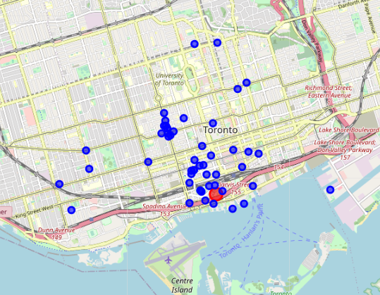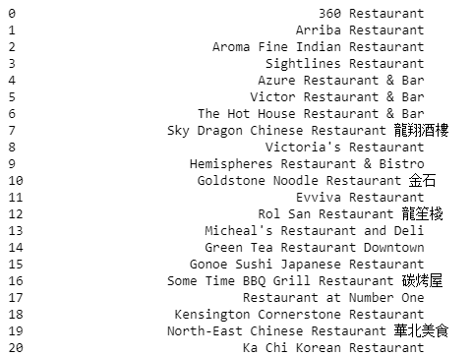**Data Analysis**

**Restaurant data collected from Foursquare API Restaurant locations in downtown Toronto**

1. **Results**

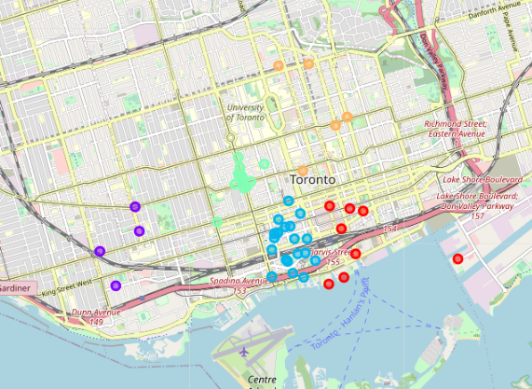

The clustering of 50 restaurants in downtown Toronto was able to provide five distinct groupings, one for each day of the week, that will allow the brewery to optimize its daily sales route based on distance from the brewery (distribution point). The five cluster are separated geographially (based on latitude / longitutde data) and denoted by different color coding. The overall objective of this project was achieved, likely providing value to the brewery owner by decreasing planning/experimentation time and decreasing unnecessary costs due to poor delivery route selection.

1. **Discussion**

The results of intial data collection provided unexpectedly clear dileniations in the geographic spacing of the restaurants. This made clustering the venues much easier and the results more expected. This outcome can not be expected in most other situations or cities. A larger collection or venues over a larger radius may have provided more interesting results to observe and with which to experiment. This can be considered a proof of concept, for which the concept proves effective on a small scale.

There are additional variables can be added to make the route selection more complex, and possibly more effective, such as traffic pattern along the route, hours of business for the venues, and average size of the weekly delivery for each cluster. Since one major constraint for the brewery is its single delivery truck, the clustering data does not provide avergage delivery size, per beer case or keg, which would likely influence the route selection and the number of return trips to the brewery on a single day.

1. **Conclusion**

This proof of concept was effective on a small scale for determining an optimum sales route, by day of the week, for a small brewery in downtown Toronto. The clusters were cleary distingushed by geographic location and color. The objective of this project was to provide a model for a potential delivery/sales route for the brewery owner's information and planning purposes. Once the owner gathers more information, develops sales accounts, and increases the size of his distribution and delivery capacity, even greater value can be gleaned from a k-means clustering exercise such as this one.

The target audience for this type of project is sales representatives and organizations engaged in all types of commerce and distribution. Collecting location data and clustering select data can optimize a single sales representative's daily sales route, as well as improving an entire beverage distributor's bottom-line by reducing items such as the following: cost of gas; wear and tear on trucks; accidents on the road; and driver over-time pay. This one project demonstrated the successful execution of a concept that can be broadened in size and variables to provide value for many different businesses.