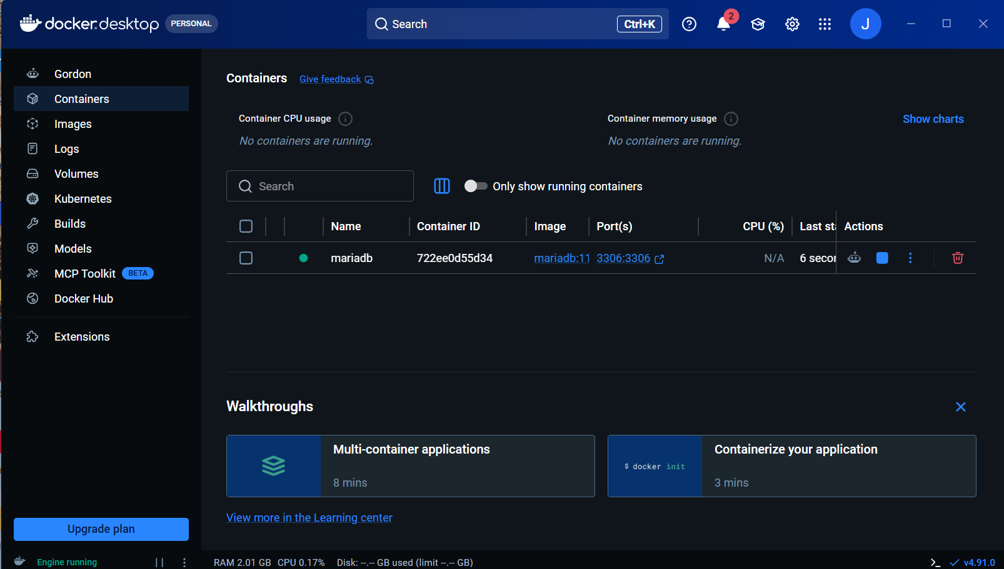Docker Setup to initialize MariaDB
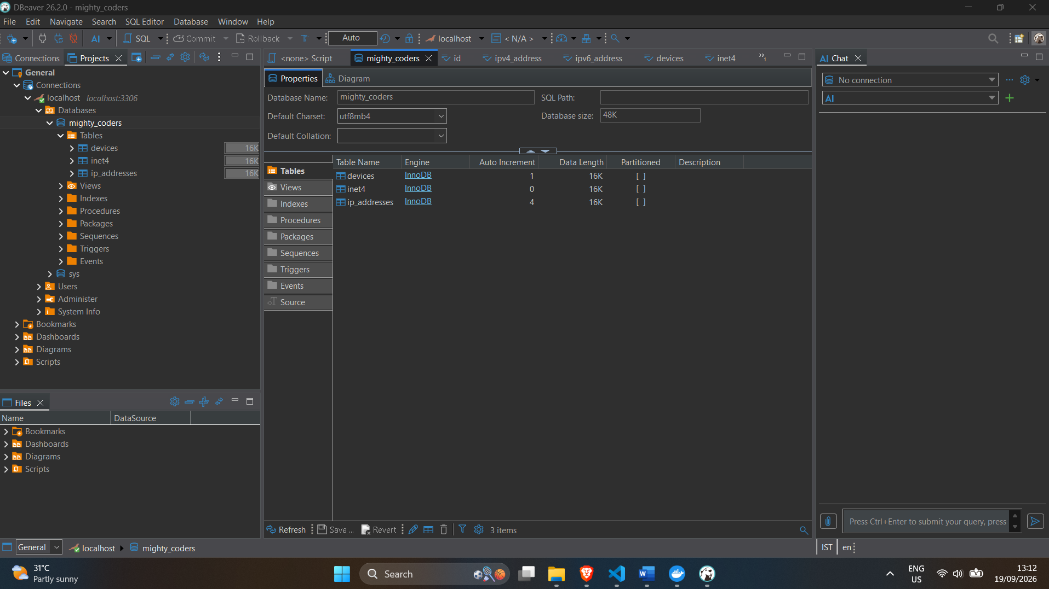using DBeaver for DB navigation and sql query
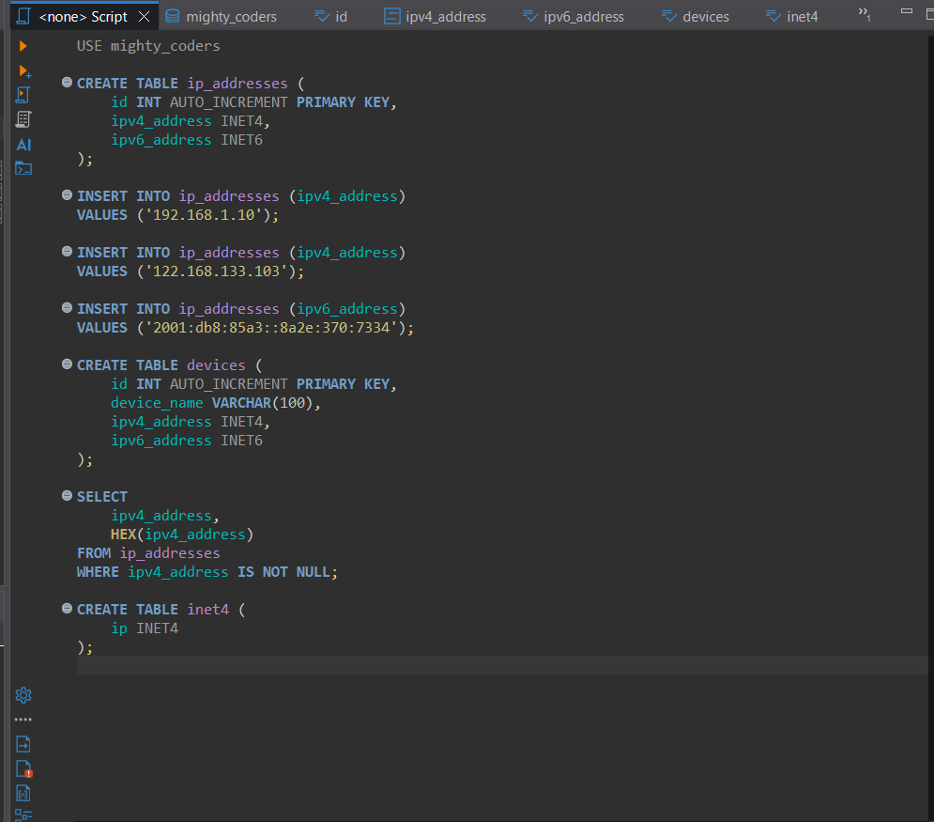SQL query written in DBeaver
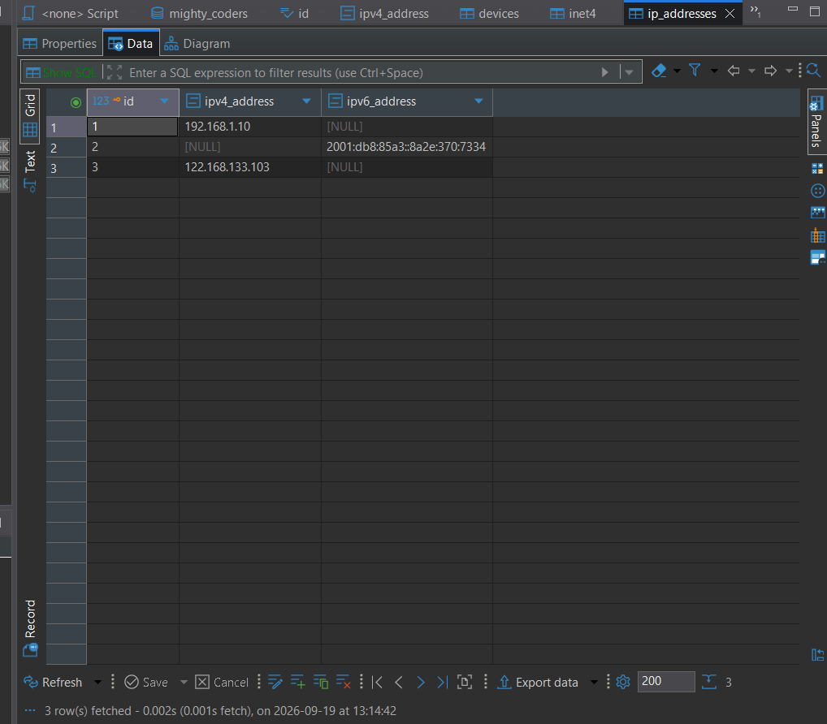able to store INET4 and INET6 in DB using SQL query
Able to sort, compare and add only valid IP addresses, throws error if Ip is incorrect.
## What I learned
- Creating INET4 and INET6 columns
- Storing IPv4 and IPv6 addresses
- Validating IP addresses
- Comparing IPv4 addresses
- Sorting IPv4 addresses

