Software Design Specification

For

Dragon Course Review

Submitted by

Team Dragon Course Review

|  |  |
| --- | --- |
| **Instructor:** | Professor Hislop |
| **Team Members:** | Francis Byrd, John Berger, Chinh Nguyen, Joshua Manicheril, Timothy Chang |
| **Cycle:** |  |
| **Date Submitted:** | 11/29/2020 |

Document template copyright 2005-2019, Gregory W. Hislop. Version 2.3. Use permitted under Creative Commons license CC-BY-NC-SA. See http://creativecommons.org/licenses/by-nc-sa/3.0/.

Grading Rubric - Design Specification

This rubric outlines the grading criteria for this document. Note that the criteria represent a plan for grading. Change is possible, especially given the dynamic nature of this course. Any change will be applied consistently for the entire class.

|  |  |  |  |  |
| --- | --- | --- | --- | --- |
| **Achievement** | **Minimal** | **Exemplary** | **Pts** | **Score** |
| **Content** | Section(s) missing, not useful, inconsistent, or wrong. | Provides all relevant information correctly and with appropriate detail |  |  |
| Introduction |  |  | 10 | 10 |
| Architectural Description |  |  | 10 | 9 |
| Interface Description |  |  | 15 | 13 |
| Detailed Design |  |  | 50 | 40 |
| **Grammar and Spelling** | Many serious mistakes in grammar or spelling | Grammar, punctuation, and spelling all correct | 5 |  |
| **Expression** | Hard to follow or poor word choices | Clear and concise. A pleasure to read | 5 | 4 |
| **Tone** | Tone not appropriate for technical writing | Tone is consistently professional |  |  |
| **Organization** | Information difficult to locate | All information is easy to find and important points stand out | 5 | 5 |
| **Layout** | Layout is inconsistent, visually distracting, or hinders use | Layout is attractive, consistent, and helps guide the reader |  |  |
| **Late Submission** |  |  |  |  |
| **Total** |  |  | 100 | **86** |

Table of Contents

1 Introduction

1.1 Scope 4

1.2 Definitions, Acronyms, and Abbreviations 4

1.3 Requirements Traceability Matrix 4

2 Architectural Description 5

2.1 System Architecture Decomposition 5

2.2 Entity Relationship Decomposition 5

3 Interface Description 7

3.1 User Interface 7

3.2 Data Interface 8

3.3 Programming Interface 8

4 Detailed Design 8

4.1 Login Design 8

4.2 Dragon Course Review Database 9

4.3 Screens 12

Introduction

## Scope

The scope of this document is to provide the capabilities, appearance, and functions of the Dragon Course Review Web Application that it needs to function. This will allow the developers of the application to understand what is needed to be built and how to do it.

## Definitions, Acronyms, and Abbreviations

**Watchlist:** Users created list of courses in which the system will notify when changes happen (waitlist opens, course availability, course closed)

## Requirements Traceability Matrix

This section maps the relationship between requirement statements and detailed design entities. As such it shows how requirements are covered by the design and demonstrates the purpose for which design entity exists.

The values in the cells of the table show which requirements provide the purpose for each entity. The cell values are:

* **Blank** – the design entity does not implement any of that requirement
* **P** for Primary - the design entity implements all or most of the requirement
* **S** for Secondary – the design entity implements a smaller but essential part of the requirement

|  |  |  |  |  |  |  |  |  |  |  |
| --- | --- | --- | --- | --- | --- | --- | --- | --- | --- | --- |
|  | **<DE1>System Architecture** | **4.1.X** | **4.2.1** | **4.2.2** | **4.2.3** | **4.2.4** | **4.2.5** | **4.2.6** | **4.2.7** | **4.3** |
| **R1.1** |  |  |  |  |  |  |  |  |  |  |
| **R1.2** |  |  |  |  |  |  |  |  |  |  |
| **R1.3** |  |  |  |  |  |  |  |  |  |  |
| **R1.4** |  |  |  |  |  |  |  |  |  | P |
| **R1.5** |  | P |  |  |  |  |  |  |  |  |
| **R2.1** |  |  |  |  |  |  |  |  |  |  |
| **R2.2** |  |  |  |  |  |  |  |  |  |  |
| **R2.3** |  |  |  |  |  |  |  |  |  |  |
| **R3.1** |  |  | P | P |  |  |  |  |  |  |
| **R3.2** |  |  |  |  | P |  |  |  |  |  |
| **R3.3** |  |  |  |  |  | P |  |  |  |  |
| **R3.4** |  |  |  |  |  |  | P | P | P |  |

*Figure 1 – Traceability between Requirements and Design Entities*

# Architectural Description

## System Architecture Decomposition

Figure 2 depicts the high-level system architecture. The system will be constructed from multiple distinct components:

* Student Interface — The front-facing aspect of the website which allows students to search for and review courses.
* Instructor Interface -- The front-facing aspect of the website which allows instructors to create, design and distribute surveys.
* Drexel Source Data - Source data used to populate course, professor and student information.
* Data Model — The classes needed to organize Courses, Users, Reviews, Surveys.
* Data Storage — The interface for storing, importing, and exporting the data model and raw collected data.

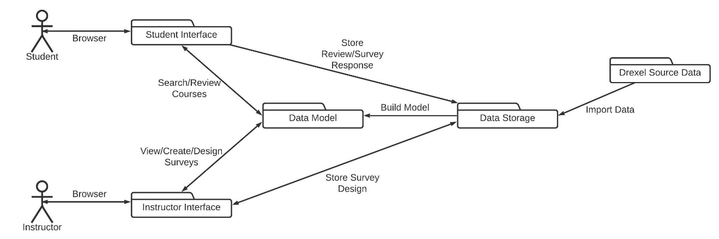

*Figure 2: Dragon Course Review Architecture*

## Entity Relationship Decomposition

Figure 3 shows the Entity Relationship for the Dragon Course Review system.

*Figure 3: Dragon Course Review ERD*

# Interface Description

## User Interface

3.1.1

* Login Screen:
  + The login screen will be blue. In the middle of the screen there will be the text “Username” and “Password” with text boxes directly to the right of them. Below the text boxes will be links for “Forgot Password” and “New User” On the top right-hand corner of the screen will be a question mark that will contain a link to a FAQ page.

3.1.2

* Home Page:
  + When the user logs in they will be taken to the home page. The logo will be listed at the top left-hand corner of the screen with a search bar in the top middle next to it. On the top right-hand corner there will be a link of a person that will take you to your account settings page and a link of a list that will take you to your watchlist page. In the middle of the page there will be four large links with the text “Search a Course”, “Find a Professor”, “Rate a Course”, and “Rate a professor”.

3.1.3

* FAQ Page
  + When a user clicks on the question mark, they will be brought to the FAQ page. The FAQ page will have the logo on the top right corner. Underneath this and centered on the screen in large text will be “How can we help you?” Underneath this will be a textbox where questions can be inserted. When the user scrolls down, they will see a list of our most frequently asked questions.
* Results Screen
  + When a search is done the user will be taken to this screen. The screen will have a logo at the top left of the screen that will take you back to the home page. TO the right of this will be the search bar which will allow another search to be done. On the top right-hand corner there will be a link of a person that will take you to your account settings page and a link of a list that will take you to your watchlist page. Starting directly below this will be results based on the search criteria. They will be clearly listed in list format. All the classes will be links to take students to view a course.
* Course view
  + When a student selects to view a specific course, they will be brought to a course view page. It will have a logo at the top left of the screen that will take you back to the home page and to the right of this will be a search bar that will allow you to make a new inquiry. The page will hold all information in a bulleted list. Below this they will be able to view user descriptions of the course and see which professors teach it.
* Watchlist screen
  + The screen will have a logo at the top left of the screen that will take you back to the home page. On the top right-hand corner there will be a link of a person that will take you to your account settings page. Starting directly below this will be the list of course in your watchlist. They will be clearly listed in list format. All the classes will be links to take students to view a course

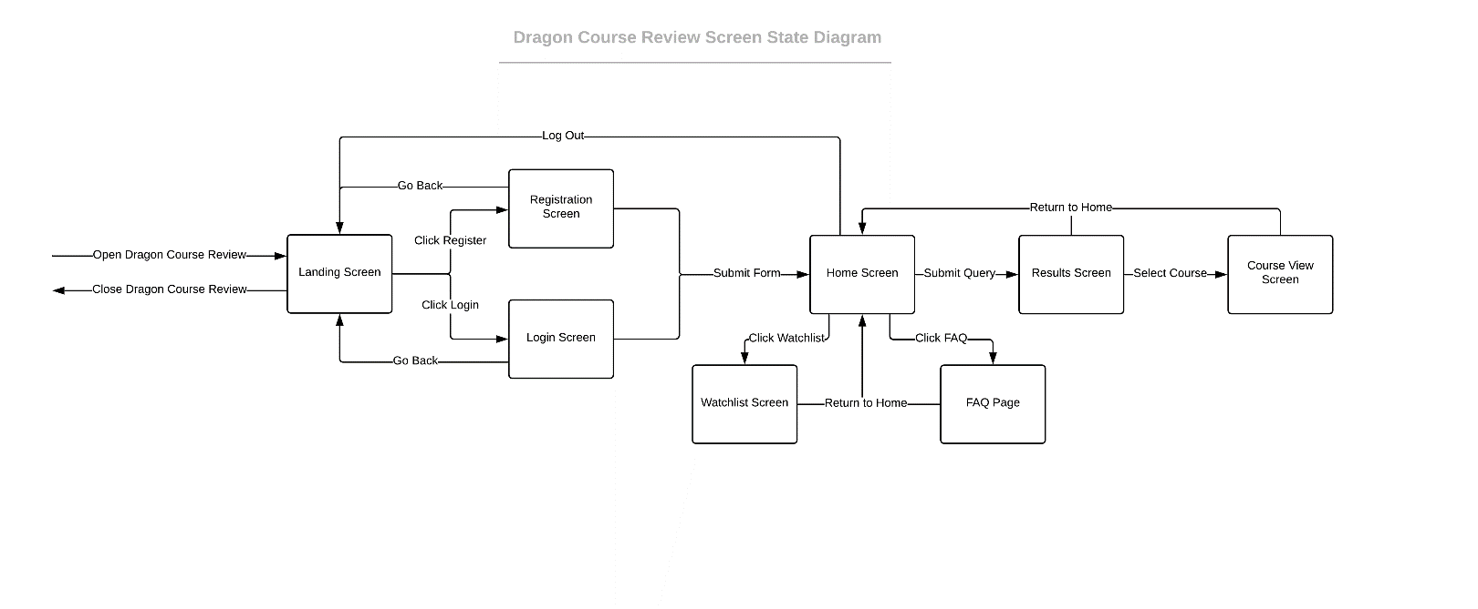

## Data Interface

* Data will be scraped and parsed from the Drexel Term Master Schedule
* Parsed data will be stored in the Courses Table to be served in the UI

## Programming Interface

* No Programming interface is provided.

# Detailed Design

## Login Design

**Type:** Code

**Description**:

The user adds their Drexel account to the system through their email and a unique password. The login authenticates the user based on these credentials. A session token is returned and used to confirm that the user is logged in past the login page. Failing the session token check on a webpage redirects the user to the login page.

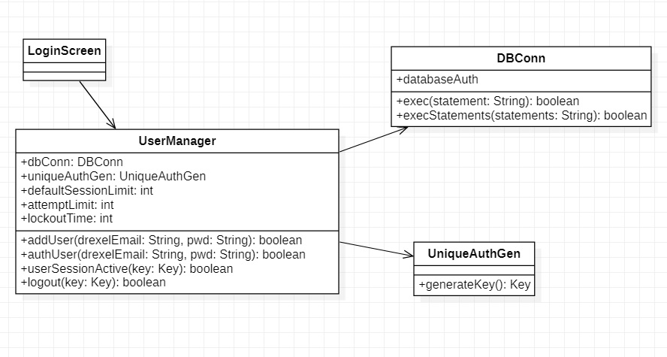

*Figure 3 - Snippet of UML for Login System*

## Dragon Course Review Database

**Type:** Database

**Description:**

See Figure 2 for ERD describing Dragon Course Review Database.

**4.2.1 Instructors Table**

**Type:** Table

**Description:** The instructors table will contain information about the instructors with each row holding various information about one instructor

**Table Name**: instructors

|  |  |  |
| --- | --- | --- |
| Field Name | Field Type | P/F Key |
| id | Int | Primary Key |
| name | Varchar |  |
| email | Varchar |  |
| department | Varchar |  |
| description | Varchar |  |

**4.2.2 Students Table**

**Description:** The students table will contain information about the students with Each row containing the student’s id number, name, and email.

**Table Name:** students

|  |  |  |
| --- | --- | --- |
| Field Name | Field Type | P/F Key |
| Id | Int | Primary Key |
| name | varchar |  |
| email | varchar |  |

**4.2.3 Courses Table**

**Description:** The courses table will contain various information about the courses with each row specifying a single cours**e.**

**Table Name:** courses

|  |  |  |
| --- | --- | --- |
| Field Name | Field Type | P/F Key |
| Id | Int | Primary Key |
| inst_id | Int | Foreign Key– instructor.id |
| Title | varchar |  |
| Dept | varchar |  |
| Desc | varchar |  |
| inst_desc | varchar |  |
| Crn | varchar |  |
| Sect | varchar |  |
| Number | varchar |  |
| Quarter | varchar |  |
| Enrolled | Int |  |
| max_enroll | Int |  |
| waitlist | int |  |
| closed | bool |  |

**4.2.4 Reviews Table**

**Description:** The reviews table will contain information about the reviews with each row holding a complete course review and ratings.

**Table Name:** reviews

|  |  |  |
| --- | --- | --- |
| Field Name | Field Type | P/F Key |
| id | int | Primary Key |
| content | varchar |  |
| course_rating | int |  |
| inst_rating | int |  |
| inst_id | int | Foreign Key – Instructors.id |
| course_id | int | Foreign Key – Students.id |
| student_id | int | Foreign Key – Courses.id |

**4.2.5 Surveys Table**

**Description:** This table will hold information on all of the surveys.

**Table Name:** surveys

|  |  |  |
| --- | --- | --- |
| Field Name | Field Type | P/F Key |
| id | int | Primary Key |
| inst_id | int | Foreign Key – Instructors.id |
| size | int |  |

**4.2.6 Questions Table**

**Description:** This table will hold common questions asked by users of the site.

**Table Name:** questions

|  |  |  |
| --- | --- | --- |
| Field Name | Field Type | P/F Key |
| id | int | Primary Key |
| survey_id | int | Foreign Key – Surveys.id |
| type | varchar |  |
| question_text | varchar |  |

**4.2.7 Answers Table**

**Description:** This table will hold answers to the common questions listed on the questions table.

**Table Name:** answers

|  |  |  |
| --- | --- | --- |
| Field Name | Field Type | P/F Key |
| id | int | Primary Key |
| question_id | int | Foreign Key – Questions.id |
| answer_text | varchar |  |
| rating | int |  |
| student_id | int | Foreign Key – Students.id |
| survey_id | int | Foreign Key – Survey.id |

**4.2.8 Watchlist Table**

**Description:** This table will contain the courses that students save in their watchlist.

**Table Name:** watch_courses

|  |  |  |
| --- | --- | --- |
| Field Name | Field Type | P/F Key |
| Id | int | Primary Key |
| student_id | int | Foreign Key – Students.id |
| course_id | int | Foreign Key – Students.id |

## Screens

**Type: Screens**

**Description:**

**4.3.1 Login Page**

**Layout:** The login screen will be blue. In the middle of the screen there will be the text “Username” and “Password” text as placeholders in username and password boxes respectively. Below the text boxes will be links for “Forgot Password?” and “New User”. Login box will be below “Forgot Password” and “New User”. On the top right-hand corner of the screen will be a question mark that will contain a link to a FAQ page.

**Visual Layout:**

**4.3 Screens**

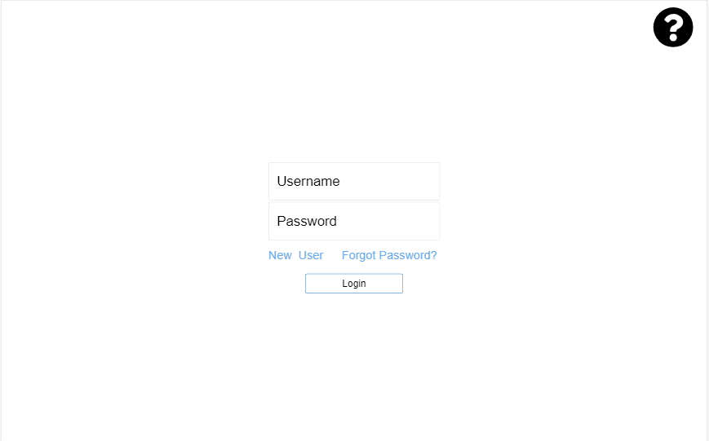

**Screen Elements:**

* + Text Box for username
  + Text box for password
  + “Forgot Password?” link
  + “New User” link
  + FAQ Page link
  + Action box for Login

**User interaction:**

* When users interact with this page, they will either be let into the site, get a new password, or make a new account. If they want to learn more information about the website, they can click on the FAQ page link.

**4.3.2 Home Page**

**Layout:** When the user logs in they will be taken to the home page. The logo will be listed at the top left-hand corner of the screen with a search bar in the top middle next to it. On the top right-hand corner there will be a link of a person that will take you to your account settings page. In the middle of the page there will be four large links with the text “Search a Course”, “Find a Professor”, “Rate a Course”, and “Rate a professor”. When a search is done the links will go away and the results will show below the search bar.

**Visual Layout:**

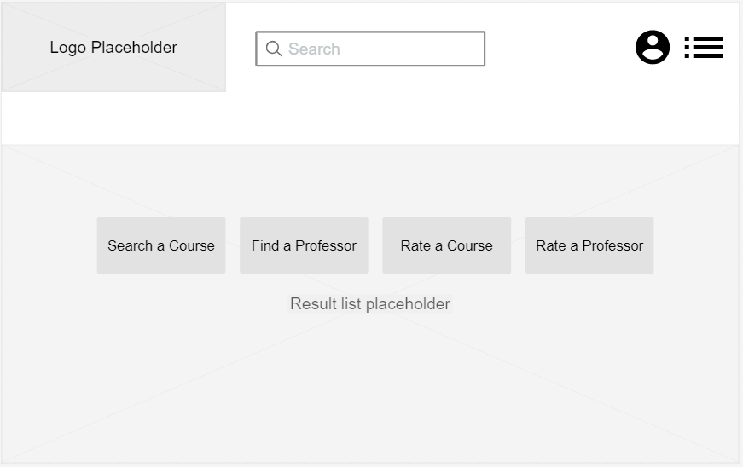

**Screen Elements:**

* + Logo image
  + "Search” textbox
  + Text box for Search Bar
  + Results list for Search
  + “Accounts Setting” link
  + “Search a Course” link
  + "Find a Professor” link
  + “Rate a Course” link
  + “Rate a Professor” link

**User interaction:**

* Users will spend most of their time on this page. It will serve as their jumping off point to other screens. Multiple links will be provided to access other screens. It will clearly display the intended functions of the website.

**4.3.3 FAQ Page**

**Layout:** When the user clicks on the FAQ link, they will be taken to the FAQ page. The logo will be listed at the top-left of the screen. Underneath this and centered on the screen in large text will be “How can we help you?” Underneath this will be a search textbox with “Type your question” placeholder where questions can be inserted. When the user scrolls down, they will see a list of our most frequently asked questions.

**Visual Layout:**

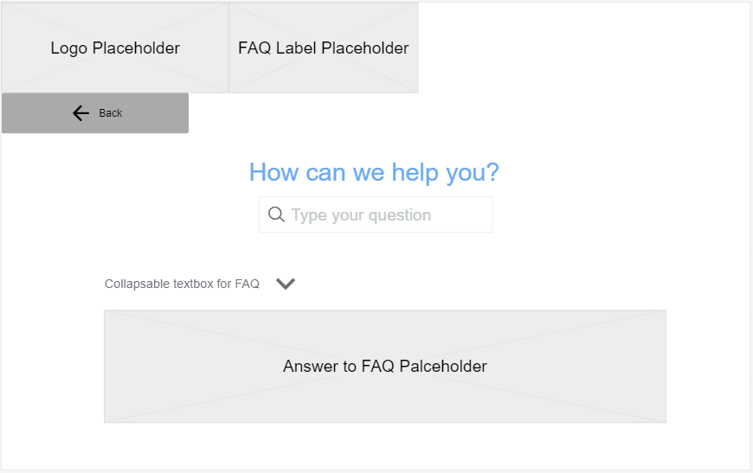

**Screen Elements:**

* + Logo Image
  + FAQ Page Label
  + “How can we help you?” label.
  + Input field for questions
  + Collapsible text boxes displaying frequently asked questions
  + Hidden text boxes displaying answers to frequently asked questions
  + “Back” link

**User Interaction:**

* Users will navigate to this page to resolve confusion on intended use, visibility, options and other elements. The FAQ page will provide answers in clear language to user questions. Previously asked questions and answers will be displayed.

**4.3.4 Results Screen**

**Layout:** When a search is done the user will be taken to the Results Screen. The screen will have a logo at the top left of the screen that will take you back to the home page. TO the right of this will be the search bar which will allow another search to be done. On the top right-hand corner there will be a link of a person that will take you to your account settings page and a link of a list that will take you to your watchlist page. Starting directly below this will be results based on the search criteria. They will be clearly listed in list format. All the classes will be links to take students to view a course.

**Visual Layout**:

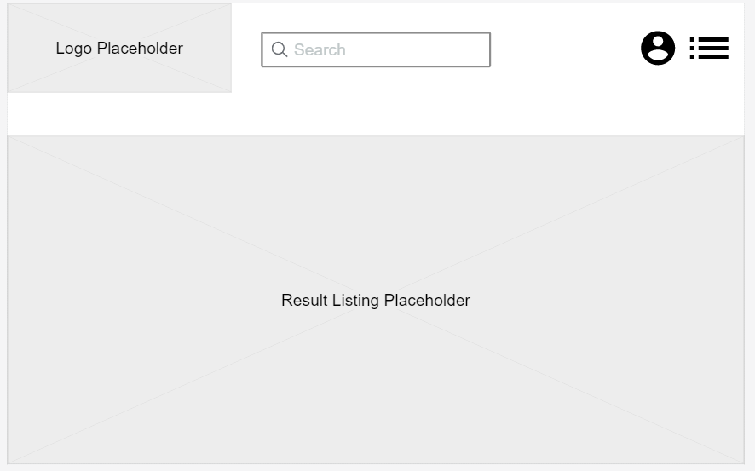

**Screen Elements:**

* + Logo Image – Clickable link to Home Page
  + Search Bar
  + Accounts link
  + Watchlist link
  + Results listing – links to Course view Pages

**User Interaction:**

* Users will use the results screen to view the results of their searches and navigate to the individual course view pages for their results. They will continue to have the option to navigate to previously defined pages. The data present in the course list will be enough to allow students to be sure that they are navigating to the correct course page.

**4.3.5 Course View**

**Layout:** When a student selects to view a specific course, they will be brought to a course view page. It will have a logo at the top left of the screen that will take you back to the home page and to the right of this will be a search bar that will allow you to make a new inquiry. The page will hold all information in a bulleted list. Below this they will be able to view user descriptions of the course and see which professors teach it.

**Visual Layout:**

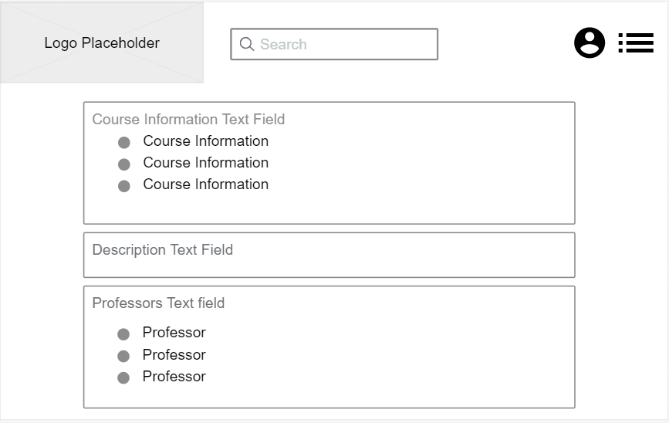

**Screen Elements:**

* + Logo Image – Clickable link to Home Page
  + Search bar
  + Text Field containing bulleted list of Course Information
  + Text Field containing user descriptions of course.
  + List of Text Fields containing professors that teach course.

**User Interaction:**

* Users will use this page to review course information and previous reviews for the course. They will also be able to view the different professors that teach the course. The user will maintain the ability to search and navigate the website on this page.

**4.3.6 Watchlist Screen**

**Layout:** The screen will have a logo at the top left of the screen that will take you back to the home page. On the top right-hand corner there will be a link of a person that will take you to your account settings page. Starting directly below this will be the list of course in your watchlist. They will be clearly listed in list format. All the classes will be links to take students to view a course.

**Visual Layout:**

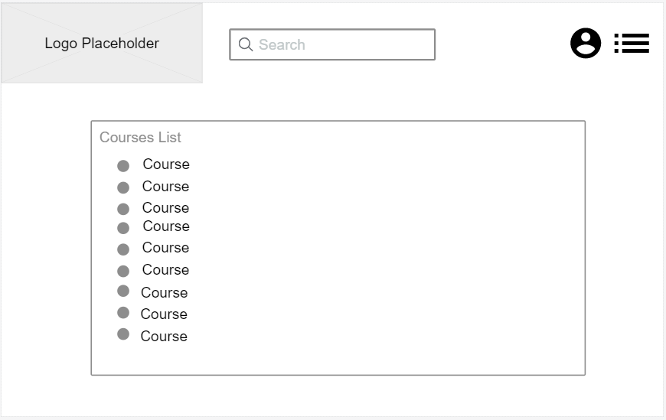

**Screen Elements:**

* + Logo Image – Clickable link to Home Page
  + Accounts link
  + Table of links to Course View page for respective course.

**User Interaction:** When a user selects the watchlist link they will be taken to the watchlist screen. Here they will be able to view all the courses they have saved and will be able to navigate to their course view page by clicking their descriptions.