3sk3

**How are you supposed to use the processors?**

Split the series into 4 parts, 1 part for each processor

**How many n's are we supposed to be using for the project?**

i used 100, it let me see the error trend pretty nicely and also took v little time

**did anyone get clarifications if it actually has to be performed by 4 seperate processes the "Simulate your parallel addition algorithm on a serial computer" is throwing me off also anyone manage to meet the bonus precision or just get close?**

i just had a function and split the size into 4 and called the function 4 times for each block ig

**can anyone provide some tips on answering questions 4a and 4b on project 1?**

I think I used the notes

**ayo brudda can i use the exponentiation in project**

i did, not sure if youre allowed though

**are we allowed to use a function to convert binary/decimal or are we supposed to do everything in the ieee 32 bit format?**

the latter, i have assumed



**How do you define/use a 32 bit ieee float in matlab?**

if you force single(x) it will use single precision 32 bit float

you dont need to do anything as matlab counts it as singles by def

**True haha but when I did that I could only represent numbers up to the 7th decimal digit**

**So then how can we check if we achieved precision of 10^-9?**

i think calculate true error

btw, when calculating error, do i have to * 100? cause without *100 my precision is good

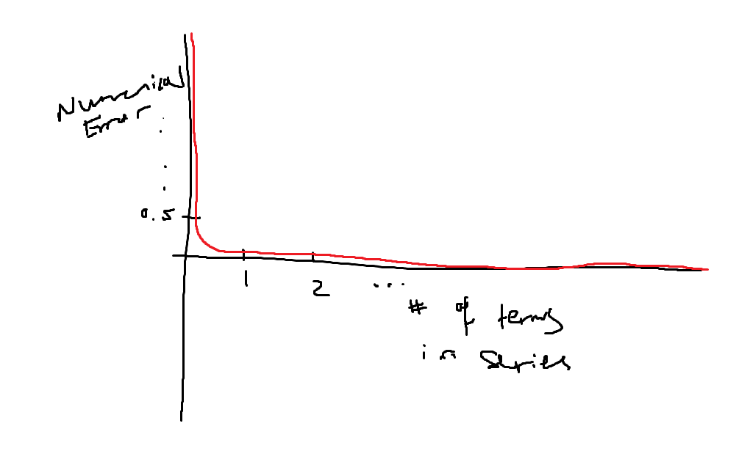

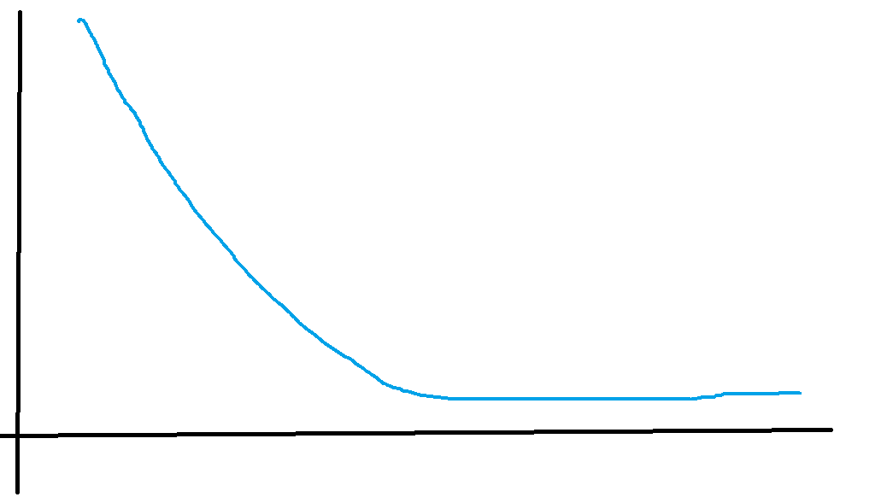

#include <stdio.h>

#include <math.h> // only for log calculation for error comparison

float calculatePartialSum(int, int);

void main()

{

unsigned int n = 1e7; // number of terms

// unsigned int n = 4294967295; // maximum number of terms

int quarter = n / 4;

int halfway = n / 2;

int three_fourths = 3 * n / 4;

float processor_1 = 0.0;

float processor_2 = 0.0;

float processor_3 = 0.0;

float processor_4 = 0.0;

float half_sum_1 = 0.0;

float half_sum_2 = 0.0;

processor_1 = calculatePartialSum(1, quarter); // from 2 to quarter - 1

processor_2 = calculatePartialSum(quarter, halfway); // from quarter to halfway - 1

processor_3 = calculatePartialSum(halfway, three_fourths); // from halfway to three_fourths - 1

processor_4 = calculatePartialSum(three_fourths, n + 1); // from three_fourths to n

half_sum_1 = processor_1 + processor_2;

half_sum_2 = processor_3 + processor_4;

float sum = half_sum_1 + half_sum_2;

printf("\n");

printf("------------------------------------------------------\n");

printf("\n");

printf("Ln2 approximation with %d terms: %.10f\n", n, sum);

printf("\n");

printf("------------------------------------------------------\n");

printf("\n");

printf("Ln2 approximation using C built-in log function: %.10f\n", log(2));

printf("\n");

}

float calculatePartialSum(int lower_limit, int upper_limit)

{

// assuming the first element of any part (lower_limit) is even => negative

// int sign = -1;

float partial_sum = 0.0;

for (int n = lower_limit; n < upper_limit; n++)

{

float term = (float)(1 / (float)n) * pow(-1.0, n - 1);

partial_sum = (float)partial_sum + term;

}

return partial_sum;

}