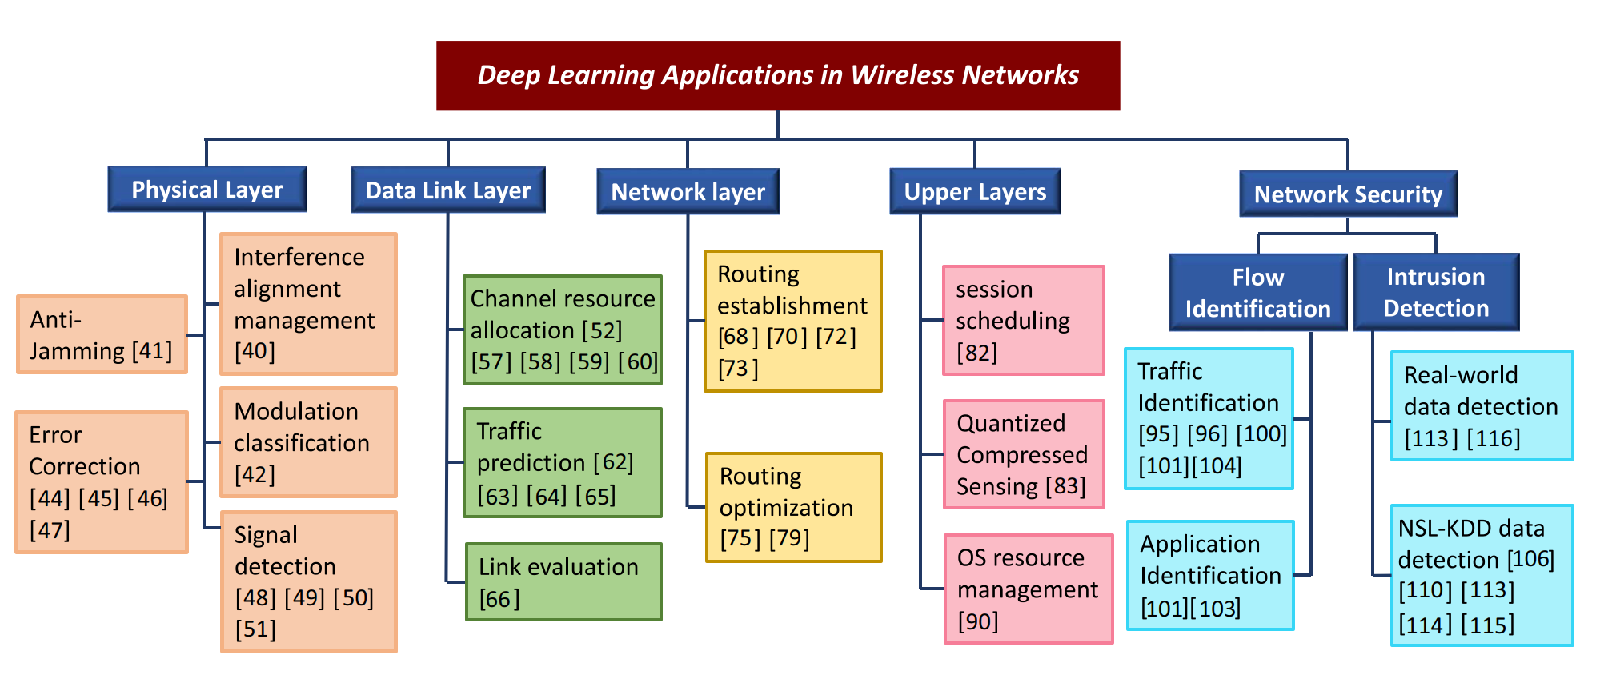

Link Layer

Deep Learning for Intelligent Wireless Networks: A Comprehensive Survey

P9 DL for Spectrum Allocation: Beam forming weight

P11: DL for Spectrum Allocation:

DRL is better than slotted Aloha

However, the real channels might be so complicated that the channel estimations

are not accurate, which may cause bias to the DL training, thereby resulting in deteriorate decisions of the spectrum allocation.

Challenge:

1. How to limit computation and data size are huge challenges for the deep learning applications in DLL.

2. Accurate estimations towards the channel conditions are crucial for the deep learning system to make accurate DLL decisions

Routing Layer

Challenge:

1. However, in real-life network, many factors may deteriorate link quality, such

as a large queue in node’s data sending buffer, high mobility, weak signal strength, interference, etc.

2. minimum required QoS with the minimization of power consumption

Routing Search:

1. OSPF used for traffic condition collection

2. each node trains N models, input is the traffic condition at that node, output is the next step node. (consider energy or throughput edge/cloud)

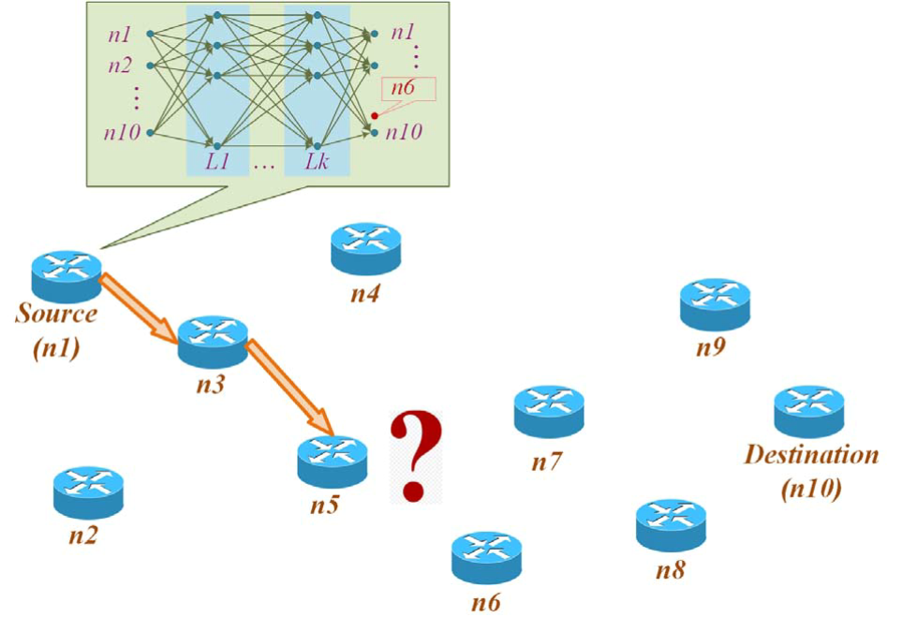

Centralized routing: transmission delay for local router to central controller

Distributed routing: models stored on local routers -> energy waste

Consider network computation power consumption in the distributed routing DL

(compact model and relatively good models)

Other possible problems in wireless

1. DL for transport optimizations: multi-queue congestion control

2. DL for big data transmission

3. Swarming control: node placement based on both mission and communication requirements. (moving nodes)

4. DL in SDN

5. DL in wireless nodes: distributed learning, chose which node to assemble final result

6. Cross-layer design (few people have done this)

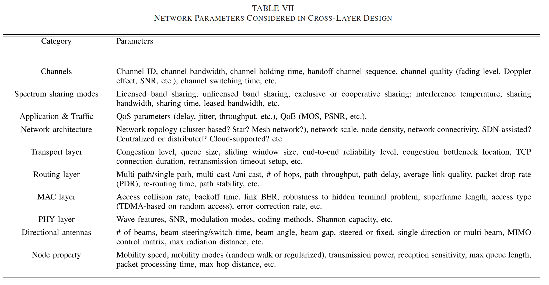

7. DL-Based Application Layer Enhancement

Use DL in cross-layer design for QoS guarantee

8.

MEC:

1. DRL for edge/local computation decision

But not mentioned for cloud, include it ?