# CV Builder App

## Login

## Last entered login credentials restored from shared preference & Required Validation

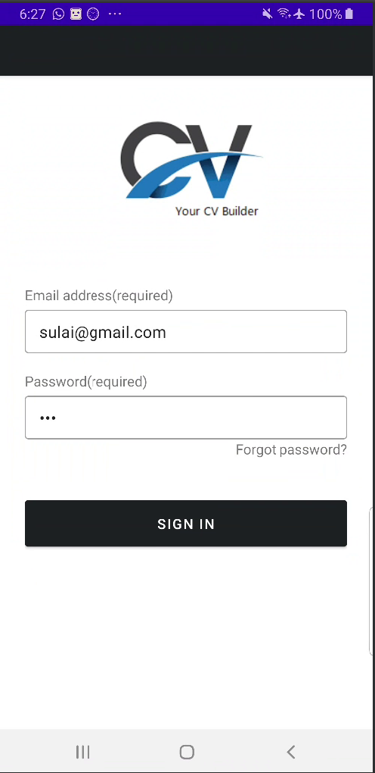

## Menu, Overflow menu

## Menu, Overflow menu

## Call icon click, LinkedIn icon click

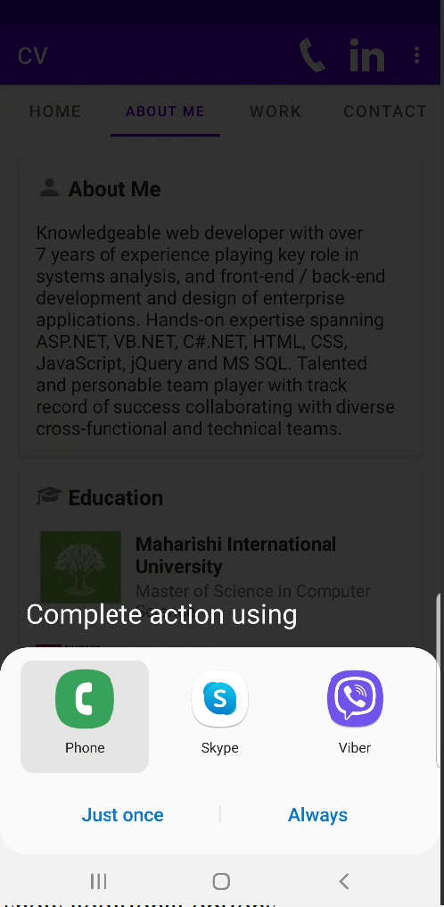

## Menu, Overflow menu

## Email click, Whatsapp click

## Home – Circular Image View & Card View Layout & Recycler View

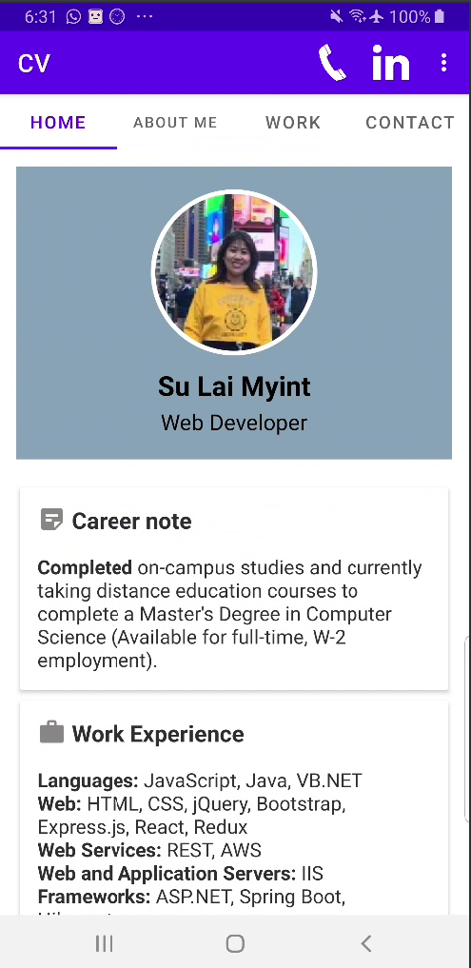

## About Me – Card layout

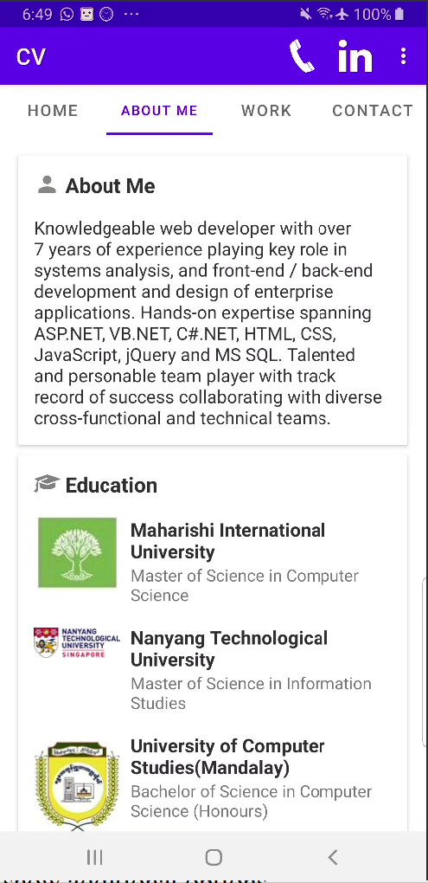

## Work – Recylcer View

## Work – Floating Icon Add New Experience

## Contact

## Phone number click

## Contact

## LinkedIn click, Github Click, Download Resume Click

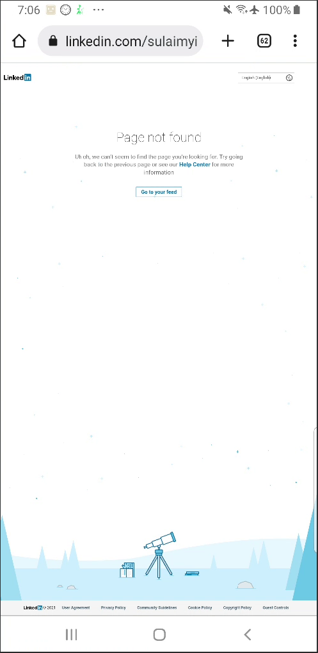

## Contact

## LinkedIn click, Github Click, Download Resume Click

