**Lab 4 Parts A, B**

1) Re-do the sequence diagram below.

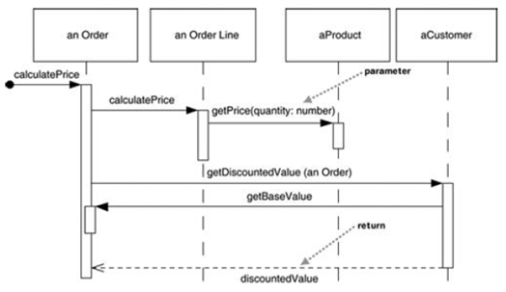

In your diagram, be sure to include the following:

* Message numbering
* An actor who initiates action
* Proper UML syntax for the objects displayed at the top.
* Iteration markers where looping occurs

2) In the School Lab from the first day, create a sequence diagram for a user requesting the showAllMembers functionality.

3) In the School Lab from the first day, create a sequence diagram for a user requesting the getToalSalary functionality.

4) In the School Lab from the first day, create a sequence diagram for a user requesting the unitsPerFaculty functionality.

5) Create an Object diagram for the School Lab.