JavaFX Lab

1. Write the JavaFX code necessary to produce the following screen (You ‘may’ need a ‘FlowPane’ Layout manager. You can use any Layout manager you want.) :

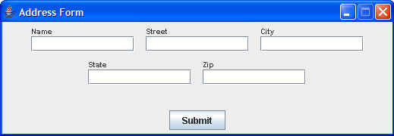

Add an appropriate EventHandler so that, when a user clicks the Submit button…
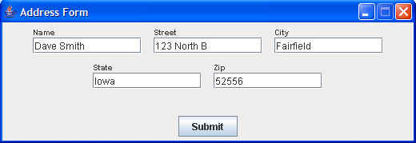

the data that has been entered into the GUI fields is output to the console in the following format:

Dave Smith
123 North B
Fairfield, Iowa 52556

2. Write the JavaFX code necessary to create the following screen:

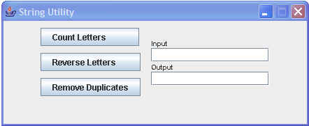

Create the necessary EventHandler so that, when Count Letters is clicked, the number of characters in the Input field is placed in the Output field,

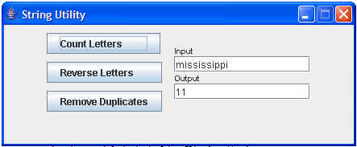

and, when Reverse Letters is clicked, the letters in the input area are reversed and placed in the output area,

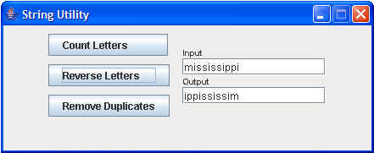

and, when the Remove Duplicates is clicked, the duplicate letters are removed and the result is placed in the output area.

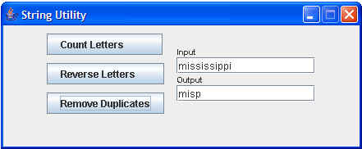

*********************************************************************

3a) Add a Menu (called myMenu), MenuItems (make up three names for three MenuItems inside myMenu), and a MenuBar to your program. Look at these classes on the Oracle JavaFX API site. If someone clicks on a MenuItem, print out a message displaying WHICH ONE OF THE THREE was clicked on.

Level 2 : 3b). For the School lab from day one, create a GUI interface using JavaFX

Level 2 : 4. For the School lab from day one, create a GUI interface using JavaFX, with a menu that gives the user choices with different menu items.
Hint : Look at Menu and MenuItem on the Oracle JavaFX API. It has code you can use.
You will also need a MenuBar.

Level 2: Experiment with different Layout Managers.

