Lesson 3 – Lab 3.1
Page 1 of 2

COMPOSITION, ASSOCIATION & DELEGATION

Human Resource Application

Objectives:
- Learn how to implement Composition and Binary Associations.
- Learn how to implement Delegation and Propagation

Create an application to keep track of different companies, their employees and which positions they hold. Code according to the following UML class diagram:
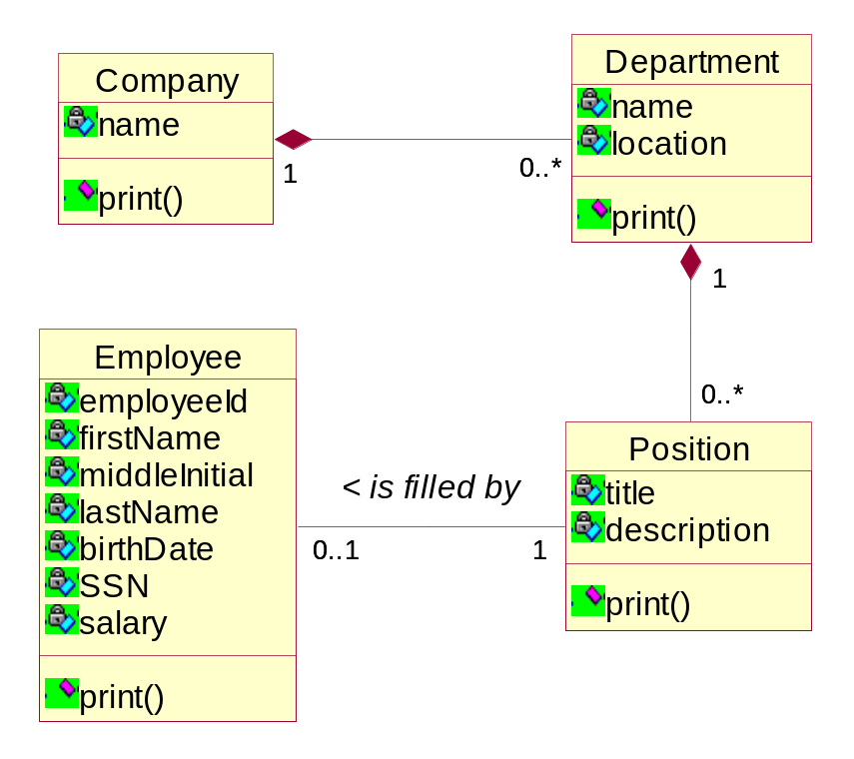
- Create an Application class which starts up your program in its main() method and creates a Company object with two Department objects. Each department should have at least three positions. Some positions may be filled and some are not.

- Write a print() method to print out the data in a company in an hierarchical manner, i.e. for each company list all its departments. For each department list all its positions and the respective employee filling the position, if any.

- The print() method should be invoked on the Company object and then propagate to all the other objects in the system.

- You will need to use the java.util.ArrayList class to maintain the one-to-many relationships.

Lesson 3 – Lab 3.1 (Continued)
Page 2 of 2

COMPOSITION, ASSOCIATION & DELEGATION

Implement the propagation of the print() method as shown in the following Sequence Diagram:

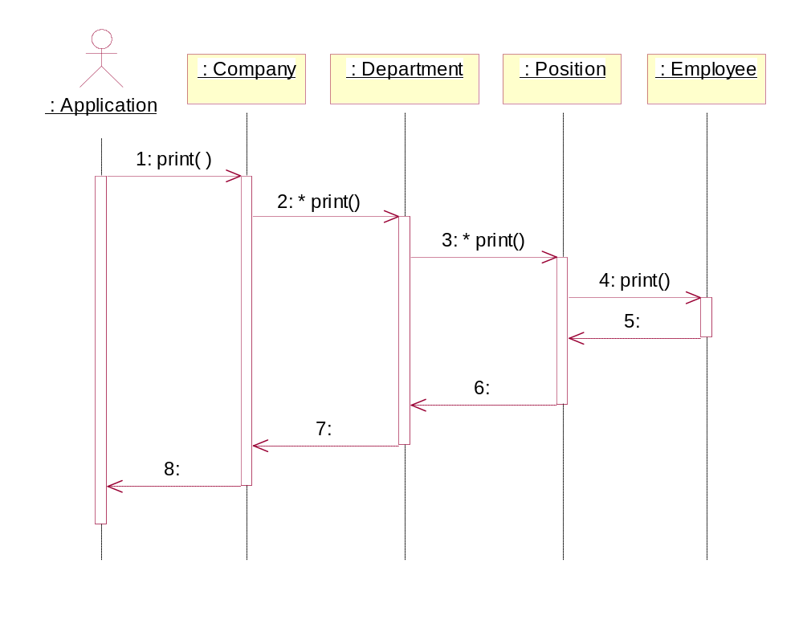

Lesson 3 – Lab 3.2

MORE DELEGATION

Human Resource Application

Objectives:
- Practice more Delegation and Propagation

Tasks:
- Add a getSalary() method to each class. The getSalary() method will return the salary of the class that it is in. E.g. if we invoke the Company.getSalary() method we expect to get the total salary that this company pays to all its employees.

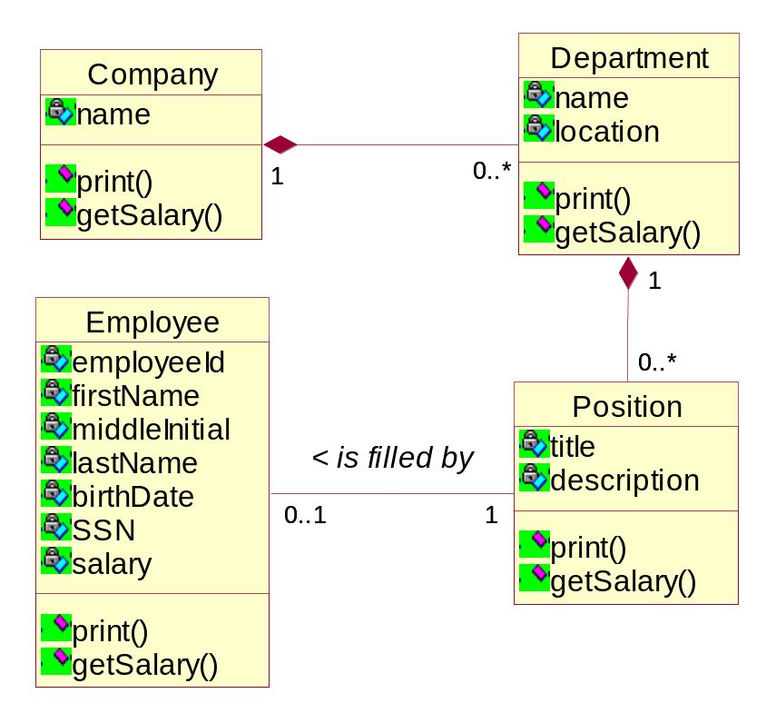

Lesson 3 – Lab 3.3

REFLEXIVE ASSOCATIONS
Reporting Hierarchy

Objectives:
- Learn how to implement Reflexive Associations.
- Practice more Delegation and Propagation.

Add a reflexive association to the Position class in order to maintain a company’s reporting hierarchy.
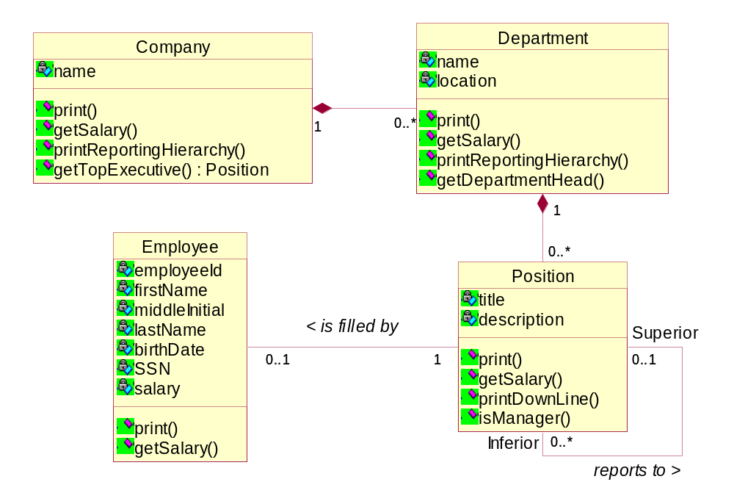

- Add a printDownLine() method to the Position class, which prints out the reporting hierarchy below the position that this method is called on:

  - Remember that a reflexive assocation with a one-to-many multiplicity represents a hierarchy or tree structure

  - When printDownLine() is called on a position object, it should print its own information, the incumbent information if any and then call printDownLine() on each of its inferior positions if it has any.

  - Indent each reporting level 2 spaces more than the one above. This way the printout will reflect the hierarchy.

- Add a printReportingHierarchy() method to the Department class, which prints the reporting hierarchy for an entire department:

  - In order to do this, the method has to first identify the top position in that department, which is the department head.

  - Since the department head is the top position in its department it can be recognized by the fact that it reports to a position in another department.

  - You will need to compare department objects, hence you should override and properly implement the equals() method in the Department class. Think carefully: which attributes to compare to uniquely identify a department?

  - Once you have identified the department head position you can print its information and invoke the printDownLine() method on it.

- The following Sequence Diagram illustrates the algorithm:
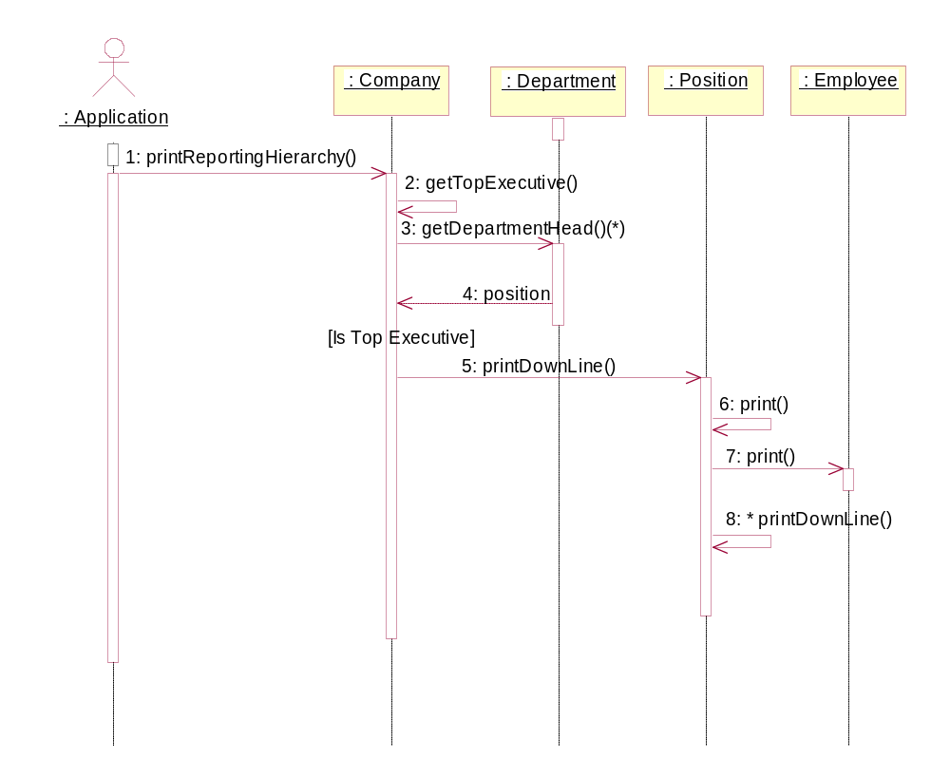

Assume the following Hierarchy. Create All necessary objects to implement this hierarchy.

In the Sales department : Tom works for Stan. Sue works for Stan. Marc works for Stan.
Bill works for Peter. Dan works for Peter.
Stan works for the Dept. head Ron. Peter works for the Dept. head Ron.

In the Marketing department : Gary works for Anne. Anne is the Dept. head.

The top executive is Lyle.

=======================================================

Su Lai’s Note:

Top Executive : Lyle
Marketing
-Anne (Dept Head)
--Gary (marketing assistant)

Sales
-Ron (Dept Head)
--Peter (Supervisor)
---Dan (sales person)
---Bill (sales person)
--Stan (Supervisor)
---Marc (sales person)
---Sue (sales person)
---Tom (sales person)

