**Example Mission Statement for TextCircle:**

I want to create a system that allows people who are learning how to code to share and discuss simple code examples, and to collaboratively and interactively experiment with code, seeing the results in real time.

**Example Three P's, Product, Price, and Promotion for TextCircle:**

TextCircle will be a web application that allows its users to live code together in realtime. Multiple users can edit the same document at the same time, seeing the changes in realtime. It might be considered as a coding version of Google Documents. The first version will work with HTML and will be aimed at people who are learning how to code. Therefore, it aims to create communities of learners who want to share and discuss code.

Initially the price will be free. However, a possible income stream is to provide 'private' areas of TextCirle to education institutions where their students can interact in closed communities.

Once I have implemented the system, I will promote it initially within my own circle of friends, several of whom are learning how to code. I will then promote it within wider communities of learner coders, for example by answering some questions on stack overflow with pasted links to my system.

**Example SWOT Analysis Chart for TextCircle:**

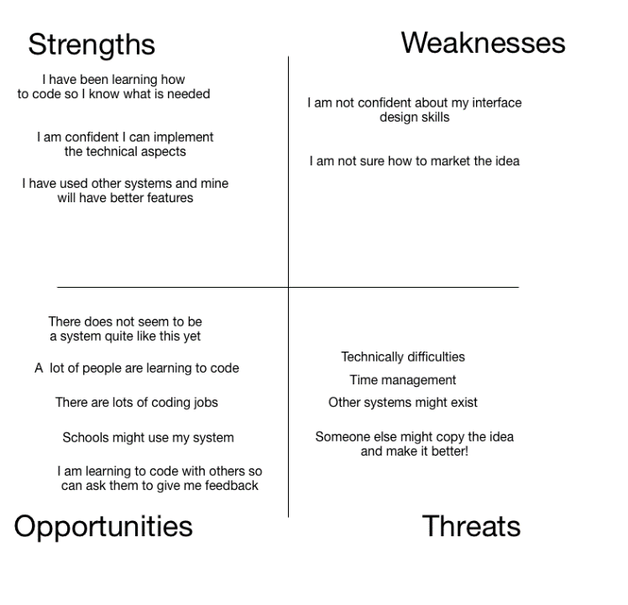

**Example ToDo List for TextCircle:**

*Write a SWOT analysis of my project idea -*

I was able to complete this no problem. I am confident I have a decent idea now!

*Try to pitch my idea to a friend or family member -*

I tried to pitch my idea and I found that it was quite easy to explain to a non-technical person.