**In-class Practice 9 (due 2020/3/26 to tsung-wei.huang@utah.edu)**

1. Finish maxflow.cpp by implementing the two functions: (1) maxflow and (2) mincut that find the maximum s-t flow of a give graph and the s-t cut set. Email your maxflow.cpp by next class.

2. What is the maximum flow of the following graph? What are the two minimum s-t cut sets?

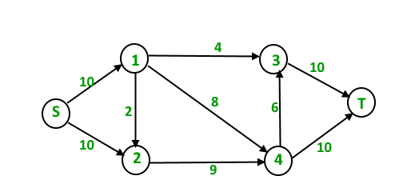

3. What is the maximum bipartite matching for the following example? (a, b, c, d, e) is one set and (v, w, x, y, z) is another set.

Image result for bipartite matching example