COP 2800
Assignment 10

This assignment has two separate programs. You are to submit two .java files. Files that do not compile will received a grade of zero.

1. SuperBall!!!
Initial screen display:
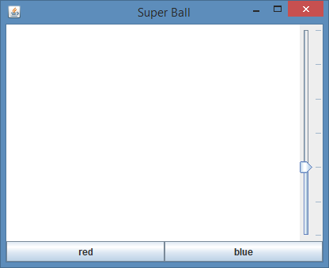

Two left clicks on the canvas..
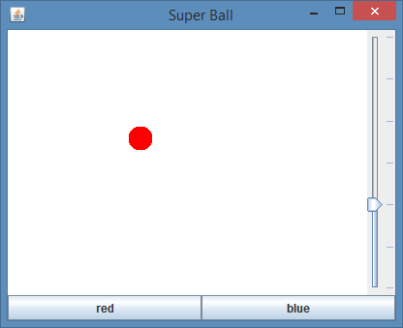

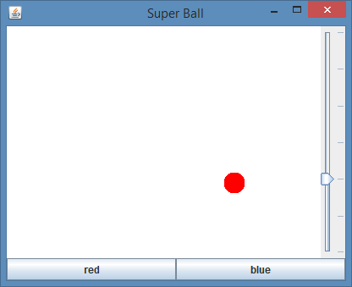

Click the ‘blue button’
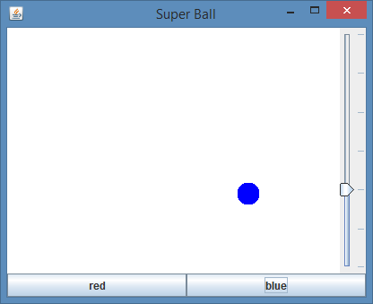

Move the slider up
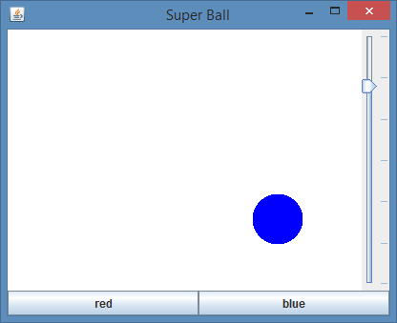

Left Click on canvas
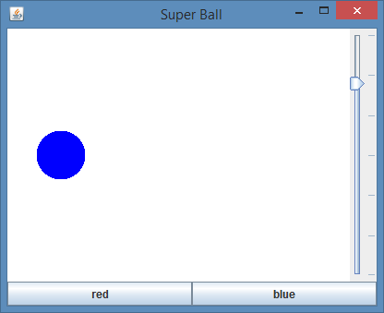

Click the ‘red’ button
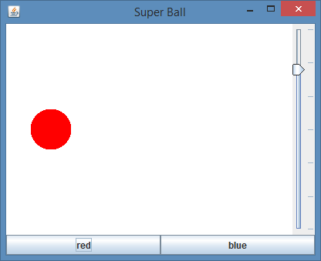

Move the slider down
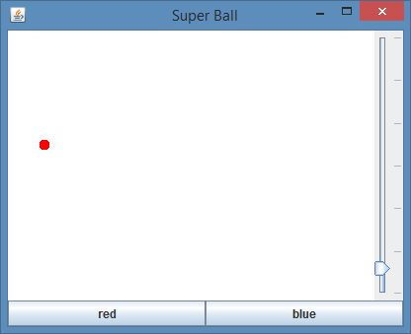

Get the idea?
Please name your program file “Assignment10Program1.java”.

Next Page

2. Remember EtchASketch? Well, maybe not, but it was hot stuff back in the 60’s. Holding down the left mouse button allows you to draw on a canavas. Clicking the “Shake” button erases.
Hints:
- Hint 1 – Play with MouseMotionListener. It is the best interface for this problem.
- Hint 2 – The program does not just paint points, it draws lines between points, like Microsoft Paint.

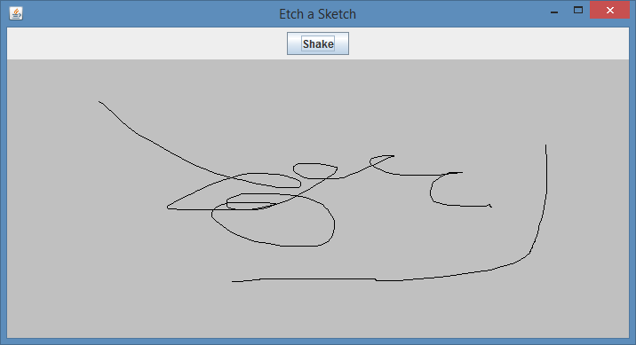

Please name your program file “Assignment10Program2.java”. (Difficult program)

