COP 2800
Assignment 11

Ah yes, the neon lights of Times Square, New York City. Have you been there at night? Well, let me tell you…
In the old days, the neon lights that lit up the marquee had letters that moved. Words seemecd to float from left to right, eventually moving off the left end of the display only to reappear again on the right. Some people refer to this as a crawler.
Implement a crawler. Your program should have a control button that will stop the crawler in it’s tracks and resume it again. ** Note when the crawler resumes moving it must not ‘jump’, but rather simply continue from its current location. **
Please title your progam Assignment11.java. Submissions that do not compile will receive a grade of 0.
Screen shots:
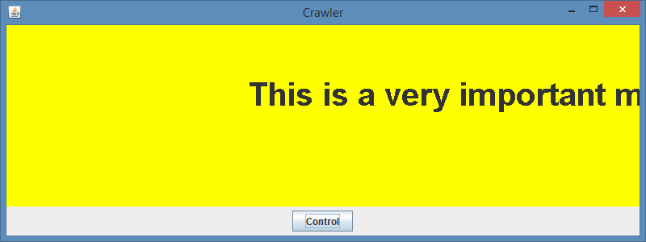
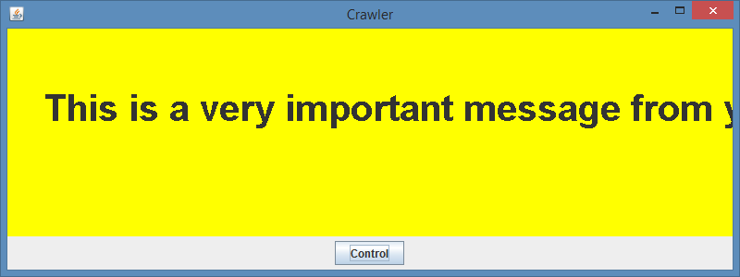

(next page)

