COP 2800
Assignment 9

Paint this!!!

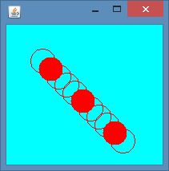

Submitted files that do not compile will receive a grade of 0.

Test next week…

Test covers everything through the lecture given October 21. You may use one page of notes (8 ½ x 11, both sides). The Java API will be provided.

