FuxiPulse
Digital Prototype Report — Draft 1
ENT207TC Digital Startup Lab
XJTLU Entrepreneur College
Week 4 Submission
Team: Group10086
October 2026

Members: Morong.Yang · Yixuan Huang · Yi.Liu · Haoming Zeng · Guanyu Han (Team Leader) · Xiuling Wen · Juntong.Fan
Pixso prototype: https://pixso.net/app/design/np0Pd6gaAjO2V_lvodWLOw?page-id=0%3A1

Field | Detail
Project title | FuxiPulse
Team / group code | Group10086 (ENT10086)
Team members | Morong.Yang; Yixuan Huang; Yi.Liu; Haoming Zeng; Guanyu Han ; Xiuling Wen; Juntong.Fan
Team formed | 8 September 2026 · Project assigned · Proposal submitted
Industry partner | Tengchong Xinling Fuxi Tower Hotel Management Co., Ltd. (腾冲心灵福禧楼酒店管理有限公司); industry contact “三丁” / Sanding team
Module | ENT207TC Digital Startup Lab
Draft | Digital Prototype Report Draft 1
Submission | Week 4 Submission
Institution | XJTLU Entrepreneur College
Clickable prototype (Pixso) | https://pixso.net/app/design/np0Pd6gaAjO2V_lvodWLOw?page-id=0%3A1
Figma export | week3/exports/FuxiPulse.fig (also in evidence/wechat-2026-09-10/)
Visily export | week3/exports/visily-to-figma.vis
Local interactive build | npm run dev → http://127.0.0.1:5173
Evidence pack | evidence/wechat-2026-09-10/
Version | Draft 1 (foundation for the final Digital Prototype Report)
Date | October 2026

1. Problem Identification

1.1 Problem Statement
Professional homestay operations staff working for a B2B homestay management company in Tengchong / Yunnan experience costly, late, and experience-dependent pricing and OTA decisions when weak / shoulder-season demand shifts, because market signals, competitor prices, and occupancy data are fragmented — causing empty rooms, ranking pressure, and revenue shortfall before coordinated action is taken.
Element | Specifics
Real user group | Ops managers, OTA operators, property managers / frontline ops at a professional homestay ops company
Clear pain point | High-frequency decisions (esp. pricing & OTA action) still rely on individual experience + scattered data
Measurable impact | Occupancy / booking pace / listing rank / near-term revenue gap (demo framing in §1.3)

Source alignment
• Team problem framing: The problem.docx; Guanyu_Problem_Users.docx
• Partner meeting (20 Sep 2026): industry expert emphasised talent shortage, experience-dependent pricing (market price × competitor price × occupancy), and OTA-centric guest acquisition
The core gap is not “no data exists.” Operators already touch OTA calendars, competitor listings, and property status. What they lack is a timely, connected way to detect weak-season risk, diagnose causes, decide explainable pricing / promotion tactics, and act across channels — with human confirmation.

1.2 Who Has This Problem?
Target users (refined after partner alignment)
After the 20 September requirements meeting and team analysis (Guanyu_Problem_Users.docx), we distinguish:
Role | Who | Meaning
Project partner | Tengchong Xinling Fuxi Tower Hotel Management Co., Ltd. | Provides real scenarios, industry experience, potential test access
Product user (primary) | Homestay ops staff, OTA operators, property managers, ops managers inside that company | People who will open the app daily
Problem owner / service object | Homestay owners / investors whose properties the company manages | Feel empty rooms and revenue loss; buy ops services
End beneficiaries | Owners, ops company, guests | Better decisions and stay experience

When it happens
• Weak / shoulder season and other demand soft patches
• When booking pace and search interest soften before calendars look fully empty
• When pricing must react to market benchmarks, competitors, and own occupancy at once
How frequently
• Recurring each seasonal cycle; pricing and OTA checks are high-frequency ops work
• Partner context: company has operated ~20 owned properties historically and touched ~100+ managed / franchised properties over ~10 years (meeting minutes — company background, not our sample size)
Demo property in the prototype
• Cloud Mist Homestay — 12 rooms, Tengchong, Yunnan (illustrative property inside the partner geography)

1.3 Why Does This Problem Matter?
Impact type | Evidence / reasoning
Financial cost | Soft occupancy + wrong or late price moves compound over days/weeks
Time / efficiency | Staff must manually stitch OTA apps, competitor checks, and occupancy
Talent / knowledge risk | Partner states professional pricing know-how is scarce; knowledge sits with individuals (*会议纪要* 20 Sep)
Channel risk | Guest acquisition is heavily OTA-dependent; pace/rank slips hurt conversion
Scale limit | Manual, experience-led ops does not scale as managed property count grows (*Guanyu_Problem_Users*)
Market opportunity | B2B ops companies serving many owners need reusable decision support, not one-off gut feel

Validation evidence used in Draft 1 (practical, not a literature review)
1. Partner / expert meeting — 20 Sep 2026, 16:00–17:20
• Sources: evidence/wechat-2026-09-10/2026-09-20_AI民宿管家项目需求对齐与进度沟通_会议纪要.docx + transcript doc
• Participants context: ENT10086 team; industry sharer “三丁”; EEH coordination
• Confirmed themes: talent & knowledge gap; pricing via market / competitor / occupancy; OTA as main acquisition channel; ~23 ops needs previously listed; some items paused (PMS-heavy tasks; review reply because platforms already offer AI)
• Verbal industry judgements (e.g. “~90% OTA acquisition”, “half the industry exits in 5 years”, “&lt;5 people nationwide can explain pricing logic”) are recorded as unverified oral claims — not treated as proven statistics in this draft
2. Team problem / user docs
• Guanyu_Problem_Users.docx — overall ops cost/efficiency/scale problem; users refined to professional ops company staff
• The problem.docx — weak-season insight gap; FuxiPulse as decision-support platform; partner meeting questions on data availability
3. UX / weekly process evidence
• Han Guanyu W3 record: meeting narrowed broad “AI butler” toward pricing MVP with human confirmation
• Yi Liu W3: OTA-agent concept; Visily–Figma–Pixso prep
• Haoming Zeng W3: Visily → Figma → Pixso asset transfer for core screens
4. Prototype demo metrics (illustrative mock data only)
• Occupancy ~43%; risk score 78/100; weekday softness framing; shortfall on the order of ¥18.6k / two weeks if no action
• These frame the decision UI; they are not finished field validation
5. Still open for later drafts
• Confirmed data fields / authorisation for Tengchong ~27 properties / ~10 test properties (mentioned in minutes, not yet locked)
• Formal interview quote log with n= and dates beyond the 20 Sep meeting

2. Current Solutions and Their Limitations
Existing approach | What happens today | Why insufficient
Manual OTA merchant apps | Check Ctrip / Meituan / Fliggy separately | Fragmented; no single risk + diagnosis + action loop
Experience-based pricing | Staff combine market feel, neighbour prices, occupancy mentally | Hard to repeat; scarce specialist knowledge (partner view)
Spreadsheets / chat notes | Track rates or tasks offline | Not live; weak root-cause explanation
Platform AI (e.g. review reply) | Some OTA features already automate narrow tasks | Does not cover weak-season diagnose → approve → multi-channel act
Hotel-grade RMS / full auto repricing | Enterprise tools / long-term “quant trading” vision | Too heavy for semester MVP; interfaces/PMS not available yet; auto price-write is not our Week-4 claim
Broad “AI butler” wish-list (~23 needs) | Order entry, room-status sync, WeChat guest contact, etc. | Many items blocked on PMS/API; partner + team agreed to narrow scope

Scope decision for this course: keep a human-confirmed decision-support loop (detect → diagnose → recommend → approve → OTA visibility), not a claim of full automatic OTA price rewriting.

3. Target User Definition

3.1 Problem Owner vs Product User
They are related but not identical:
• Problem Owner: Homestay owners / investors whose revenue drops in weak season
• Product User: Professional ops / OTA / property managers inside the partner management company who make daily decisions for those properties
FuxiPulse is designed for the Product User, delivering value that the Problem Owner feels as better occupancy / RevPAR outcomes.

3.2 Simple User Persona
Category | Description
User group | Professional homestay ops / OTA operator at a Tengchong-focused management company
Age / background | Working-age hospitality ops staff; OTA-fluent; limited formal revenue-management training [NEED TEAM INPUT: exact age band if required]
Main goal | Protect occupancy and revenue in weak / shoulder season with explainable tactics, without uncontrolled auto price changes
Current frustration | Must stitch market, competitor, and occupancy signals manually; decisions feel late and hard to justify
Digital behaviour | Daily OTA merchant apps + WeChat; open to web dashboard; low trust in black-box auto repricing
Need from solution | Early risk signal + clear “why” + ranked tactics + Accept / Modify / Reject + channel pulse

Working persona label: “Tengchong Ops Lead” — manages OTA-dependent properties (demo: Cloud Mist Homestay, 12 rooms).

4. Solution Concept

4.1 One Sentence Solution
We propose a digital application, FuxiPulse, that turns fragmented occupancy, market, and OTA signals into an AI-assisted detect → diagnose → research → approve → act → learn loop to help professional homestay operations staff solve late, experience-dependent weak-season pricing and channel decisions.

4.2 How The Solution Works
Open Dashboard (detect risk)
↓
Weak Season Analysis (forecast + diagnose)
↓
Research Agent (grounded context) [supporting]
↓
Strategy Center (ranked tactics + Approve / Modify / Reject)
↓
OTA Operations (channel pace / rank / sync after approval)
↓
Performance Feedback (before / after → next cycle) [supporting]
Aligned with partner + team MVP logic from the 20 Sep discussion:
Data in → AI analysis → explainable recommendation → human confirmation → record outcome
(Auto PMS/OTA write is future work, not Draft 1 proof.)
Step | User action | System processing | Benefit
1 | Open property pulse | Risk score + pace / search factors | Early warning
2 | Review diagnosis | ~14-day demand + root causes | Know *why*
3 | Optional research | Sources · reasoning · findings | Trust / less black box
4 | Approve / modify / reject | Ranked tactics with impact & risk | Human keeps control
5 | Check OTA layer | Share / pace / rank across channels | Action path to distribution
6 | Review feedback | Before/after metrics | Learning loop

Clickable prototype: https://pixso.net/app/design/np0Pd6gaAjO2V_lvodWLOw?page-id=0%3A1

5. Chosen Features
Three core features for Draft 1 (module requirement). Supporting screens follow.

Feature 1 — Weak Season Analysis (Predict & Diagnose)
Field | Detail
Name | Weak Season Analysis
User problem addressed | Staff see soft calendars but not near-term demand path or root causes
User interaction | Open analysis → read prediction vs historical → review problem banner → inspect top causes
System logic | Combine occupancy / booking patterns with market signals → forecast → rank causes (weekday softness, events, competitive pricing, etc.)
Why selected | Matches partner pain of experience-only judgement; turns “rooms empty” into a targeted response
Evidence | docs/screenshots/fuxipulse-02-predict-diagnose.png

Feature 2 — Strategy Center (Human Approval)
Field | Detail
Name | Strategy Center + Human Approval
User problem addressed | Even with a diagnosis, staff need ranked, explainable tactics they can trust enough to execute
User interaction | Review featured recommendation → compare cards → Approve / Modify / Reject
System logic | Rank tactics (e.g. weekday package, selective rate adjust, visibility boost) with impact & risk; block go-live until human confirmation
Why selected | Meeting + UX work both insist on human confirmation for first MVP; protects margin and trust
Evidence | docs/screenshots/fuxipulse-04-strategy-approval.png; earlier mobile Pricing Accept/Modify/Ignore in docs/screenshots/journey/03-pricing-mobile.png

Feature 3 — OTA Operations
Field | Detail
Name | OTA Operations
User problem addressed | Strategy that never hits channels does not stop losses; multi-OTA monitoring is manual
User interaction | Inspect channel share / booking pace / listing rank → monitor post-approval sync language
System logic | Surface distribution pulse; attach approved actions to channels; keep human confirmation before sync claims
Why selected | Partner stresses OTA as primary acquisition surface; closes detect→act loop
Evidence | docs/screenshots/fuxipulse-06-ota.png

Supporting features
Feature | Role
Operations Dashboard | Detection entry + risk score + pipeline
Research Agent | Explainable external / market context
Knowledge Base | Reusable ops / pricing / OTA playbooks
Performance Feedback | Before/after learning loop

6. Prototype Development Journey Evidence
This section shows iteration, with files recovered from the team WeChat file transfer (Sep–Oct 2026).
Step | Artefact (path) | What changed | Why / feedback
1. Initial notes / research | The problem.docx; Guanyu_Problem_Users.docx; Guanyu_Theapp_wewill_bulid.docx | From broad “AI homestay butler” → ops cost/efficiency/scale + weak-season decision support | Partner is a B2B ops company; users refined to professional ops staff, not only owner-operators
2. Partner alignment meeting | 2026-09-20_…会议纪要.docx + transcript | Pricing inputs clarified (market / competitor / occupancy); auto-write de-scoped for MVP; OTA diagnosis retained as frame | EEH + industry expert: semester needs a runnable demo, not a full PMS-integrated product in 8 weeks
3. Hand / low-fi mobile UX | UX_Design_Mobile_Low_Fidelity_Wireframes-English.zip → docs/screenshots/journey/ (01-today … 04-market); Homestay-UX-Design-ZH.docx | Four mobile pages: Today / Operations / Pricing / Market; Pricing already had Accept · Modify · Ignore | Han Guanyu UX v1 (20 Sep): prove task focus + human decision control on phone
4. Visily wireframes | week3/exports/visily-to-figma.vis; week3/visily-input/*.png | Converted / cleaned digital screens for desktop ops loop | Course Week 3 workflow; denser dashboard needs more space than phone
5. Figma refinement | week3/exports/FuxiPulse.fig | Frame alignment, hierarchy, consistent shell | Haoming Zeng W3: Visily → Figma transfer; layer fixes
6. Pixso interactive prototype | https://pixso.net/app/design/np0Pd6gaAjO2V_lvodWLOw?page-id=0%3A1 | Click-through for Checkpoint / Draft 1 demo | Mentor can walk detect → diagnose → approve → OTA without a finished backend

Architecture shift (documented learning): mobile low-fi was useful for task hierarchy; after the pricing/OTA focus solidified, the team moved toward a desktop dashboard for multi-metric comparison (Han Guanyu W3 judgement — not yet user-tested).
Demo path: Dashboard → Weak Season → Research → Strategy (Approve) → OTA → Feedback
Still images: docs/screenshots/fuxipulse-01 … 07 plus journey mobiles above.

7. Digital Prototype Overview

7.1 Prototype Purpose
Users can: see weak-season risk; inspect forecast/diagnosis; review research context; approve/modify/reject strategies; inspect OTA channel pulse; open knowledge and feedback screens.
This proves problem → solution → features → interaction, not production OTA API write access.

7.2 Main Screens
Screen | Purpose
1. Operations Dashboard | Early risk visibility; property pulse; agent pipeline
2. Weak Season Analysis | ~14-day forecast + problem detection + top causes
3. Research Agent | Sources · reasoning · findings
4. Strategy Center | Ranked tactics + human approval
5. OTA Operations | Channel share, pace, rank; post-approval sync framing
6. Knowledge Base | Shared playbooks / operating memory
7. Performance Feedback | Before/after into next cycle

Connections: sidebar navigation; primary story path Dashboard → Weak Season → (Research) → Strategy → OTA → (Feedback).

8. Future Development Direction
After Draft 1 (do not claim these as finished):
Next | Notes
Build core loop in code | Detect → diagnose → strategy approval → feedback (Vite/React repo)
Validation | Lock data fields with partner; run structured ops-user tests (plan ≥10 related users — *Guanyu_Theapp*)
Technology | FastAPI / Postgres / agents discussed as later stack options; current prototype evidence is Pixso + React UI
OTA / PMS | Prefer CSV/Excel or mocked import until interfaces/authorisation exist; no auto price-write as Week-4 success criterion
Deprioritise for now | Full 23-need butler, review-reply plugin, robot housekeeping, continuous auto repricing

Appendix A — Five Draft 1 Questions
# | Question | Answer
1 | What problem? | Late, fragmented, experience-dependent weak-season pricing & OTA decisions for professional homestay ops
2 | Who / when? | Ops / OTA / property managers at partner company; weak/shoulder season when pace softens early
3 | Who uses the solution? | Same professional ops users (owners are problem owners / beneficiaries)
4 | How large / important? | Recurring seasonal + channel cost; partner reports large managed portfolio exposure; verbal macro stats marked unverified
5 | How does the prototype solve it? | FuxiPulse clickable loop: detect → diagnose → approve → OTA visibility → learn

Appendix B — Draft 1 Checklist
Requirement | Completed?
Problem clearly defined | Yes
User identified | Yes (owner ≠ user clarified)
Evidence included | Yes — 20 Sep meeting + team docs + UX journey files
Solution explained | Yes
Three features justified | Yes
Prototype journey documented | Yes — mobile → Visily → Figma → Pixso with file paths
Cover fields complete | Yes — Group10086 + full 7-member roster
Current solutions & limitations | Yes
Future development honest | Yes

Appendix C — Remaining Team Inputs (short)
1. Any additional interview notes beyond 20 Sep (with permission to quote)
2. Confirmation of which 3 features Mentor already approved in Checkpoint 1 (if different)
3. Optional: 1–2 published sources if you want secondary research beyond partner testimony

Appendix D — Evidence Index
File | Use in report
evidence/wechat-2026-09-10/2026-09-20_…会议纪要.docx | Partner validation
evidence/wechat-2026-09-10/…转写结果.docx | Meeting transcript
evidence/wechat-2026-09-10/Guanyu_Problem_Users.docx | Problem + user refinement
evidence/wechat-2026-09-10/Guanyu_Theapp_wewill_bulid.docx | Solution / data / test plan
evidence/wechat-2026-09-10/The problem.docx | Early English problem + FuxiPulse statement
evidence/wechat-2026-09-10/韩冠宇+W3每周记录.docx | UX journey + leadership + MVP narrowing
evidence/wechat-2026-09-10/刘翌ENT207TC Week 3.docx | OTA-agent thinking + tool workflow
evidence/wechat-2026-09-10/W3 Weekly Record(1).docx | Visily–Figma–Pixso transfer evidence
week3/exports/FuxiPulse.fig / visily-to-figma.vis | Design chain artefacts
docs/screenshots/journey/*.png | Mobile low-fi evidence
Pixso URL | Clickable MVP v0.1

End of Digital Prototype Report Draft 1 — updated with WeChat evidence pack (Sep–Oct 2026).

Prototype Screen Evidence (selected)
The following stills support the three core features and the design journey. The live clickable prototype is linked on the cover page.
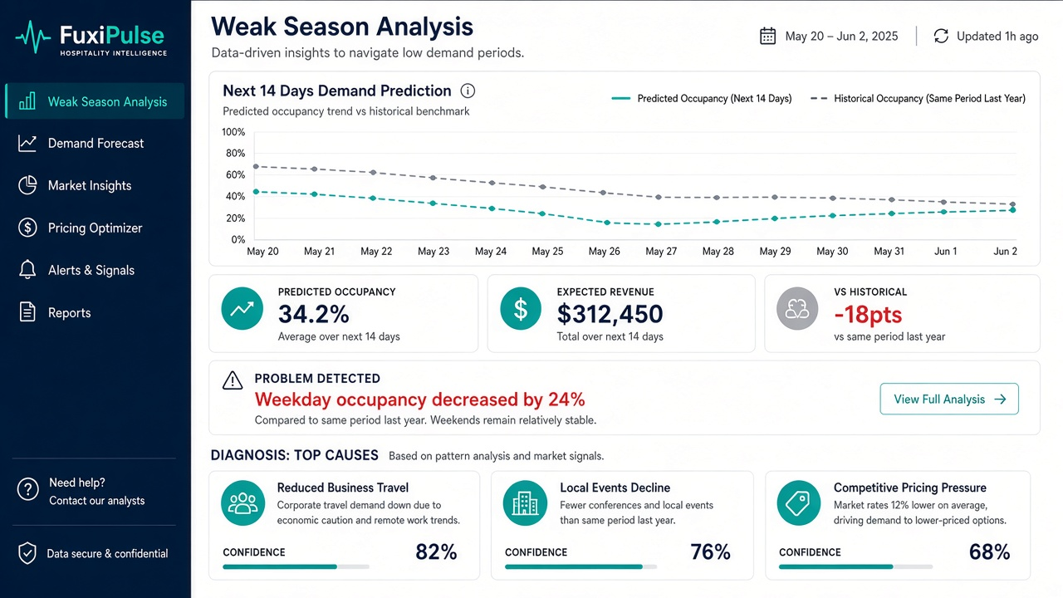
Figure A. Weak Season Analysis (core feature 1)
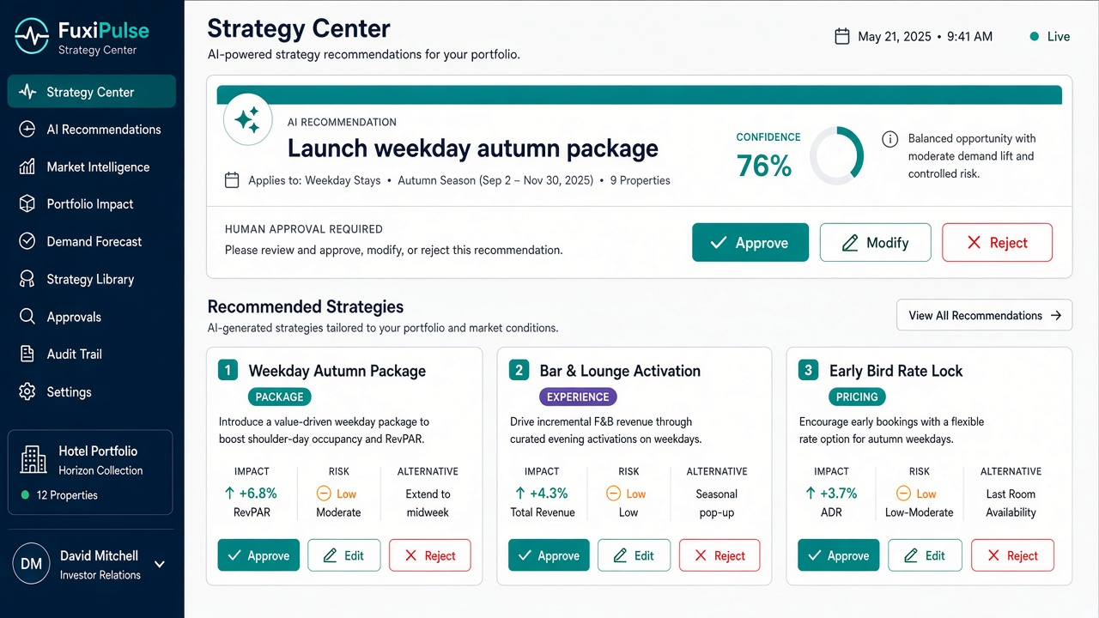
Figure B. Strategy Center + Human Approval (core feature 2)
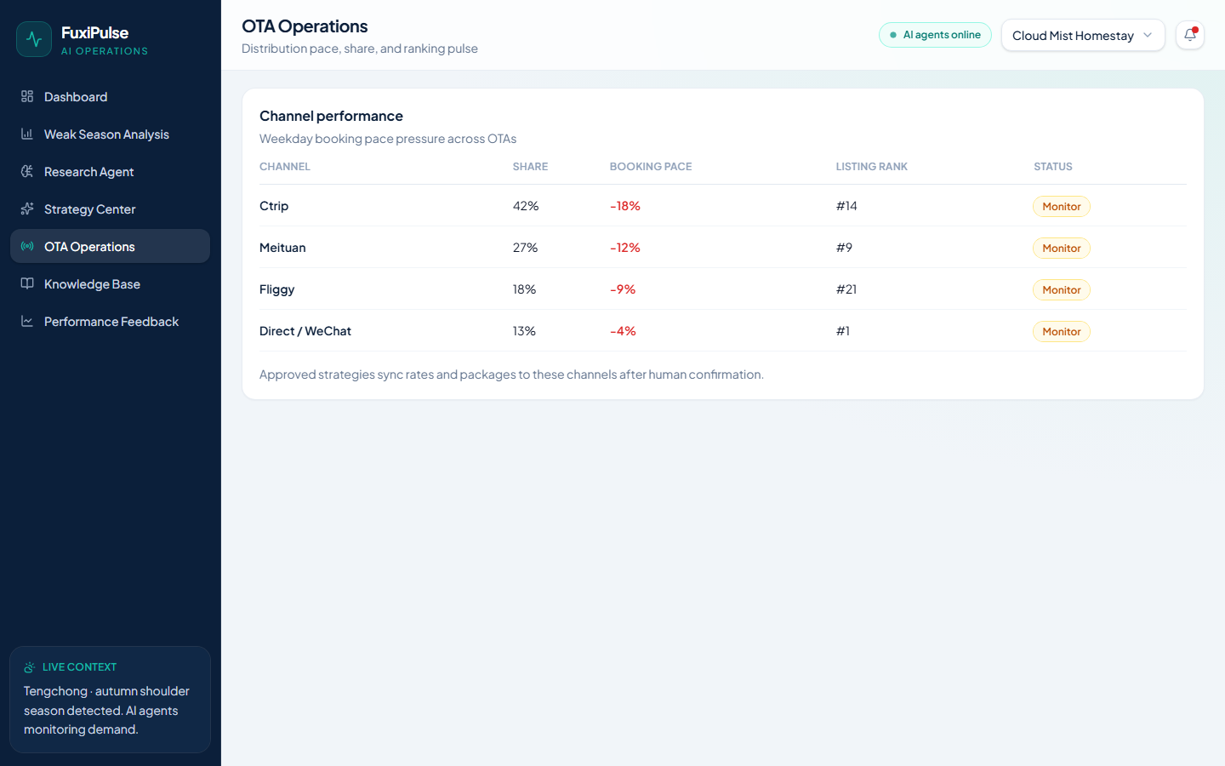
Figure C. OTA Operations (core feature 3)
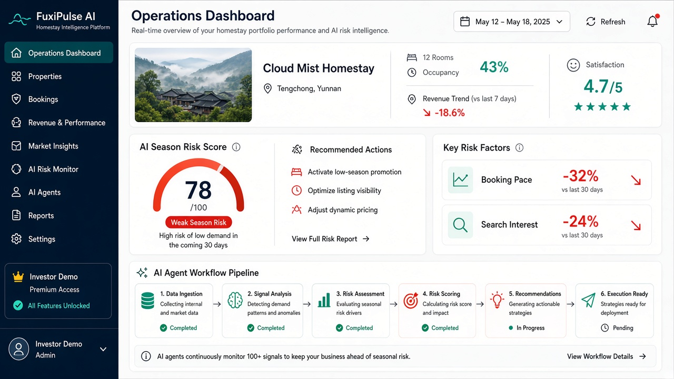
Figure D. Operations Dashboard (supporting entry screen)

Design Journey — Mobile Low-Fidelity
Early mobile UX (Today / Operations / Pricing / Market) before desktop dashboard pivot.
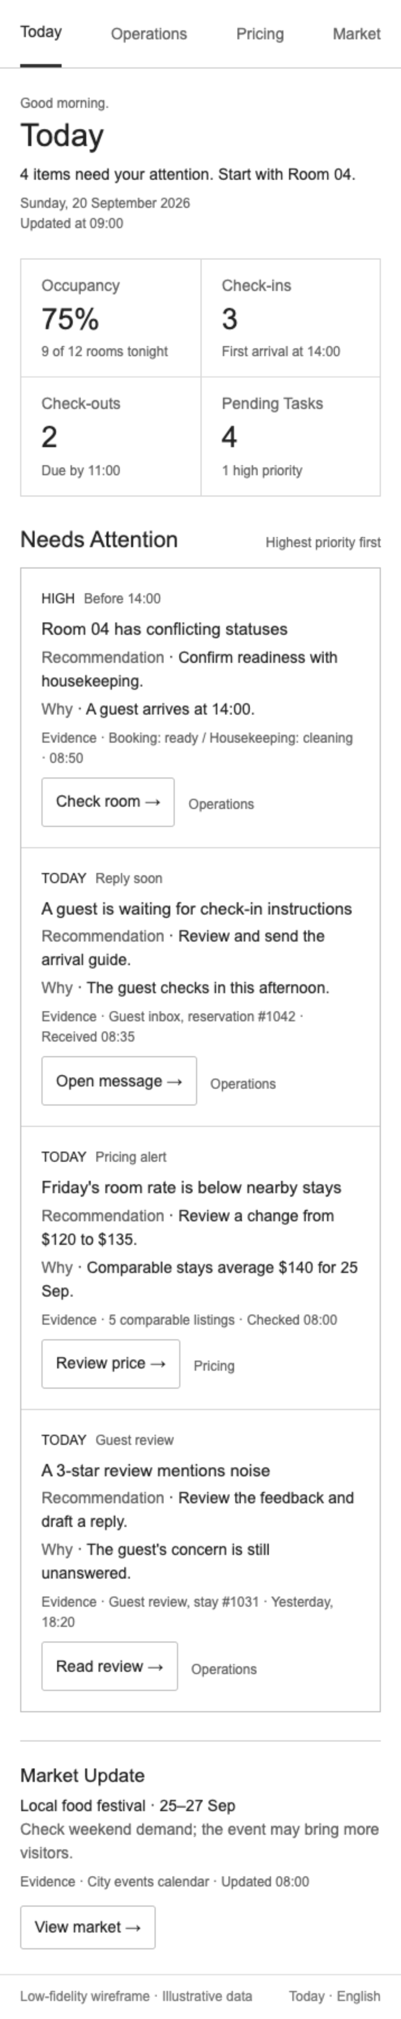
Figure E. Mobile Today
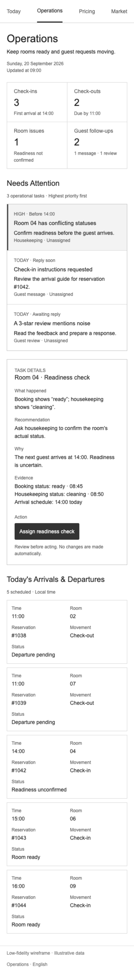
Figure F. Mobile Operations
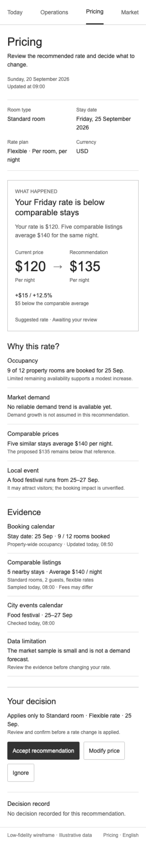
Figure G. Mobile Pricing (Accept / Modify / Ignore)
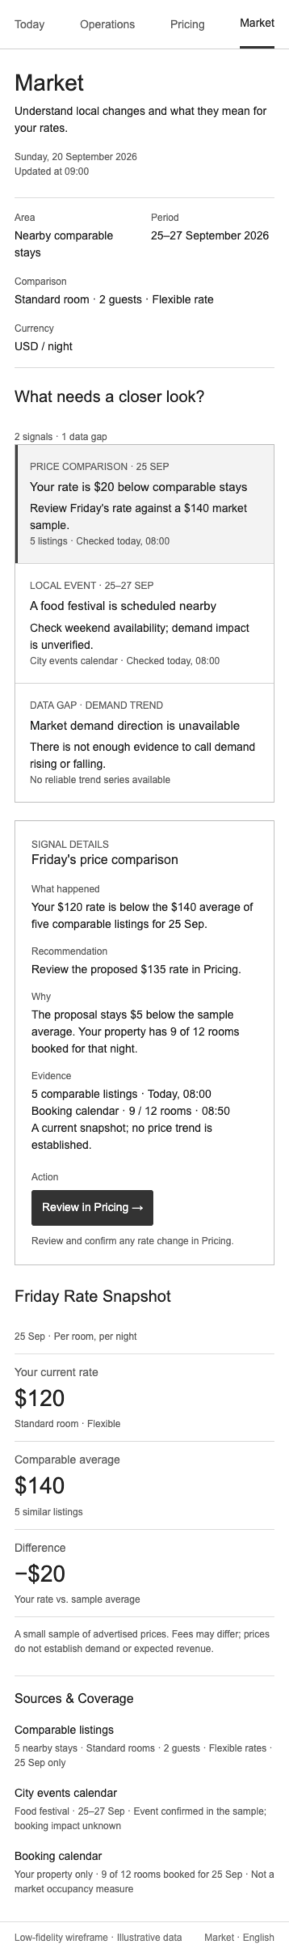
Figure H. Mobile Market

