ENT207TC Week 3
Individual Weekly Record
Student: Han Guanyu | Week: Week 3

1. Weekly Work Summary
This week, I clarified how my UX work could support a more focused AI dynamic pricing project. I participated in the meeting with the EEH teacher and a Yunnan homestay industry expert on 20 September. The discussion connected the project to operational problems such as reliance on individual experience, limited specialist knowledge and the difficulty of making pricing decisions as market conditions change.
The meeting and the documents received afterwards helped narrow the project direction from a broad AI homestay assistant towards dynamic pricing. I identified three central inputs: regional market benchmarks, competitor prices and the homestay’s own occupancy or room sales status. I began separating the long-term ambition for automated pricing from a minimum viable product (MVP) that could realistically be demonstrated within the course.
Before the meeting, I had independently written Homestay-UX-Design-ZH.docx for a mobile homestay operations assistant. I organised the design around Today, Operations, Pricing and Market. The Pricing page already presented current and recommended prices, reasons, supporting evidence and Accept, Modify and Ignore options. I worked through the Visily–Figma–Pixso workflow to develop the prototype, translating my UX thinking into screens and interactions that could be shown and discussed. Prototype development remains in progress; the design document also identifies differences that still need to be reflected in the clickable version.
I took over the role of team leader this week due to a change in team responsibilities and availability. I posted the Week 3 record task in the WeChat group. For Stage 1, I asked every member to submit a Word document by 25 September at 24:00, covering Weekly Work Summary, Challenges Encountered, Help Sought and Evidence, and Outcome of the Help. I specified the filename format “Name + W3 Weekly Record” so that individual contributions would be identifiable.
For Stage 2, I set my consolidation deadline as 26 September at 24:00. Integrating the individual records into a group-level version is planned, not completed. I have also started reviewing the ENT module’s overall objectives, the semester project direction, upcoming tasks and the division of responsibilities across seven members. This organisational work is ongoing.

2. Challenges Encountered
Defining a feasible scope. My earlier mobile design covered several daily operational tasks, while dynamic pricing became more central after the industry discussion. I therefore needed to reconsider what could be built and meaningfully examined during the remaining course period. The requirements manual describes continuous monitoring and automatic price changes, but the meeting minutes recommend a smaller demonstration based on data input, analysis, an explained recommendation and human confirmation. I am still working on the exact MVP boundary, including what data will be available and what the demonstration should show.
Reconsidering the interface architecture. A mobile interface was a reasonable starting point for checking daily tasks. Pricing may involve comparing several dates, room types, competitor prices and occupancy figures together. I now think a PC or desktop-oriented dashboard could provide more space for this work. This is my design judgement, not a finding from user testing. The challenge is to connect the business task to the product scope, device and information architecture, rather than simply enlarge the mobile screens.
Taking on coordination responsibilities. As team leader, I need to look beyond my own UX work and understand semester objectives, milestones, individual responsibilities and evidence collection. I have introduced a basic weekly documentation process, but I have not completed the wider task division. Coordinating seven members requires clear ownership without creating unnecessary reporting work. I am currently working out how to make the next tasks and their expected outputs clearer.

3. Help Sought and Evidence
Industry and course guidance. In the meeting, I received industry context from the Yunnan homestay expert and guidance on course constraints from the EEH teacher. The meeting minutes dated 20 September record the expert’s three pricing inputs and the teacher’s emphasis on staged course deliverables. The minutes’ project suggestions separately recommend an MVP with human confirmation. I treat that as a proposal to refine, rather than a fully agreed specification. The Homestay OTA Intelligent Dynamic Pricing AI System Requirements Manual, especially Sections 3, 4 and 7, provides the broader pricing logic and automation vision. Reading these sources together helped me distinguish immediate priorities from longer-term requirements.
Teaching materials. ENT207TC Week 3.pdf explains that the group should finalise its project idea and move from sketches through Visily and Figma into a Pixso prototype. Pages 2–3 and 9–10 connect this work to Week 4 Checkpoint 1 and Draft 1. This guidance helped me use the prototype to communicate the problem, proposed solution and selected features. Figure 1 is evidence of that guidance, rather than evidence that I have completed every course requirement.
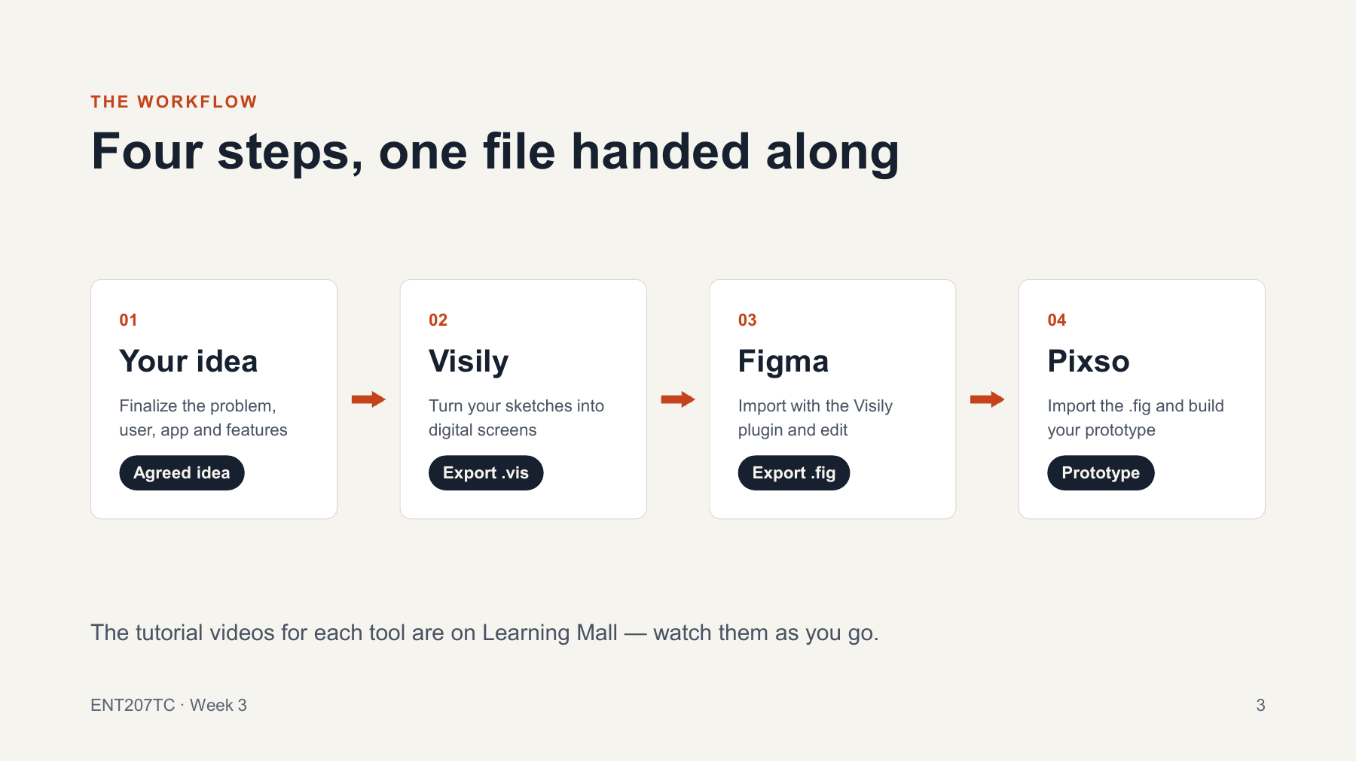
Figure 1. The Week 3 prototype workflow. Source: ENT207TC Week 3.pdf, p. 3.
Evidence of my individual work. Homestay-UX-Design-ZH.docx records my earlier UX decisions. Its Pricing section and Figure 3 show the recommendation, evidence link and human decision controls reproduced in Figure 2 below. This is my own work evidence, not external help. The prices and occupancy figures are illustrative, and the document’s research and testing activities remain planned.

4. Outcome of the Help
The meeting gave me a clearer basis for deciding what to design. I now understand pricing as a decision informed by market benchmarks, comparable competitors and the property’s own sales position. The earlier assistant concept was broader than the problem I could realistically help validate within this course period.
I now see data input or reading, AI analysis, an explainable pricing recommendation and human confirmation as a more realistic first-version direction. The requirements manual remains useful as a long-term reference, but its automation and revenue expectations are not demonstrated results. Data access, interface connections and validation still need further work.
My earlier mobile design remains useful because it helped me explore information hierarchy, task prioritisation, explainable recommendations and human decision control. The new business information has led me to reconsider the interface around the more specific pricing task. A desktop direction is an option I want to examine, rather than a decision already supported by user research.
The Week 3 guidance gave me a practical route for turning these ideas into a discussable prototype. Taking over as team leader also prompted me to clarify individual documentation and plan consolidation. My next steps are to define the pricing MVP more precisely, decide the appropriate interface architecture and complete a clearer division of work across the seven-member team.
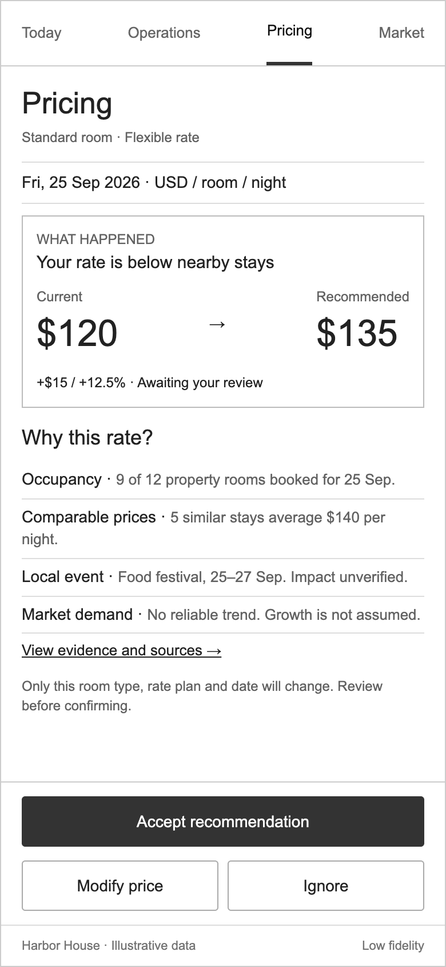
Figure 2. My earlier Pricing screen with explanation and human decision controls.
Source: Homestay-UX-Design-ZH.docx, Pricing section, Figure 3. Illustrative data only.

