**Homework #6**

**(Due date: 02 November 2023)**

**Objective :**

Learn to use if/else and switch statements to do decision making, then combine with for and while loops to perform some operations.

**6.1**

A circular prime is a prime number that remains prime as each leftmost digit (most significant digit), in turn, is moved to the right hand side. For instance, the number 19937 is a circular prime, since all numbers in the sequence 19937, 99371, 93719, 37199 and 71993 are prime numbers.

Write a program let the user input a range [i, j], computes the number of circular primes in that range. All integers will be less than 200,000 and greater or equal to 10. You can assume that in any pair i is lesser or equal than j.

input:

10 10

10 1000

10 200000

Output:

**6.2**

Write a program let the user input a pair of integers (m,n), determine whether m is the power of n.

Input:

0 0

0 2

2 2

16 2

243 9

243 3

Output :

**Please note:: users of visual studio add the following code to your**

**program’s beginning**



繳交格式及規定 :

程式重點地方請加註解,給分也會酌量參考註解。

請繳交 .c 檔即可。

c 檔的檔名一律統一,以學號為檔名壓縮成一個以學號為名的壓縮檔上傳,

上傳請一律繳交壓縮檔。

Example:

若學號為 B123456789, 則.c/.cpp 檔名為 B123456789.c ,

而壓縮檔名為 B123456789.rar。

繳交期限 2023.11.02 (四) 09:00 分之前,逾期一律不收,

無輸入輸出及逾期者一律以 0 分計算。

作業請上傳中山網路大學 網大上傳方式:

1. 點選要繳交的作業,選擇「進行作業」。

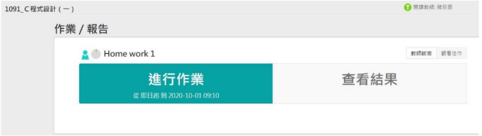

1. 依照流程上傳檔案。

