DAFFY · INTERNAL
Auto Ticket Handling
The life cycle of a ticket, from the moment you mark it to the moment it is live in production
You mark a support ticket. An AI analyst studies it and proposes a fix. You approve. An AI night-run agent builds the fix. You test it on your dev app and approve it again. One button then releases every approved fix to production and closes the tickets. You make four decisions; everything between them is done for you.
Who does what
  You (the admin)  Decide. You mark tickets, approve proposals, test fixes on dev, approve them for production and press Promote. Nothing reaches production without your press. |   The two AI agents  Think and write. The analyst investigates and proposes. The night-run agent reproduces the problem and writes the fix. Both are Claude, run from your laptop, with spending limits. |   The automation  Does the same thing every time, no AI. The bridge on your laptop, the n8n schedules and the Daffy app move tickets between stages, re-check the work, merge, deploy and send the emails.

Where it all runs. The agents and the bridge run on your laptop (it wakes itself for the scheduled runs). The review screen and the ticket data live in the Daffy app and its Supabase database. n8n (Docker on the laptop) is the clock and the post office: it starts the runs and sends the emails. GitHub keeps the code and Vercel hosts production.

The whole journey in one picture
Read left to right. The icon and colour at the left of each row say who acts: you, an AI agent, or the plain automation. The number in each box matches the step table on the next pages.
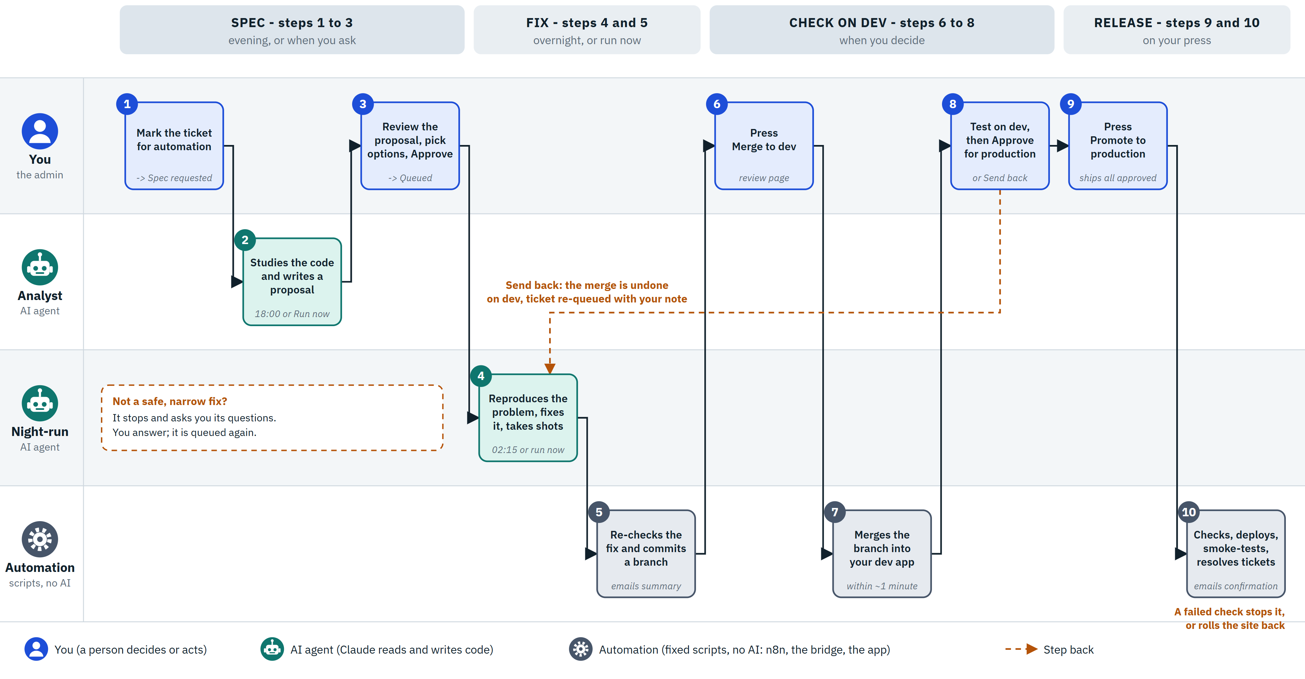

Step by step
 | WHO | WHAT HAPPENS | WHERE YOU SEE IT | STATUS
1 | You | Pick a ticket in the admin list and set Auto-handle to Spec requested. Add your own notes to the ticket if you want the analyst to see them. | Tickets list (admin) | S
2 | Analyst agent | Reads the ticket and the real code, read-only. Writes a proposal: what it found, what else could be affected, the decisions you need to make (each with a recommended option), HTML mockups for visual changes, a written brief for the night run, and what is out of scope. It says so when it thinks the work is better done together with you. | Review & approvals; email summary | A
3 | You | Open the proposal, choose an option for each decision, and press Approve. Or ask for a change (with a comment), or reject it (the ticket is deferred with your reason). Approving copies the brief and your choices into the ticket, which is where the night run reads its orders. | Review & approvals | Y
4 | Night-run agent | First a read-only check: is this a safe, narrow code fix? If not, it stops and asks you questions. If it is, it works in a throwaway copy of the code with its own test server and a dedicated test account: reproduces the problem, makes the narrowest fix, re-runs its checks, takes up to four screenshots and writes test steps for you. It never pushes anything and never writes database migrations. | Review & approvals (questions or fix card) | P / D
5 | Automation (bridge) | Does not trust the agent's word: runs the type check and lint itself. If both pass it commits the fix on its own branch (auto-fix/tck-N) and posts a fix card (summary, files, checks, screenshots, test steps). Emails you the night summary. | Fix card; email | D
6 | You | Open the fix card and press Merge to dev. The button only files a request. (An optional switch, off today, lets the night run merge by itself when every safety gate passes.) | Review & approvals | D
7 | Automation (poller + bridge) | A poller on your laptop picks the request up within a minute and merges the branch into the main branch of your dev copy. Nothing is pushed anywhere. | Fix card shows Merged on dev | M
8 | You | Try the change in your dev app using the agent's test steps. Happy: press Approve for production. Not happy: press Send back with a comment; the merge on dev is undone and the ticket goes back to the night run with your comment. | Review & approvals (dev app for testing) | R / Y
9 | You | When you have one or more fixes approved, a Promote to production bar appears. One press, and a confirmation, ships all approved fixes together as one release. The button only files the request; you do not wait. | Review & approvals | R
10 | Automation (bridge + n8n) | Applies each approved fix to the release branch, checks that any database change only adds things, runs the type check and lint, applies migrations to production, deploys, smoke-tests the live site, then tags the release, pushes to GitHub and marks the tickets resolved (their reporters are notified). A failure before the deploy changes nothing; a failure after it rolls back to the previous deployment. Finally it emails you and Orit a confirmation with every step. | Email; ticket is Resolved | resolved
The status of a ticket
Every automated ticket carries one status letter, shown as a coloured label in the admin list and on the review page. A label that needs you also says so.
S | Spec requested | You asked for an analysis; the analyst has not delivered yet.
A | Awaiting your approval | A proposal is ready for you to review.
Y | Queued for night run | Approved; the night run will pick it up.
P | Returned with questions | The night run stopped and needs your answers.
D | Fix ready - merge to dev | A fix sits on its own branch. After release the ticket shows Fixed by automation.
M | On dev - waiting for your test | The fix is merged in your dev app and waits for your test.
R | Approved for production | Tested and approved; ships with the next Promote.
When things run
WHAT | WHEN | NOTES
Analyst | Every evening at 18:00, or Run analysis now | A Windows task at 17:45 is the backstop if n8n missed it. Emails a summary.
Night run | 02:15 every night | A Windows task at 02:00 wakes the laptop; Windows is kept awake while it works. Emails a summary.
Requests poller | Every minute | Picks up your button presses: Run analysis, Merge to dev, Send back, Promote.
Daily digest | 07:00 every day | To you and Orit: every ticket status, what needs you, automation statistics, change since yesterday.
Promotion | When you press the button | About 2 minutes once started; a confirmation email follows.
What keeps it safe
- Only you can release. Production changes only when you press Promote, and only with fixes you approved one by one.
- The agents never push. Their work stays on your laptop, on a branch, until you merge it.
- The agents do not mark anything resolved. Only the final release step does, and only for tickets you approved.
- No database changes from the night agent. If a fix would need one, it stops and asks you.
- Checks are re-run by scripts, not taken from the agent’s report: type check and lint, and again on the release branch before deploy.
- A release is built from the approved fixes only, not from everything that happens to be on your dev copy.
- If anything fails before the deploy, nothing changes; after the deploy, production is rolled back to the previous version.
- Spending limits: per-ticket caps for each agent and a daily cap of $20 for the night run. The last full night run (7 tickets) cost $4.32.
Where it can still use you, and ideas for the next task
Everything above works today. The list below is what is manual, unproven or missing. It is only a starting point for choosing the next piece of work.
1 | Auto-merge to dev is built but switched off. The night run could merge a passing fix by itself, so you only start at “test on dev”. One setting turns it on.
2 | Fixes that need a database change. The night agent is not allowed to write migrations, and the release step only applies simple additions. That path has not been used for real yet.
3 | Release rollback is untested in production. It was tested on a copy; the live release has only run successfully so far.
4 | The agent cannot see what you see. Its screenshots cannot click through a screen, and the test account has no data, so Hebrew layout, tables with real data and multi-step flows are judged by you.
5 | Everything depends on the laptop being on. There is no cloud fallback if it is off or offline.
6 | Only code fixes are handled. New features, bigger redesigns and tickets the analyst marks “better together” still need a person.
7 | Release is all-or-nothing. One press ships everything approved; to leave a fix out you withdraw its approval first.
8 | No release history screen. Releases are recorded and emailed, but there is no page listing them.
9 | The agents do not learn from your corrections. A Send back fixes the one ticket, but the lesson is not fed back into the analyst’s or the night run’s instructions.
10 | Naming. The review page is still called “Spec review”; “Review & approvals” is ready on dev and waits for the next release.
Based on the system as running on 7 October 2026 (production version 1.1.51). Source of truth in the repository: docs/design/auto-ticket-handling.md and automation/n8n/bridge/README.md.

