**Deliverable 1: Relational Database Design**

The Cheesecake Factory is a US based casual dining restaurant company that has numerous locations across 41 states. It is founded in 1978 by Overton who opened the first Cheesecake Factory restaurant in Beverly Hills, California. Cheesecake Factory is known for its enormous portion of food and an assortment of cheesecakes ranging from the classic to more unique flavors. With 185 locations, Cheesecake Factory is widely known among the US citizens and even foreigners. Since Cheesecake Factory is a restaurant, it would have a physical store, employees, customers, and the products they offer, which are food and beverages.

The team members are Josephine Boenawan and Theresia Susanto.

In the following Entity Relationship Diagram, we made a few assumptions.

* Assumption #1: There are no promotions or special prices
* Assumption #2: The menu remains the same every day

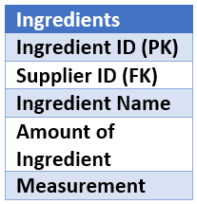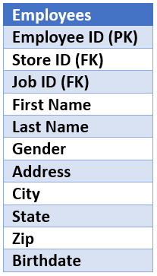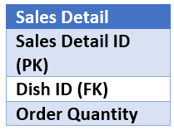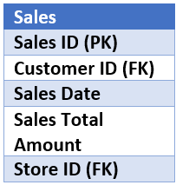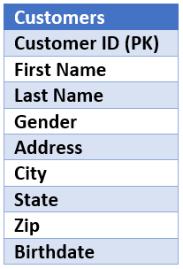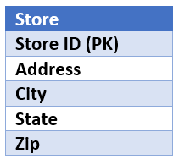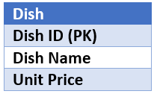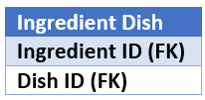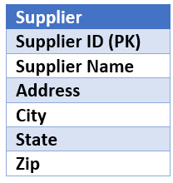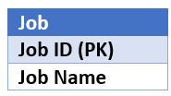

1

1

1

1

1

1

1

1

1

M

M

M

M

M

M

M

M

M