**Attention Seeking Robot**

**By Swapnil Taneja (MS UCSD), Nikita Kharat (MS UCSD)**

This project is for ensuring that infants up to the age of six months develop as normally as possible. The idea is to simulate an environment for kids to play so that they can engage in the physical activities for sound growth. The project uses a Sphero-a spherical robot and a capacitive touch sensitive fabric which would be integrated into the playmat for providing control to the robot.

**1 Abstract**

First few months of an infant’s life are extremely crucial for motor and cognitive development. These skills are essential for the baby to achieve milestones in their physical progress such as crawling and standing up without support. Tummy time also called prone positioning helps in fulfilling these milestones by engaging the infant in activities which would help them strengthen their muscles.

Our project aims to capture the kid’s attention by making them focus on a moving robot in front of them. The control to this robot would be provided by the playmat on which the baby is positioned. Depending upon the way baby leans or touches the playmat the robot would move accordingly.

We achieve this by moving a Sphero SPRK+ robot using capacitive touch sensors and communicating the data through various layers. SDKs for Android Mobile devices and Serial Communication help us in performing the communication task at these layers effectively and reliably.

In this report, the first section discusses the necessity and importance of such a robot. We also summarize the reasons to choose Sphero as the robot and the research we did to select the design of the entire project. Next section discusses the process we went through to prototype our design in detail. Later we explain the results we observed and the problems we faced as well. Future work is described in the last section.

**2 Introduction and Statement of Needs**

Tummy time or prone positioning is the time a baby spends on her stomach, which requires the baby to lift her head up strengthening her neck and shoulder muscles. The need arises from the fact that infants within the age group upto six months connected with hardware such as feeding or gastric tubes have certain restrictions in terms of mobility during their tummy time. They may get irritated due to the pain these tubes cause and may not want to lie on their stomach. These limitations affect their muscle toning, posture and motor development skills which in long term can cause slow growth and weak muscles as compared to a kid who is perfectly fine. If an infant tends to lie in the same positions for longer period of time without any physical activity, it can lead to skull deformities such as flat head syndrome as well.

If an infant lies in one position for long and a skull deformity already exists, it might get more intense as such deformities progress at a fast rate in babies that are just few weeks old. Mechanical adjustments and physical therapy should be provided to such kids to ensure that it doesn't progress and become permanent[2].

It is important for a baby to make those attempts of reaching something or wiggling as these are preparatory steps towards rolling over, sitting upright and crawling which are the signals for healthy development in their formative years. Thus, it becomes necessary to engage them and grab their attention in a way which can promote physical activity necessary for muscle strengthening and head control[1][6].

We had a conversation with Dr. Jeannie Huang, Professor of Pediatrics at UCSD, where she emphasized the need of integrating technology within this area to help infants, in the age group upto 6 months, reach their milestones in terms of motor skill enhancement. She encouraged us to come up with a game that can help the kids, with tubes attached to them, develop normally. She also shared some online resources which helped us understand the importance of prone positioning in an infant’s formative years. During the discussion, she also mentioned that it is necessary to come up with a technology which would be easily adaptable at home and user friendly. It often happens that the parents are not comfortable with the devices which are used back at the children’s care unit.

Babies tend to be interested in flashy things and different sounds as they are still trying to figure out their surroundings. The system that we implemented includes a spherical robot flashlight functionalities and it engages the kids by moving in different directions around the baby to promote head movements by manipulating their sensory capabilities. This helps in simulating a fun environment for the baby as it involves a moving object which flashes light keeping them focussed enough to foster better development.

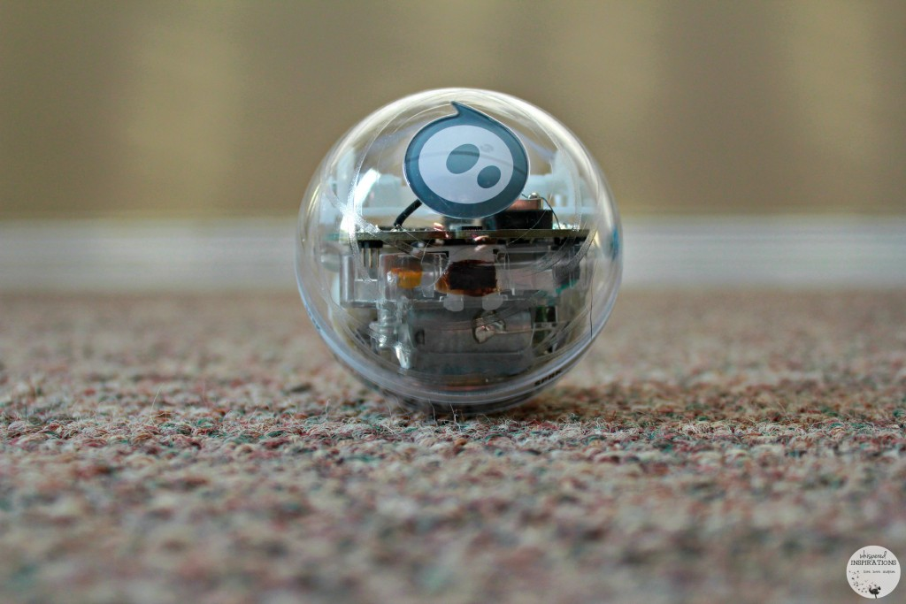

Fig 1. Baby and a Sphero

**3 Methodology**

In this section, we will discuss our prototyping design process in detail.

**3.1 Project Design Process**

The movement of our robot is controlled by the inputs sent to it through the playmat. So, we first worked with the conductive fabric and interfaced it with the Flora microcontroller to process the capacitive differences obtained from the fabric and produce the necessary control. We decided to work with Flora microcontroller due to its compactness as it needs to be integrated with the playmat the baby lies on. We were inspired by the fact that flora is used most commonly with wearables/fabric and hence it was a good option for us. This interfacing enabled us to test the serial communication between them as it is an important aspect of our project.

We used Arduino IDE to program as it provides an easy interface for Flora controller[9][13]. We also decided to use jSSC library for serial communication between Laptop and Flora microcontroller [10]. We based our choice after experimenting with rxtx library and its compatibility with our 64 bit machines[11].

As the Sphero robot connects to an application through Bluetooth, the next step in the process was to design an application which would enable this. We researched the available SDKs and decided to work on creating an Android Application. We were inspired by the “Sphero Edu” Application that comes with a lot of options for the user of sphero. It allows the user to program Sphero via Bluetooth[7]. It also has the Bluetooth Profiles (Characteristics and Services ) for reading sensor data such as Gyroscope.

In next steps, the application was connected to the laptop via usb serial ports for transmitting the control data from the touch sensor. Android Debug Bridge (ADB) tool was used for this purpose. ADB provides a very useful tool to connect , access and write data to the Android phone over USB and Wifi [8] . We chose USB over Wifi because of simplicity purposes. In order to use Wifi directly without ADB we would have to configure port forwarding at Routers which adds another layer of complexity to our project. This was followed by interfacing the Sphero to the application via Bluetooth. The final step was to test the control of the robot through fabric inputs.

The next sections describe the above mentioned project steps in detail.

**3.2 High Level Overview Diagrams**

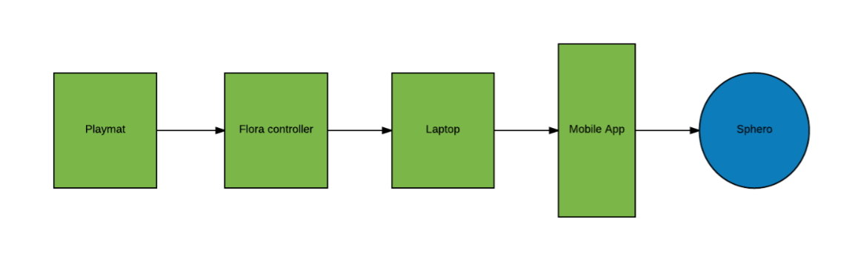

Fig 2. Project Overview

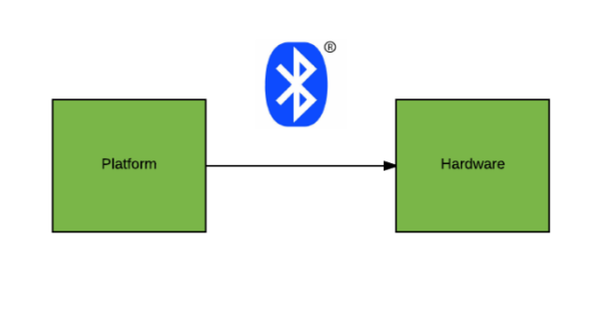

Fig 3. Communication Overview

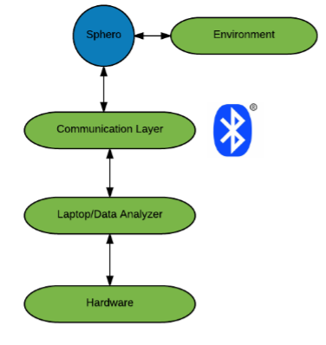

Fig 4. Software Platform

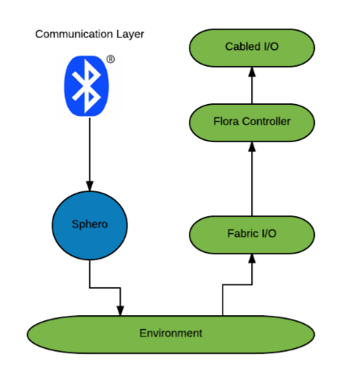

Fig 5. Hardware Platform

**3.3 Detailed Textual Description**

**Project Overview**

Figure 2 illustrates the basic functionality of our project. Sphero will be controlled by the application via Bluetooth connection. This would be enabled by communicating the data obtained through the Flora microcontroller through laptop to the application via USB connection.

**Communication Overview**

The above image, Figure 3, shows the overview of the architecture, where there is a software platform interacting with the hardware over Bluetooth and cables. These individual blocks are explained in the description below. Software platform is supposed to receive control signals and send them to the sphero via intermediate layers. Similarly, sphero is active in the field and interacts directly with the stakeholder. In this case, we have a sphero ball engaging the baby.

**Hardware platform**

Hardware platform, Figure 4, consists of a Sphero robot, capacitive fabric, Flora and cables. Sphero robot’s motion depends upon its programming which is communicated to it through Bluetooth technology. The capacitive fabric will produce an output when it senses capacitance change and that will control the Sphero’s motion to warrant the kid’s attention.

We also provide a demo of the working robot . The functioning of the capacitive touch sensors along with sphero can be seen at the link at [14]

**Software platform**

Software platform, Figure 5, has a communication layer to interact with the hardware and sends pertinent signals/data to and fro. PC/Mobile device is the primary device incharge of motion and other controls. The robot’s motion would depend on the output produced by the fabric. FLORA controller will be used to process this information and communicate it with the primary device. Flora interacts with the laptop via jSSC library . jSSC library provides an API for the java code that reads data from the serial USB COM ports on Windows and serial /dev/ttyS[X] ports on Linux machines (Ubuntu). Data Analyser receives input from the hardware and processes data into a format that is readable by the Android Application.

The Application is capable of receiving single character among the set - l , r, f, and b . We modularized our approach and tested this module separately. We developed this protocol for ease of communication. Each symbol stands for left , right , forward and backward. We can give the input to the application among this set and the sphero would move in the direction accordingly. We recorded the working demo of this Module and can be seen here at [15].

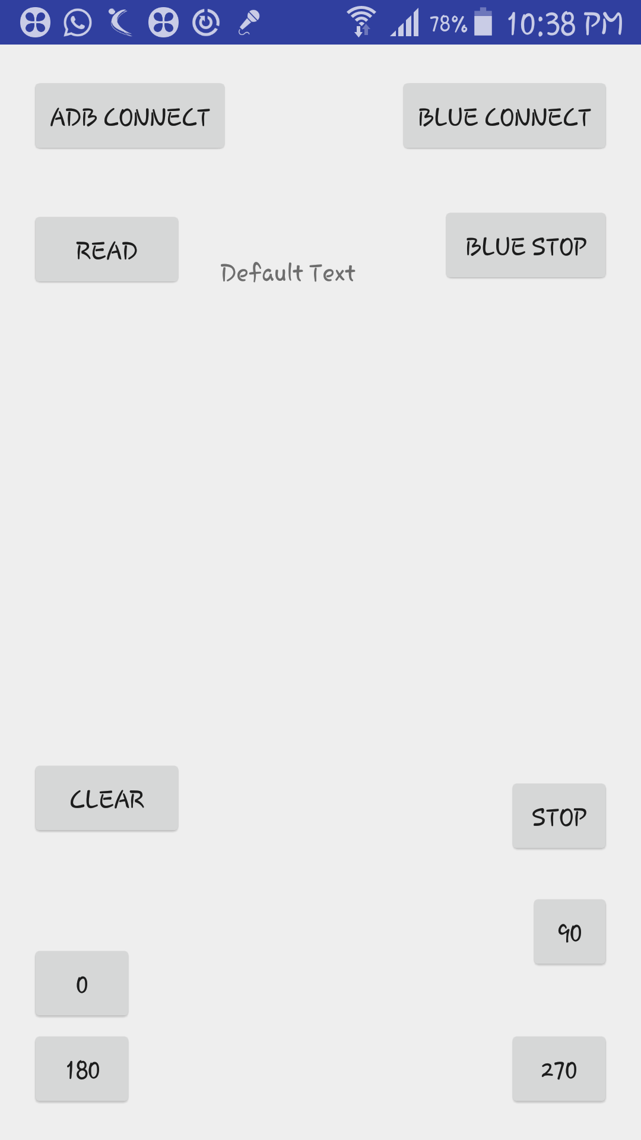

Fig 6. Application Interface

The screenshot of the application looks like the above image. As soon as the application starts , it looks for Sphero via Bluetooth and tries to connect to it. Clicking ADB connect starts a Server hosted on the mobile device listening for client sockets. After clicking the ADB connect , we start the client on our laptop . And as soon as we run the client, Server receives the socket and the connection is successful .

We also provide options for manually connecting to the Sphero - Blue Connect looks for a Sphero device via Bluetooth Smart (Low Energy ). Blue Stop breaks the connection and powers down the Sphero Robot. In addition we also provide manual controls to Sphero via the buttons labels 0, 90 , 180, 270. These numbers represent the degree where the robot should move after having referenced.

**3.4 Functional and Usability Testing Methodology**

As per the planned methodology mentioned in the proposal, we tested the working of sections/modules of the project accordingly. We modularized our approach for effective testing . This approach helped us find internal bugs that would not have been easy to find for the case in which the entire structure would be used for testing. The metrics to test the correctness and fulfilment of our goals were mostly visual.

**Attention Capture Evaluation**

Sphero on its own is capable of flashing lights which is required to capture the kids attention. The robot is programmed in such a way that it is able to display lights in different color as it moves. This is a proof of concept and we would definitely like to check the usability of our robot with our primary stakeholders to verify if robot is able to capture baby’s attention efficiently.

**Flora Control**

In this module , we interfaced our fabric and tested its functioning using LED lights. We added additional circuitry so that the LED would light up when the touch was made. This helped us build the framework for Capacitive Touch Sensors.

**Rolling Motion Evaluation**

This was tested by checking the accuracy with which the robot moved from manual inputs. Our first step was to test if the mobile itself was able to connect to the robot (For testing Bluetooth connection). In the next step we introduced buttons on the Android application to control the Motion. Further, we tested that the application received inputs from laptop. And then in the end assembled everything.

**Networking Evaluation**

We first developed an application which would connect to Sphero to make sure our basic connectivity was working correctly. We then decided to test ADB connections with the laptop. The next step was to transfer the data from the microcontroller to the laptop via jSSC library.

**4 Results**

**Interfacing Flora with the conductive fabric**

We noticed that when the conductive fabric was tested on different surfaces and environments, it produced varying values every time. These values correspond to the inference that the playmat is sensing a touch implying the capacitance is varying. This variance had to be fixed to make sure the control is active at all times.

This problem was resolved by modifying the code uploaded through Arduino IDE as the average value which determines the range at which the fabric should sense the touch was reset after a certain number of touches to ensure consistent results.

**Serial Communication between the application and Flora**

We faced major issues while trying to enable serial communication between the application and Flora through the laptop. We used the RXTX library to achieve the communication. RXTX is a java library that provides serial communication for Java Development Toolkit. It wasn’t compatible with the system we were trying to build and hence even after trying to resolve the issue, we couldn’t get it to work.

Similar issues were faced with javax.comm package as it failed to recognize the communication ports to which the Flora was connected which is crucial to our project. We tried resolving this problem by working on a 32 bit machines as well but unfortunately it didn’t work out. We finally proceeded with JSSC as this had the support for our 64 bit machines.

**Bluetooth Connection**

We interacted with the Sphero via Bluetooth Smart . Compared to Classic Bluetooth, Bluetooth Smart is intended to provide considerably reduced power consumption and cost while maintaining a similar communication range. Bluetooth Smart uses the same 2.4 GHz radio frequencies as Classic Bluetooth, which allows dual-mode devices to share a single radio antenna.

We used the Sphero Android SDK [12] . The Main branch is not updated and hence we used the beta branch. DualStackDiscoveryAgent() Class provides a good functionality to connect to the sphero. We were able to successfully and reliably connect to the Bluetooth using this API.

**USB connection of the application with laptop**

For this part we used Android Debug Bridge (ADB) tool. ADB starts an ADB server and a ADB client on the development machine as soon as it is started. Now, if there are any android devices connected to the development machine, ADB can detect it and connect to it by communicating to the ADB Daemon thread. This requires enabling USB debugging . Once the setup is done, we run our java code to start a client that interacts with ADB client . ADB server handles the connection between ADB client and daemon. Daemon then forwards our request to the Server that is run in our Android application.

After handling with a lot of tcp issues we were able to find port Addresses that can be used for this connection. In order to increase reliability of this connection , we also changed the code to be more resilient by setting the setReuseAddress flag to True. Naturally, our application needed to deal with a lot of hardwares (laptop and sphero) at the same time. Our application is multithreaded. That means we also had to deal with concurrency issues particularly because the UI thread can not be run anywhere else and needs a Handler thread to manage UI changes. We were able to build a reliable and resilient Serial Communication.

**5 Discussion and Future Work**

For future work , another feature we wish to implement is face detection which would be as an option to control the robot. The baby’s head movement can be tracked via live video acquisition and the robot can move accordingly. This would make the existing system smarter by involving an automatic control feature.

To take this one step ahead, we can also make the robot recognize emotions of the baby and other features can be added to relax the baby. Features can be used to train machine learning models that can capture the baby’s attention. A glimpse of the architecture would like the model shown in Figure 7.

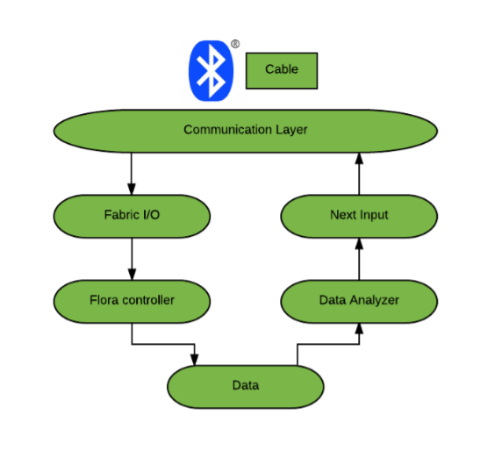

Fig 7. Software Platform for future work

We would like to meet Dr. Huang to discuss further addition to the robot in terms of features to facilitate physical developments in kids. As we haven’t tested the usability of the device with our primary stakeholders, this meet can help us understand the milestones our robot achieved. She can definitely give us an insight into a particular feature she wants our robot to have to encourage a movement in the infant.

**Acknowledgements**

We would like to extend our gratitude to Professor Riek and Darren Chan for helping us throughout the course of the project. We are also grateful towards Professor Huang for taking time out of her schedule to talk to us.

**References**

[1] John M. Graham, Jr, MD, ScD. Tummy Time is important. In *Clinical Pediatrics* Journal, March 2006.

[2] John Persing, MD; Hector James, MD; Jack Swanson, MD; John Kattwinkel, MD; Committee on Practice and Ambulatory Medicine; Section on Plastic Surgery; and Section on Neurological Surgery. Prevention and Management of Positional Skull Deformities in Infants. In *American Academy of Pediatrics News and Journals,* July 2003, Volume 112 / Issue 1.

[3] Simon Says, “Pay Attention to This Robot.” Published on April 29, 2011. Retrieved from https://www.wallstreetdaily.com/2011/04/29/attention-seeking-robot/

[4] M. L. Walters, K. Dautenhahn, R. te Boekhorst, K. L. Koay, S. N. Woods. Exploring the Design Space of Robot Appearance and Behavior in an Attention-Seeking ‘Living Room’ Scenario for a Robot Companion. In *Proceedings of the 2007 IEEE Symposium on Artificial Life (CI-ALife 2007).*

[5] Attention and Memory in Deep Learning and NLP. Published in January 2016. Retrieved from http://www.wildml.com/2016/01/attention-and-memory-in-deep-learning-and-nlp/

[6] Written by Bonnie Vengrow. Introducing Tummy Time to Baby. Retrieved from <https://www.thebump.com/a/tummy-time-when-to-start-how-to-do>.

[7] Official Website of Sphero Edu. Accessed from <http://www.sphero.com/education>.

[8] Android Debug Bridge (Android Studio) User Guide. Retrieved from <https://developer.android.com/studio/command-line/adb.html>.

[9] Official Arduino Website. Accessed from <https://www.arduino.cc/>.

[10] jSSC source. Retrieved from <https://javalibs.com/artifact/org.scream3r/jssc>.

[11] RXTX source. Retrieved from <http://rxtx.qbang.org/wiki/index.php/Main_Page>.

[12] Android SDK for Sphero. Accessed from <https://github.com/orbotix/Sphero-Android-SDK>.

[13] Official Flora description. Accessed from https://www.adafruit.com/product/659.

[14] Sphero control video. Access from <https://www.youtube.com/watch?v=LMreatWOKds>.

[15] Prototype working video. Access from <https://youtu.be/VoIssIS4IDQ>.