**Filters:**

Client : HUL

TG-Market: CS AB 15+ YRS_*Pune

time-period: 26-2015

## Table 1( on global selection):

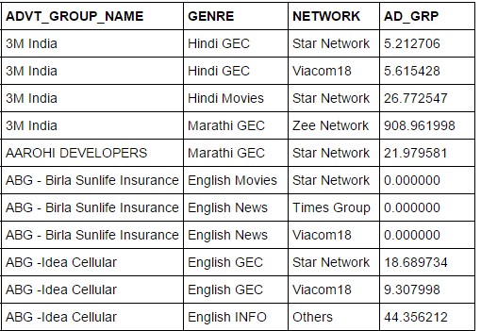

# Program Metrics

## Table 2(sum of ADGRP):

**group by (genre, network) on Table 1**

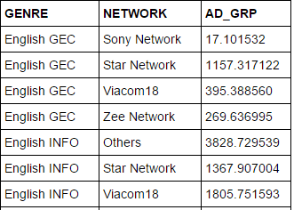

## Table 3(for Genre share):

**group by (genre) on Table 2**

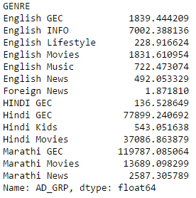

## Table 4(Genre TG-Market mapping for affinity):

**has to take from other table**

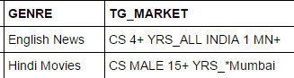

# Client Metrics

## Table 5( sum of ADDGRP) :

select client = 'HUL' group by (genre, network ) on Table 1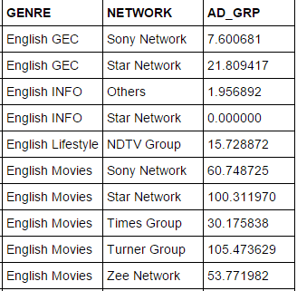

## Table 6(for Genre share):

**group by (genre) on Table 4**

GENRE

English GEC 29.410098

English INFO 1.956892

English Lifestyle 15.728872

English Movies 350.482144

Hindi GEC 8026.874763

Hindi Movies 4940.641074

Marathi GEC 29286.579884

Marathi Movies 3087.141292

# Result:

Combination of all tables

