Client Server:

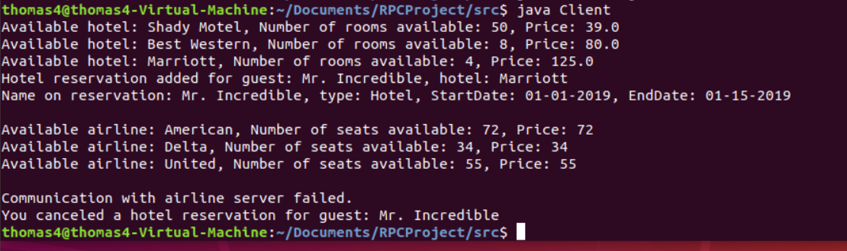

Airline Server:

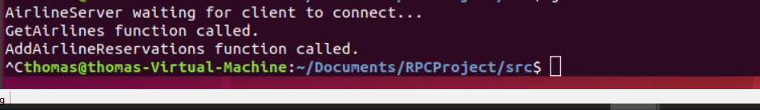

Hotel Server:

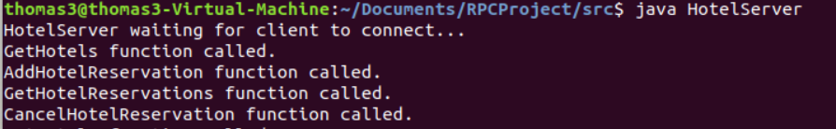

Car Server (was not called):

