 |  | 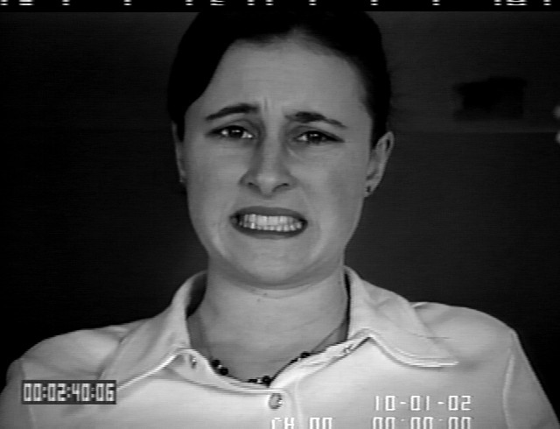 |  |  |  | 
Angry | Disgust | Fear | Happy | Neutral | Sad | Surprise

Angry | Disgust | Fear | Happy | Neutral | Sad | Surprise

Angry | Disgust | Fear | Happy | Neutral | Sad | Surprise

Angry | Disgust | Fear | Happy | Neutral | Sad | Surprise

