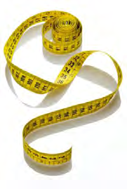

**Convert lengths**



In this activity you will convert between metric units of length:   
kilometres, metres, centimetres, and millimetres.

**1 km = 1000 m**   
**1 m = 100 cm**   
**1 m = 1000 mm**   
**1 cm = 10 mm**

**Think about**

how to change from one unit to another.

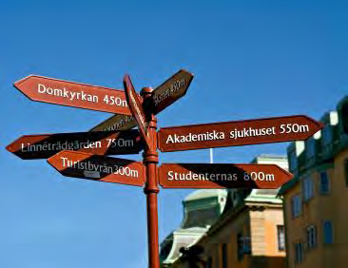

|  |  |  |  |  |
| --- | --- | --- | --- | --- |
| **A kilometre is one thousand metres!** | so **km** | |  1000 | **m** |
| or | **m** | ÷ 1000 | **km** |
|  |

÷ 1000

**A millimetre is a thousandth of a metre!** so **mm m**

|  |  |  |
| --- | --- | --- |
| or **m** |  1000 | **mm** |
| **A centimetre is one hundredth of a metre!** so **cm** | ÷ 100 | **m** |
|  |
| or **m** |  100 | **cm** |

**Think about**

how to use this to help you change to different units … and back again ….

|  |  |  |  |  |  |  |  |
| --- | --- | --- | --- | --- | --- | --- | --- |
| **mm** | ÷ 10 | **cm** | ÷ 100 | **m** | ÷ 1000 | **km** |  |
|  |  |  |
|  10 | |  100 | |  1000 | | |
| mm | | cm | | m | | km |
| Nuffield Free-Standing Mathematics Activity ‘**Convert lengths’** Student sheets | | | | | | | Copiable page 1 of 3 |

© Nuffield Foundation 2011 ● downloaded from www.fsmq.org

**Try these …. Fill the gaps.**

**A** 3 cm = _________ mm 12 cm = _________ mm 285 cm = _________ mm

**B** 6 m = _________ cm 2.4 m = __________ cm 0.7 m = _________ cm

**C** 8 km = _________ m 0.8 km = _________ m 0.08 km = _________ m

**D** 40 mm = _________ cm 250 mm = _________ cm 400 mm = _________ cm

**E** 500 cm = _________ m 750 cm = __________ m 20 cm = _________ m

**F** 2000 m = _________ km 3500 m = _________ km 300 m = _________ km

**G** 0.4 km = _________ m = _________ cm

**H** 0.15 km = _________ m = _________ cm

**I** 0.07 km = _________ m = _________ cm

**J** 3 m = _________ cm = _________ mm

**K** 0.3 m = _________ cm = _________ mm

**L** 90 000 cm = _________ m = _________ km

**M**1500 cm = _________ m = _________ km

**N**250 cm = _________ m = _________ km

**O**600 mm = _________ cm = _________ m

|  |  |  |
| --- | --- | --- |
| **P** | 50 mm = _________ cm = _________ m |  |
| Nuffield Free-Standing Mathematics Activity ‘**Convert lengths’** Student sheets | | Copiable page 2 of 3 |

© Nuffield Foundation 2011 ● downloaded from www.fsmq.org

**Let's play bingo!**

**1** Choose a card.

**2** As each length is called (or written on the board), look for an equal length on your card.

If there is one, cover it or cross it out.

**3** The winner is the first person to   
cover or cross out all the lengths on their card.

**Dominoes**   
**1** Shuffle, then share all of the dominoes between the players. **2** The first player puts down any domino.

**3** Each player in turn tries to put down a domino   
next to a domino showing an equal length.

**4** The first player to use all of their dominoes wins.

**At the end of the activity**  
**•**How many metres are there in a kilometre?

**•**How do you convert metres to centimetres?

**•**How do you convert millimetres to metres?

**•**How many millimetres are there in a centimetre?

**•**Estimate how far you will walk today, in a week, in a year, in your lifetime.

|  |  |
| --- | --- |
| Nuffield Free-Standing Mathematics Activity ‘**Convert lengths’** Student sheets | Copiable page 3 of 3 |

© Nuffield Foundation 2011 ● downloaded from www.fsmq.org