Tyler Sykora
IT 30000
Shawn Golden
8/31/2026
GitHub Setup & First Repository

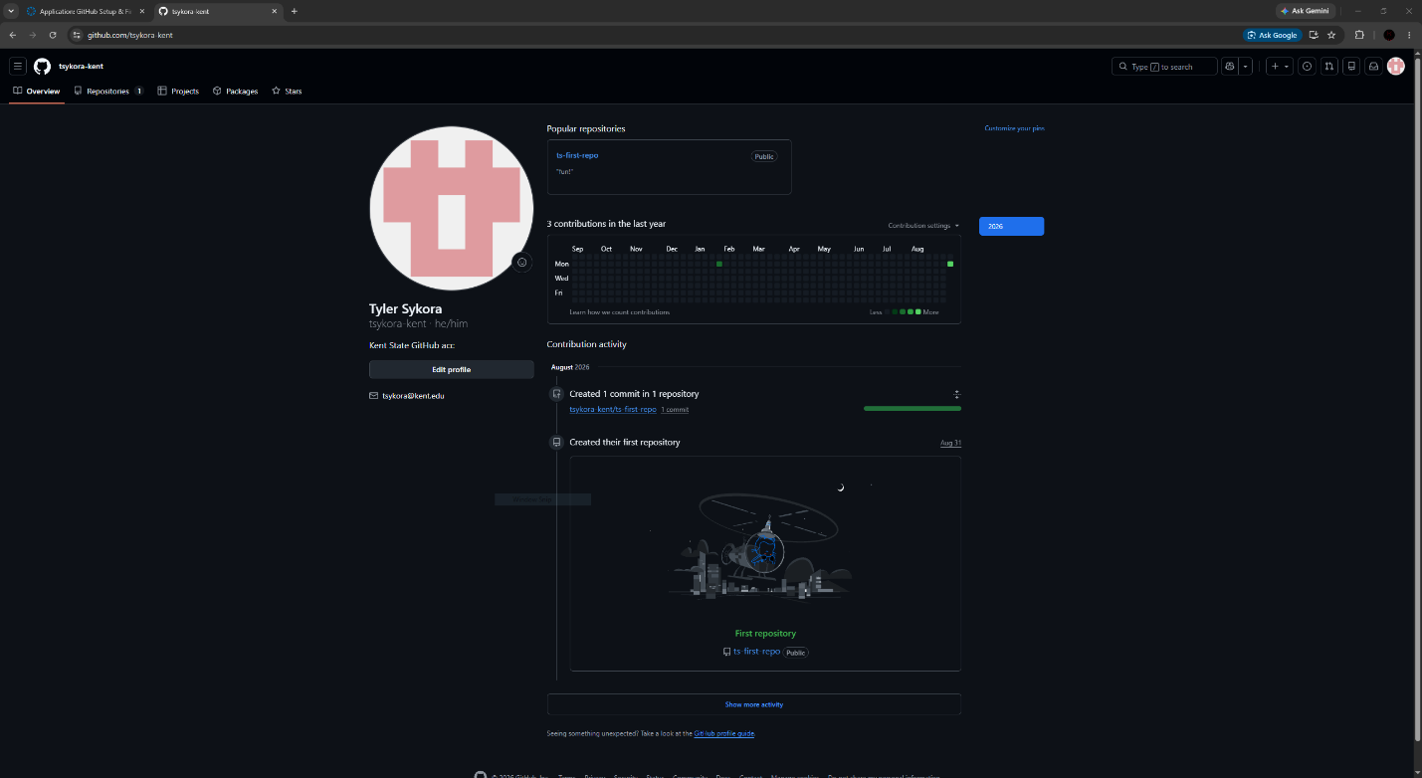
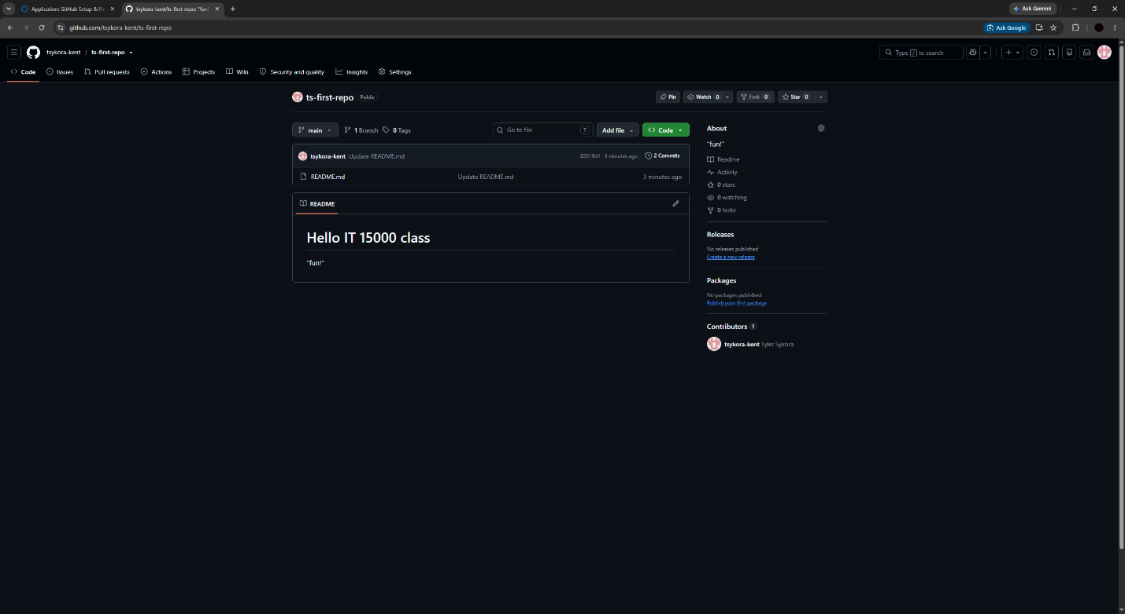
This assignment has taught me how to create a GitHub repository for the first time and given insight on how to create and add files to the directory. I have also learned how to add contributors to access the repository and that GitHub has several different management options in its settings. It addition, it is convenient having some built in updating features to files.

