Extended Design and Architecture Specification
Project: RoadRunners Car Rental System | Version 1.1
1. UML Class Diagram
The updated PlantUML code below uses precise relationship notation (Composition, Aggregation, and Association).

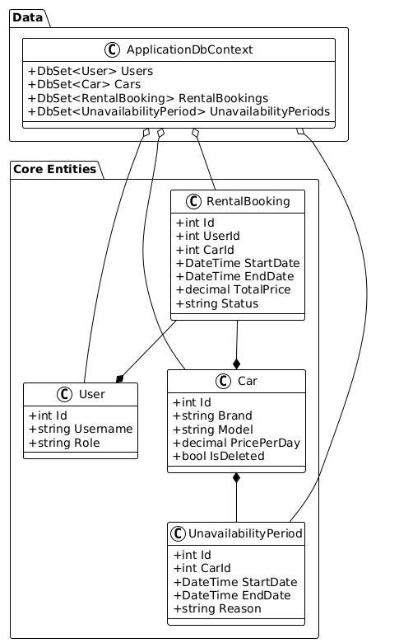

2. Application Architecture Description
Layered Structure Details:
- UI (Presentation): Uses the MVC pattern. Views are strictly responsible for layout, while Controllers handle interaction logic.
- Logic (Business): Encapsulated in the CarController (pricing engine) and AdminController (fleet constraints logic).
- Data Access: Entity Framework Core with SQLite. Implements global query filters for soft-delete logic.
3. Extended Testing Plan
ID | Test Case Description | Input / Scenario | Expected Result
TC1 | Client Registration | Unique Username, Valid Password | Account created, redirected to Login
TC2 | Auth Failure | Correct User, Wrong Password | Error message: 'Invalid credentials'
TC3 | Tiered Pricing (Standard) | 3 days @ â‚¬75/day | Total: â‚¬225 (No discount)
TC4 | Tiered Pricing (Tier 1) | 4 days @ â‚¬75/day | Total: â‚¬296.25 (â‚¬225 + â‚¬71.25 [5% off])
TC5 | Tiered Pricing (Cap) | 15 days @ â‚¬100/day | Total: â‚¬1160 (Cap at 40% discount for days 11-15)
TC6 | Overlap Check (Internal) | Ex: May 5-10. New: May 6-8 | Rejection: Dates overlap with existing booking
TC7 | Overlap Check (Edge) | Ex: May 5-10. New: May 10-12 | Rejection: Last day of existing is first of new
TC8 | Admin Maintenance Lock | Car 1 locked May 20-22 | Car 1 disappears from search for those dates
TC9 | Unavailability Merging | Admin adds May 1-5 and May 4-10 | Calendar displays a single block: May 1-10
TC10 | Soft-Delete Persistence | Delete Car 1 (with past rentals) | Car 1 hidden from fleet; History preserved in Rental Log
TC11 | Future Booking Deletion | Delete Car 2 (has booking tomorrow) | Car 2 deleted; Client booking status set to 'CanceledByAdmin'
TC12 | Log Filtering | Admin selects 'Last Month' | Table shows only rentals within the previous 30 days

4. Modeling & Design Considerations
- Performance: SQLite indexing on Username and Foreign Keys ensures fast lookup even as the rental log grows.
- Scalability: The use of EF Core Migrations allows the schema to evolve easily as new car features are added.

