Activity 01

1. (3 points) Explain the key differences between dictionary, set and array.

Dictionary is unordered and contains key-value pairs  
Set is unordered and contains unique values  
Array is ordered and contains (not required to be unique) values

1. (3 points) Explain the annotations @IBOutlet and @IBAction. When do we use @IBOutlet and @IBAction?

@IBOutlet connects code (for example variable) to UI Layout. @IBAction is essentially a function that operates similarly. However, compared to @IBOutlet it makes those certain storyboard components trigger code when interacted with rather than just be static.

1. (3 points) Write a function which takes an array of type double and returns the average of an array.

func doubleSum(doubleA: [Double]) -> Double {

var sum: Double = 0

for i in doubleA {

sum += i

}

return sum

}

1. (16 points) Create a project in XCode with the project name as “**LastName_DiceGame**” LastName is your last name.
2. You need to create a dice game application by taking names of the two players as an input.
3. When you click on the “Roll a dice” button, your app needs to generate a random number and assign it to each player. The range of random number is from 1 to 6 inclusive.
4. Compare the random numbers of two players and print the output as below.
   1. Both the players have same random numbers, then print “The game is tie”
   2. Otherwise, print the winner with highest random value.

Following screenshots are of a sample app design with all the three cases:

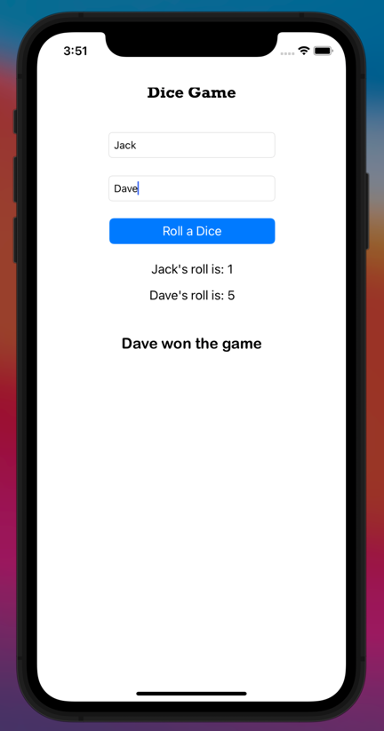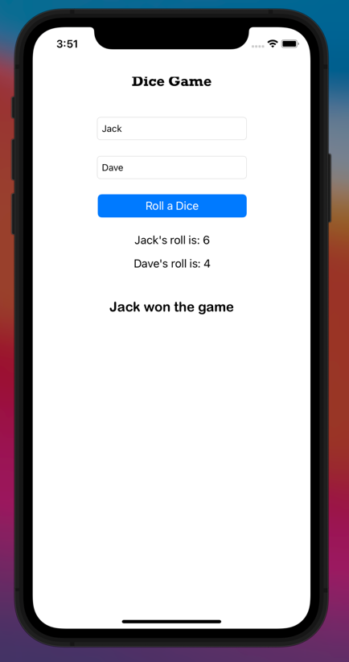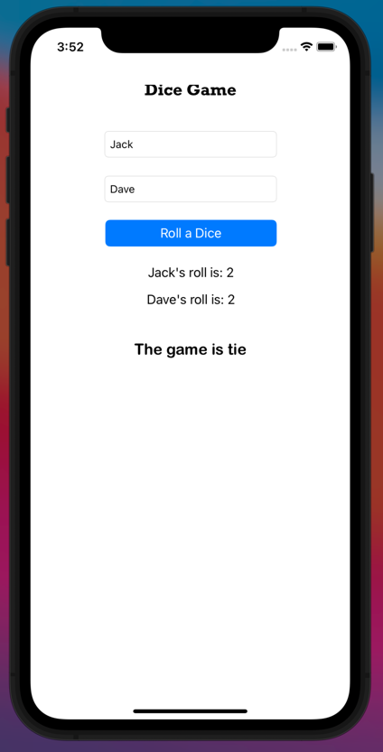

Screenshot of a working app:

