**New Era of Vehicle-Machine Interconnection**

Contact us:

ibsghk@gmail.com

**——****Geely’s Acquisition of Meizu Tech**

# Abstract:

In this research, we mainly talk about the synergy after the acquisition of XINGJI Times and Meizu Tech.

* With the development of electric vehicles, the upgrade of hardware will gradually slow down, while the iteration of software will continue to advance.
* Companies which grab the software advantage will have larger bargaining power.
* Vehicle and mobile phone companies take actions based on their business strategy to cut a pie in this blue ocean.

Content:

Abstract: 1

1. Transaction Background - LI Shufu's XINGJI Times acquires 79.09% stake in Meizu 4

1.1 Buyer – XINGJI Times 5

1.1.1 Company Overview 5

1.2.2 Equity Structure 5

1.2.3 Company Advantages 6

1.3 Seller - Meizu 7

1.3.1 Company Overview 7

1.3.2 Equity Structure 7

1.3.3 Company Advantages 8

2. Insight 8

2.1 Complementary resources at the hardware and software level Geely 8

2.1.1. Current dilemma on the smart cockpit 8

2.1.2. Advantages brought by Meizu 9

2.1.3. Meizu’s comparative advantage with other companies 10

2.2 Meizu was sold to save itself from being marginalized year after year 11

2.2.1. Current dilemma 11

2.2.2. Current resolution 11

2.3 Geely’s perception for the change 11

2.4 The actions of mobile phone companies 12

2.4.1 Xiaomi -- Pushing into the vehicle manufacturing market 12

2.4.2 OPPO, VIVO -- Still on the edge of building cars 13

2.4.3 Huawei -- Determined not to build cars, but maybe not that determined? 13

2.4.4 Analysis 14

2.5 The actions of car companies 15

2.5.1 NIO-- Defense, instead of offense 15

2.5.2 Great Wall, Chery, Nezha -- Have already voted no 15

2.5.3 Analysis 16

1. Transaction Background - LI Shufu's XINGJI Times acquires 79.09% stake in Meizu

The State Administration for Market Regulation released the public notice of the case of acquisition of equity interest in Zhuhai Meizu Technology Co. According to the public information, on June 13, the State Administration for Market Regulation announced that Hubei XINGJI Times Limited and Zhuhai Meizu Technology Co. According to the announcement, before the transaction, Meizu Technology (MEIZU) founder HUANG Xiuzhang and Taobao (China) held 49.08% and 27.23% of Zhuhai Meizu's equity, respectively, and jointly controlled Zhuhai Meizu. After the transaction is completed, Huang Xiuzhang’s stake in Zhuhai Meizu will be reduced to 9.79%, and Taobao China will withdraw from holding and controlling Zhuhai Meizu, and XINGJI Times will gain sole control of Meizu.

**XINGJI Times**

**Meizu Tech.**

**79.9%**

Geely's acquisition of Meizu can help Geely quickly broaden its product layout in the intelligent cockpit while also helping Meizu find a good home. This acquisition will allow Meizu to survive better and also enable Meizu to catch the next wave of change in the smartphone landscape.

The use of Meizu to enhance the competitiveness of Geely's car system does not mean that Geely does not care about the cell phone product itself. On the contrary, Li Shufu has also stressed that with the rapid iteration of mobile communication technology and the upgrade of individual consumption, users' demand for smartphones has become dependent, and the development prospects of more high-grade and more intelligent cell phones are still promising.

XINGJI Times has sufficient capital, strategic orientation, and co-branded design, which can enhance Meizu’s technological advantages. After the acquisition, both companies will complement the resources at hardware and software level.

1.1 Buyer – XINGJI Times

1.1.1 Company Overview

Hubei XINGJI Times Technology Co., ltd is a technology company held by Ningbo Geely Group. The scope of business includes the production, research, and development of 3C consumer electronics products needed for "connected driving, " including smartphones, AR glasses, peripheral intelligent ecological products, etc.

1.2.2 Equity Structure

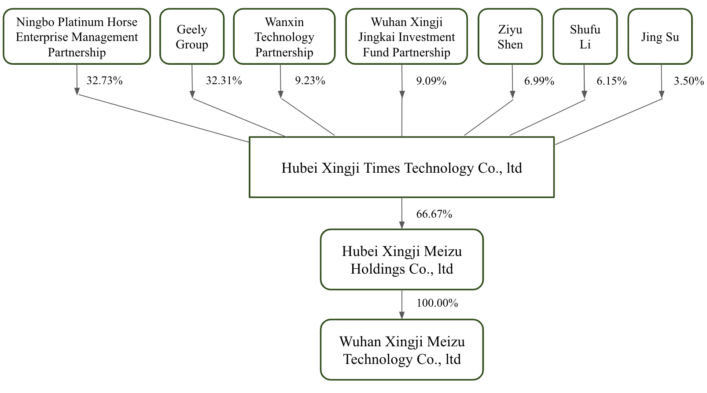

*Source: Wind, IBSG Resarch*

The top three shareholders for Hubei XINGJI Times are Ningbo Platinum Horse Enterprise Management Partnership, shareholding 32.73%；Geely Group，shareholding 32.31%；Haining Wanxin Technology Partnership, shareholding 9.23%. The actual controller is Li Shufu, chairman of Geely Group, who directly and indirectly controls nearly 58% of the company's equity. Noteworthy，Ningbo Platinum Horse and Geely Group jointly participated in the angel round of financing for XINGJI Times; the valuation amount and finance funding were not disclosed. Wang Yong, a designated representative, was formerly a vice president of ZTE Corporation, who is called by one of the leaders for “中华酷联” later, he also served as Vice President of ASUS Computer China.

1.2.3 Company Advantages

1.Sufficient Capital

Since Li Shufu announced his entry into the cell phone industry on September 28, 2021, Geely has continued to increase its investment and recruiting in building high-end cell phones. It is reported that many members of Geely's cell phone team are cell phone industry bigwigs, Meanwhile, not only is Geely determined not to take the OEM route for its cell phone,instead relies on complete independent research and development to build a corporate moat and create a flagship cell phone, but also setting R&D center in Shanghai will locating production base in Wuhan.

2.Strategic Orientation

Geely has developed a very clear product positioning, accumulated industry elites, and also devoted a significant number of resources to research and development. Its purpose is self-evident, namely, to make high-end smartphones an integral part of the smart driving ecosystem. Coincidentally, the intelligent factory of Geely's acquired supercar brand, Rutgers, is also located in Wuhan. Thus, Geely is determined to do an excellent job in smartphone production and manufacturing and seize market share through technology differentiation to truly "integrate global resources and serve global markets".

3.Co-branded design

In this high-end machine market, there are many cases that rely on cooperation with supercar brands to get good sales: Huawei joint Porsche design, Redmi products with Mercedes AMG racing elements, OPPO Find series phones had joined the Lamborghini logo and so on. Looking forward to the future, Geely, Rutgers and Meizu cell phone co-branding can once again set off the water in this market.

1.3 Seller - Meizu

1.3.1 Company Overview

Founded in 2003, Meizu Technology (Meizu), as a leading innovator of technology lifestyle products and software eco-services in China, has been committed to fusing elegant design and intimate experience to create warm and distinctive products for consumers worldwide. "Meizu Design has won several international Red Dot & iF designs awards, including the IF design global gold award in 2020. 2019 Meizu was selected as one of the top 50 brands in China abroad by BrandZ and one of the top 100 most valuable brands in China. Its products are mainly divided into PRO, MX and Meilan series and Flyme mobile operating system, in addition, it also provides cell phone film, cell phone case, data cable, smart bracelet, Bluetooth headsets and other products.

1.3.2 Equity Structure

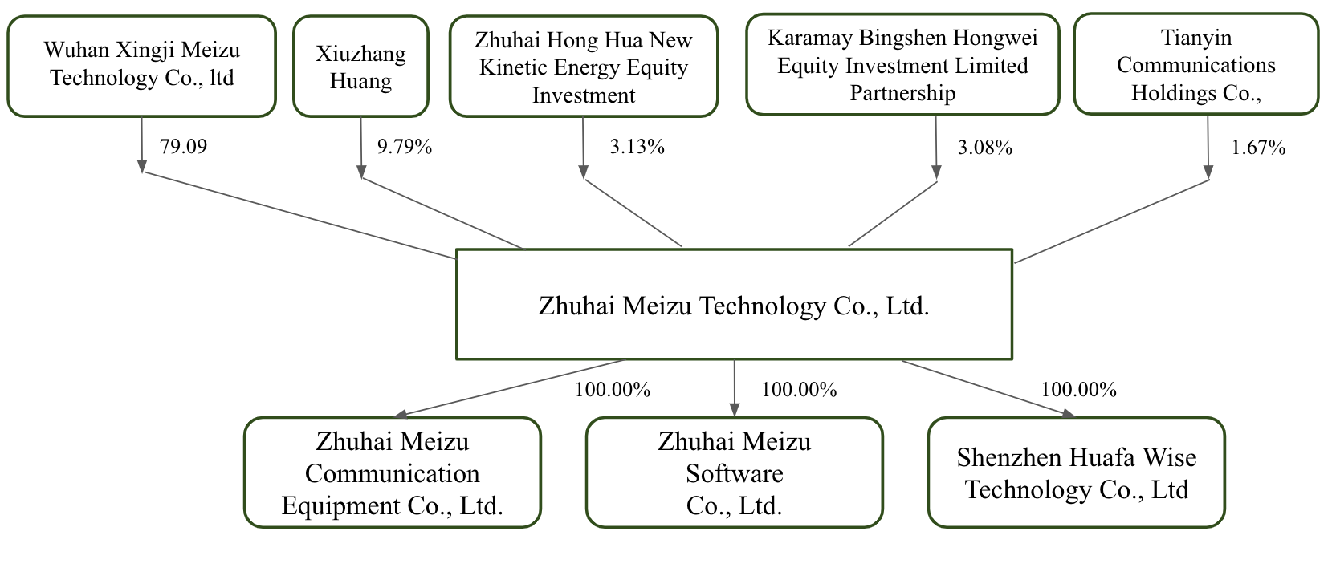

*Source: Wind, IBSG Resarch*

After the completion of the transaction, the former largest shareholder and founder of Meizu, Huang Xiuzhang, is the second largest shareholder with 9.79% shareholding, and the first largest shareholder is Wuhan XINGJI Meizu Technology Co., which is 100% owned by Hubei XINGJI Meizu Technology Co. with 79.09% shareholding. After this merger, Shen Ziyu is the chairman of Meizu Technology, while Huang Xiuzhang, the founder of Meizu Technology, stepped down from the position of chairman and turned to be a product strategy consultant. The original executive team and the technical team did not undergo much turmoil.

1.3.3 Company Advantages

1. Technical advantages

Meizu's accumulation, system and process in cell phones for more than ten years can quickly ensure the product is mature and launched as scheduled. After that, Meizu Flyme Os will expand to the travel ecology, and XINGJI Era will also make interaction experience around Flyme Os, learn from Apple's Carplay, give the cell phone's ability to the car, and step into the car field.

2. Reputation

When it was first born, Meizu was the progenitor of Chinese smartphones, and it was on par with Xiaomi in about 15/16. The M9, which was hailed as a god machine, had a 3.5-inch ASV screen with a 3.54-inch 640x960 pixel ASV high-resolution capacitive touch display, an ARM Cortex-A8 architecture with a 1 Gigahertz Hummingbird S5PC110 processor, 512MB of RAM, and a 5-megapixel camera, and was all the rage in 2011. In recent years, due to various problems such as the business model, Meizu does not have enough financial support but still retains a part of solid users.

2. Insight

2.1 Complementary resources at the hardware and software level Geely

2.1.1. Current dilemma on the smart cockpit

On October 31, 2021, Geely Automobile officially released the "Nine Dragon Bay Action"(九大龙湾行动) plan.

| **Smart Geely 2025** | **Operation Longwan** |
| --- | --- |
| Operation Longwan I | 5 years of R&D investment 150 billion RMB |
| Operation Longwan II | Realize self-driving full-stack self-development |
| Operation Longwan III | Launch more than 25 new intelligent new energy products in 5 years |
| Operation Longwan IV | The total sales volume of the group in 2025 aiming at 3.65 million |
| Operation Longwan V | Overseas sales reach 600,000 vehicles in 2025 |
| Operation Longwan VI | Total carbon emissions reduced by 25% in 2025 |
| Operation Longwan VII | Achieve 100% full-scene digital value chain |
| Operation Longwan VIII | EBIT exceed 8% in 2025 |
| Operation Longwan IX | 350 million shares, the first batch to motivate 10,000 employees |

*Source: Company offical website, Soochow Securities, IBSG Resarch*

In the field of the smart cockpit, Geely Automobile takes Geely Group itself and Volvo as the two lines, takes self-research as the core, and jointly promotes it with external manufacturers. It includes three development paths: Mobileye all-inclusive solution (chip + algorithm) pure external procurement, Waymo cooperates with Volvo (providing a complete set of software and hardware solutions and algorithms for Auto piloting) and full stack self-developed route.

2.1.2. Advantages brought by Meizu

The layout of Shen Ziyu in the Hubei XINGJI Times Technology Co. (XINGJI Times) of Meizu acquisition focuses on the mobility of the brand. The goal is to create a complete set of interoperable intelligent systems around mobile terminals.The chip is the underlying foundation, the mobile phone is the terminal that is closest to the user, the car is the necessary terminal for the user to travel, and the AR glasses are the future exploration. Each business has a strong correlation and reusability at the business level. In the Geely Group ecosystem, a household car business has earned enough profits, solved the most difficult car-making link on the entire road, won the independent control of Meizu, and made up for the relatively simple link in the entire business line.

XINGJI Times has submitted a number of mobile phone-related trademark applications, including "UPUPHONE", "Visitor", "Portable Big Screen" and so on. In terms of internal strategy, "vehicle-machine coordination" is also planned.

Geely Mobile is piecing together professionals in the mobile phone industry and directly acquiring a relatively complete mobile phone team, and Meizu is a natural choice. "Meizu enterprise essence and assets are very good (2020 to achieve a turnaround in profit), and has a complete mobile phone product line, mature system and a large number of talents", Meizu has been deeply engaged in the field of electronics consumption for nearly 20 years, with intellectual property rights related to human-computer interaction communication, and can be pulled through in all terminals including the brother company Star Era in the future, covering travel, life, work and other fields. Meizu has a deep enough talent system, operation and supply chain experience in the mobile phone industry, and brand and product capabilities with wide popularity and reputation, which can greatly reduce risks.

2.1.3. Meizu’s comparative advantage with other companies

In 2012, the Flyme system based on Android deep customization was released, and its simple operation logic and unique aesthetic UI, as well as the interactive experience that is more in line with the usage habits of the Chinese people, has become one of the three domestic operating systems that lead the user experience, and its continuous iteration has affected the entire evolution process of China's mobile phone system interaction and experience in the past decade.

Meizu has more than ten years of operating system development experience, accumulated hundreds of millions of users, is a well-supported set of very good high-experience operating system. Human-computer interaction is the most core component of all end devices and cross-terminal operating systems. In the view of the Star Era, only good interaction will have a basis for good architecture and technology, otherwise it is a waste of time to break away from the architecture and technical basis of any interaction, and Meizu's strength in Flyme is precisely the shortness of today's travel technology ecology. On the one hand, Flyme should focus on improving the system-level interactive experience of all mobile phones and other terminal products in Meizu and XINGJI Shidai, and on the other hand, it should also promote deep integration with the vast travel technology ecosystem.

Meizu launched the Flyme for Car system in 2021, and at the same time customized the car machine system for some car companies and also relied on the Flyme system for profit.

2.2 Meizu was sold to save itself from being marginalized year after year

2.2.1. Current dilemma

In the past two years, the annual shipment of Meizu mobile phones has dropped to about one million units, compared with the shipment of 20 million units at its peak. Meizu sold only 450,000 mobile phones in 2021, with a market share of about 0.2%, compared with 1.4% in 2019; IDC data shows that Meizu's market share in the first quarter of this year is not even 0. 1%. Meizu's best-selling products are not the acclaimed Meizu 16 series or the latest Meizu 18, but the iPhone phone case.

Meizu's strategic positioning is to focus on "small and beautiful", relying on products to influence users and sit firmly in the industry; now Meizu is trying to find a balance between performance configuration and "small and beautiful". Meizu is left with only the software and hardware team, supply chain integration experience and Flyme on-board system several home button,

2.2.2. Current resolution

Geely is eager for car-machine coordination and has a 10-billion-yuan budget to make mobile phones, which can help Meizu with its current funding problem. Meizu’s product line will be kept individual, as well as offering Flyme system for Geely’s smart cockpit.

2.3 Geely’s perception for the change

In traditional industrial thinking, software is an accessory of a car. However, with the development of automotive intelligence, the essence of the car is slightly changed, from a mechanical device to an electronic device. And the industry insiders joke that the smart cockpit is actually a giant mobile phone.

Software defines the car; data determines the experience. Smart cars are generally equipped with a large central control screen, but most drivers operate relatively few when driving, and the main behavior data of users are still on their mobile phones. Under this circumstance, whoever grabs more user data and applies it rationally can better optimize the user experience. One of the ways for car companies to obtain more user data and optimize the user experience is building up their own mobile phones, like what Geely does.

But why did Geely choose Meizu among all domestic mobile brands? In fact, the hardware of domestic mobile phones relies on basic components, for example chips, coming from upstream suppliers such as Qualcomm. Therefore, from the perspective of hardware, it is hard for a domestic mobile company to take a lead and most of the competition comes from their ecosystem. The company with hardware capabilities, like Huawei, has large bargaining power, and instead of being merged with another company, they can choose to corporate or even develop their own cars. Geely’s target should satisfy two requirements, one is that the mobile phone company should own an outstanding ecosystem, and another is that the bargaining power can always belong to Geely. For Meizu, its competitive advantage comes from its ecosystem Flyme and it is in a dilemma and needs a ‘big hand’ to help it out. Its ecosystem will benefit Geely in the field of car intelligence, making it obtain more user data and optimize user experience. What’s more, Meizu also make achievements in the smart wear business and smart phone business. Geely is not only optimistic about mobile phones, but also putting its eyes on the entire smart entrance.

2.4 The actions of mobile phone companies

2.4.1 Xiaomi -- Pushing into the vehicle manufacturing market

At the end of March 2021, after 75 days of in-depth research, Lei Jun, head of Xiaomi, made the most important decision in the history of Xiaomi: to formally enter the new energy vehicle industry. Unlike other mobile phone manufacturers, Xiaomi chose a more difficult option: it did not want to be a supply chain company, but wanted to make its own vehicles.

Xiaomi Automobile will invest 10 billion dollars in the next 10 years and will continue to invest resources in core technology research and development. In September 2021, Xiaomi completed the acquisition of Deepmotion, a self-driving startup, at a total cost of $77.37 million. The four original Deepmotion co-founders CEO CAI Rui, CTO Li Zhiwei, chief scientist Yang Kuiyuan, and Research and development director Zhang Chi all joined Xiaomi Automotive as expert engineers in the Intelligent driving department. The former deputy general manager of SAIC-GM-Wuling Sales Company Zhouxing has officially joined Xiaomi Automobile in August 2022. His arrival implies that Xiaomi Automobile is doing well and has already started to develop a comprehensive plan in the sales department.

In October 2021, Lei Jun revealed that Xiaomi car will be mass-produced in the first half of 2024.

2.4.2 OPPO, VIVO -- Still on the edge of building cars

In October 2021, Wu Heng, vice president of software engineering of OPPO, announced a solution called “OPPO Smart travel” (OPPO Carlink) at OPPO developer Conference, which is a set of system mobility solutions from hardware to software, from two-wheeled electric vehicles to four-wheeled vehicles, from technology to service, cross-terminal and full-scene. In February 2022, Chen Mingyong, head of OPPO, said in an interview with the media that smart cars and electric cars will be the way forward for the automobile industry, but the value OPPO plays in them is limited at present. At least at the current stage he has not found the necessity of building a car.

In April 2022, Zhu Guitang, general manager of Vivo investment management, responded that so far, the company still wants to focus on mobile phones and related products. “From the perspective of ability, we want to focus on what we can do well,” he said.

At Vivo's developer conference at the end of last year, Vivo showed off its latest fruit in the smart car space -- Jovi InCar 2.0, which features non-inductive connectivity, multi-screen linkage, vehicle-home connectivity 2.0, two-wheeler connectivity, smart car keys, and more. Currently, Jovi InCar 2.0 has partnered with 80+ Automotive brands to fully cover 3000W+ users, with an average of 90+ minutes of active use per day.

2.4.3 Huawei -- Determined not to build cars, but maybe not that determined?

In June 2021, in a summit forum jointly held by China Electric Vehicle 100 Committee and Great Wall Motor, Huawei declared for the eighth time: Never build cars! Chi Linchun, president of BUMarketing and Sales Service Department, emphasized that cars are very different from mobile phones and, at present, as Huawei does not have the strength in making cars. What’s more, Huawei will not hold or invest in any automobile companies, even 1%.

At present, Huawei has been deeply involved in the key areas of smart cars. From manufacturing smart car parts and components, to building a new business model HUAWEI Inside with BAIC, CHANGAN AUTO, and the GAC, and then to using their channels to sale SERES cars, the arrangement of HUAWEI automobile has been more and more thorough. HUAWEI can provide rich solutions for car companies from sensors to calculate force platform, chips, operating system and so on.

It’s obvious that Huawei has the ability to make and sell cars well. And whether it will make its own cars depends on whether it makes up its mind. In November 2020, Huawei Aspirations community published the document “Resolution on Business Management of Intelligent Automotive Components”, which is valid for 3 years. Time will tell whether Huawei’s decision against building cars is only limited to the current stage or whether its determination is in fact unwavering.

2.4.4 Analysis

With the development of electric vehicles, under the action of Moore's Law, the upgrade of hardware will gradually slow down, while the iteration of software will continue to advance. Some car companies are also worried that if they adopt third-

party overall solutions for a long time, they will be more constrained in the later stage. With the evolution and iteration of the car-machine system, the ability to iteratively upgrade many data and applications will be more and more controlled. In the hands of third-party car system manufacturers, car companies are increasingly unable to leave the car solutions provided by third-party manufacturers. This is why mobile phone manufacturers have also begun to plan to build cars because they have more advantages at the level of the car system.

As the core and most profitable part of new energy vehicles, there are many intelligent components including the three-electric system. From the perspective of profit, choosing a full-stack solution from a third-party mobile phone manufacturer also means that the most critical part of new energy vehicles is software . The traditional structure is no longer the concern. And the key to the development is car intelligence. The mobile phone companies also want to get a piece of the pie.

2.5 The actions of car companies

2.5.1 NIO-- Defense, instead of offense

In February 2022, NIO poached Yin Shuijun, the former president of Meizu Mobile, to take charge of NIO's mobile phone business. Meanwhile, NIO has advertised positions related to the mobile phone business on its recruitment website.

In the portrait of NIO owners, 50% of the owners are Apple users and 40% are Huawei users. After the Huawei crackdown, Apple accounts for more than 60% of NIO owners. However, Apple’s ecology is very closed to the automobile industry. For example, Apple does not open the interface to the UWB, which is standard for the second generation of NIO models.

Li Bin, founder of NIO, further explained in the core group of car owners why NIO makes mobile phone, saying that the starting point of making mobile phone is very simple, "is to give our car owners a mobile phone with the best car-machine interconnection experience."

2.5.2 Great Wall, Chery, Nezha -- Have already voted no

Great Wall Chairman Wei Jianjun has taken a clear position in the internal meeting, "Great Wall focuses on building good cars, do not make mobile phones, also do not make planes".

In an interview with the media, the chairman of Chery Automobile Yin Tongyue also made it clear that Chery will not make mobile phones, "cars are already a big cake."

Zhang Yong, co-founder of Ne Zha, is even more blunt: "I don't buy the idea that mobile phones limit the car user's experience. If that's the case, it's better to figure out the car-phone interaction, not the phone itself." Zhang added that companies still on the breadline should continue to focus on their main business in the coming years.

2.5.3 Analysis

The distributed architecture of today's new energy vehicles is different from traditional vehicles. It is no longer simply to stack more independent hardware for vehicle functions, but more based on the system kernel. Through the distributed architecture, the hardware resources of the vehicle are connected with software applications, so the ability to deploy automotive hardware through the system is of great significance.

At present, the car systems include Android, Linux, and AliOS. Tesla uses the Linux system, and mainstream domestic car companies use the Android system. At present, the Android system has the largest market share and the most abundant functions and ecology. Most of the mainstream mobile phone software has an Android car version. In particular, the current car Android and mobile phone. Android systems are basically the same system architecture, and it uses the same code base as mobile Android, which reduces the technical barrier for car companies to enter the mobile phone market. Compared to the company developing mobile phones from zero to one, traditional car companies have strong capital support and relatively strong technical background, because of which, there exists a number of car companies that announce participation in the mobile phone industry.

However, the ability of car manufacturers in the customization and optimization of the Android system is naturally inferior to that after nearly ten years of iterations of Android manufacturers. Therefore, they are willing to seek a fusion of new power. Some of the companies choose to independently research and develop, some choose to acquire another company, and some choose to cooperate with the mobile phone company. Independently research and development may be hard to find the right direction and realize the construction of the whole industry chain, but it will save cost to some extent. Mergers and acquisition may bring pressure on capital, but it will set a solid foundation for control power. Corporation may increase the cost of communication, but it can directly use the well-established industry chain resources.

The choices are based on their own business strategies. And they are willing to explore the mobile phone industry to prom.