Background

This problem is a flower classification problem using image data. There are 5 classes including daisy, dandelion, roses, sunflowers, tulips. There are total 2569 training data, 550 validation data and 551 test data with different image sizes. Since there is a lot background noise in all image, a deep neural network is needed in this problem. Models with pre-trained weight on IMAGENET is used with some modifications.

Preprocessing

All images need to be resized to 200x200 and normalized by 1/255. As the training sample is not large enough, an image data generator is used to generate minibatches of image. Shear intensity, amount of zoom, width/ height shift, rotation, horizontal/ vertical flip is used to make the model have a better generalization.

Model

Inception-v3 model which is created by google is used. The last layer is adjusted to a fully connected relu layer, a batch normalization layer and a 5-unit softmax layer. The optimizer is rmsprop with loss function equals categorical cross-entropy and learning rate = 0.001. To avoid overfitting, 500 epochs with early stopping and method of reducing learning rate is used to tune last added layer only. Learning rate is reduced when the validation loss has stopped improving for 10 epochs. Training will be stopped if the validation loss has stopped improving for 20 epochs.

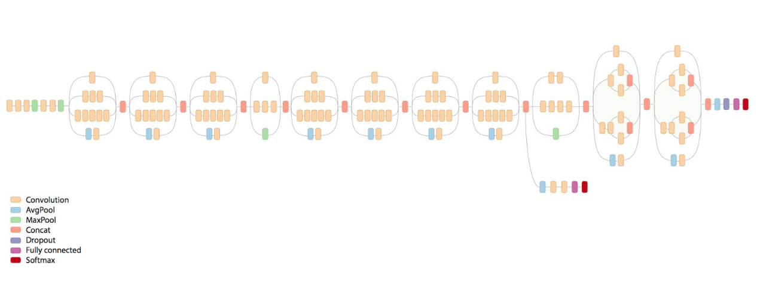

Neural network architecture of Inception V3

Result

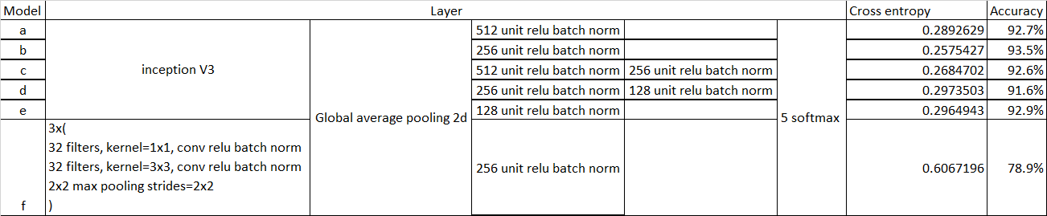

Model f uses a shallow convolution neural network and achieves 78.9% accuracy, it shows most of features can be captured by convolution layers and image preprocessing.

Models which use inceptionV3 only have a small difference in accuracy. Model b performs the best in validation set with accuracy 93.5%. Model b is selected to predict the test data.

In the confusion matrix of model b, we can see that the positive predicted value is worst for class 4(tulips). The prediction of class 4 is mixed with other classes.

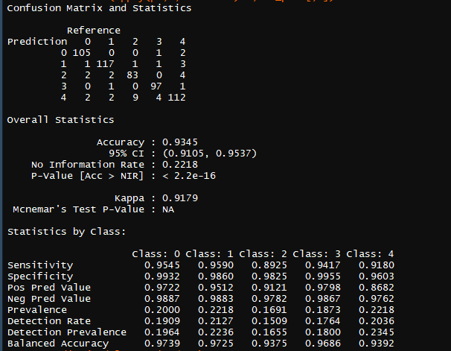

Reference:

1. Szegedy, C., Vanhoucke, V., Ioffe, S., Shlens, J., & Wojna, Z. (2016). Rethinking the Inception Architecture for Computer Vision. *2016 IEEE Conference on Computer Vision and Pattern Recognition (CVPR)*. doi:10.1109/cvpr.2016.308