WORKSHEET 1: PMP Method Selection

Catchment Name……………………………………………..… Catchment Area ……………….
LONG DURATION PMP
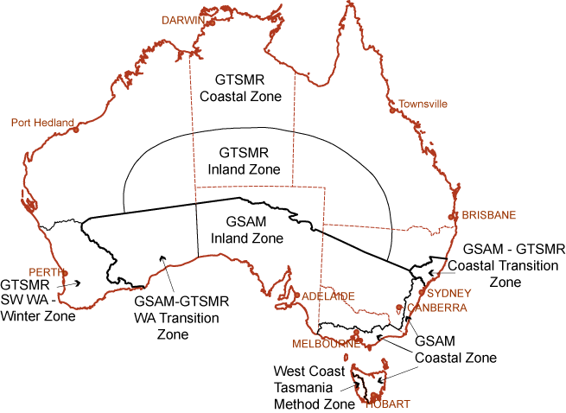  NB This diagram is available on the GTSMR Guide CD as:  ● \pmp_zones\pmp_zonesl.shp a GIS suitable shapefile and  - ● \documents\method_zones.pdf suitable for printing on A3 paper |  |  |  |  |  |  |  | CIRCLE THE ZONE IN WHICH THE CATCHMENT IS LOCATED:
 |  |  |  |  |  |  |  | GTSMR  (Coastal) |  |  | GTSMR  (Inland)
 |  |  |  |  |  |  |  | GTSMR  (Coastal & SWWA) |  |  | Coastal Transition  - GTSMR Coastal  - GSAM Coastal
 |  |  |  |  |  |  |  | GSAM  (Coastal) |  |  | WA Transition  - GTSMR Coastal  - GSAM Inland
 |  |  |  |  |  |  |  | GSAM  (Inland) |  |  | WCTas
SHORT DURATION PMP (GSDM)
Is the catchment less than 500km² and south of 30°S?  Is the catchment less than 1000km²?  NO  NO  YES  YES |  |  |  |  | Short duration PMP estimates cannot be calculated for the catchment.  PMP estimates can be calculated using the GSDM for this catchment. Use \pmp_zones\gsdm_limits.shp to establish the duration limit.  PMP estimates can be calculated using the GSDM for this catchment and can include seasonal estimates. Use \pmp_zones\gsdm_limits.shp to establish the duration limit.
PMP METHOD SUMMARY
Fill in the table below with the PMP method/s applicable to the catchment, referring to Table 1.1 for any additional information needed. NB: for the Transition zones, write separate entries for GTSMR and GSAM.
 | METHOD |  | ZONE |  |  | SEASON |  |  | DURATIONS
 | eg GSAM |  | Coastal |  |  | Annual |  |  | 24-96 hours
 | eg GSDM |  | 6 hours |  |  | Annual |  |  | 1-6 hours
WHAT NEXT?
GSAM: |  | Calculate the PMP estimates for the catchment following the procedures in this guide.
GSDM: |  | Calculate the PMP estimates for up to 6 hours following the GSDM guidebook  (Bureau of Meteorology, 2003) (http://www.bom.gov.au/hydro/has/gsdm_document.shtml).
GTSMR: |  | Calculate the PMP estimates for the catchment following the procedures in the GTSMR Guide CD (Bureau of Meteorology, 2004) (http://www.bom.gov.au/hydro/has/gtsmr_cd.shtml).
WCTas: |  | Contact the Hydrometeorological Advisory Service, Bureau of Meteorology.

