# C:\Users\Messom\Desktop\Monash.jpg

# FIT5042 C/D/HD Design Report (Major Tasks)

# Save Native Animals

Jaimon Thyparambil Thomas : 29566428

**Contents Page**

**Your design report must include the following:**

**Credit Level**

1. Overview of your application's goals
2. User stories
3. Functional diagram
4. Usability Design Review
5. Checklist of site functionality.

**Additional Distinction Level (the above and the following)**

1. Entity Relation Diagram
2. Data dictionary

**Additional High Distinction Level (the above and the following)**

1. Development Methodology
2. Versioning

**Your design report must include the following:**

**Credit Level**

1. **Overview**

Save Native Animals is a Web App created by LocalHeritage Pty Ltd an Australian Local Indigenous Heritage Non-Governmental Organisation (NGO). In this App heritage workers will document details regarding all the native animals of various regions across the world. In this App workers will also be able to add upcoming events for native animals in any region. They will also be able to specify the sponsor for the events. This web app aims to solve the problem of data collection and management of data collected by the Heritage workers regarding the Native animals.

Save Native Animals Web App allows:

* Users to add information regarding regions, native animals, events and sponsors.
* Users will be able to do advanced search related to native animals.
* Workers will be able to add/edit/delete regions, native animals, events, sponsors and users.
* Workers will also be able to edit/delete other user’s entries.
* Workers will also be able to o advanced search related to native animals.

1. **User stories**

The following are the user stories implemented:

* As a user, I would like to add new information regarding native animals across the world. So that the NGO will be able to function better.
* As a user, I would like to add new information regarding any region. So that it can be used for later purpose by the NGO.
* As a user, I would like to add information regarding any upcoming events related to native animals and details related to its sponsors so that NGO and public can learn about that information.
* As a user, I would like to view all information regarding animals, regions, events and sponsors so that I am up-to-date regarding the information and be able to make any actions if necessary.
* As a worker, I would like to be able to do all the process that normal users are able to do. So that the NGO ca function better.
* As a worker, I should be able to edit existing information added by any user so that all the information in the web app is up-to-date.
* As a worker, I should be able to remove any unwanted information from the Web App.
* As a worker, I should be able to add new public users and admins, so that I can have more people collecting and managing data.
* As a worker I would like to edit existing user information’s, so that all information regarding the user is up-to-date.
* As a worker I would like to delete existing users, so that our Web App will only have active users.

1. **Functional diagram**

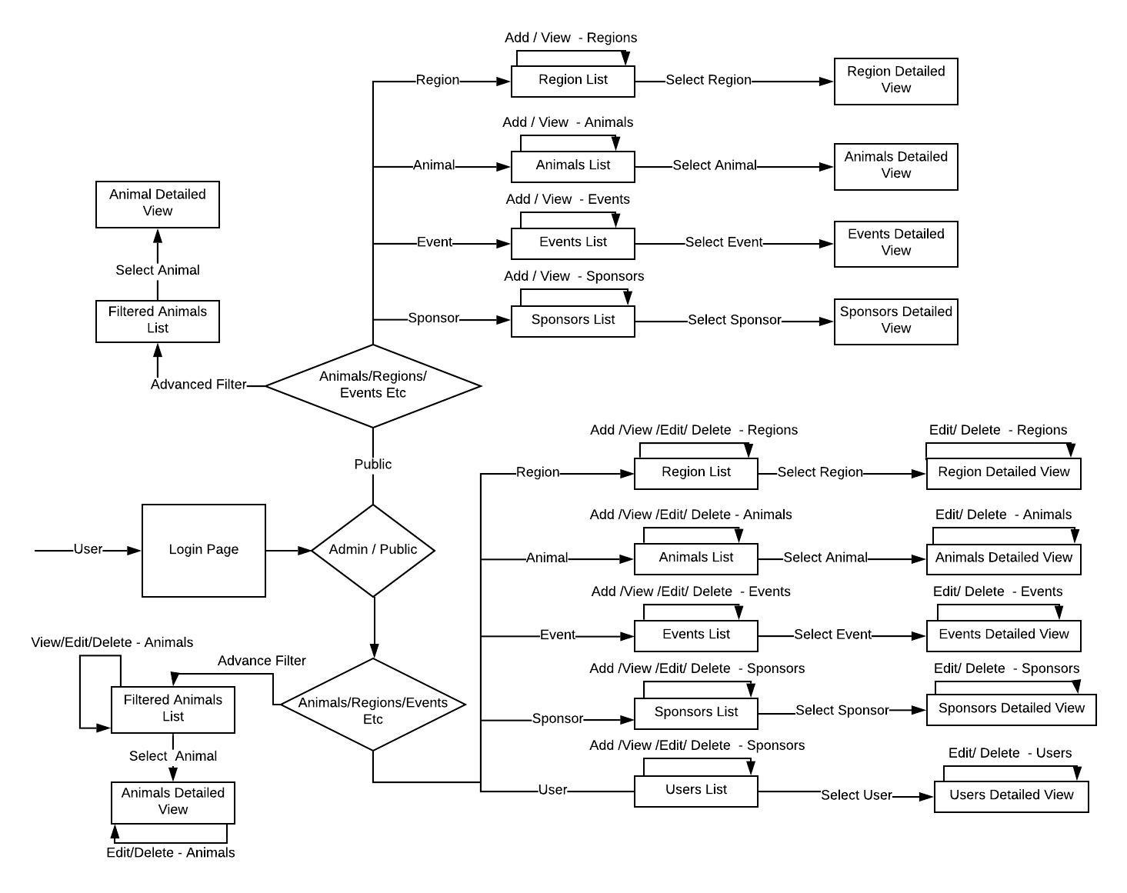

1. **Usability Design Review**

* Navigation
  + Save Native Animals app provides navigation tabs through which users can navigate to desired pages easily like animals, regions etc.
* Familiarity
  + Save Native Animals app maintains usual conventions like keeping logout button on the top right corner
  + Forms are filled in the usual manner by providing familiar buttons like add, delete etc.
  + Error Messages, validations and action buttons are same across all the pages which increases the familiarity in using the app.
* Consistency
  + Consistency is maintained throughout the app that is whenever any search or list tab is accessed always same data is shown.
  + Error Messages, validations and action buttons are same across all the pages which increases the consistency throughout the app.
* Error Prevention
  + Error prone situations are prevented both in the JSF pages as well as manage Beans. By providing proper error messages before any write to the database. Similarly input errors are checked in the JSF pages as well as manage beans.
* Feedback
  + Depending on users feedback information is provided like there will be a list page as well as a details page for all entities. When the user chooses a particular entity like animal, region etc its details page is displayed.
  + Similarly, whenever a mouse is hovered over any action button, the buttons are properly highlighted
* Visual Clarity
  + whenever a mouse is hovered over any action button, the buttons are properly highlighted providing more visual clarity.
  + Overall Application looks simple which makes it more user friendly
* Flexibility
  + Tab buttons can be used within the application to increase the efficiency of use within the application.

1. **Checklist of site functionality**

|  |  |
| --- | --- |
| **1. Credit Functionality** | **TICK**  **if complete** |
| The Web Application must be able to search results of at least two tables | Ticked |
| Results with tabular format with heading. | Ticked |
| Option to view the full details | Ticked |
| Validations in place | Ticked |
|  |  |
| **2. Distinction Functionality** |  |
| All users can: View | Ticked |
| Add | Ticked |
| Update | Ticked |
| Delete | Ticked |
| Workers can update / delete other users’ entries | Ticked |
| Implementation of validations for Dates, emails, phone numbers, two passwords same | Ticked |
|  |  |
| **3. High Distinction Functionality** |  |
| Search for data in tables using a combination of fields | Ticked |
| use of a RESTful Web Service in your application |  |
| Make use of some features from javaScript framework / Ajax | Ticked |
|  |  |
| **4. Technical Requirements** |  |
| **Credit** |  |
| JSF web clients | Ticked |
| Persistence API | Ticked |
| Application managed entity manager or container managed entity manager. | Ticked |
| JPQL to retrieve data | Ticked |
| **Distinction** |  |
| Web client is required | Ticked |
| BOTH Criteria API and JPQL | Ticked |
| Role based authentication (implemented using JAAS) | Ticked |
| Interaction between clients and database handled by EJBs | Ticked |
| **High Distinction** |  |
| use of a RESTful Web Service in your application |  |
| Use of JavaScript Frameworks / Ajax | Ticked |
| Ability of mapping inheritance to database must be demonstrated. |  |
| Bean validations used to validate data. |  |
| Consumption of web services conducted in EJBs. |  |
|  |  |
| **Audit** |  |
| No breaking of copyright |  |

1. **Entity Relation Diagram**

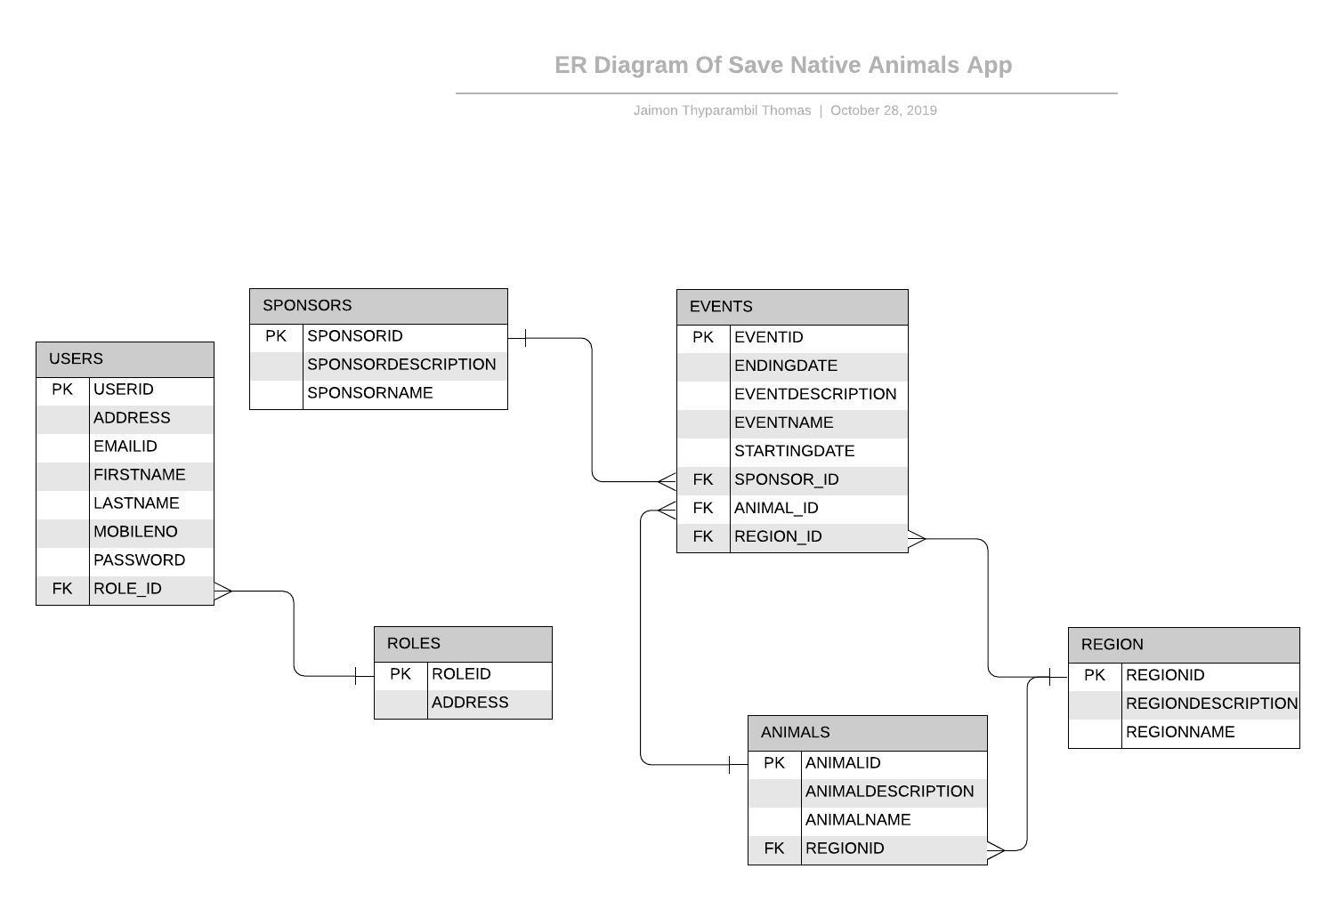

1. **Data dictionary**

|  |  |  |
| --- | --- | --- |
| USERS |  |  |
| USERID | INTEGER | Unique Identifier For Users Table, Primary Key |
| ADDRESS | VARCHAR | Address of User |
| EMAILID | VARCHAR | Email ID of User |
| FIRSTNAME | VARCHAR | First Name of User |
| LASTNAME | VARCHAR | Last Name of User |
| MOBILENO | VARCHAR | Mobile no of User |
| PASSWORD | VARCHAR | SHA-256 encrypted hash of User Password |
| ROLE_ID | INTEGER | Unique Identifier For Role Table, Foreign Key |

|  |  |  |
| --- | --- | --- |
| SPONSORS |  |  |
| SPONSORID | INTEGER | Unique Identifier For Sponsors Table, Primary Key |
| SPONSORDESCRIPTION | VARCHAR | Description of Sponsor |
| SPONSORNAME | VARCHAR | Name of Sponsor |

|  |  |  |
| --- | --- | --- |
| ROLES |  |  |
| ROLEID | INTEGER | Unique Identifier For Roles Table, Primary Key |
| ROLENAME | VARCHAR | Name of Role |

|  |  |  |
| --- | --- | --- |
| REGION |  |  |
| REGIONID | INTEGER | Unique Identifier For Region Table, Primary Key |
| REGIONDESCRIPTION | VARCHAR | Description of Region |
| REGIONNAME | VARCHAR | Name of Region |

|  |  |  |
| --- | --- | --- |
| EVENTS |  |  |
| EVENTID | INTEGER | Unique Identifier For Events Table, Primary Key |
| ENDINGDATE | TIMESTAMP | Starting Date of Event |
| EVENTDESCRIPTION | VARCHAR | Description of event |
| EVENTNAME | VARCHAR | Name of Event |
| STARTINGDATE | TIMESTAMP | Ending Date of Event |
| SPONSOR_ID | INTEGER | Unique Identifier For Sponsors Table, Foreign Key |
| ANIMAL_ID | INTEGER | Unique Identifier For Animal Table, Foreign Key |
| REGION_ID | INTEGER | Unique Identifier For Region Table, Foreign Key |

|  |  |  |
| --- | --- | --- |
| ANIMAL |  |  |
| ANIMALID | INTEGER | Unique Identifier For Animal Table, Primary Key |
| ANIMALDESCRIPTION | VARCHAR | Description of Animal |
| ANIMALNAME | VARCHAR | Name of Animal |
| REGION_ID | INTEGER | Unique Identifier For Region Table, Foreign Key |

1. **Development Methodology**
2. **Versioning**

|  |  |  |
| --- | --- | --- |
| Version No | Changes Made | Date |
| 1 | Initial Draft | 28th October 2019 |