REPORT BEFORE IMAGE AUGMENTATION AND ENHANCEMENT
First scratch CNN with FC of 128 parameters, image size = (224,224), AdaptiveAvgPool2d((1, 1)), No AMP just CPU, no cached image
 | Model | Accuracy | Balanced Accuracy | Macro Precision | Macro Recall | Macro F1 | Log Loss
0 | EFFicientNetB0 | 0.7026 | 0.6585 | 0.5328 | 0.6585 | 0.5588 | 0.8151
1 | CNN | 0.6627 | 0.6411 | 0.4488 | 0.6411 | 0.5024 | 0.8619
2 | Random Forest | 0.6597 | 0.4051 | 0.3914 | 0.4051 | 0.3871 | 0.9001
3 | LSTM | 0.5220 | 0.5280 | 0.3604 | 0.5280 | 0.3701 | 1.2098
4 | Logistic Regression | 0.5569 | 0.4805 | 0.3285 | 0.4805 | 0.3535 | 1.3619
5 | Majority Baseline | 0.6697 | 0.1429 | 0.0957 | 0.1429 | 0.1146 | 11.9066
Training history
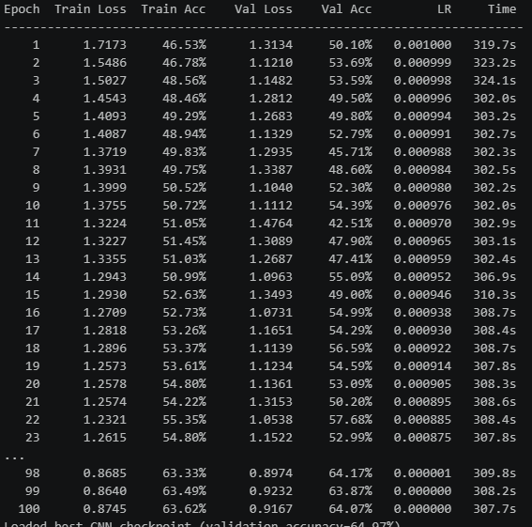
Classification report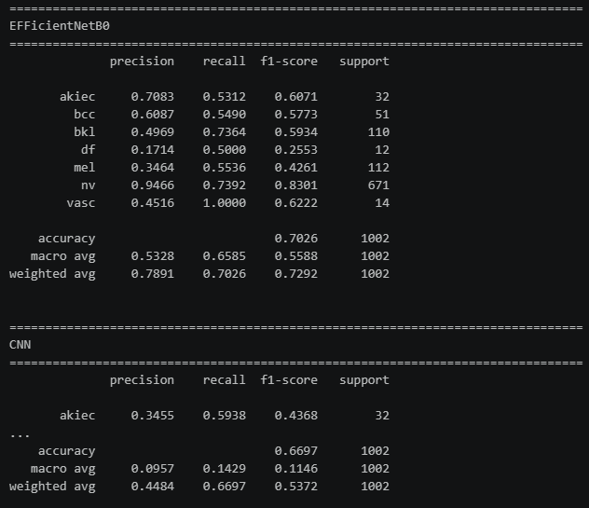

Scratch CNN confusion matrix
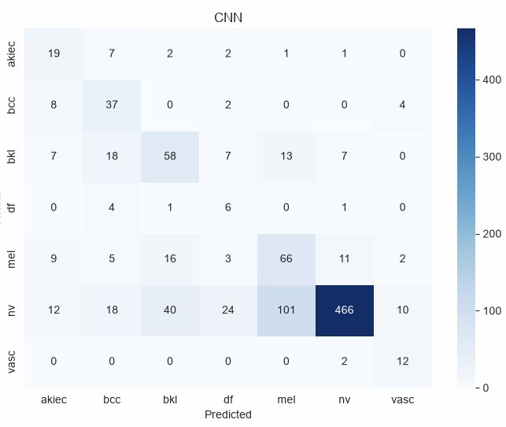

CNN Training Curve
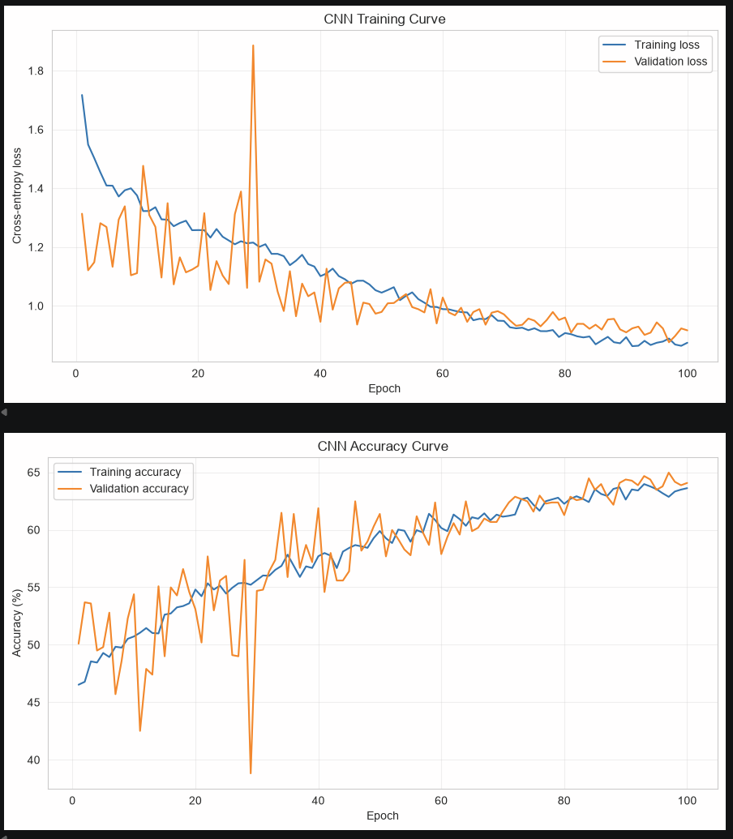

EffnetB0 confusion matrix
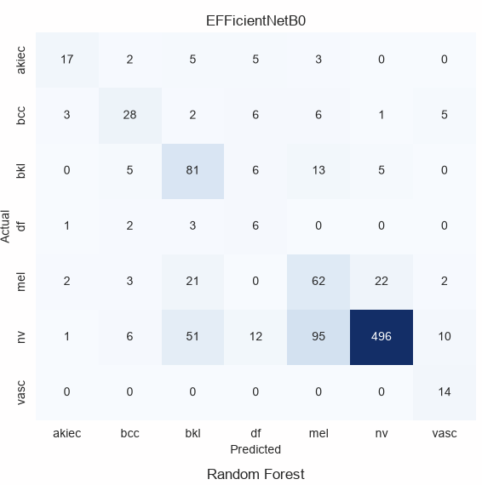

ROC Curve
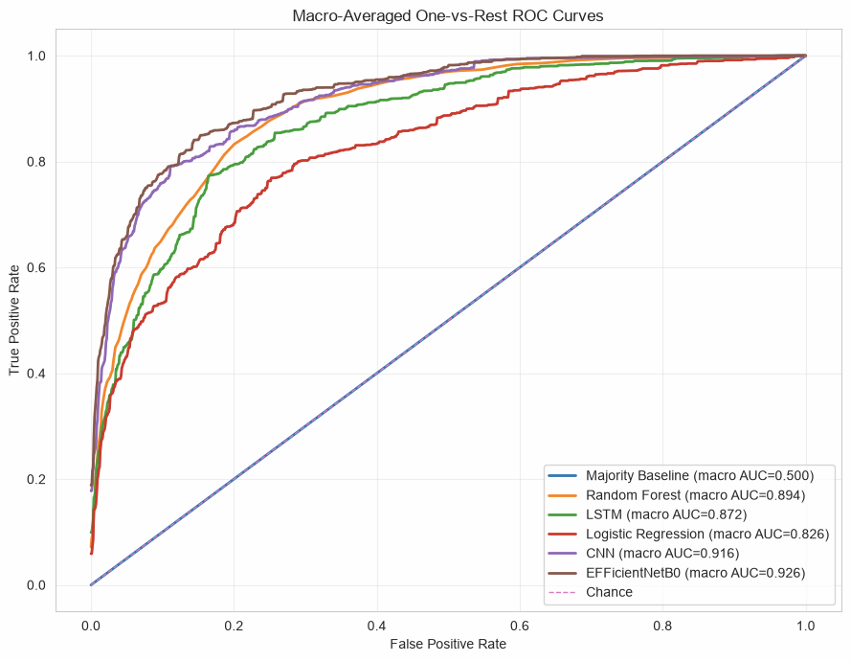

Second scratch CNN with FC of 2048 parameters, image size = (224,224), AdaptiveAvgPool2d((1, 1)) with AMP and cached image
 | Model | Accuracy | Balanced Accuracy | Macro Precision | Macro Recall | Macro F1 | Log Loss
0 | EFFicientNetB0 | 0.7036 | 0.6458 | 0.5453 | 0.6458 | 0.5638 | 0.7919
1 | CNN | 0.6437 | 0.6327 | 0.4388 | 0.6327 | 0.4932 | 0.9207
2 | LSTM | 0.5469 | 0.5639 | 0.3803 | 0.5639 | 0.4113 | 1.1116
3 | Random Forest | 0.6597 | 0.4051 | 0.3914 | 0.4051 | 0.3871 | 0.9001
4 | Logistic Regression | 0.5569 | 0.4805 | 0.3285 | 0.4805 | 0.3535 | 1.3619
5 | Majority Baseline | 0.6697 | 0.1429 | 0.0957 | 0.1429 | 0.1146 | 11.9066
Training history
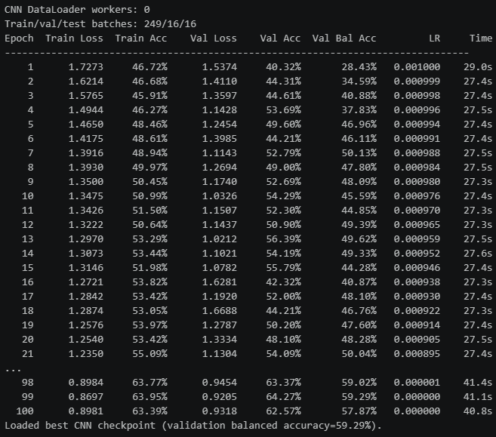
Classification Report
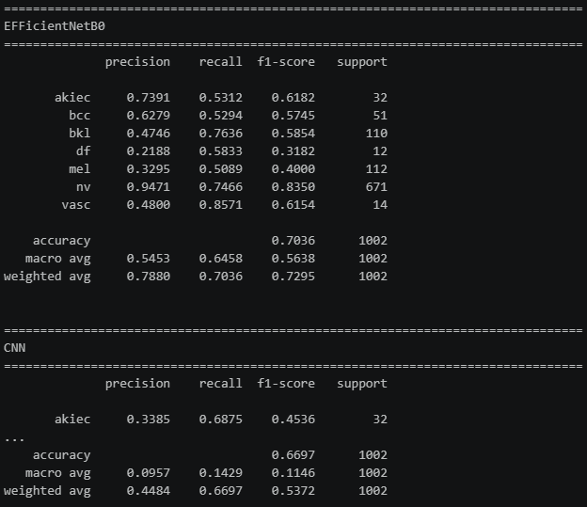

Scratch CNN Confusion Matrix
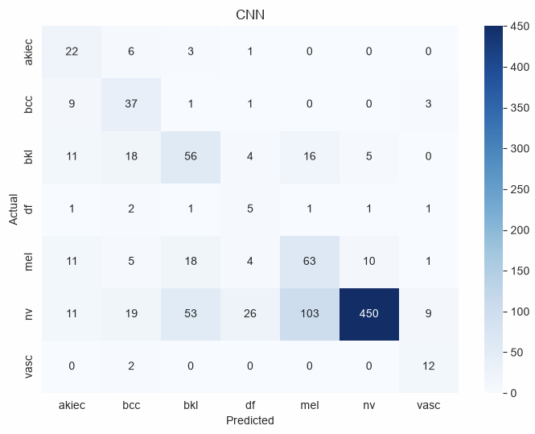

CNN training/accuracy curve
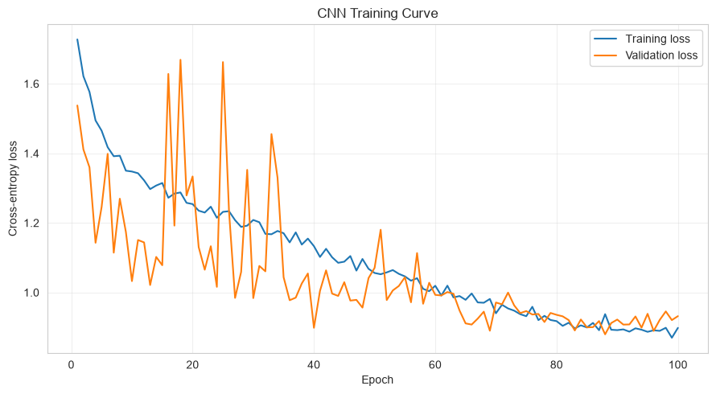
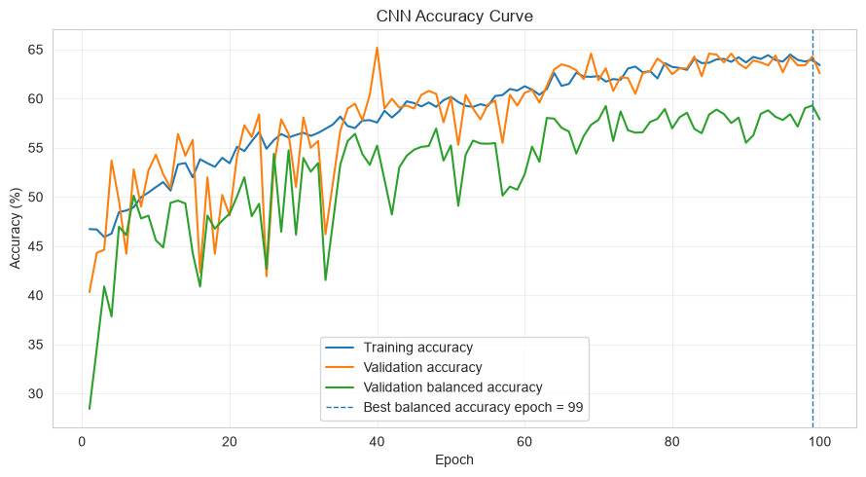

EffnetB0 confusion matrix
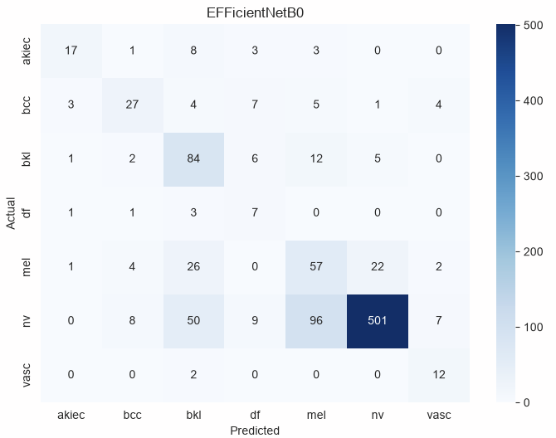

ROC Curve
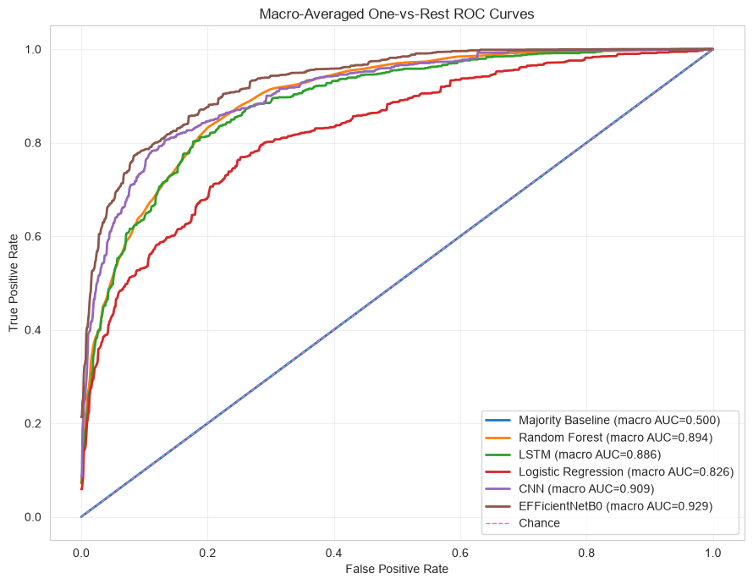
Third scratch CNN with FC of 500k parameters, image size = (224,224), AdaptiveAvgPool2d((4, 4)) with AMP
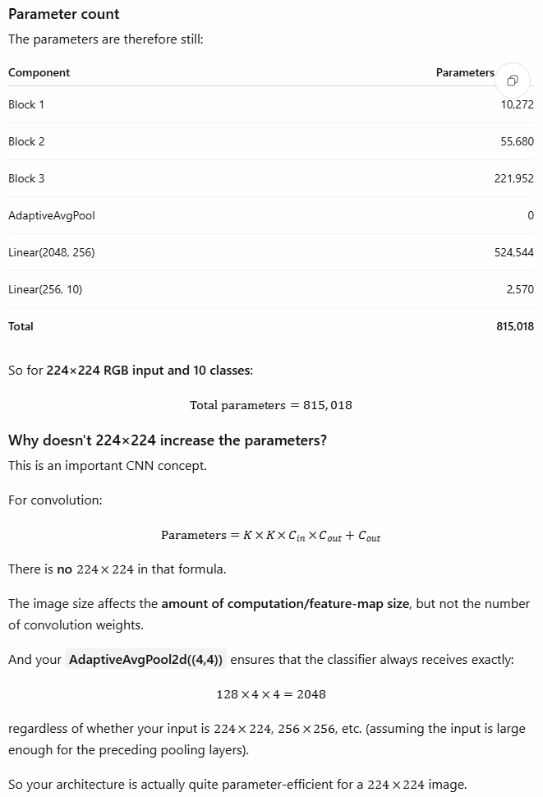
 | Model | Accuracy | Balanced Accuracy | Macro Precision | Macro Recall | Macro F1 | Log Loss
0 | EFFicientNetB0 | 0.6806 | 0.6359 | 0.4923 | 0.6359 | 0.5163 | 0.8849
1 | CNN | 0.6597 | 0.5815 | 0.4539 | 0.5815 | 0.4953 | 0.9037
2 | LSTM | 0.5469 | 0.5639 | 0.3803 | 0.5639 | 0.4113 | 1.1116
3 | Random Forest | 0.6597 | 0.4051 | 0.3914 | 0.4051 | 0.3871 | 0.9001
4 | Logistic Regression | 0.5569 | 0.4805 | 0.3285 | 0.4805 | 0.3535 | 1.3619
5 | Majority Baseline | 0.6697 | 0.1429 | 0.0957 | 0.1429 | 0.1146 | 11.9066
Training history
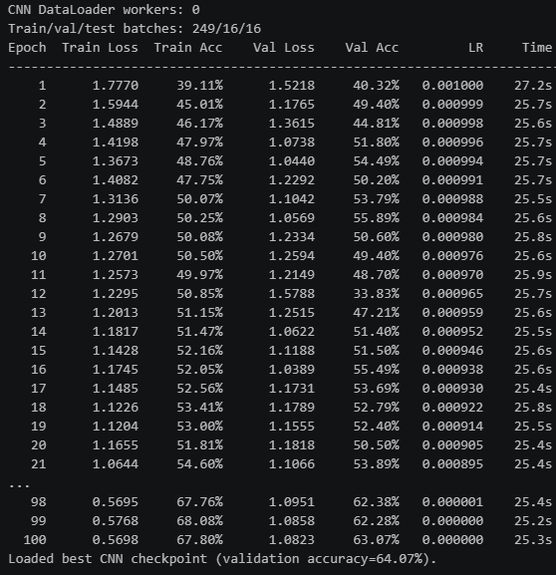
Classification Report
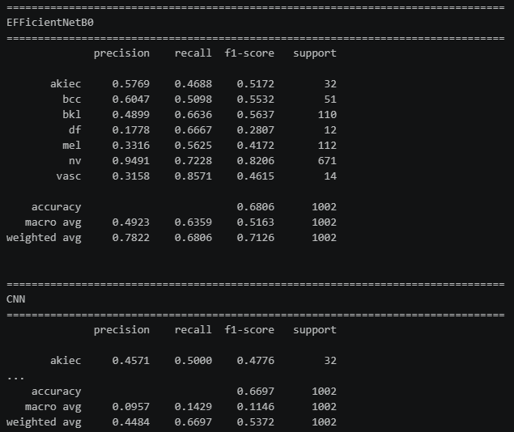

Scratch CNN confusion matrix
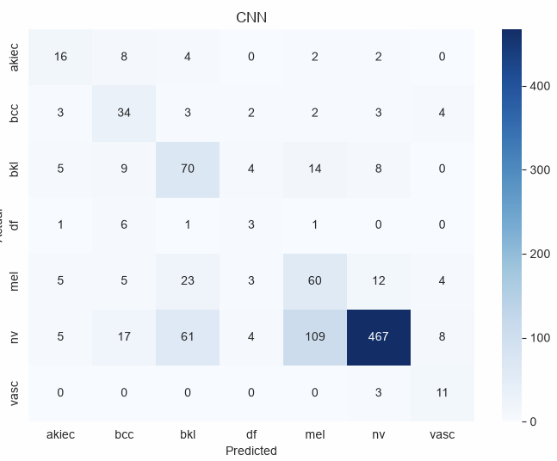

CNN training/accuracy curve
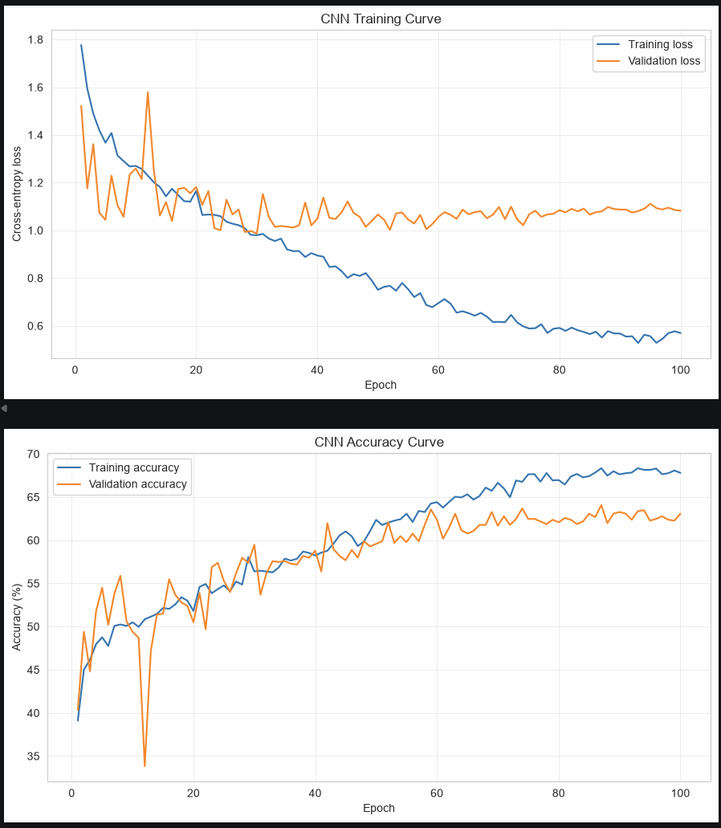

EffnetB0 confusion matrix
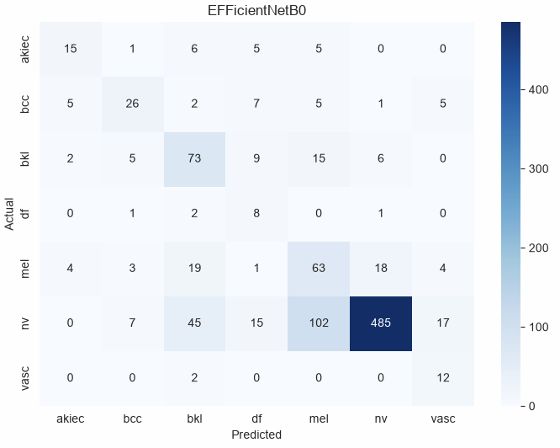

ROC Curve
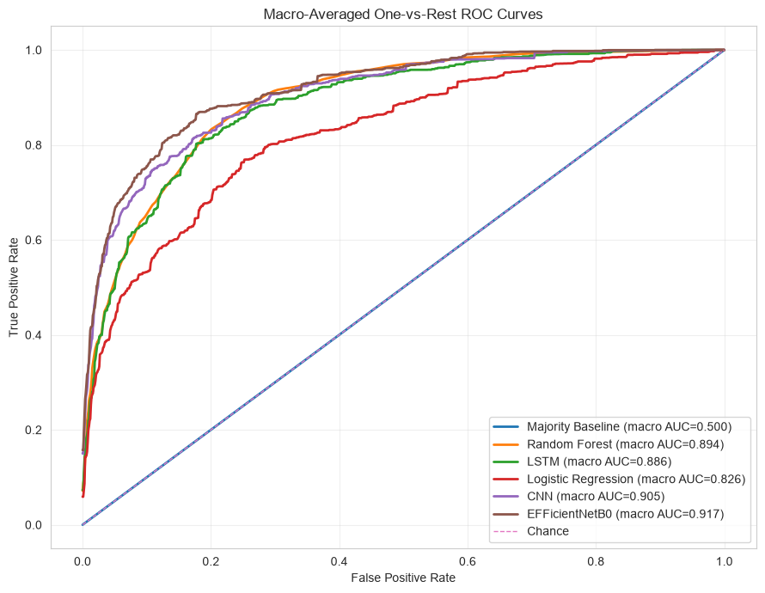

RESULT AFTER IMAGE AUGMENTATION AND ENHANCEMENT KEEP OLD ARCHITECTURE
 | Model | Accuracy | Balanced Accuracy | Macro Precision | Macro Recall | Macro F1 | Log Loss
0 | EFFicientNetB0 | 0.7136 | 0.6206 | 0.4955 | 0.6206 | 0.5176 | 0.8089
1 | CNN | 0.6387 | 0.6130 | 0.4618 | 0.6130 | 0.4932 | 0.9035
2 | Random Forest | 0.6597 | 0.4051 | 0.3914 | 0.4051 | 0.3871 | 0.9001
3 | LSTM | 0.5299 | 0.5422 | 0.3590 | 0.5422 | 0.3853 | 1.1310
4 | Logistic Regression | 0.5569 | 0.4805 | 0.3285 | 0.4805 | 0.3535 | 1.3619
5 | Majority Baseline | 0.6697 | 0.1429 | 0.0957 | 0.1429 | 0.1146 | 11.9066
Training history
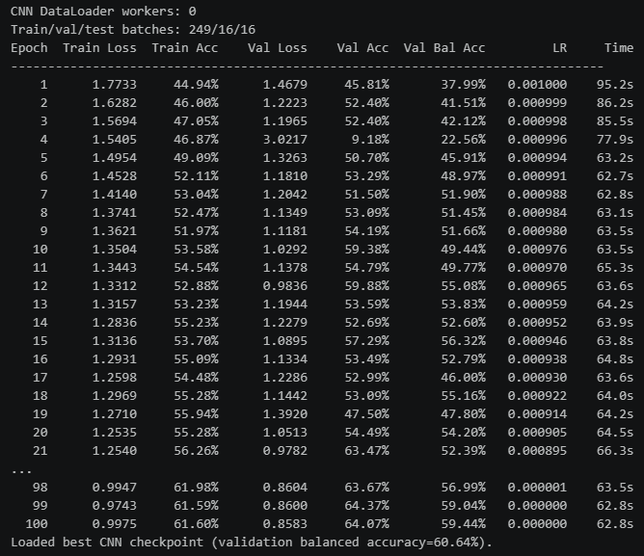
Classification Report
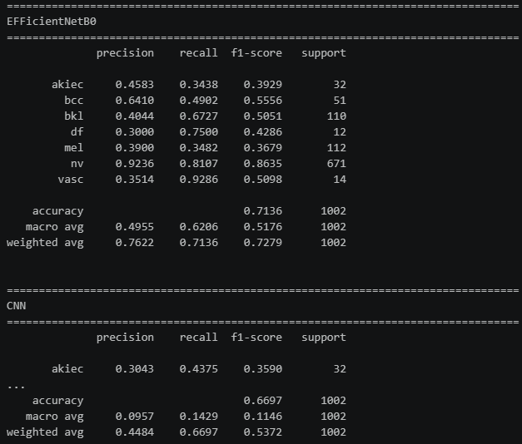

Scratch CNN confusion matrix
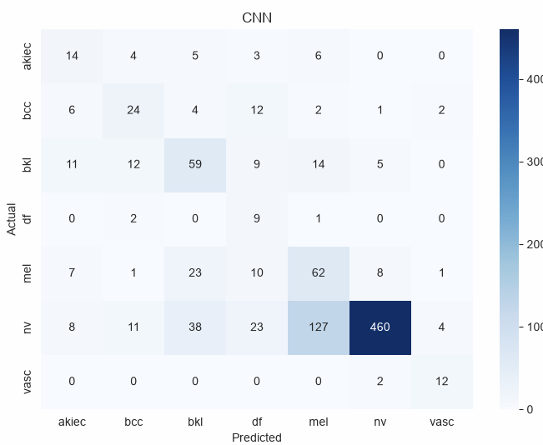

CNN training/accuracy curve
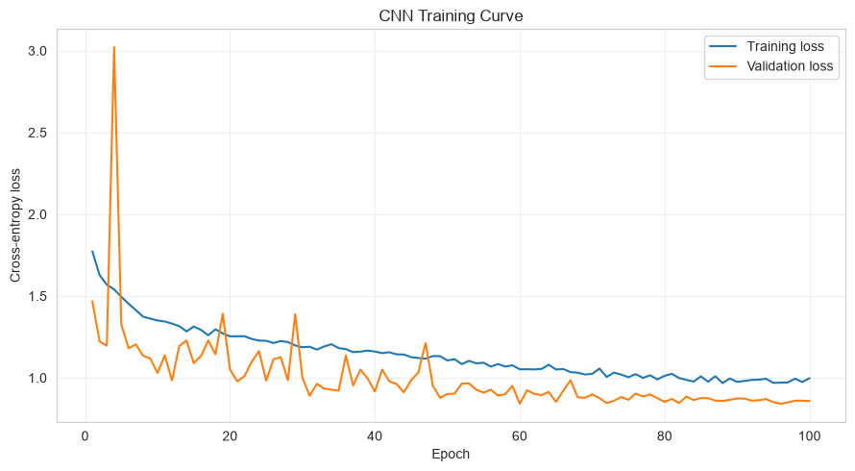
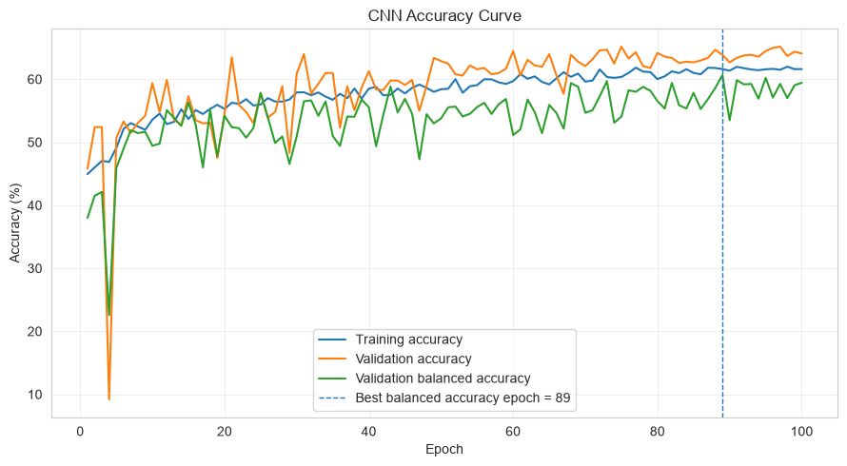
EffnetB0 confusion matrix
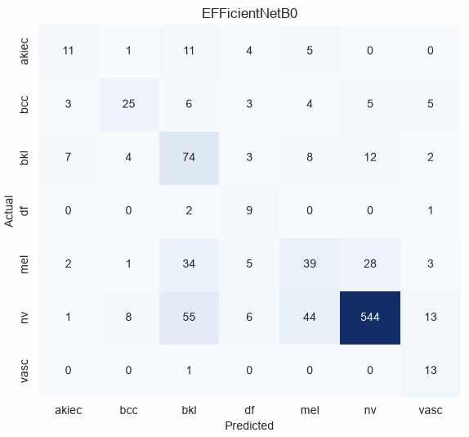

EfficientB0 Curve
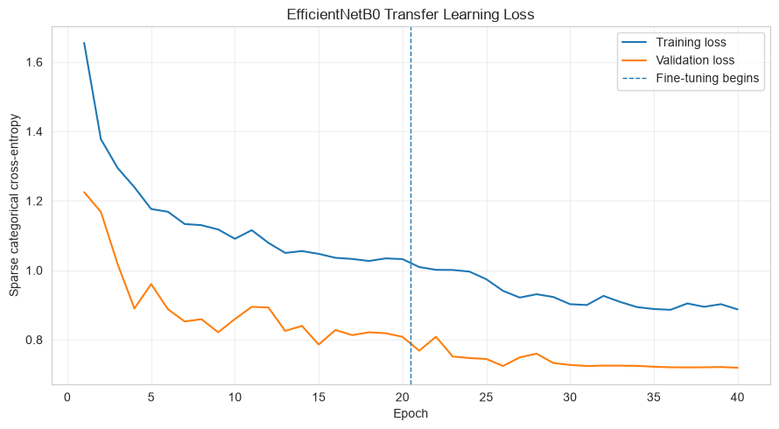
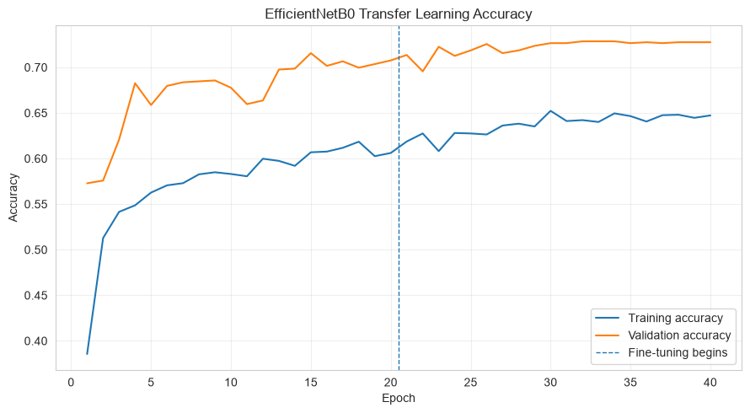

ROC Curve
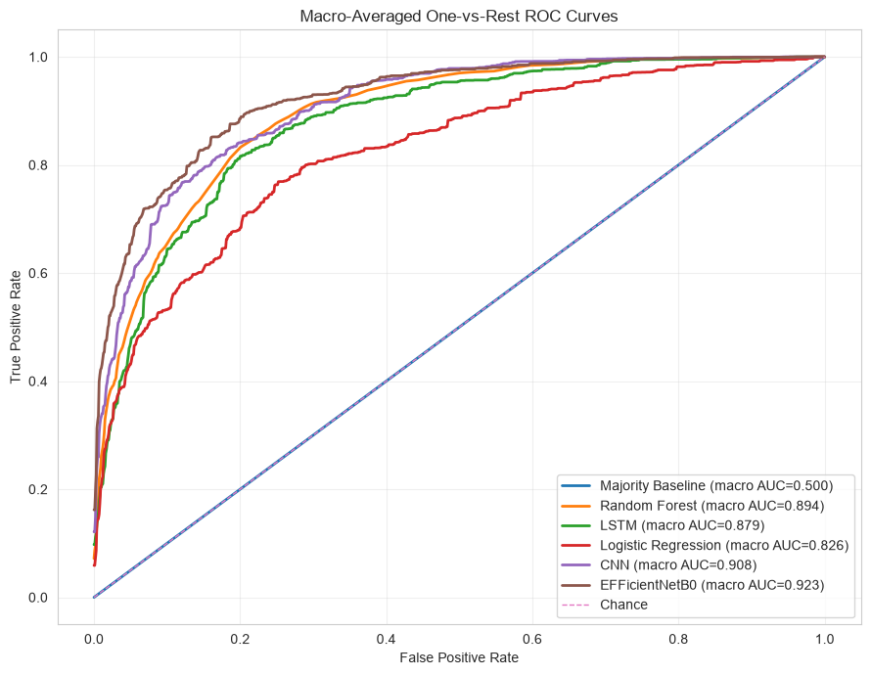

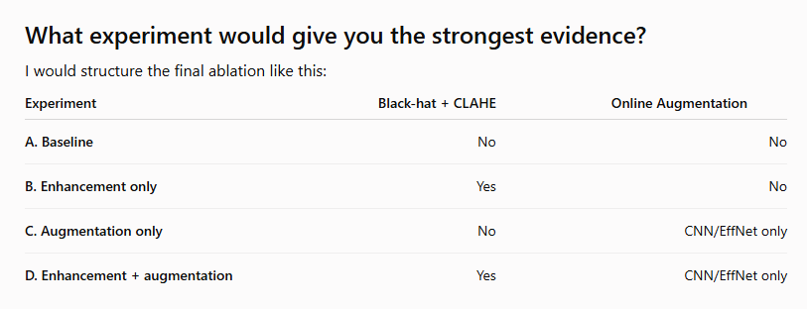

A. Baseline: eda_processing_split_1st_ver_wo_cached_img
 | Model | Accuracy | Balanced Accuracy | Macro Precision | Macro Recall | Macro F1 | Log Loss
0 | EFFicientNetB0 | 0.7026 | 0.6585 | 0.5328 | 0.6585 | 0.5588 | 0.8151
1 | CNN | 0.6627 | 0.6411 | 0.4488 | 0.6411 | 0.5024 | 0.8619
2 | Random Forest | 0.6597 | 0.4051 | 0.3914 | 0.4051 | 0.3871 | 0.9001
3 | LSTM | 0.5220 | 0.5280 | 0.3604 | 0.5280 | 0.3701 | 1.2098
4 | Logistic Regression | 0.5569 | 0.4805 | 0.3285 | 0.4805 | 0.3535 | 1.3619
5 | Majority Baseline | 0.6697 | 0.1429 | 0.0957 | 0.1429 | 0.1146 | 11.9066
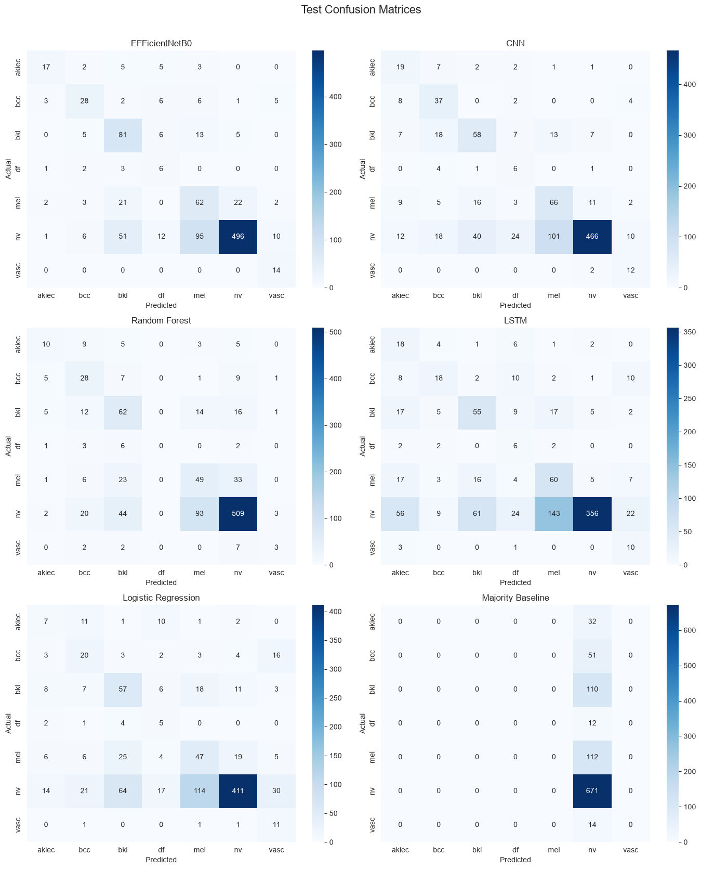
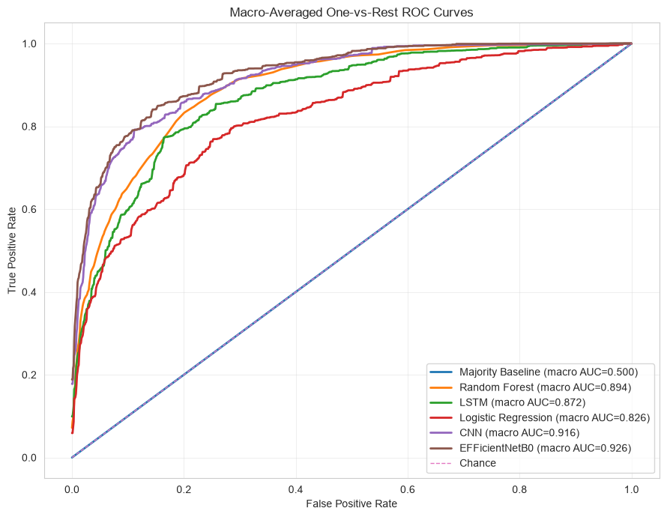
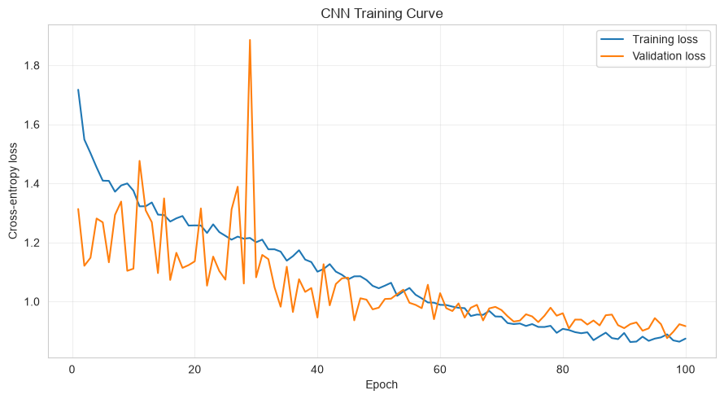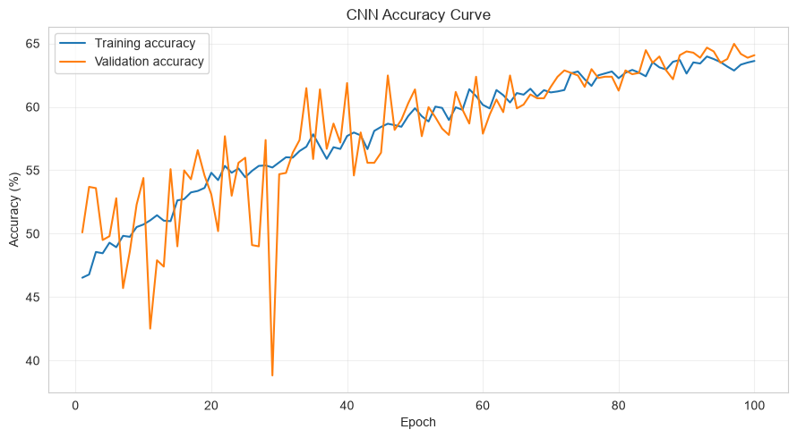
B. Enhancement only

C. Augmentation only
D. Enhancement + Augmentation: eda_processing_split_latest_1x1_w_enh_aug
 | Model | Accuracy | Balanced Accuracy | Macro Precision | Macro Recall | Macro F1 | Log Loss
0 | EFFicientNetB0 | 0.7136 | 0.6206 | 0.4955 | 0.6206 | 0.5176 | 0.8089
1 | CNN | 0.6387 | 0.6130 | 0.4618 | 0.6130 | 0.4932 | 0.9035
2 | Random Forest | 0.6597 | 0.4051 | 0.3914 | 0.4051 | 0.3871 | 0.9001
3 | LSTM | 0.5299 | 0.5422 | 0.3590 | 0.5422 | 0.3853 | 1.1310
4 | Logistic Regression | 0.5569 | 0.4805 | 0.3285 | 0.4805 | 0.3535 | 1.3619
5 | Majority Baseline | 0.6697 | 0.1429 | 0.0957 | 0.1429 | 0.1146 | 11.9066

