Run gameui.java under Gameui package. This image would occur. You would notice this is not a static image by clicking on the white piece and the piece’s color would change a little when pressed.

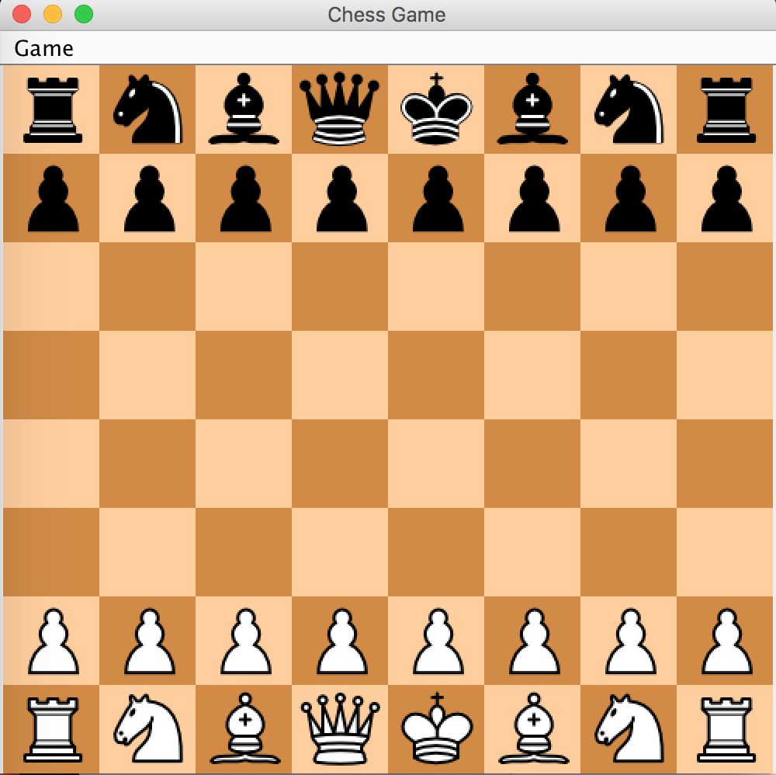

If you click Game, there would be a column pop up where restart is available. Like below, and if you click on restart, a window would pop up that says “I was clicked by restart”

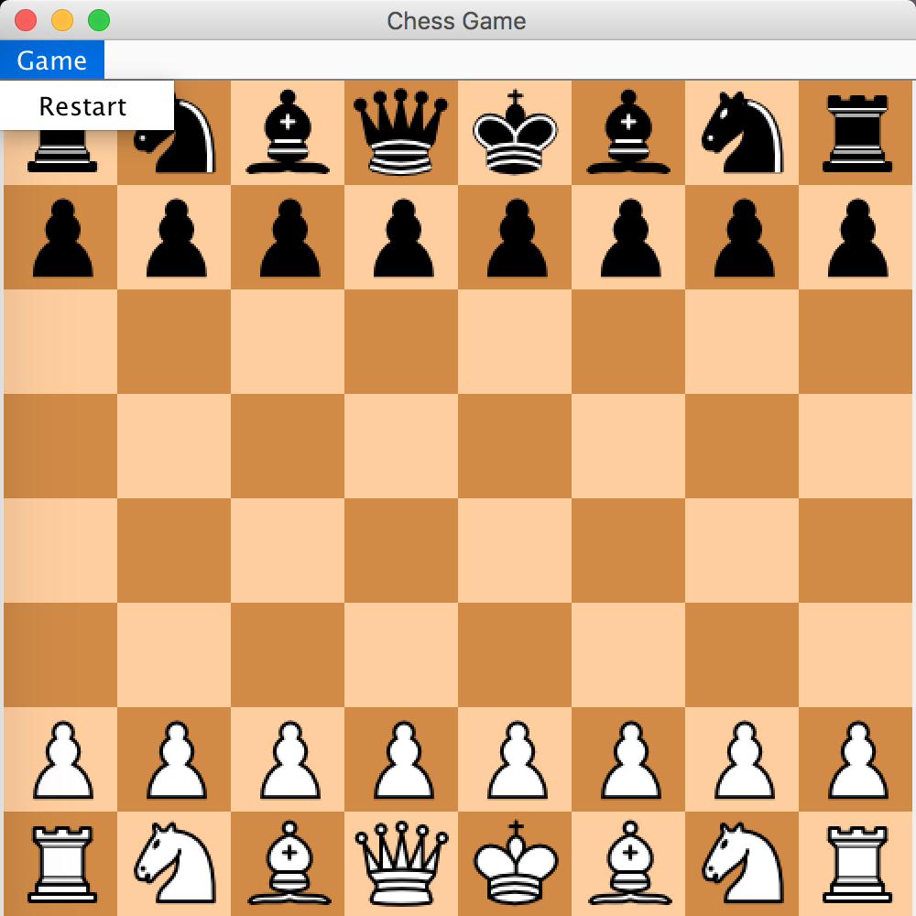

Menu:

Part1: Message for interaction

Part2: Game Menu bar functionality

Part3: Player Menu bar functionality

Part1:

After Gameui() is run, this window would pop up

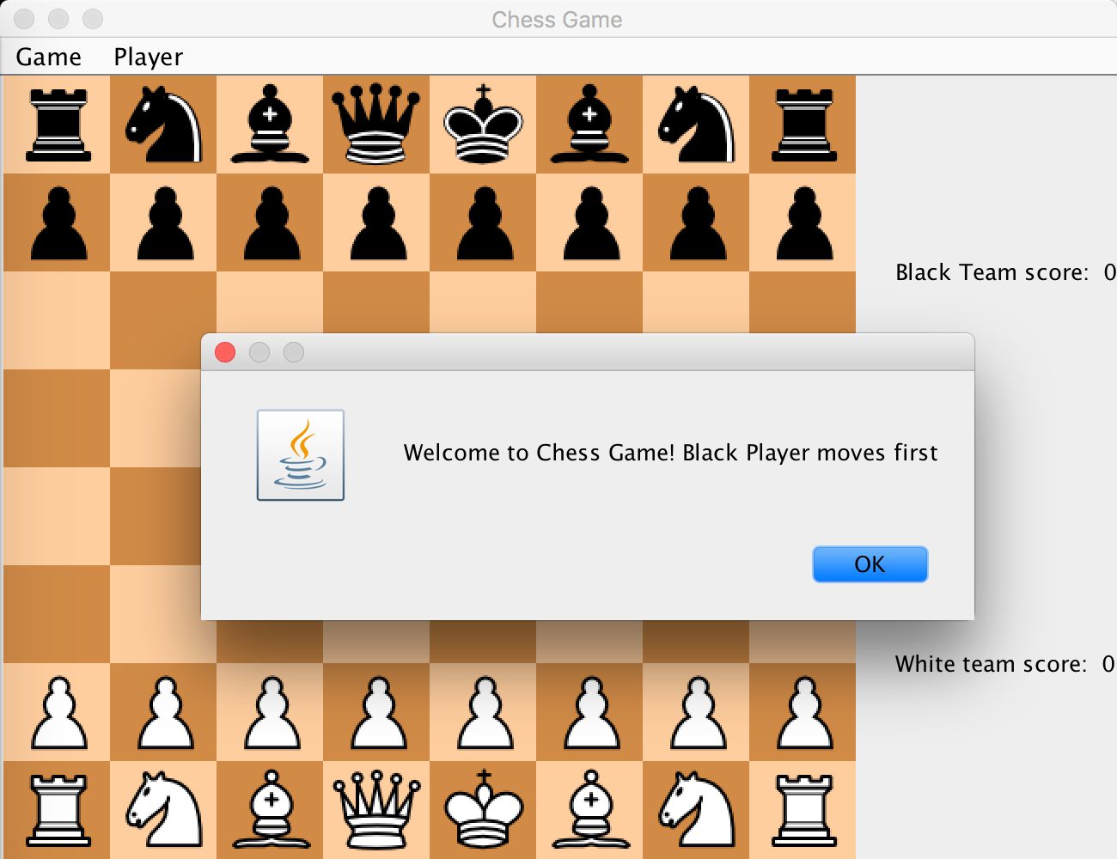

It welcomes the user and informs that black chess moves first.

Then for every chess clicked, possible moves for the selected piece will be colored as white.

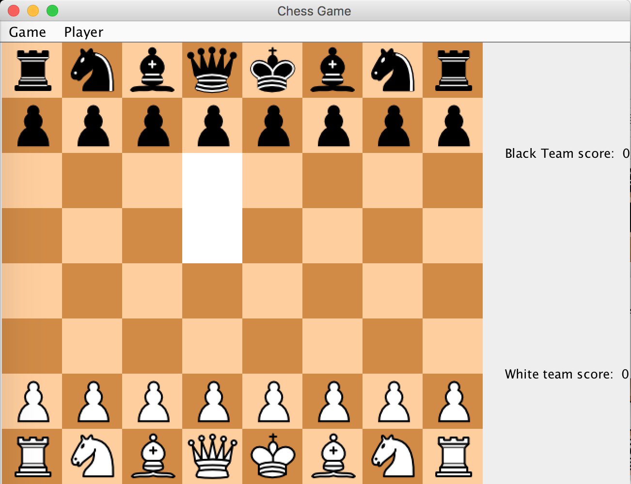

Black team and white team will alternate to move. When its white team’s turn if user select a block that does not have any white piece. This message will show up to indicate now it is white team’s turn.

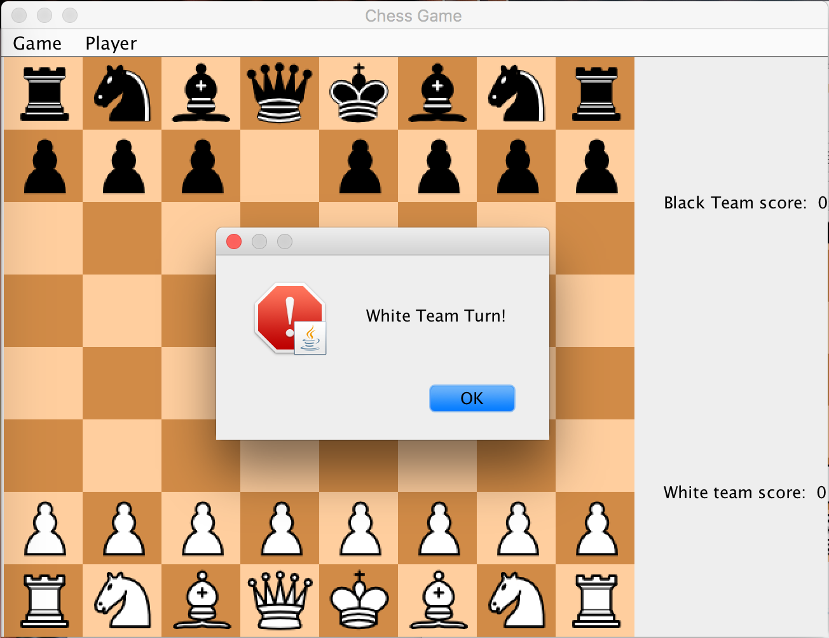

If one side’s king is checked this message will show up

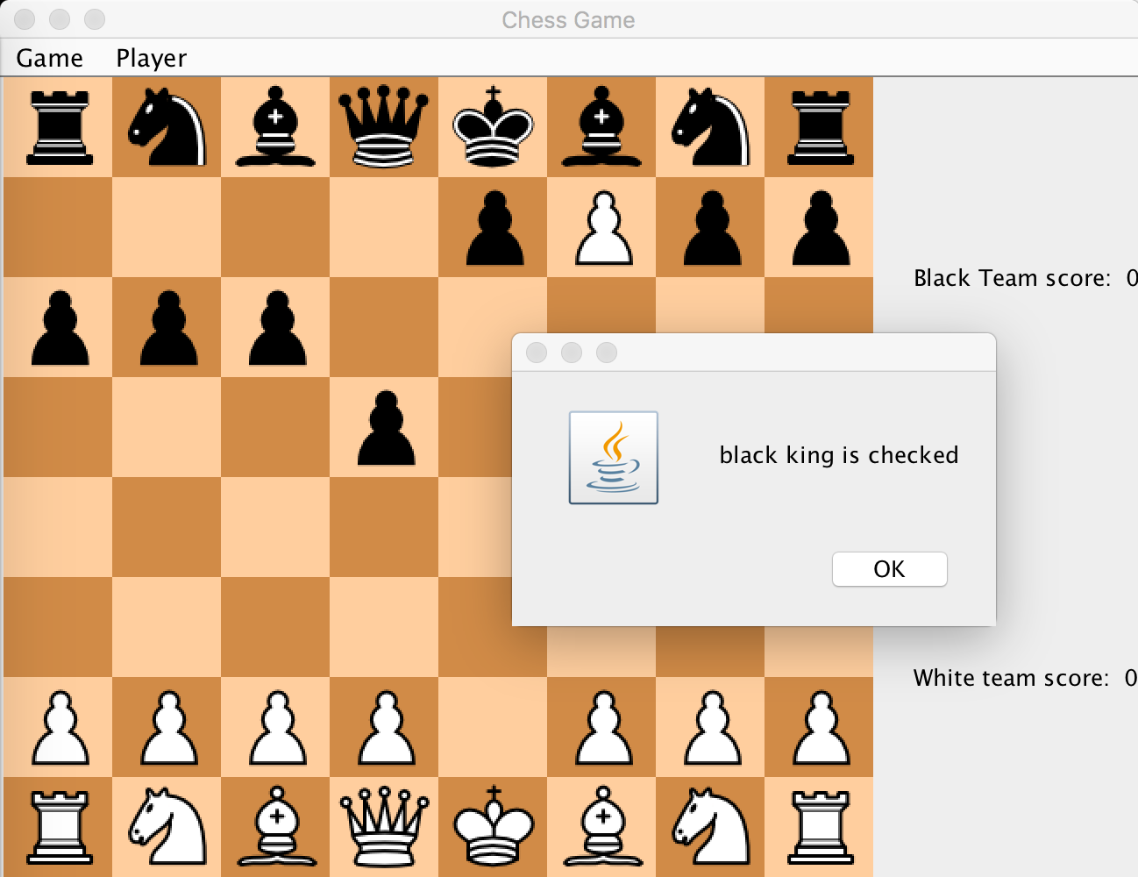

And if you choose to move pieces that will not get king out of check state. This message will show up to indicate it is a illegal move.

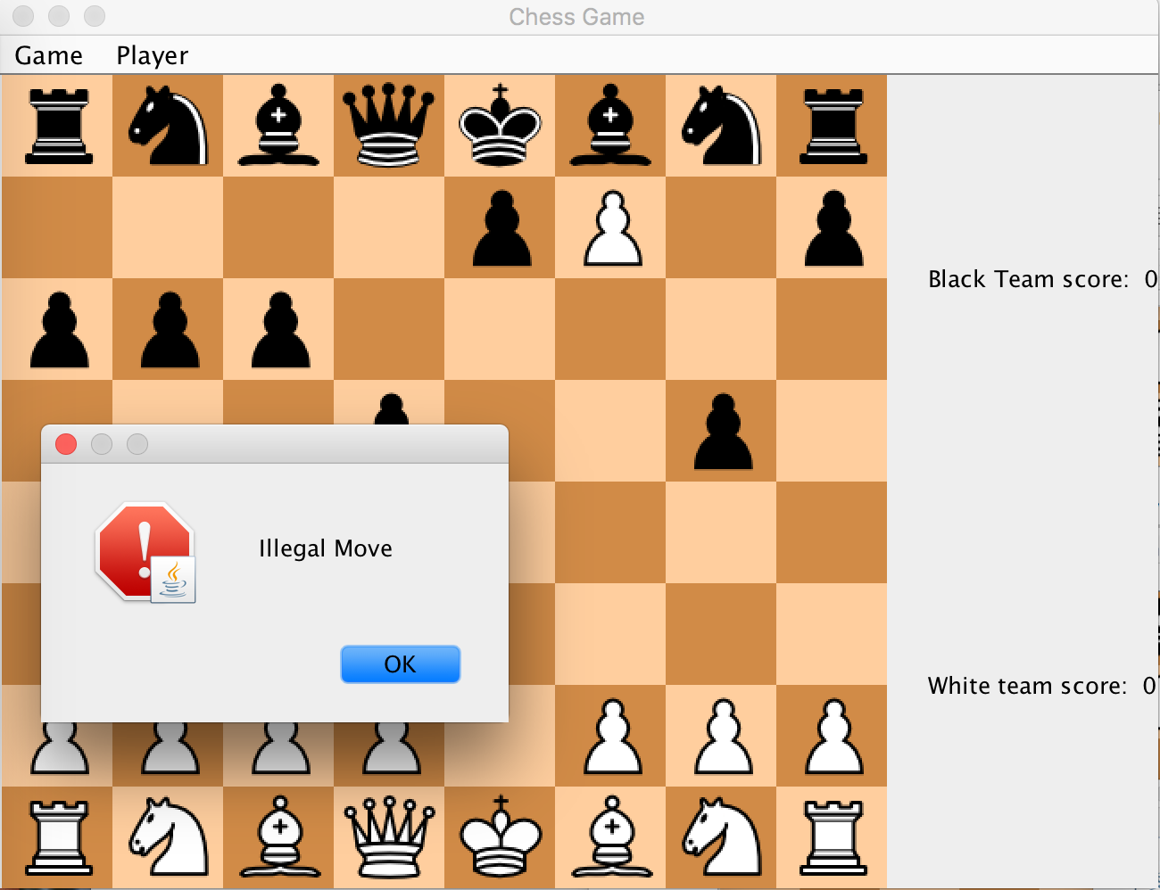

After ok is clicked, the board will undo to its previous state.

For checkmate, this message will show up to and then add 1 point to the winning side.

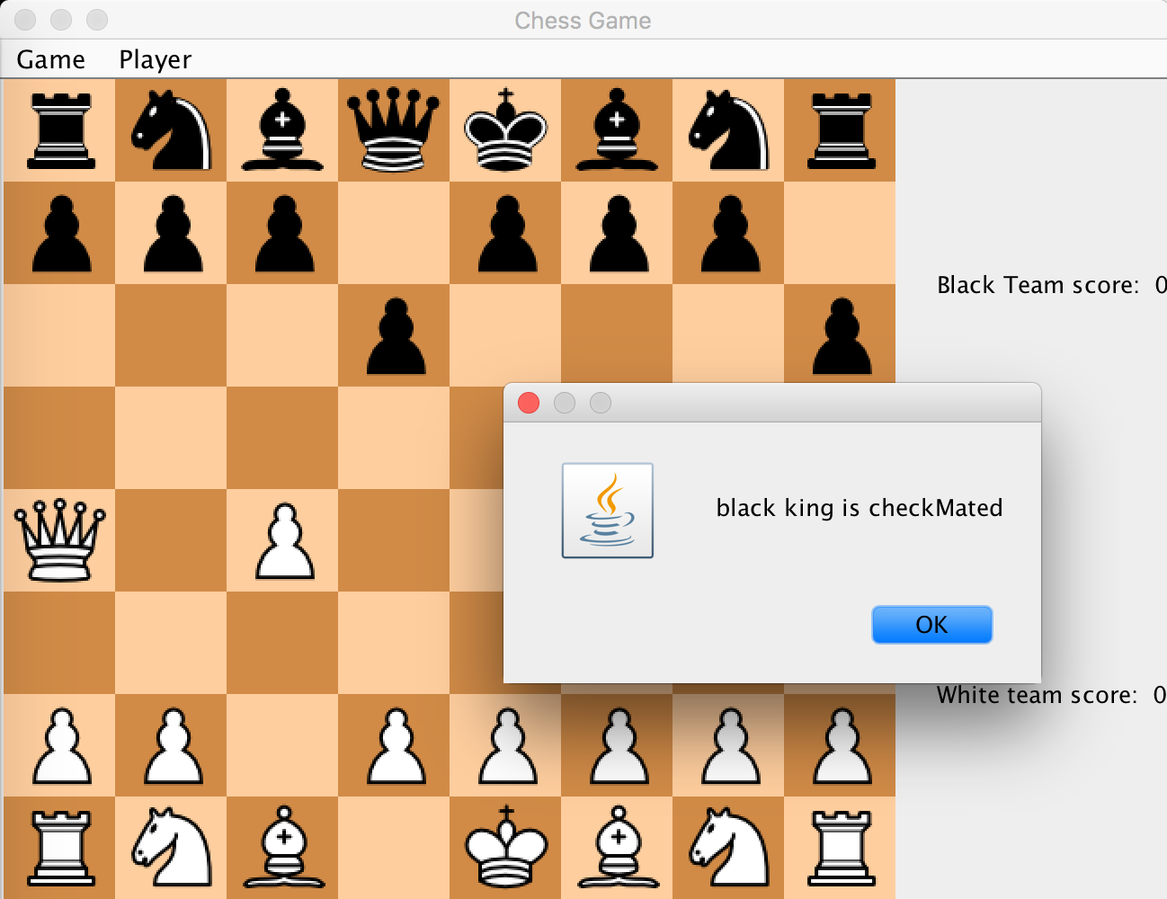

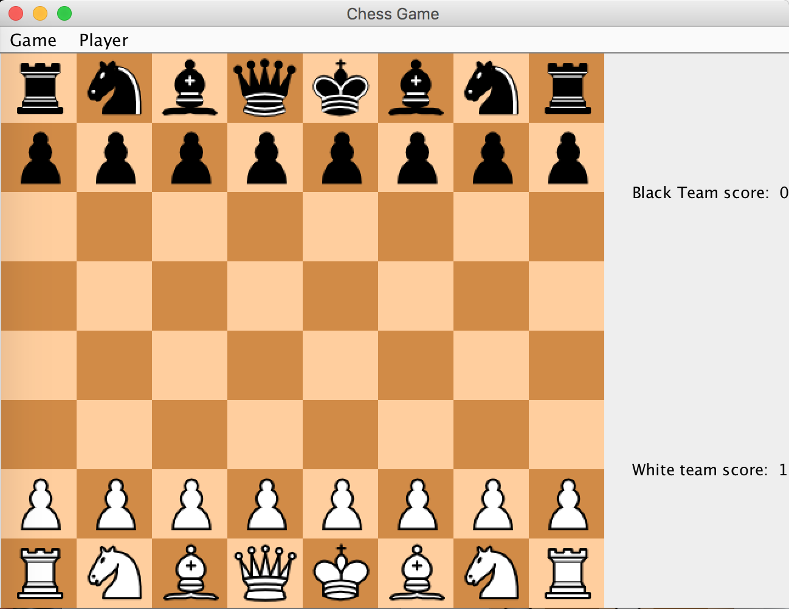

Part2:

There are three menu items under Game like shown below

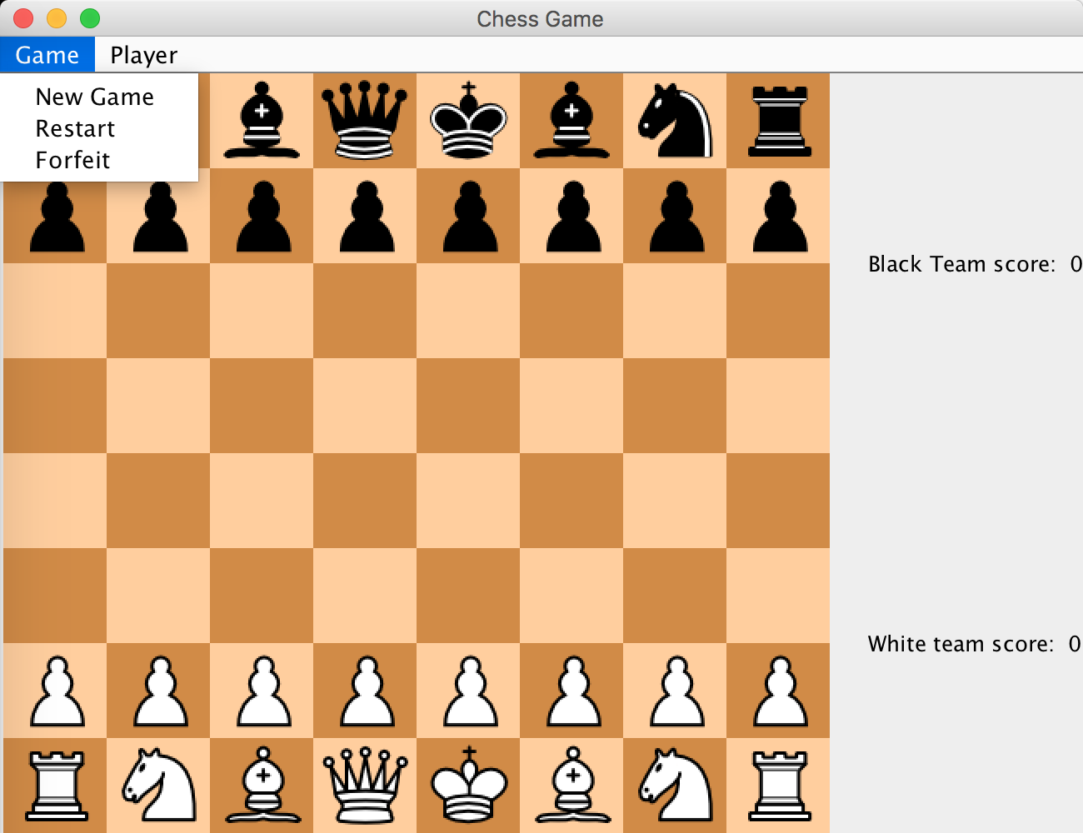

If you click on New Game, the game will ask if you want to start a new game and if the user press yes. It will start a new Game. Any modified player name will be re-modified to “Black” and “White”. And the score will be cleared to 0.

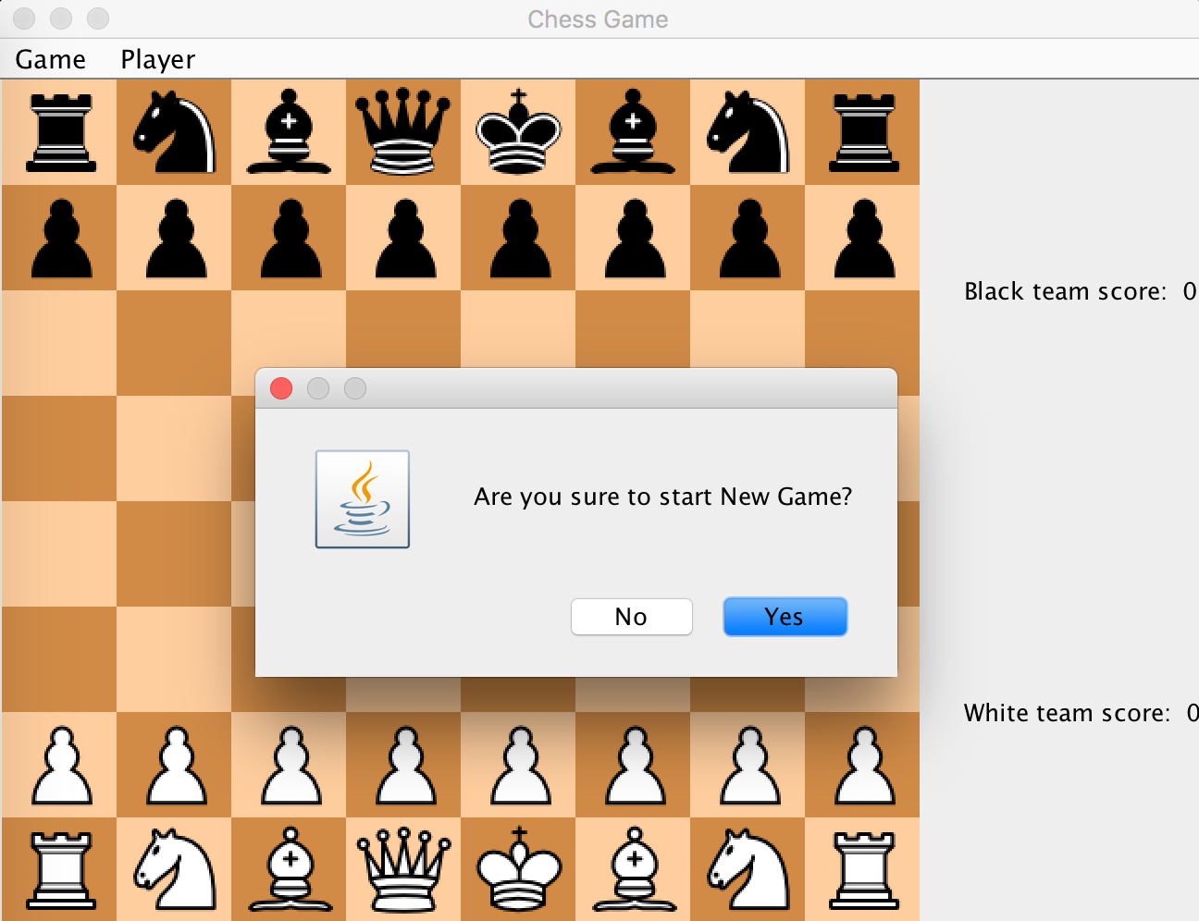

If you click on restart, the game will ask for the opponent’s consent to restart the game. No side’s score will be incremented. Both player’s name and score will still be the same

(Shown below is black team’s turn, when it clicks restart. It will ask for white team’s consent)

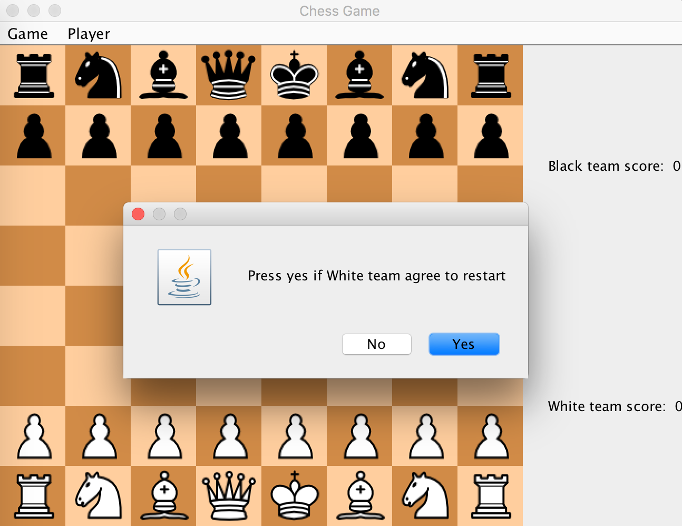

If you click on forfeit, it will ask the current turn player if the player is sure to forfeit the game. If the user press yes, then opponent’s score will be incremented and game will restart.

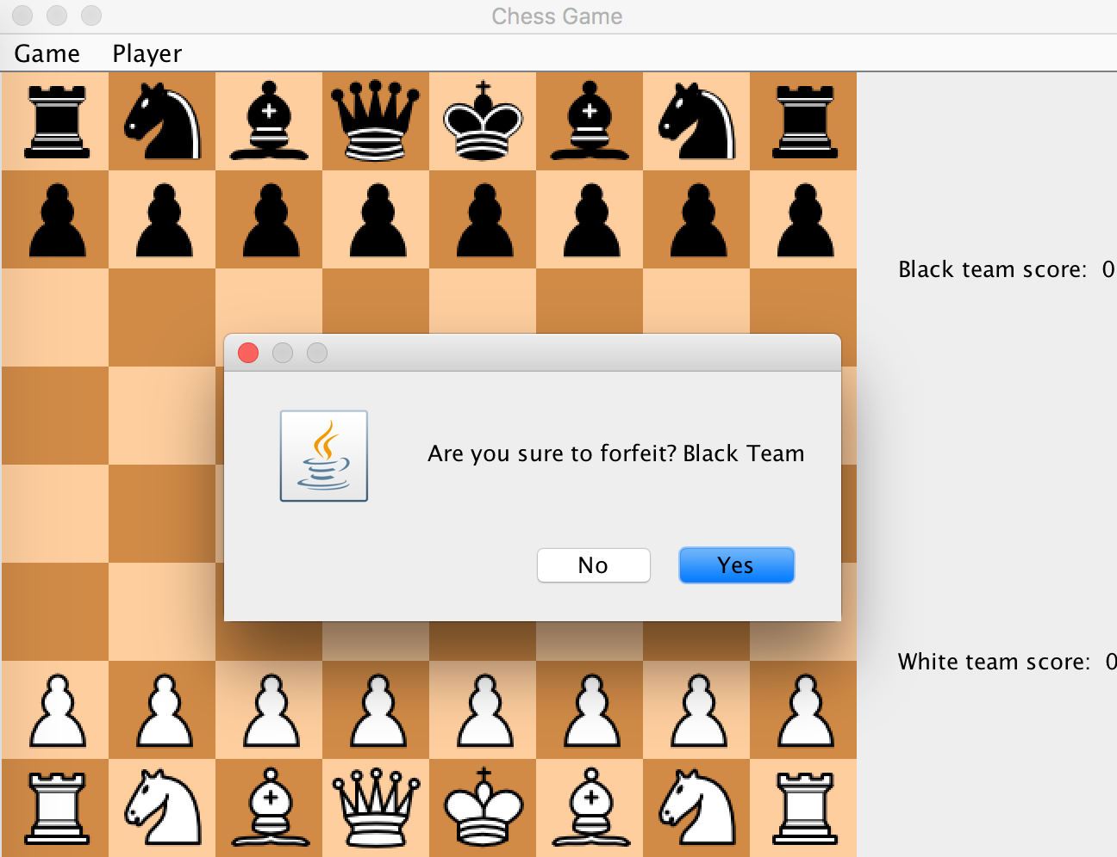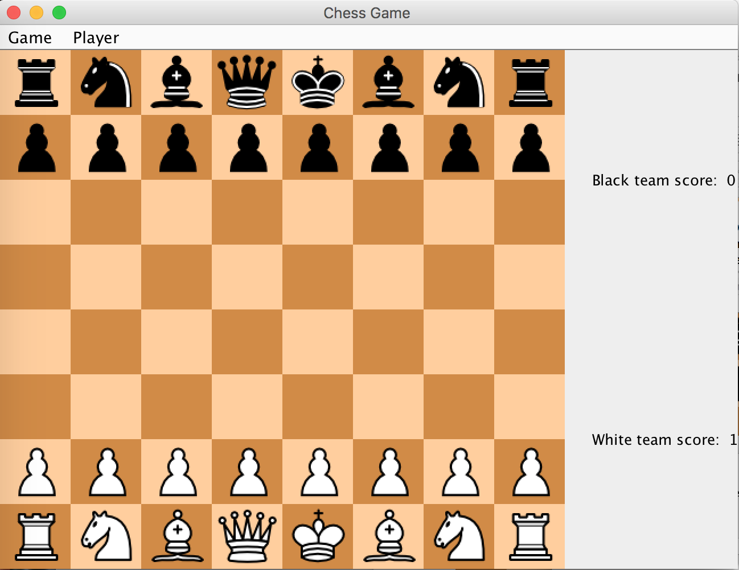

Part 3:

The Player menu bar has two menu items like shown below

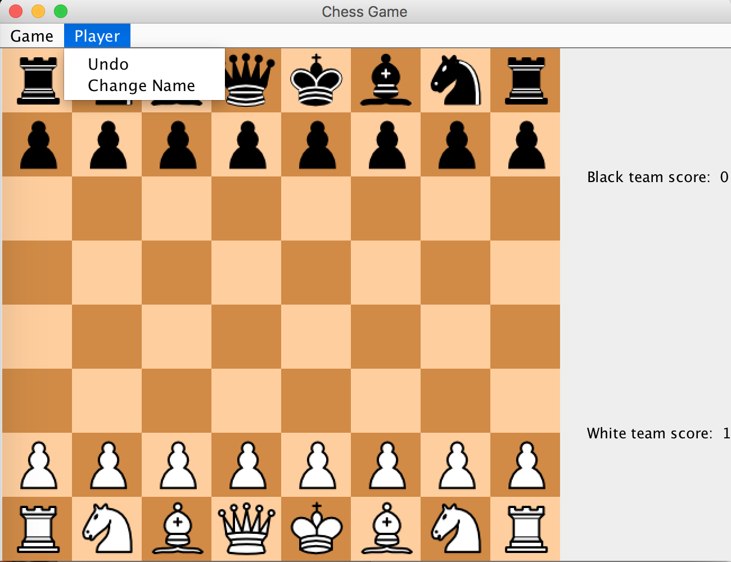The undo button will undo two player’s move alternatively until no more move is able to be undone.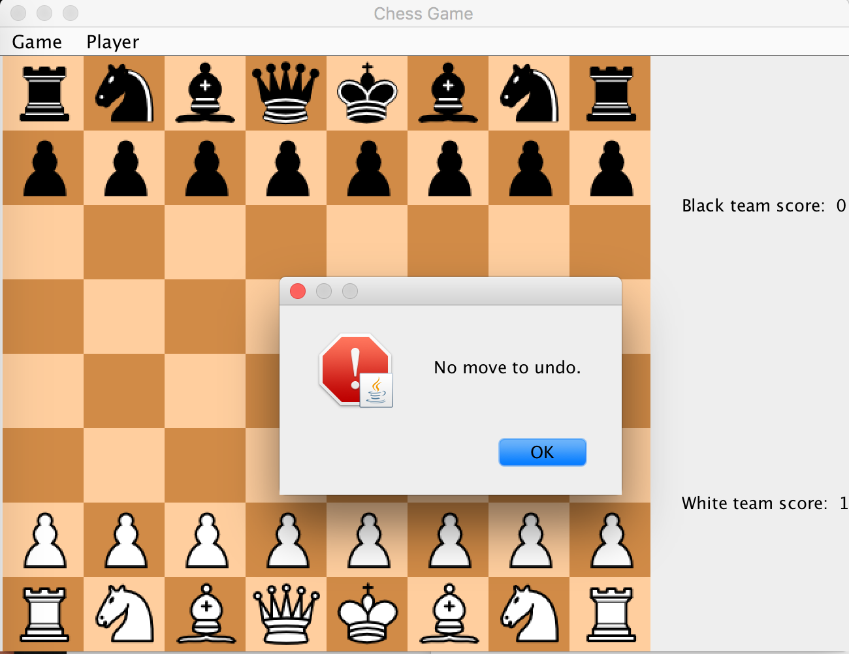The change name button will change the current turn user’s name. 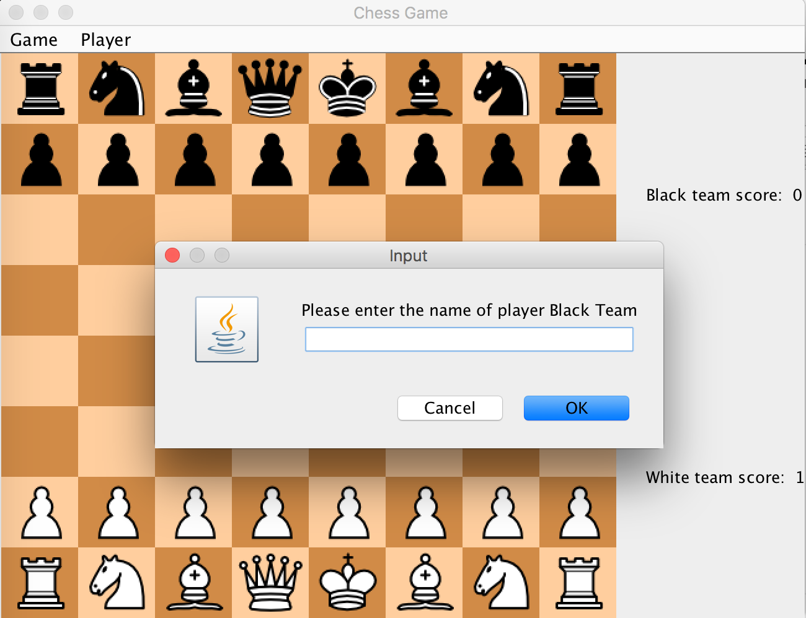

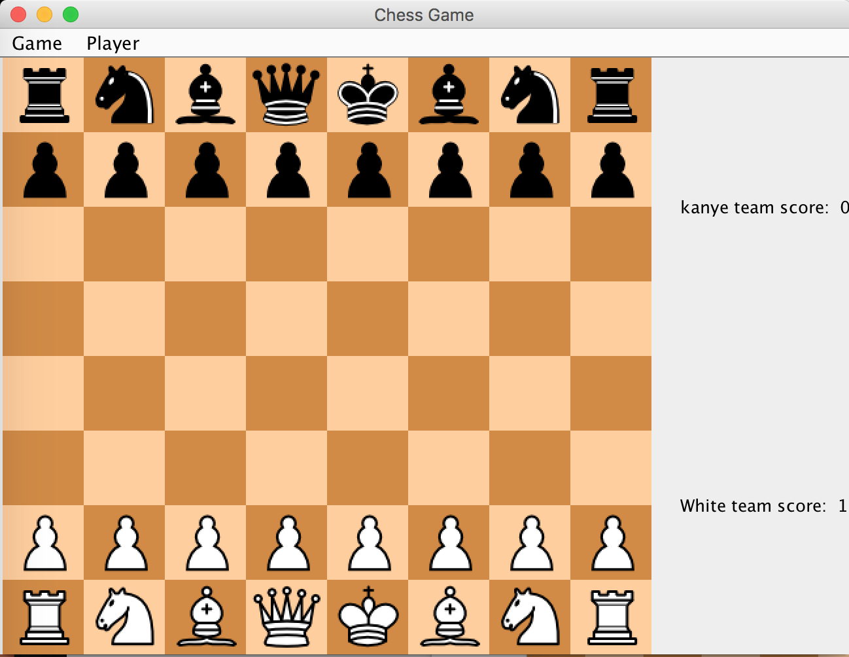

Have fun playing chess!