Assignment 2.1

Part 1*Who are the "hub" actors in your dataset? That is, which actors have the most connections with other actors? Two actors have a connection if they have acted in the same movie together.*

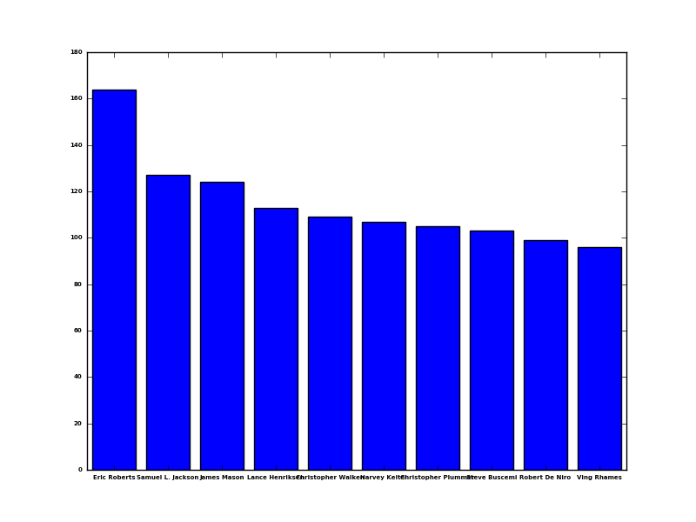

*Is there an age group that generates the most amount of money? What does the correlation between age and grossing value look like?*

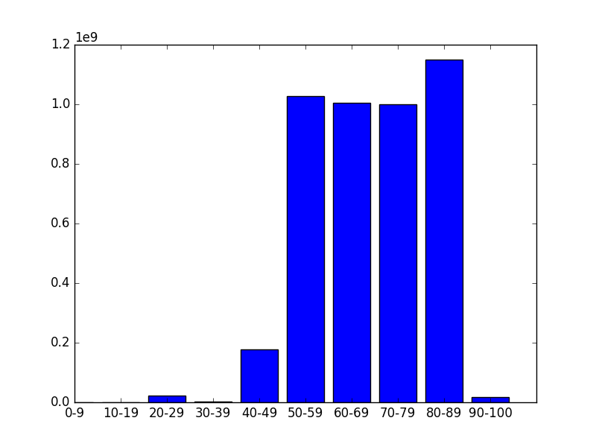

API

Post command to add Bruce Willis to the data base

curl -i -H "Content-Type: application/json" -X POST -d '{"name":"Bruce Willis"}' <http://127.0.0.1:5000/actors>

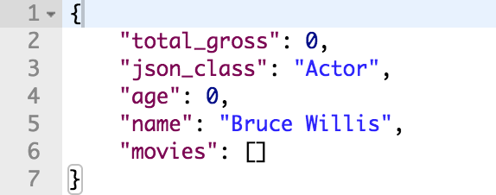

Delete command to delete bruce willis out of the data base

curl -i -X DELETE -H "Content-Type: application/json" <http://127.0.0.1:5000/actors/Bruce_Willis>



Put command to update the status of bruce willis

curl -i -X PUT -H "Content-Type: application/json" -d '{"age":10}' <http://127.0.0.1:5000/actors/Bruce_Willis>

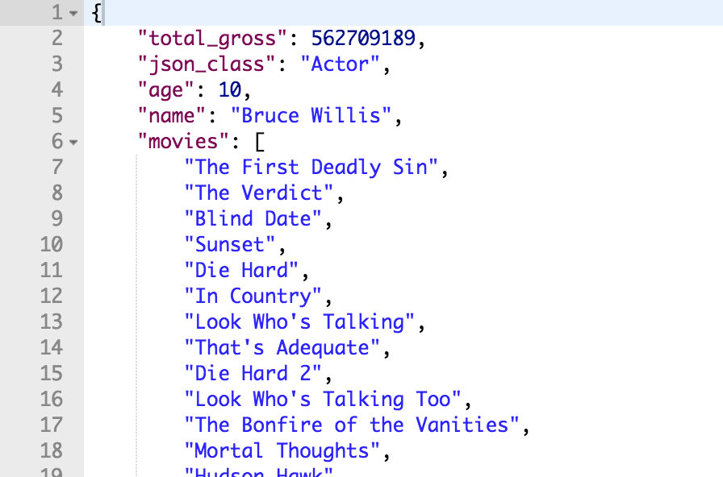

Part3

Visualization of my database

