北美台灣工程師協會 - 達拉斯分會

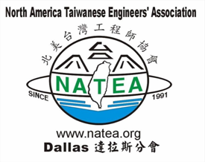

You are cordially invited to attend NATEA-Dallas 2006 Annual Meeting

Technology Innovation & Entrepreneurship

Featuring

Dr. Tu Chen 陳都 博士, Past Chairman, Komag, Inc.
Dr. Michael Chen 陳希寬 博士, Past President, Hsin-Kong Corp
Dr. Ming-chi Wu 吳明基 博士, CEO, Development Center for Biotechnology of Taiwan

Plus
2006 NATEA-Dallas College Students Scholarship Announcement
Election of the 2007 NATEA-Dallas Board of Directors

Date: Saturday, December 9th, 2006
Time: 1:30PM – 5:30PM
Place: Holiday Inn, DFW Airport West
3005 WEST AIRPORT FREEWAY
BEDFORD, TEXAS 76021

You are all invited to Dinner Banquet hosted by
FAHR and TAA-DFW ($25/person)
6:30PM – 9:30PM

For more information, contact any one of the board members
C.Y.Chang: 972.820.5705; Wen Chan: 817.354.6215;
Fannie Chao: 972.491.3130; Paul Chen: 972.618.4102;
Jim Yang: 214.477.2138

