TT Spektra

TTSTVR

Documentation

This version 2015-01-07

Covers TTSTVR version 2014:25:b

General 3

Basic elements 4

TVRBroadcast 4

BroadcastDateTime 5

BroadcastInformation 6

OtherBroadcast 7

TVRProgram 9

VersionableInfo 11

Description 12

PersonList 12

ProgramData 14

SeriesSeason 15

ProgramSeries 16

Sport-events 17

TechnicalProperty-values 18

SeriesEvent-values 18

BroadcastEvent-values 18

ProgramFormat-values 18

Function-värden 19

Additional media type 19

# General

The goal of the TT Spektra XML-model is to allow structuring of the tv and radio table listings in such a detail that the users can automatically sort, retrieve and format the information in their preferred way.

Each program is handled as an object with one part describing the content of the program and one part describing the details of the current broadcast.

This documentation is a general description. For detailed description of each element and attribute please use the complete XML schema.

This documentation focuses on what is most important for the receiver of tv and radio table listings. Please note that many elements and attributes are non-mandatory and often empty.

(Some of the elements and attributes in TTSTVR are mainly for internal usage when TT Spektra process the data.)

If you need more information please contact

Johan Lindgren, developer

jl@tt.se

060-17 68 15

(if you have technical questions.)

Marc Löfgren, TV Editor, Nyhetsbyrån TT Spektra

marc.lofgren@ttspektra.se

070-337 41 94

(for questions about the TV and radio service of TT Spektra.)

# Basic elements

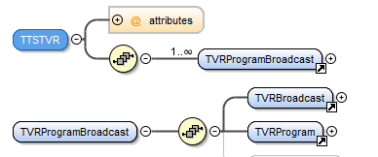

The root-element of **TTSTVR** is named just **TTSTVR**. It holds one or more programs. Each program is contained in an element called **TVRProgramBroadcast**. That element is divided into one **TVRBroadcast** with information about the current broadcast and a **TVRProgram** with information about the content of the program, regardless of when it is broadcasted.

# TVRBroadcast

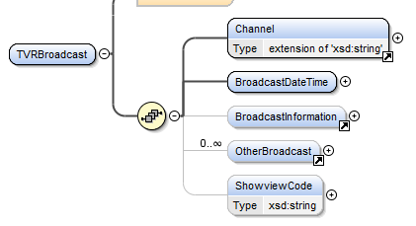

This is a description of the **TVRBroadcast** part.

**Channel** hold the name and id of the channel where the program is currently broadcasted.

*Exampel:*  <Channel id="256">CanalPlus First</Channel>

# BroadcastDateTime

**BroadcastDateTime** hold information about the start and end date and time of this broadcast. Date and time is the exact time.

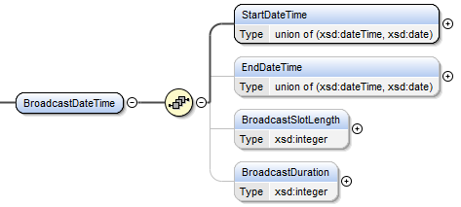

**StartDateTime** hold the date and time the broadcast start, including an UTC offset.

*Exampel*: <StartDateTime>2009-06-23T00:30:00+02:00</StartDateTime>

**EndDateTime** is the end date and time, but mostly the starting date and time of the next program meaning it includes information and advertisement after this program and before the next .

*Exampel*: <EndDateTime>2009-06-23T02:30:00+02:00</EndDateTime>

**BroadcastSlotLength** is the total time from start to end in seconds.

*Example*: <BroadcastSlotLength>7200</BroadcastSlotLength>

**BroadcastDuration** is the actual length of the program in minutes. Therefor often shorter than the BroadcastSlotLength.

*Exampel*: <BroadcastDuration>118</BroadcastDuration>

# BroadcastInformation

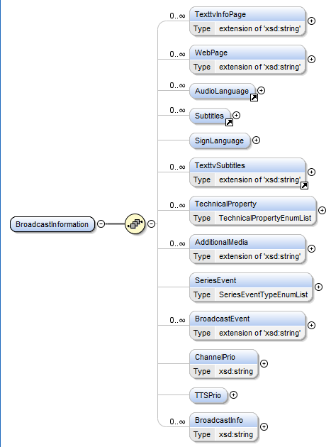

**BroadcastInformation** hold information about the current broadcast, mostly of technical nature. They are all optional.

**TexttvInfoPage** Teletext page number with more information about the program.

**WebPage** Reference to a web page related to the program. The url-address is placed in the URL-attribute and the description of the page as content of the element.

**AudioLanguage** lists the audio language(s) in the program.

**Subtitles** lists the language(s) that appear as subtitles in the program.

**SignLanguage** If the attribute **Value** is *true* the program is sign-language interpreted.

**TexttvSubtitles** lists teletext pages with subtitles.

**TechnicalProperty** hold technical information about the broadcast. For example “stereo” or “bredbild”. All according to a list of values. Please note that TT Spektra might add values to this list.

**AdditionalMedia** hold information about special type of broadcasts. The attribute Type tells which type of broadcast and the attribute URL hold the adress to the alternative broadcast.

**SeriesEvent** has information if the program is a series and this broadcast is something special, like the first episode, or the first episode this season.

**BroadcastEvent** has information if there is something special about this broadcast, like a premiere.

**ChannelPrio** has the priority the channel itself has set for this program.

**TTSPrio** has the priority TT Spektras has set.

**BroadcastInfo** has any type of extra information about the broadcast that is not covered in the above elements with their fixed values.

# OtherBroadcast

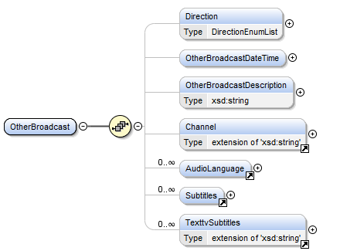

The same structure is used both for indicating past reruns and coming reruns of this program. Which mean there can be more than one **OtherBroadcast** in one **TVRBroadcast**.

**Direction** tells if this **OtherBroadcast** is a past or coming rerun, can be *Tidigare* or *Kommande*.

Tidigare mean a past rerun. It is fairly common that it is only known that it is a rerun but no further details.

**OtherBroadcastDateTime** can have the elements **StartDateTime** and **EndDateTime** that hold as much informations as is known about the time of the rerun, either past or coming.

Both **StartDateTime** and **EndDateTime** in **OtherBroadcastDateTime** have attributes for **Year, Month, Day, Hour, Minute, Second** and **Timezone**. TT Spektra will enter as much information as possible into these attributes, but often only the year of the rerun is known.

**OtherBroadcastDescription** is used if it is a rerun and the time is not easily described with the above attributes. Example: "*även i natt*" (meaning ”later tonight”).

**Channel** is used if the rerun is in another channel than the current broadcast. If the element is missing or empty it means the rerun is in the same channel as the current broadcast.

**AudioLanguage** is the audio language in the rerun.

**Subtitles** hold the language shown as subtitles in the rerun.

**TexttvSubtitles** hold information about subtitles available as teletext pages for the rerun.

**ShowviewCode** hold the showview code for this program in this channel and this broadcast.

*Example*: <ShowviewCode>31464410</ShowviewCode>

**TVRBroadcast** can have an attribute **SectionBroadcast** that normally is *None* or missing, which means *None*.Other possible values are *Block* or *Section*. Block mean a program holding a number of following parts, all having the value *Section* in this attribute.

# TVRProgram

**TVRProgram** contain the information about the content of the program and can be reused for other broadcasts of the same program.

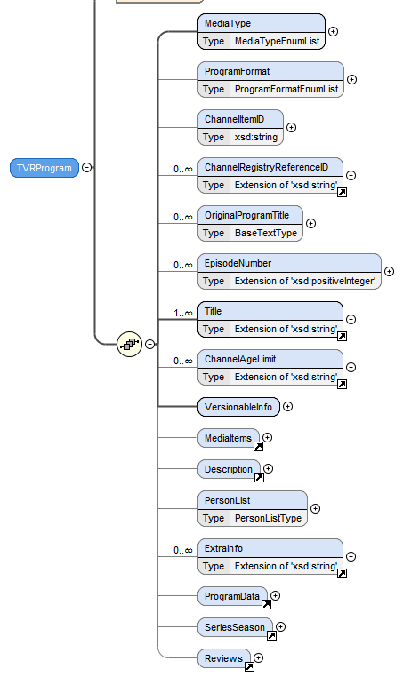

**MediaType** says if it is a radio or tv-program.

*Example*: <MediaType>TV</MediaType>

**ProgramFormat** has information about the format of the program. For example *nyheter*, *underhållning*, *film* meaning *news, entertainment* and *film*. Se attached list.

*Example:* <ProgramFormat>Film</ProgramFormat>

**ChannelItemID** If the broadcasting channel has a public id for this broadcast of this program.

*Example:* <ChannelItemID>630439</ChannelItemID>

**ChannelRegistryReferenceID** If a channel has a permanent id for this program.

*Example:*

<ChannelRegistryReferenceID ChannelID="256">23895</ChannelRegistryReferenceID>

**OriginalProgramTitle** The original title of the program.

*Example:*

<OriginalProgramTitle>Ensemble, c'est tout</OriginalProgramTitle>

**EpisodeNumber** Episode number and the channel that assigned the number. Different channels can group the episodes differently and use different numbers. The attribute **Scope** says if the number is per season or totally.

*Example*: <EpisodeNumber AssignedBy="256" Scope="Säsongen">24</EpisodeNumber>

**Title** The title of the program assigned by a channel.

*Example:* <Title ChannelID="256">Marie Antoinette</Title>

**ChannelAgeLimit** The age limit suggested by a specific channel.

*Example:* <ChannelAgeLimit ChannelID="256">Från 10 år</ChannelAgeLimit>

# VersionableInfo

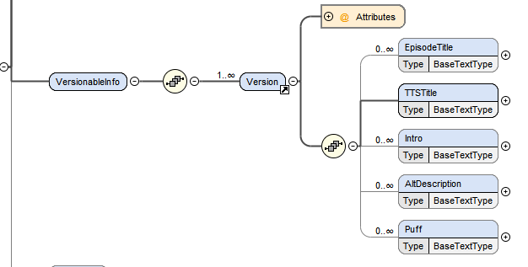

**VersionableInfo** can have one or more **Version** of descriptive elements about the program. Each customer will only receive one **Version**. But it makes it possible for TT Spektra to supply different customers with custom formatted desriptions.

**EpisodeTitle** If the program is an episode in a series this can hold a title specific for this episode. Often used as a subtitle for the overall title of the series.

**TTSTitle** is the title TT Spektra assigned and updates if the program information is updated. It is adviced to use this title.

**Intro** is a short description of the program.

*Example:* <Intro>Amerikansk dramaserie från 2008</Intro>

**AltDescription** can have an alternative description. See **Description** and **TextDesc** further down.

**Puff** is a text-field especially for sport events.

# Media Items

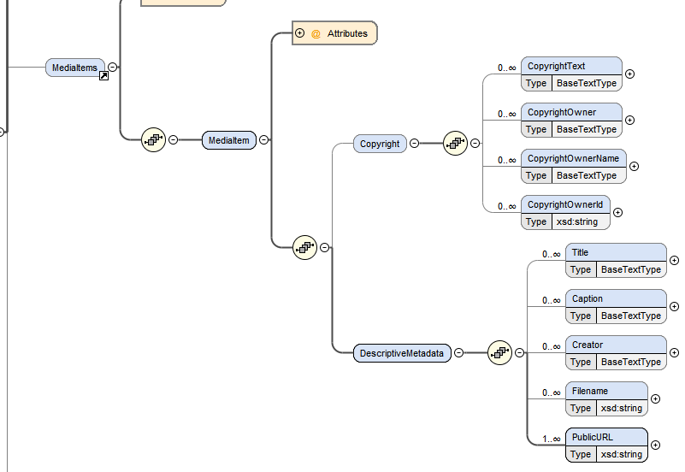

**MediaItems** can contain one or many **MediaItem.**

**Copyright** contain information about copyright attached to the referenced image.

**DescriptiveMetadata** hold metadata about the referenced image.

**Title** is the title of the referenced image/media object.

**Caption** holds the caption of the image, if any.

**Creator** is the creator of the image/media object.

**Filename** is suggested filename for the object/image.

**PublicURL** hold a full url to the object.

# Description

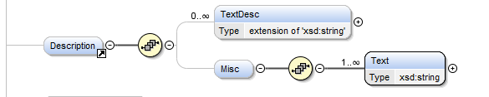

**Description** can have three **TextDesc**. They are numbered in an attribute called **Part**. The reciever can choose to use one, two or all three to build the textual description of the program. The text is written to so it can automatically be concatenated.

*Example:* <Description><TextDesc Part="1">Maya Dolittle har samma fantastiska förmåga som sin pappa – hon kan prata med djur.</TextDesc>

<TextDesc Part="2">En dag blir hon kontaktad av USA:s president som behöver hjälp att få kontroll på sin aggressiva hund.</TextDesc>  
<TextDesc Part="3">Nog skulle en rekommendation från presidenten öka Mayas chanser att bli antagen till veterinärskolan.</TextDesc> </Description>

# PersonList

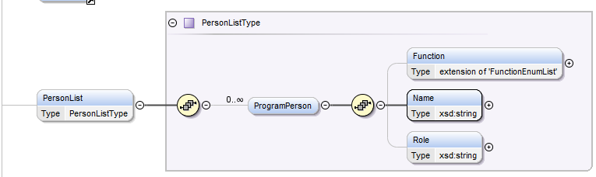

**PersonList** hold a list of **ProgramPerson** that each describe one person related to the program. Most common are actors, who have the word *Skådespelare* in **Function.** They can also have the name of their character in **Role**. Det egna namnet i **Name**. The attribute **Rank** is used per function in the current list and can be used to automatically choose how many of each function to present.

*Example*: <ProgramPerson>  
 <Function Rank="1">Skådespelare</Function>  
 <Name>Dominic Purcell</Name>  
 <Role>Tim Manfrey</Role>  
 </ProgramPerson>

Other common functions are ***Regissör*, *Programledare*, *Kommentator*** meaning *Director, Host, Commentator*.

**OBS**: A special function is ***Medverkande***. If they appear in the list they should NOT automatically be included. They are already mentioned in the text and function is there for other purposes. If they are included the information might be doubled and it might look bad. For example if the program is about a funeral and the person being buried is listed here.

**ExtraInfo** is an element seldom used. It only exist for the extraordinary occasion that there is some type of information that is not suited in the other elements.

# ProgramData

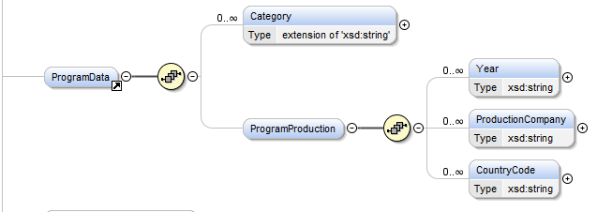

**Category** can be repetead once for each category the program belong to.

*Example:* <Category id="1010002">Thrillerfilm</Category>

**ProgramProduction** hold information about the production of the program. **Year** is the year the program was produced. **ProductionCompany** hold the name of the company that produced the program. **CountryCode** hold language code of the country where the program was produced. Please note that the elements are repetable.

*Example:* <ProgramProduction>  
 <Year>2006</Year>  
 <CountryCode>GBR</CountryCode>  
 <CountryCode>ESP</CountryCode>  
 </ProgramProduction>

# Reviews

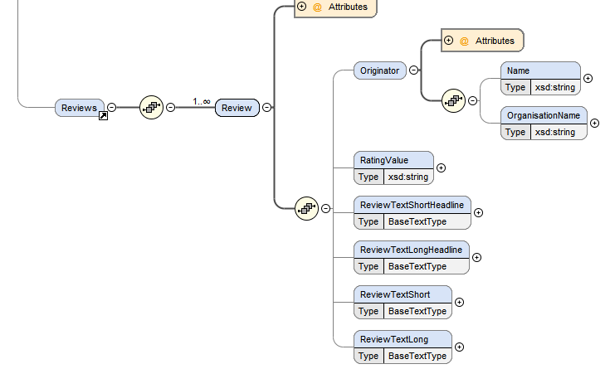

**Reviews** hold one or many **Review.** One **Review** is a rating of one program.

**Originator** is the name and organization of the person who sat the rating/review.

**RatingValue** is the actual rating value.

**ReviewTextShortHeadline** hold the short headline of the review.

**ReviewTextLongHeadline** hold the long headline of the review.

**ReviewTextShort** hold the short version of the text.

**ReviewTextLong** hold the long version of the text.

# SeriesSeason

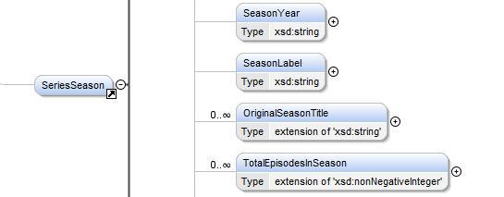

If the program is an episode in a serie **SeriesSeason** has information about the whole season. The above elements are special in the SeriesSeason. It has also the same elements as the program but describing the whole season. One example is actors that are part of the whole season. Compared to actors just appearing in one episode.

**SeasonYear** tells wich year this season is. It can also be combined like *2001-2002*.

*Example:* <SeasonYear>2008</SeasonYear>

**SeasonLabel** can hold a text describing the season. For example *Jubileumssäsongen*. It can also have a number of the season.

*Example:* <SeasonLabel>3</SeasonLabel>

**OriginalSeasonTitle** has the original title of this season.

*Example:* <OriginalSeasonTitle>DRAGONS DEN</OriginalSeasonTitle>

**TotalEpisodesInSeason** hold the total number of episodes in this season as described by one channel. The id of the channel is placed in **AssignedBy**.

*Example:* <TotalEpisodesInSeason AssignedBy="1">3</TotalEpisodesInSeason>

# ProgramSeries

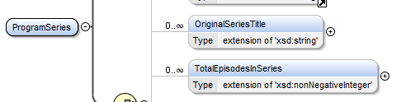

Last in **SeriesSeason** is **ProgramSeries** that hold information about the series regardless of season. Most elements are already described above.

The elements special in **ProgramSeries** is:

**OriginalSeriesTitle** The original title of the hole series.

and

**TotalEpisodesInSeries** The total number of episodes in the serie according to the channel indicated in AssignedBy.

# Sport-events

Sport programs with the program format "*Sportevenemang*" has the information structured a bit differently, but still using the same XML elements.

**Tournament**:

TVRProgram/SeriesSeason/VersionableInfo/Version/TTSTitle

**Discipline**:

TVRProgram/VersionableInfo/Version/Intro

**Place/Arena:**

TVRProgram/Description/TextDesc1

**Teams/Competitors:**

TVRProgram/VersionableInfo/Version/EpisodeTitle

**Sport:**

TVRProgram/VersionableInfo/Version/TTSTitle

Or seen from the other direction:

TVRProgram/VersionableInfo/Version/EpisodeTitle shall hold **Team/Competitor.**

TVRProgram/VersionableInfo/Version/TTSTitle shall hold the name of the **Sport**.

TVRProgram/VersionableInfo/Version/Intro shall hold sporting event like **400 m.**

TVRProgram/Description/TextDesc1 shall hold the name of the **Place/Arena.**

TVRProgram/SeriesSeason/VersionableInfo/Version/TTSTitle shall hold the name of the **tournament/championship or league.**

Following are lists of values that might appear in elements or attributes generally named the same as these sub-headlines. But values can be added to the lists. The values are in Swedish with English explanation in parenthesis.

# TechnicalProperty-values

* Bredbild (Widescreen)
* Letterbox
* Multikanalsljud (Surround)
* Dolby
* sv/v (Black and white)
* Stereo
* HD

# SeriesEvent-values

* Programstart (First)
* Seriestart (Start of a series)
* Säsongstart (Start of a season)
* Reprisstart (Start of reruns)
* Säsongsavslutning (End of a season)

# BroadcastEvent-values

* Direkt (Live)
* Samsändning (In cooperation between channels)
* Eftersändning (Delayed)
* Premiär (Premiere)

# ProgramFormat-values

* Aktuellt (Current)
* Dokumentär (Documentary)
* Feature
* Film (Movie)
* Nyheter (News)
* Tv-serie
* Underhållning (Entertainment)
* Utbildning (Education)
* Sportevenemang (Sport event)
* Övrigt (Other)

# InfoType – värden

* Info
* Hemmalag (Home-team)
* Bortalag (Away-team)
* Tävling (Competition)

# MediaItemRole – värden

* Primary
* Auxillary

# MediaItemType – värden

* Image
* Video
* Audio
* Binary

# Function-värden

* Artist
* Berättare (Narrator)
* Domare (Judge)
* Expert
* Expertkommentator (Expert commentator)
* Författare (Author)
* Gäst (Guest)
* Gästskådespelare (Guest actor)
* Kommentator (Commentator)
* Manus (Script)
* Medverkande (Participant).
* Producent (Producer)
* Programledare (Host)
* Redaktör (Editor)
* Regerande mästare (Current champion)
* Regissör (Director)
* Reporter
* Röst (Voice)
* Skådespelare (Actor)
* Svensk deltagare (Swedish participant)
* Tävlande (Competitor)
* Uppläsare (Narrator)

# Additional media type

* Webb-tv
* Podsändning
* Webbradio

