Tricia Corraine Tagle Oct 11, 2019

AB Psych181 Progcon

**Flowcharts and Pseudocodes**

***Flowcharts***

Flowcharts and Pseudocodes are two important things to develop good and logical programming which usually composed of commands and programming language.

Flowcharts are visual presentations in program flow indicating the input, output and processes in doing program. It is important to be used in multiple fields to document, study, plan, improve and communicate often complex processes in clear, easy-to-understand diagrams since each shape is appropriate in specific functions such as the oval, diamond and arrows. These are the lists of shapes with their corresponding function to better understand its context.

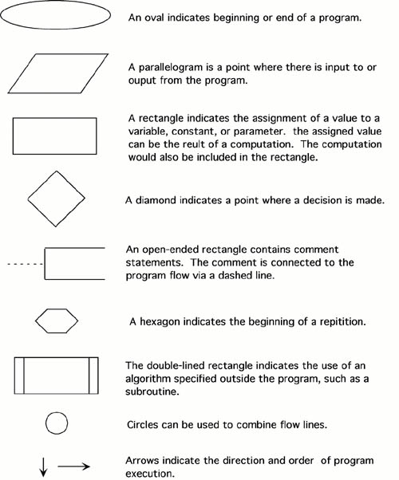

***Shapes and its functions***

Also, there are different types of flowcharts to be used by the user depending on the certain purpose and target. According to the Sterneckert (2003) in his book Critical Incident Management, there are 4 types of program and are most commonly used.

These are:

* Document Flowcharts
* Data Flowcharts
* System Flowcharts
* Program Flowcharts

***Pseudocodes***

While, in Pseudocodes, or Program Design language (PDL) allows the user to combined program languages to develop the actual code. With this, it helps users to organize and sequence describing the computer algorithms. However, there is no exact rules in combinations but some are still following the basics in writing pseudocodes in which the actions are usually written first in a capitalized case.

Basically, Pseudocodes are text-based" detail (algorithmic) design tool for the users to be able to understand the meaning of codes and be readable.

* **INPUT** – indicates a user will be inputting something
* **OUTPUT** – indicates that an output will display on the screen
* **WHILE** – a loop (iteration that has a condition at the beginning)
* **FOR** – a counting loop (iteration)
* **REPEAT – UNTIL** – a loop (iteration) that has a condition at the end
* **IF – THEN – ELSE** – a decision (selection) in which a choice is made
* any instructions that occur inside a selection or iteration are usually indented

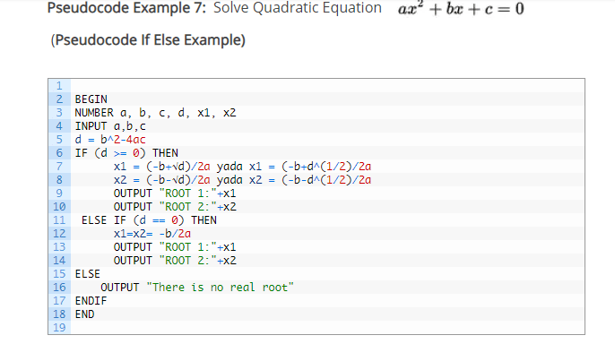

***Example of Pseudocode***

**Citation**

(n.d.). Retrieved from http://www.owlnet.rice.edu/~ceng303/manuals/fortran/FOR3_3.html.

What is a Flowchart. (n.d.). Retrieved from https://www.lucidchart.com/pages/what-is-a-flowchart-tutorial#section_2.

(n.d.). Retrieved from https://www.unf.edu/~broggio/cop2221/2221pseu.htm.

Jackson, D. (2017, September 28). Pseudocode and its importance. Retrieved from https://medium.com/@andremj013090/pseudocode-and-its-importance-5f71e38a0d95.

Mike, & Paul. (2019, April 13). Pseudocode Examples. Retrieved from https://www.csharp-console-examples.com/general/pseudocode-examples/.