Tricia Corraine Tagle

ABPsych 181

**Machine Project 1: Adding of two numbers**

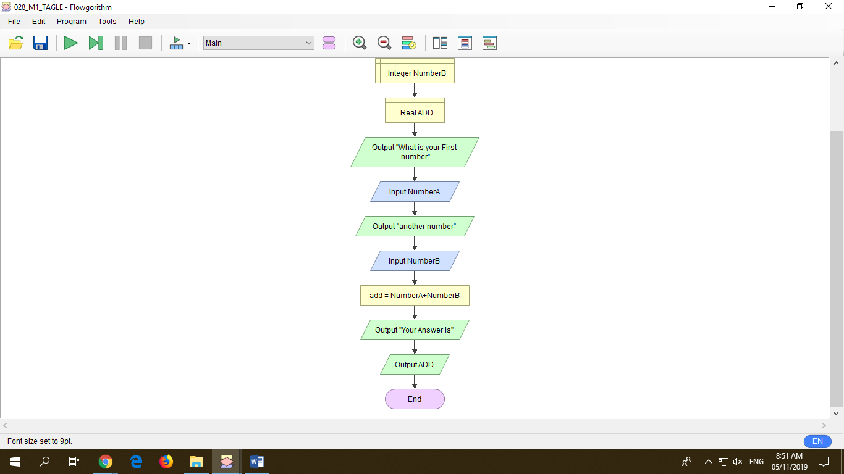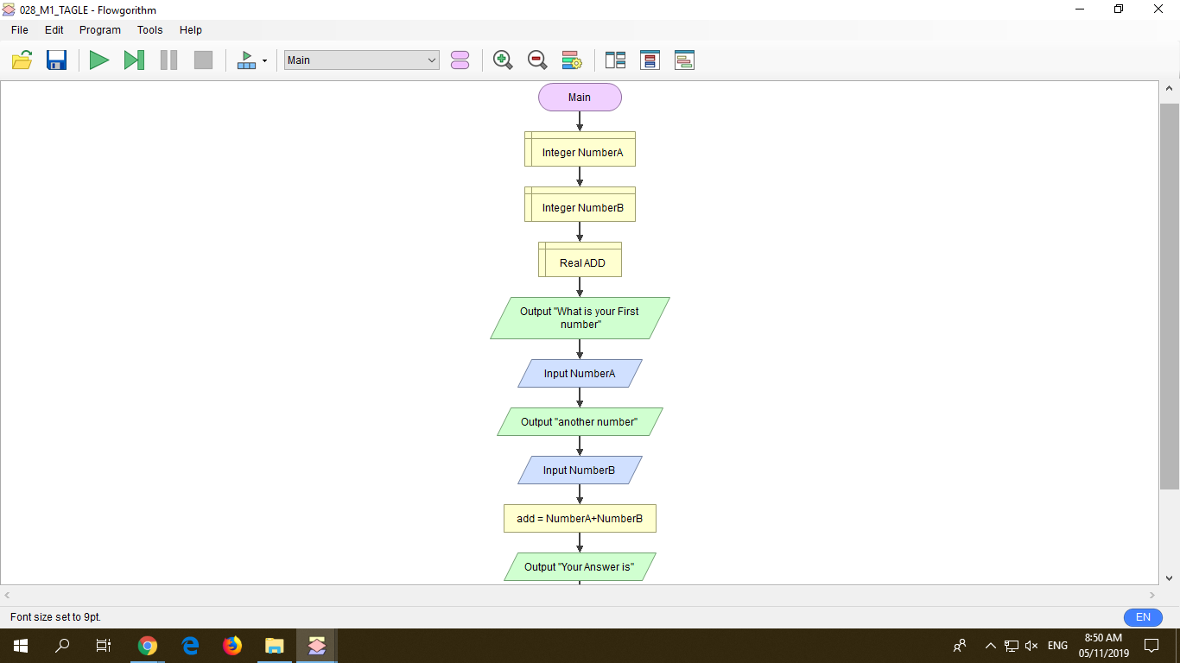

In adding two numbers, declaring integers letter A and B is important for the flowchart to read the input numbers by the user. In which, it will be calculated as seen above through assigning add variable with the exact computation expression using the NumberA and NumberB as “NumberA +NumberB”. Afterwards, the system will authomatically output the summation of the given numbers by inputting “output ADD”, representing the Real ADD declaration remarks.

**Step 1:** Declare Integer NumberA or depending on your chosen name

**Step 2:** Declare again another for the second number

**Step 3:** Declare REAL ADD, so that the program will read it as a function

**Step 4:** Put Output with your choice of statement so that you could communicate with the user. Just make sure to use quote and quote.

**Step 5:** Input of any number (from the use)

**Step 6:** The same as Step 4 but it talks about the Second number

**Step 7:** The Input of the second number

**Step 8:**Assign ADD so that the program will calculate the 2 numbers given to be displayed

**Step 9:** Output of the Final answer

**Machine Project 2: Get the area and diameter of the Circle**

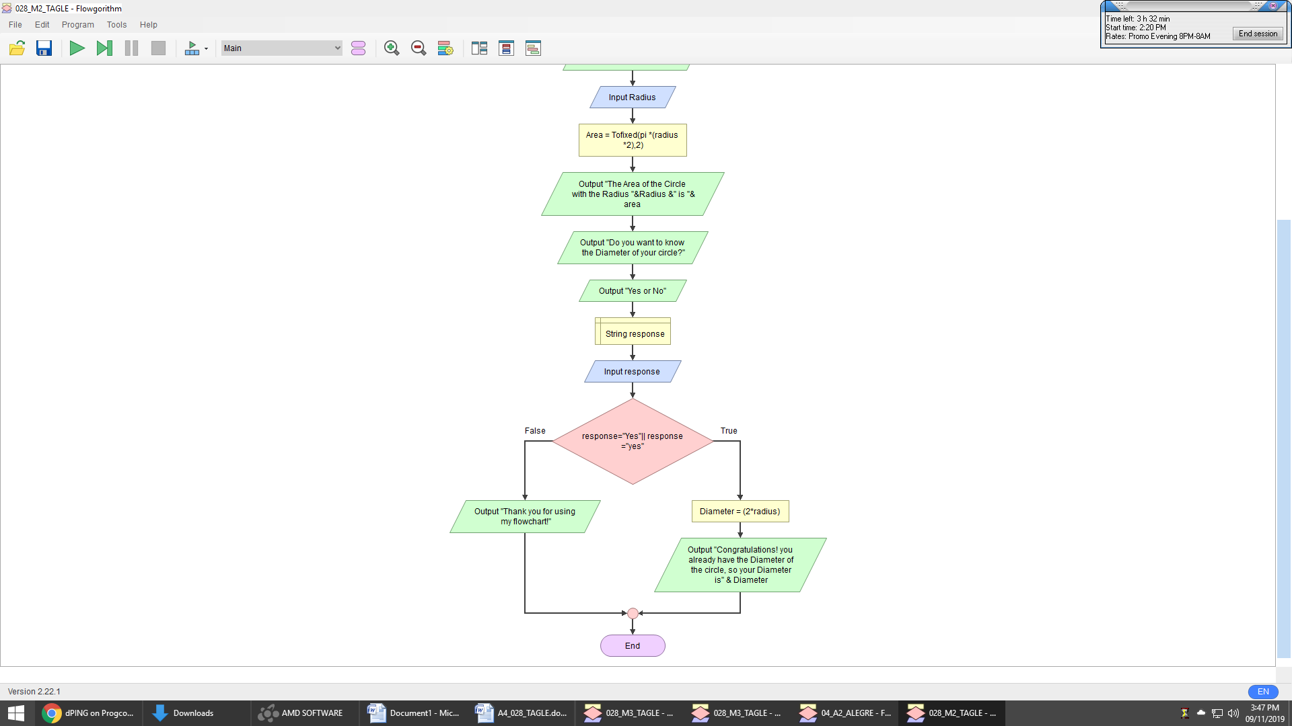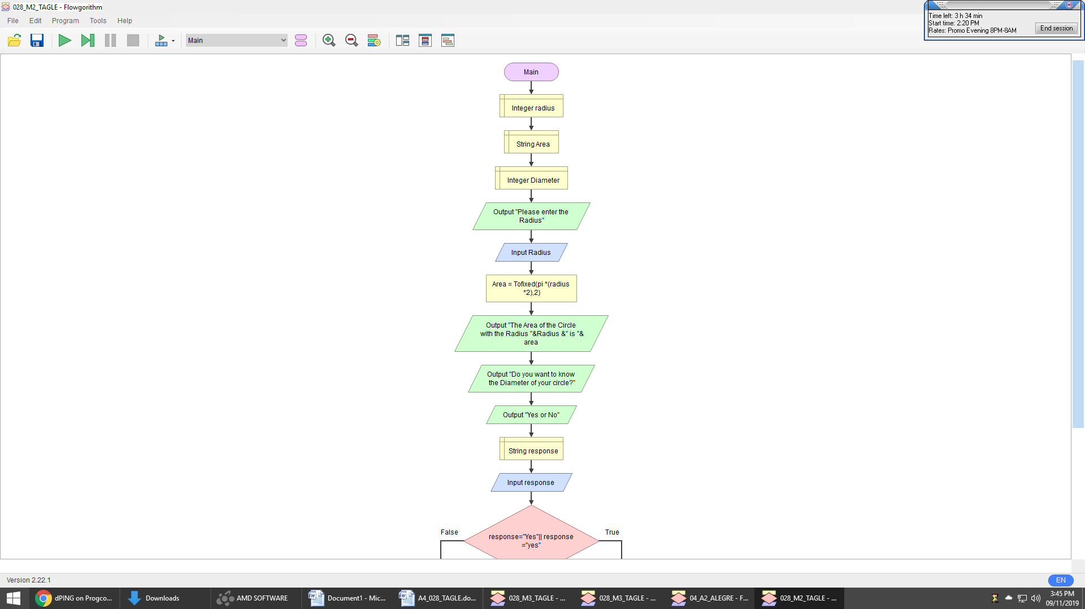

In finding two (2) answers in flowchart, it is needed to have a desicion so that the user(s) may verified if they want to continue in operation or not. As example above, it aims to find the area of the circle and diameter, the system will ask first the user to input the radius of his/her choice and declaring it as Integer is imporatnt so that the system will simply calculate it by the function assigned in the flowchart written as “Tofixed(pi *(radius *2),2)”, then the output for the Area of the cicle will be displayed. Then, in the decision, the user will be asked one more time if he/ she wants to continue in finding the diameter of the circle expressed by multipling the area outputted by 2. If yes, the sytem will leave a statement of congratulating the user with the Output diameter in which, also is declared. If no, the system will just be leaving a thank you statement and will end the program.

**Step 1:** Declare Integer Radius

**Step 2:** Declare String Area

**Step 3:** Declare Integer again named as Diameter

**Step 4:** Put Output asking to input the Radius of the circle as declared above so that the user is expected to input any number.

**Step 5:** then, the system will automatically outputted the Area

**Step 6:** This is where the desicion takes place by asking the user if he/ she will continue in finding the diamter or not

**Step 7:** Declare response equal to yes or no so the system can read the decision made by the user

**Step 8:** If Yes, assign calculation for diameter by the expression “(2*radius)”

**Step 9:** But if no, the system will end and will leave a comment depending on the developer of the flowchart just like the statement presented above "Thank you for using my flowchart!".