QUESTION 1:
S3 BUCKET
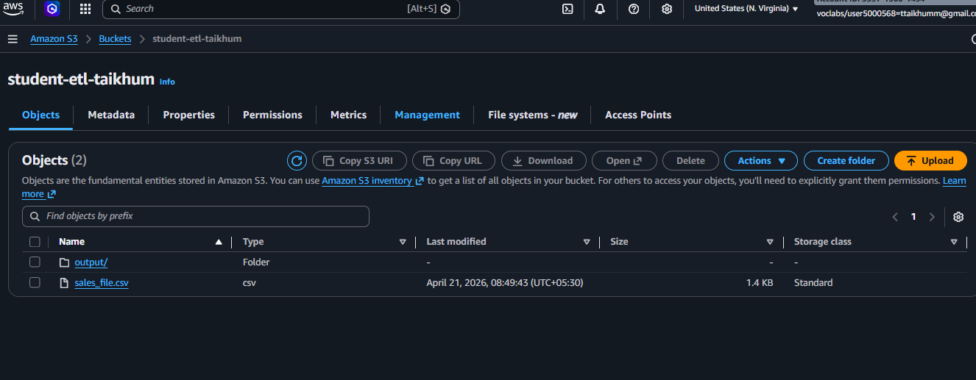

EC2 :
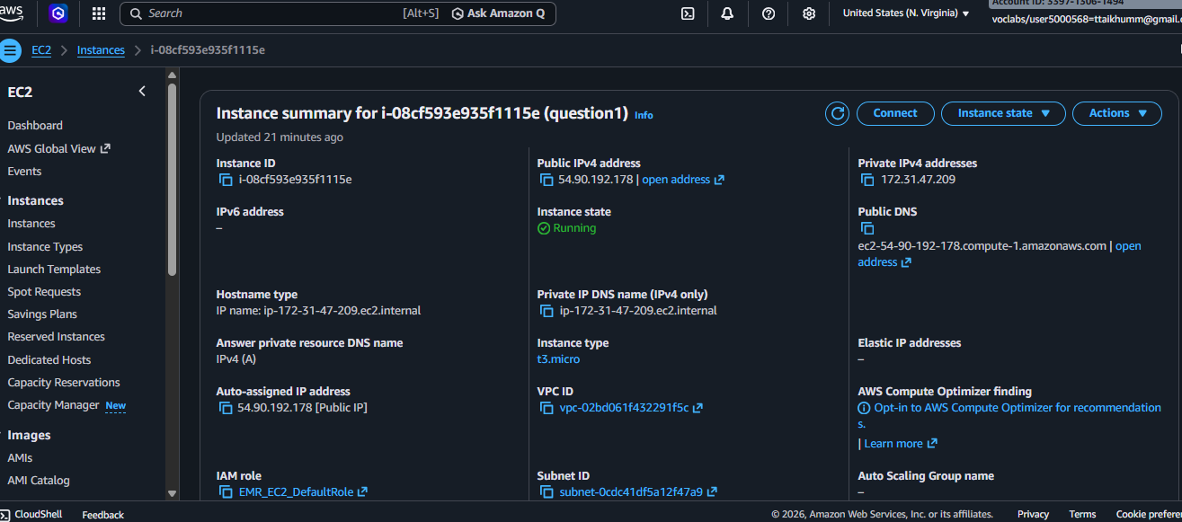

PYTHON SCRIPT :
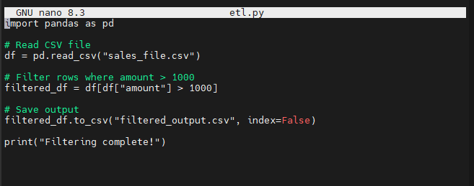

Commands to run and upload it to s3 bucket in o/p folder:

python3 etl.py
aws s3 cp filtered_output.csv s3://student-etl-taikhum/output/filtered_output.csv

FINAL OUTPUT :
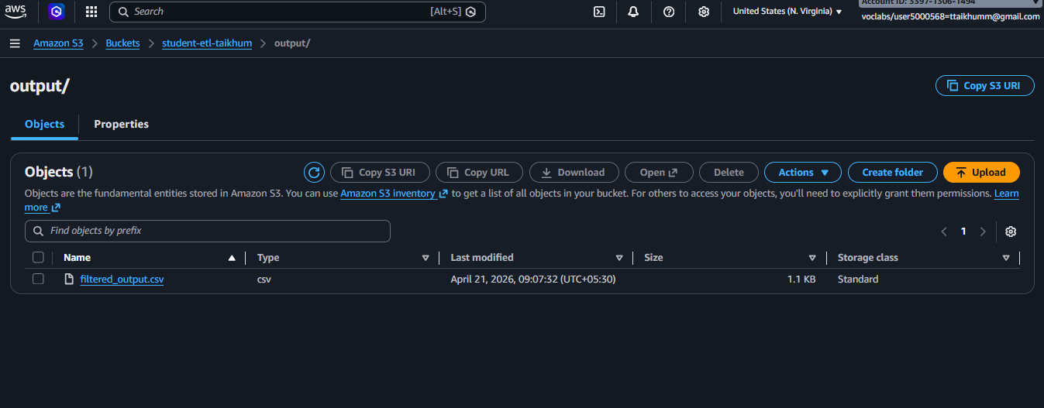

Q-2
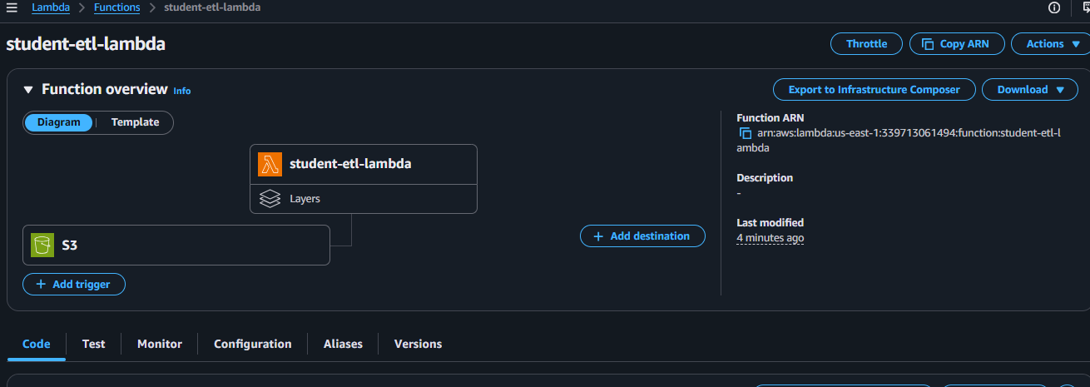
Lambda code:
import boto3
import pandas as pd
from io import StringIO
from datetime import datetime
import urllib.parse
import logging

# AWS clients
s3 = boto3.client("s3")

# Logger setup
logger = logging.getLogger()
logger.setLevel(logging.INFO)

def lambda_handler(event, context):

try:
# Get bucket name
bucket = event["Records"][0]["s3"]["bucket"]["name"]

# Get file name (handle URL encoding)
key = urllib.parse.unquote_plus(
event["Records"][0]["s3"]["object"]["key"]
)

logger.info(f"Processing file: {key}")

# Read file from S3
obj = s3.get_object(Bucket=bucket, Key=key)
df = pd.read_csv(obj["Body"])

# Add processed timestamp column
df["processed_timestamp"] = datetime.utcnow().isoformat()

# Convert dataframe back to CSV
csv_buffer = StringIO()
df.to_csv(csv_buffer, index=False)

# ✅ FIX: since file is in root bucket
processed_key = "processed/" + key

# Upload processed file to S3
s3.put_object(
Bucket=bucket,
Key=processed_key,
Body=csv_buffer.getvalue()
)

logger.info(f"File saved to: {processed_key}")

return {
"status": "success",
"input_file": key,
"output_file": processed_key
}

except Exception as e:
logger.error(f"Error occurred: {str(e)}")
raise e

Q-3
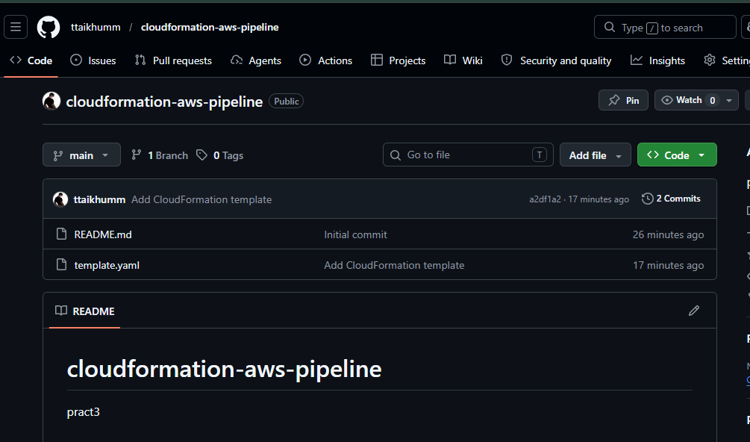
AWSTemplateFormatVersion: '2010-09-09'
Description: S3 + EC2 + IAM Role with S3 access

Resources:

MyS3Bucket:
Type: AWS::S3::Bucket

MyIAMRole:
Type: AWS::IAM::Role
Properties:
RoleName: EC2S3AccessRole
AssumeRolePolicyDocument:
Version: '2012-10-17'
Statement:
- Effect: Allow
Principal:
Service: ec2.amazonaws.com
Action: sts:AssumeRole
Policies:
- PolicyName: S3AccessPolicy
PolicyDocument:
Version: '2012-10-17'
Statement:
- Effect: Allow
Action:
- s3:*
Resource: "*"

MyInstanceProfile:
Type: AWS::IAM::InstanceProfile
Properties:
Roles:
- !Ref MyIAMRole

MyEC2Instance:
Type: AWS::EC2::Instance
Properties:
InstanceType: t2.micro
ImageId: ami-0c55b159cbfafe1f0
IamInstanceProfile: !Ref MyInstanceProfile

