Data Viz Examples

I believe that high-quality data visualization is critically important for effectively communicating research and information. Below are some samples of my own data visualization work (more coming soon).

# Spatial Point Pattern Maps

Example using toy data

#### Hot-Spot Analysis

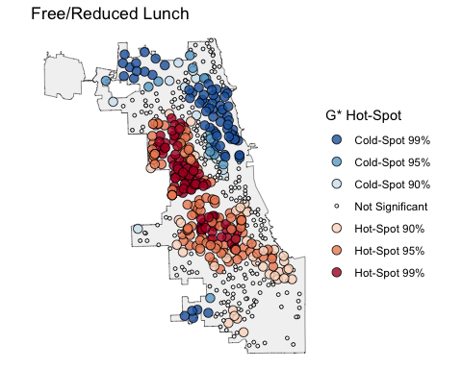

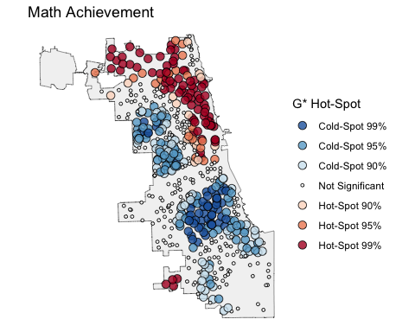

#### Outlier Analysis

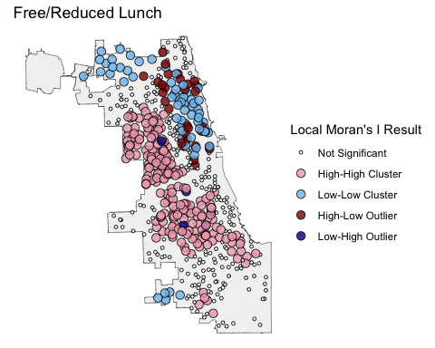

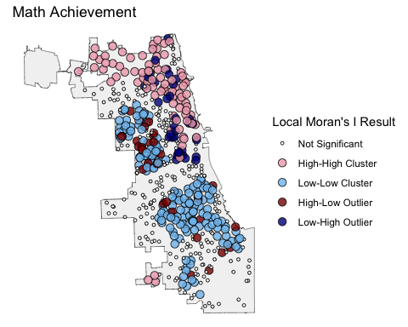

#### Localized Regression

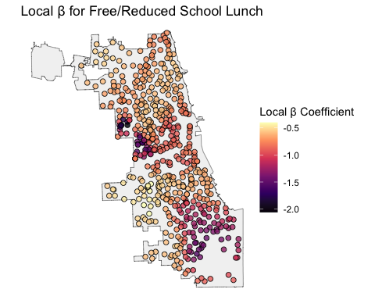

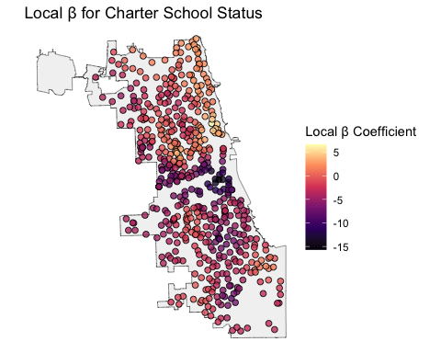

# Interactive Dashboard

I created the below dashboard to go with my paper [“The Route to Graduation”](https://doi.org/10.1177/15210251231156421) that explored the association between transit accessibility and Pell completion rates. The dashboard allows you explore different slices of the data used in the paper, e.g. different regions and/or college types. The dashboard was developed using Shiny and R.

*Note: This is just a preview window. If it isn’t displaying neatly, you are using a smaller screen, or you want to explore the dashboard in more detail, it might be easier to view it in its own window* [*here*](https://ttalvlatt.shinyapps.io/rtg-dashboard/)*.*