[Sign in](https://medium.com/m/signin?operation=login&redirect=https%3A%2F%2Ftowardsdatascience.com%2Fdata-science-meets-ufc-does-a-fighters-stance-really-give-them-an-advantage-fdc6141f6e29&source=post_page-----fdc6141f6e29---------------------nav_reg-)

[Get started](https://medium.com/m/signin?operation=register&redirect=https%3A%2F%2Ftowardsdatascience.com%2Fdata-science-meets-ufc-does-a-fighters-stance-really-give-them-an-advantage-fdc6141f6e29&source=post_page-----fdc6141f6e29---------------------nav_reg-)

[[](https://towardsdatascience.com/?source=post_page-----fdc6141f6e29----------------------)](https://towardsdatascience.com/?source=post_page-----fdc6141f6e29----------------------)

* [DATA SCIENCE](https://towardsdatascience.com/data-science/home?source=post_page-----fdc6141f6e29----------------------)
* [MACHINE LEARNING](https://towardsdatascience.com/machine-learning/home?source=post_page-----fdc6141f6e29----------------------)
* [PROGRAMMING](https://towardsdatascience.com/programming/home?source=post_page-----fdc6141f6e29----------------------)
* [VISUALIZATION](https://towardsdatascience.com/data-visualization/home?source=post_page-----fdc6141f6e29----------------------)
* [AI](https://towardsdatascience.com/artificial-intelligence/home?source=post_page-----fdc6141f6e29----------------------)
* [VIDEO](https://towardsdatascience.com/video/home?source=post_page-----fdc6141f6e29----------------------)
* [ABOUT](https://towardsdatascience.com/about-us/home?source=post_page-----fdc6141f6e29----------------------)
* [CONTRIBUTE](https://towardsdatascience.com/contribute/home?source=post_page-----fdc6141f6e29----------------------)

You have **1** free story left this month.

[Sign up and get an extra one for free.](https://medium.com/m/signin?operation=register&redirect=https%3A%2F%2Ftowardsdatascience.com%2Fdata-science-meets-ufc-does-a-fighters-stance-really-give-them-an-advantage-fdc6141f6e29&source=-----fdc6141f6e29---------------------metered_view_2-)

Data Science Meets UFC: Does a Fighter’s Stance Really Give them an Advantage?

A quantitative attempt at answering an age old question in combat sports.

[[](https://towardsdatascience.com/@ravimalde?source=post_page-----fdc6141f6e29----------------------)](https://towardsdatascience.com/@ravimalde?source=post_page-----fdc6141f6e29----------------------)

[Ravi Malde](https://towardsdatascience.com/@ravimalde?source=post_page-----fdc6141f6e29----------------------)

[Follow](https://medium.com/m/signin?operation=register&redirect=https%3A%2F%2Ftowardsdatascience.com%2Fdata-science-meets-ufc-does-a-fighters-stance-really-give-them-an-advantage-fdc6141f6e29&source=-145818fddbcd-------------------------follow_byline-)

[Mar 11](https://towardsdatascience.com/data-science-meets-ufc-does-a-fighters-stance-really-give-them-an-advantage-fdc6141f6e29?source=post_page-----fdc6141f6e29----------------------) · 11 min read



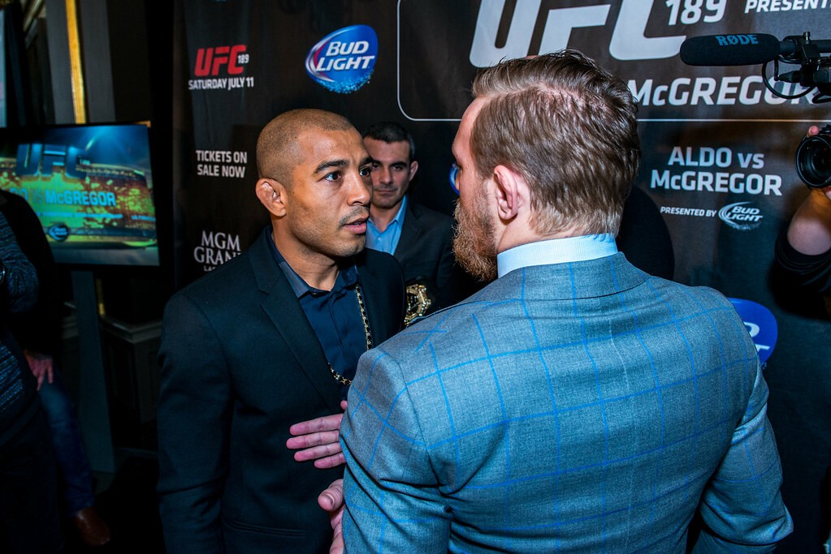

Image licensed for reuse by Andrius Petrucenia (<https://www.flickr.com/photos/andriux_uk_events/18781656035>)

Conor McGregor vs Jose Aldo was one of the fastest knockouts in UFC history, resulting in a win for the Irishman after just 13 seconds. It pitched a devastatingly talented left-handed southpaw (McGregor) against the Brazilian undefeated orthodox that was considered by some to be the greatest MMA featherweight of all time. Seconds after referee Big John McCarthy announced to the men that it was time to fight, Aldo lunges forward and swings for a left hook. Conor takes a step back and counters with a perfectly placed left hook of his own. With Aldo laying on the floor, Conor continues to rain down on him with hammer fists, at which point the referee declares an end to the fight.

Easy as that. (<https://giphy.com/conormcgregor>)

So how much of Conor’s win can be attributed to his unorthodox stance? This article takes a quantitive approach at answering the following question:

“Does having an unorthodox stance give a fighter an advantage in the ring (or octagon)?”

In case any readers aren’t familiar with the various stances in combat sports I’ll save you a google and give a brief description now:

* **Orthodox** fighters are for the most part **right-handed** and stand with their left shoulder forward and right shoulder back.
* **Southpaw** individuals are normally **left-handed** and stand with their right shoulder forward, left shoulder back.
* **Switch** fighters could be considered **ambidextrous** and have the ability to change seamlessly between orthodox and southpaw stances.
* A few other stances exist but they are very rare, as will be seen later in the analysis.

It is often said that unorthodox fighters have an advantage; this is commonly thought to be because there are fewer of them, meaning that a fighter is less able to anticipate their unorthodox opponent’s actions when they eventually face one. The same advantage is believed to exist in other sports such as tennis, cricket and baseball. To give some numerical context, Dr Florian Loffing of the University of Oldenburg in Germany conducted a study between 2009 and 2014 in which he collected the names and handedness of the top 100 players for badminton, squash, tennis, table tennis, cricket and baseball. His findings were that in male baseball, 30% were left handed and in female tennis this figure was 19%¹. These numbers are far higher than in the general population, approximately 10.3% and 7.7% for males and females respectively¹.

Does this advantage actually exist in the domain of MMA or is it just a common misconception? If it does exist, is it simply due to fighters being less prepared for unorthodox opponents or is there more to this than meets the eye?

In the following sections I’ll walk you through my approach at getting to the bottom of these questions, from data collection, cleaning, and feature engineering, to analysis and lastly my interpretation of the results.

If you would like to follow along with the code then please visit the GitHub repository at the following link:

<https://github.com/ravimalde/ufc_fighter_stance>

**Data Collection — Web Scraping**

Before conducting any comparisons between orthodox and non-orthodox fighters I needed to get my hands on some data. Conveniently, the UFC maintains a website with the details of every fighter in the organisation². This is presented in the form of a table as shown below.



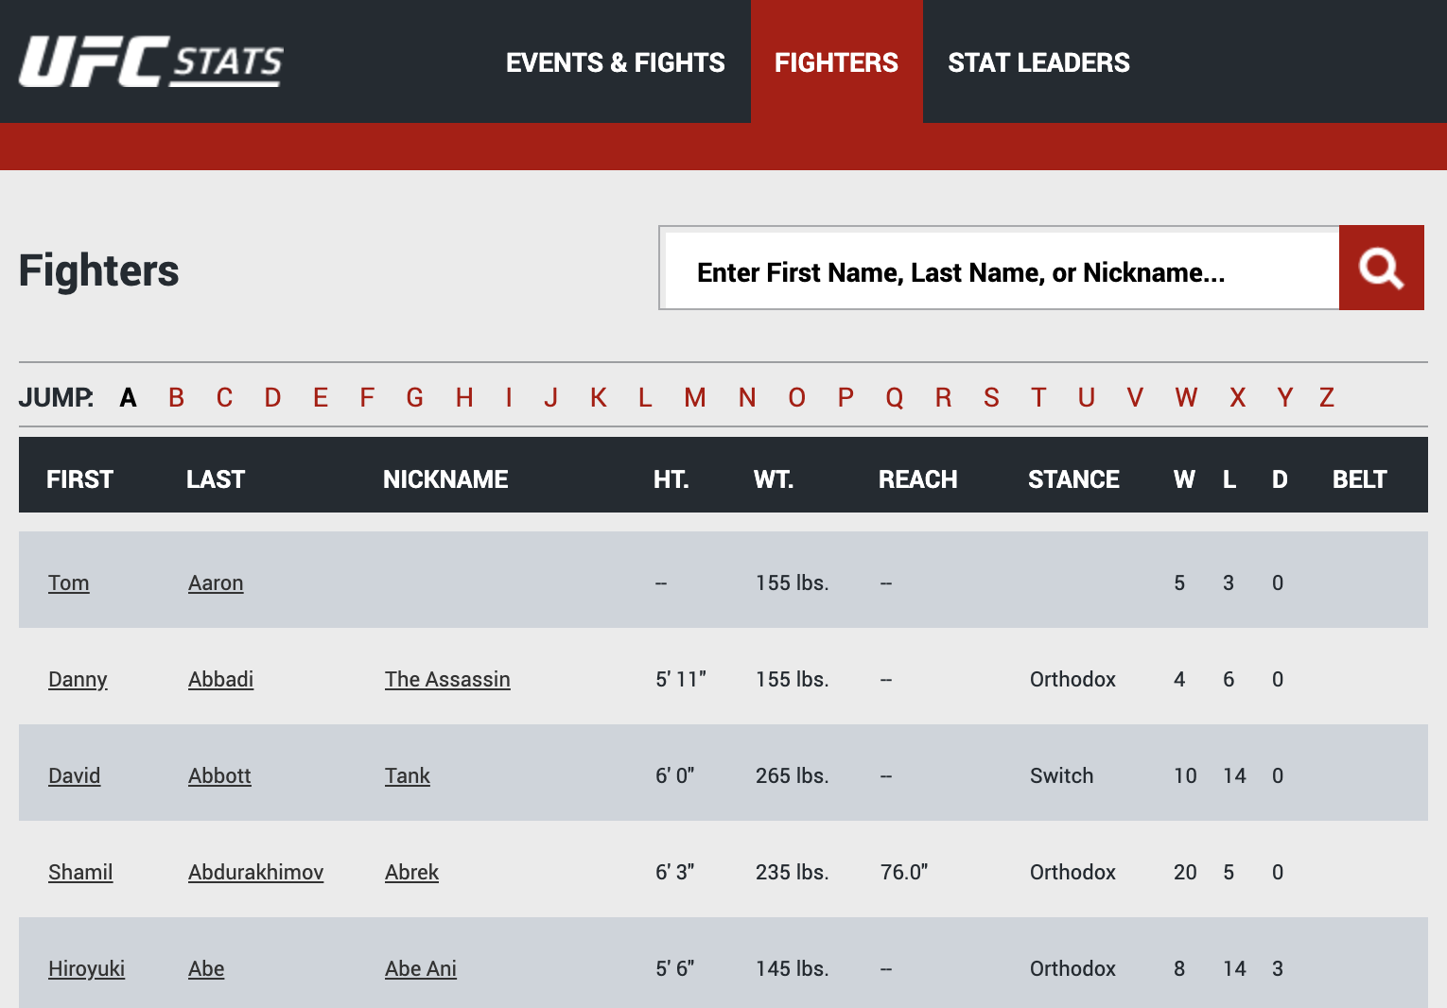

<http://ufcstats.com/statistics/events/completed?page=all>

Crucially, contained in this table was information on the fighter’s stance along with their wins, losses and draws. From this it would be possible to gauge the success of each fighter and determine if there is a significant difference between the stances.

I used the BeautifulSoup and requests libraries to scrape as this provides a simple framework for parsing HTML. As can be seen from the image above, there was a web page for each letter of the alphabet and all of these needed to be scraped if I was to have information on every fighter. The urls for the ‘A’, ‘B’ and ‘C’ pages were as follows:

<http://www.ufcstats.com/statistics/fighters?char=a&page=all>

the ‘a’ in ‘char=**a**&page’ changes to ‘b’…

<http://www.ufcstats.com/statistics/fighters?char=b&page=all>

and then the ‘b’ in ‘char=**b**&page’ changes to ‘c’…

[http://www.ufcstats.com/statistics/fighters?char=c&page=all](http://www.ufcstats.com/statistics/fighters?char=b&page=all)

so on and so forth for each letter of the alphabet.

Below is the code snippet showing how the web scrape was completed inside a for loop that iterated over the alphabet, each time updating the url to cycle through each page.

To see how the data was then organised into a pandas DataFrame, please take a look at the GitHub repository linked before this section. For the sake of brevity this process will not be outlined here. The image below shows the first 5 rows of the DataFrame created.



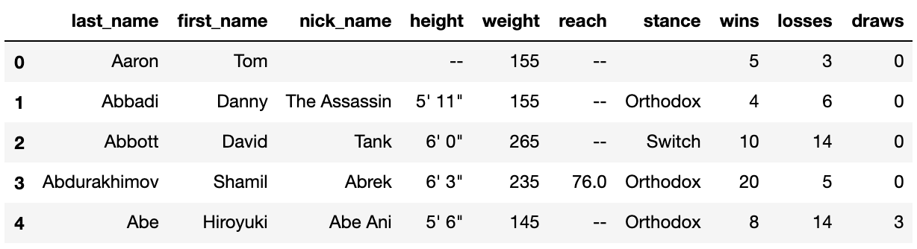

**Data Wrangling — Cleaning and Feature Engineering**

The scraping was a success. I now had information on every fighter in the UFC organisation, and even better, it was data provided from the organisation itself, therefore it was bound to be of high quality and ready for analysis.

Not quite.

As can be seen from the DataFrame above, much of the information was missing. For some fighters, details such as height, reach and stance were absent, despite these being the most basic stats. As the focus of this analysis was on stance, all fighters without an entry in the stance column were omitted. Unfortunately this reduced the number of fighters contained in the dataset from 3405 to 2571. Ouch!

Then came some feature engineering, which means transforming raw features (wins, losses, draws) into new features that are more useful for the analysis. I needed to create a standardised metric for gauging each fighter’s success rate. Two methods came to mind:

1. Win : loss ratio (total wins / total losses)
2. Win : total fights ratio (total wins / total number of fights)

The issue with the win:loss ratio was that if a fighter was undefeated, the ratio would be infinite as there would be a division by 0. The win:total fight ratio was therefore my metric of choice. However, new fighters posed a problem for this method as well. If a new addition to the UFC family had a 100% win rate after their first fight it would skew the results and reduce the quality of any insights from this analysis. I only wanted fighters that had sufficiently proven themselves to be in the analysis, so I removed all individuals with fewer than 5 fights. This reduced the number of rows in the DataFrame from 2571 to 2421.

The breakdown of the remaining dataset was as such:

* Orthodox — 1886 fighters
* Southpaw — 430 fighters
* Switch — 98 fighters
* Open Stance — 6 fighters
* Sideways — 1 fighters

Data cleaning up to this point had indirectly removed all but one sideways stance fighter and almost all open stance individuals too. Due to the tiny sample size of both of these categories I removed these stances from the analysis.

**Statistical Analysis — Time to Answer the Question!**

The data had been wrestled and wrangled and now it was ready for visualisation. Upon first glance it appeared that orthodox and southpaw fighters have a very similar spread of win ratios. This was surprising as being a southpaw is normally seen as an advantage. It also looked as if switch fighters have more success than both orthodox and southpaw fighters. This came as less of a surprise.



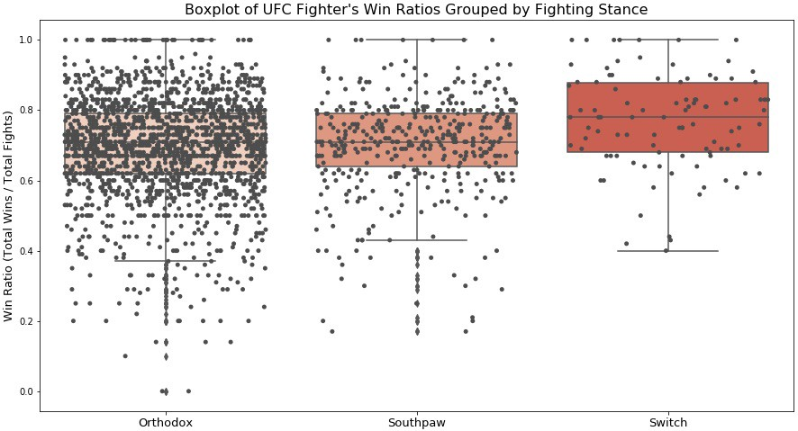

As a data scientist I couldn’t accept my interpretation of the boxplot as fact, it could just be down to chance that switch fighters have won more often. To determine if a statistically significant difference existed, a one-way ANOVA (Analysis of Variance) test was needed. There are two assumptions that must be met for a one-way ANOVA to be a valid method of analysis for this dataset:

1. The distribution of residuals (the difference between each data point and the mean of its group) must be normal.
2. The groups must be homoscedastic (of equal variance).

To check the distribution of residuals I used the statsmodels library to create a Q-Q plot. This plots the theoretical quantiles (normally distributed) against the sample quantiles. The graph is fairly linear, meaning that the distribution is close to normal. The one-way ANOVA test is robust enough to handle a slight violation of the normality condition, therefore I considered the first assumption to be satisfied.



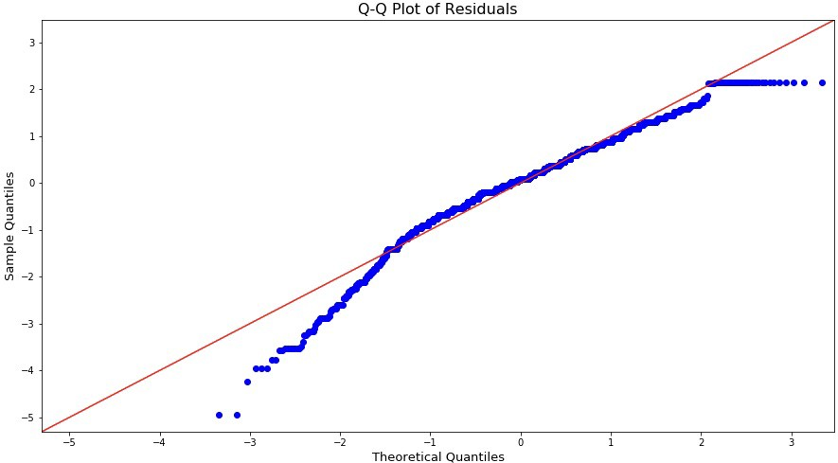

To test for homoscedasticity I used a Levene test from the scipy library. This returned a P-value greater than the 0.05 threshold I had set, meaning the groups were homoscedastic and the second condition of ANOVA was satisfied.

The two hypotheses for the ANOVA test were as follows:

* H0 (Null) — there is no difference in orthodox, southpaw and switch fighters’ win ratios.
* Ha (Alternative) — there is a difference between orthodox, southpaw and switch fighters’ win ratios.

I used the statsmodels library again to conduct the ANOVA. It returned a P-value that was below a predetermined threshold of 0.05, even when considering a Bonferroni correction to reduce the chance of false positives. This meant that I should reject the null hypothesis and that there is indeed a significant difference between the win ratios of the stances. However, the ANOVA test does not tell us between which groups the differences lie.

To find out exactly which stances perform differently from each other I conducted a Tukey’s HSD test, again from the statsmodels library. The table below shows that the null hypothesis should be rejected for the Orthodox-Switch comparison, and the Southpaw-Switch comparison. For the Orthodox-Southpaw comparison the null hypothesis should be accepted; that is to say that there is no significant difference between the win ratios of orthodox and southpaw fighters.

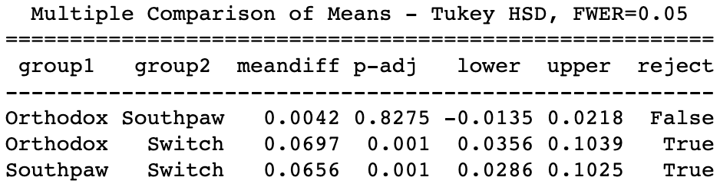

Next, the effect size of the significant pair-wise comparisons were calculated using Cohen’s d formula. This yielded the following results:

* Orthodox-Switch: d = 0.46
* Southpaw-Switch: d = 0.45

An effect size of less than 0.2 is considered small and a value over 0.8 is considered large. The larger the effect size, the stronger relationship is between variables; meaning an effect size of approximately 0.5 suggests that there is a fairly strong relationship between a fighter’s stance and win:total fights ratio when considering switch vs orthodox and southpaw.

The mean win ratio for each stance were as follows:

* Orthodox: 0.70
* Southpaw: 0.70
* Switch: 0.76

**Interpretation of Results**

Dr Loffing’s study of left handed athletes found that the representation of left handed people was greater for sports with higher time pressures. He found that baseball, cricket and table tennis were the fastest paced sports and these also had the highest number of left handed athletes. Dr Scott Hardie of the University of Abertay proposed that this “may be due to the way that left-handers [are] able to deal with fast-paced information³,” resulting in faster reaction times.



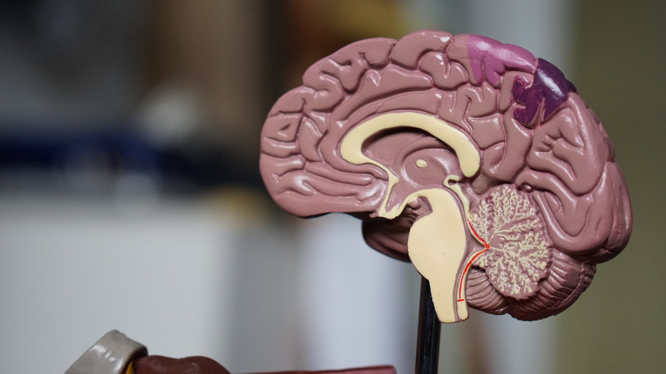

Could the answer lie in the cognitive differences between lefties and righties? <https://unsplash.com/photos/3KGF9R_0oHs>

One Austrian study published by the journal of Neuropsychology in 2006 found that lefties had significantly faster inter-hemispheric transfer times⁴ (communication between the left and right hemispheres of the brain). So scientific findings say it’s possible that left handed athletes have some cognitive advantage, but it has yet to be proven that this is the main cause for the overrepresentation of lefties in professional sports.

From the fighters in the dataset that had information on their stance I found that 22% were southpaws. This is over double the representation of left handers in the general population! Is this because of their faster reaction times? Possibly, but if so then we would also expect to see them have a higher win ratio than orthodox fighters, which we don’t. As mentioned at the beginning of the article, another possible reason for this is that at lower levels of competition, fighters are less exposed to unorthodox opponents, thus giving the unorthodox individuals an edge, resulting in a higher representation at an elite level. However, once at this elite level, their success is not higher than other stances because fighters prepare relentlessly in training camp against sparring partners of a similar style to their fight night opponent. This may eliminate any surprise advantage of a southpaw.

So why do switch fighters have a higher win ratio than the other stances? The reasons are probably as one would expect:

* The first being that switch fighters may just have more arrows in their quiver. They are able to strike and defend from more angles, throwing off their opponent’s game plan when they switch stance mid-bout.
* The second reason being that when preparing for a switch opponent, a fighter must dedicate time preparing for an orthodox opponent and a southpaw opponent which results in less preparation for both styles.

Sorry Conor, southpaw fighters aren’t more successful in the octagon. (<https://giphy.com/conormcgregor>)

**Improvements and Future Projects**

As you have probably already noticed, the sample size of switch fighters was very small for this analysis. For any statistical analysis, a larger sample size is always preferred as it reduces the role that chance plays in any of your findings. If anyone is interested in conducting a similar analysis of their own I would suggest expanding your data sources to include other MMA organisations such as Bellator and One Championship. In fact the scope of the analysis could be broadened to incorporate other combat sports such as boxing and Muay Thai, as the same principles of fighter stance apply.

Looking forward, it is a personal goal of mine to create a UFC fight predictor. This would allow a user to input any two fighters from the organisation, and using machine learning algorithms it would output the percentage chance of each fighter winning. If this is of interest to you then stay tuned in the coming months. For now, thank you for reading!

**Citations**

[1] Dr Florian Loffing, Left-handedness and time pressure in elite interactive ball games (2017)

**[Left-handedness and time pressure in elite interactive ball games](https://royalsocietypublishing.org/doi/10.1098/rsbl.2017.0446" \t "_blank)**

[Frequency-dependent selection can ensure the maintenance of polymorphisms in animal and non-animal species [ 1, 2]. In…](https://royalsocietypublishing.org/doi/10.1098/rsbl.2017.0446" \t "_blank)

[royalsocietypublishing.org](https://royalsocietypublishing.org/doi/10.1098/rsbl.2017.0446" \t "_blank)

[2] UFC Fighter Statistics

**[Stats | UFC](http://www.ufcstats.com/statistics/fighters?char=a&page=all" \t "_blank)**

[Edit description](http://www.ufcstats.com/statistics/fighters?char=a&page=all" \t "_blank)

[www.ufcstats.com](http://www.ufcstats.com/statistics/fighters?char=a&page=all" \t "_blank)

[3] The Guardian: Dr Scott Hardie

**[Why do left-handers excel at certain elite sports but not others?](https://www.theguardian.com/science/2017/nov/22/why-do-left-handers-excel-at-certain-elite-sports-but-not-others" \t "_blank)**

[From cricketer Wasim Akram to baseball pitcher Clayton Kershaw and table tennis star Ding Ning, the world of sport has…](https://www.theguardian.com/science/2017/nov/22/why-do-left-handers-excel-at-certain-elite-sports-but-not-others" \t "_blank)

[www.theguardian.com](https://www.theguardian.com/science/2017/nov/22/why-do-left-handers-excel-at-certain-elite-sports-but-not-others" \t "_blank)

[4] Cherbuin N, Brinkman C, Hemispheric interactions are different in left-handed individuals (2006)

**[Hemispheric interactions are different in left-handed individuals.](https://www.ncbi.nlm.nih.gov/pubmed/17100514" \t "_blank)**

[Neuropsychology. 2006 Nov;20(6):700-7.](https://www.ncbi.nlm.nih.gov/pubmed/17100514" \t "_blank)

[www.ncbi.nlm.nih.gov](https://www.ncbi.nlm.nih.gov/pubmed/17100514" \t "_blank)

**[Towards Data Science](https://towardsdatascience.com/?source=post_sidebar--------------------------post_sidebar-)**

A Medium publication sharing concepts, ideas, and codes.

[Follow](https://medium.com/m/signin?operation=register&redirect=https%3A%2F%2Ftowardsdatascience.com%2Fdata-science-meets-ufc-does-a-fighters-stance-really-give-them-an-advantage-fdc6141f6e29&source=post_sidebar--------------------------follow_sidebar-)

40

Thanks to Yenson Lau.

* [UFC](https://towardsdatascience.com/tagged/ufc)
* [Data Science](https://towardsdatascience.com/tagged/data-science)
* [Statistical Analysis](https://towardsdatascience.com/tagged/statistical-analysis)
* [Combat Sports](https://towardsdatascience.com/tagged/combat-sports)
* [Python](https://towardsdatascience.com/tagged/python)

40 claps

[[](https://towardsdatascience.com/@ravimalde?source=follow_footer--------------------------follow_footer-)](https://towardsdatascience.com/@ravimalde?source=follow_footer--------------------------follow_footer-)

WRITTEN BY

[**Ravi Malde**](https://towardsdatascience.com/@ravimalde?source=follow_footer--------------------------follow_footer-)

[Follow](https://medium.com/m/signin?operation=register&redirect=https%3A%2F%2Ftowardsdatascience.com%2Fdata-science-meets-ufc-does-a-fighters-stance-really-give-them-an-advantage-fdc6141f6e29&source=follow_footer-145818fddbcd-------------------------follow_footer-)

Data Scientist | Machine Learning Engineer

[](https://towardsdatascience.com/?source=follow_footer--------------------------follow_footer-)

[**Towards Data Science**](https://towardsdatascience.com/?source=follow_footer--------------------------follow_footer-)

[Follow](https://medium.com/m/signin?operation=register&redirect=https%3A%2F%2Ftowardsdatascience.com%2Fdata-science-meets-ufc-does-a-fighters-stance-really-give-them-an-advantage-fdc6141f6e29&source=follow_footer--------------------------follow_footer-)

A Medium publication sharing concepts, ideas, and codes.

[Write the first response](https://medium.com/p/fdc6141f6e29/responses/show?source=follow_footer--------------------------follow_footer-)

**More From Medium**

[**10 Smooth Python Tricks For Python Gods**](https://towardsdatascience.com/10-smooth-python-tricks-for-python-gods-2e4f6180e5e3?source=post_internal_links---------0------------------)

[Emmett Boudreau](https://towardsdatascience.com/@emmettgb?source=post_internal_links---------0------------------) in [Towards Data Science](https://towardsdatascience.com/?source=post_internal_links---------0------------------)

[[](https://towardsdatascience.com/10-smooth-python-tricks-for-python-gods-2e4f6180e5e3?source=post_internal_links---------0------------------)](https://towardsdatascience.com/10-smooth-python-tricks-for-python-gods-2e4f6180e5e3?source=post_internal_links---------0------------------)

[[](https://towardsdatascience.com/10-smooth-python-tricks-for-python-gods-2e4f6180e5e3?source=post_internal_links---------0------------------)](https://towardsdatascience.com/10-smooth-python-tricks-for-python-gods-2e4f6180e5e3?source=post_internal_links---------0------------------)

[**How to process a DataFrame with billions of rows in seconds**](https://towardsdatascience.com/how-to-process-a-dataframe-with-billions-of-rows-in-seconds-c8212580f447?source=post_internal_links---------1------------------)

[Roman Orac](https://towardsdatascience.com/@romanorac?source=post_internal_links---------1------------------) in [Towards Data Science](https://towardsdatascience.com/?source=post_internal_links---------1------------------)

[[](https://towardsdatascience.com/how-to-process-a-dataframe-with-billions-of-rows-in-seconds-c8212580f447?source=post_internal_links---------1------------------)](https://towardsdatascience.com/how-to-process-a-dataframe-with-billions-of-rows-in-seconds-c8212580f447?source=post_internal_links---------1------------------)

[[](https://towardsdatascience.com/how-to-process-a-dataframe-with-billions-of-rows-in-seconds-c8212580f447?source=post_internal_links---------1------------------)](https://towardsdatascience.com/how-to-process-a-dataframe-with-billions-of-rows-in-seconds-c8212580f447?source=post_internal_links---------1------------------)

[**A Better Way To Become A Data Scientist Than Online Courses**](https://towardsdatascience.com/a-better-way-to-become-a-data-scientist-than-online-courses-2abc343d4d55?source=post_internal_links---------2------------------)

[Chris](https://towardsdatascience.com/@chris.the.data.scientist?source=post_internal_links---------2------------------) in [Towards Data Science](https://towardsdatascience.com/?source=post_internal_links---------2------------------)

[[](https://towardsdatascience.com/a-better-way-to-become-a-data-scientist-than-online-courses-2abc343d4d55?source=post_internal_links---------2------------------)](https://towardsdatascience.com/a-better-way-to-become-a-data-scientist-than-online-courses-2abc343d4d55?source=post_internal_links---------2------------------)

[[](https://towardsdatascience.com/a-better-way-to-become-a-data-scientist-than-online-courses-2abc343d4d55?source=post_internal_links---------2------------------)](https://towardsdatascience.com/a-better-way-to-become-a-data-scientist-than-online-courses-2abc343d4d55?source=post_internal_links---------2------------------)

[**3 Reasons why you Shouldn’t become a Data Scientist**](https://towardsdatascience.com/3-reasons-why-you-shouldnt-become-a-data-scientist-93cfeb9a6ce7?source=post_internal_links---------3------------------)

[Dario Radečić](https://towardsdatascience.com/@radecicdario?source=post_internal_links---------3------------------) in [Towards Data Science](https://towardsdatascience.com/?source=post_internal_links---------3------------------)

[[](https://towardsdatascience.com/3-reasons-why-you-shouldnt-become-a-data-scientist-93cfeb9a6ce7?source=post_internal_links---------3------------------)](https://towardsdatascience.com/3-reasons-why-you-shouldnt-become-a-data-scientist-93cfeb9a6ce7?source=post_internal_links---------3------------------)

[[](https://towardsdatascience.com/3-reasons-why-you-shouldnt-become-a-data-scientist-93cfeb9a6ce7?source=post_internal_links---------3------------------)](https://towardsdatascience.com/3-reasons-why-you-shouldnt-become-a-data-scientist-93cfeb9a6ce7?source=post_internal_links---------3------------------)

[**How to Build a Data Science Portfolio Website**](https://towardsdatascience.com/how-to-build-a-data-science-portfolio-website-335b0f253822?source=post_internal_links---------4------------------)

[Julia Nikulski](https://towardsdatascience.com/@julia.nikulski?source=post_internal_links---------4------------------) in [Towards Data Science](https://towardsdatascience.com/?source=post_internal_links---------4------------------)

[[](https://towardsdatascience.com/how-to-build-a-data-science-portfolio-website-335b0f253822?source=post_internal_links---------4------------------)](https://towardsdatascience.com/how-to-build-a-data-science-portfolio-website-335b0f253822?source=post_internal_links---------4------------------)

[[](https://towardsdatascience.com/how-to-build-a-data-science-portfolio-website-335b0f253822?source=post_internal_links---------4------------------)](https://towardsdatascience.com/how-to-build-a-data-science-portfolio-website-335b0f253822?source=post_internal_links---------4------------------)

[**Coding Mistakes I Made As A Junior Developer**](https://towardsdatascience.com/coding-mistakes-i-made-as-a-junior-developer-e151dd3b3c7d?source=post_internal_links---------5------------------)

[Chris](https://towardsdatascience.com/@chris.the.data.scientist?source=post_internal_links---------5------------------) in [Towards Data Science](https://towardsdatascience.com/?source=post_internal_links---------5------------------)

[[](https://towardsdatascience.com/coding-mistakes-i-made-as-a-junior-developer-e151dd3b3c7d?source=post_internal_links---------5------------------)](https://towardsdatascience.com/coding-mistakes-i-made-as-a-junior-developer-e151dd3b3c7d?source=post_internal_links---------5------------------)

[[](https://towardsdatascience.com/coding-mistakes-i-made-as-a-junior-developer-e151dd3b3c7d?source=post_internal_links---------5------------------)](https://towardsdatascience.com/coding-mistakes-i-made-as-a-junior-developer-e151dd3b3c7d?source=post_internal_links---------5------------------)

[**Data Classes in Python**](https://towardsdatascience.com/data-classes-in-python-8d1a09c1294b?source=post_internal_links---------6------------------)

[Halil Yıldırım](https://towardsdatascience.com/@halilylm?source=post_internal_links---------6------------------) in [Towards Data Science](https://towardsdatascience.com/?source=post_internal_links---------6------------------)

[[](https://towardsdatascience.com/data-classes-in-python-8d1a09c1294b?source=post_internal_links---------6------------------)](https://towardsdatascience.com/data-classes-in-python-8d1a09c1294b?source=post_internal_links---------6------------------)

[[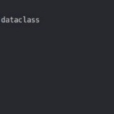](https://towardsdatascience.com/data-classes-in-python-8d1a09c1294b?source=post_internal_links---------6------------------)](https://towardsdatascience.com/data-classes-in-python-8d1a09c1294b?source=post_internal_links---------6------------------)

[**A Single Line of Python Code Scraping Dataset from Webpages**](https://towardsdatascience.com/a-single-line-of-python-code-scraping-dataset-from-webpages-c9d2a8805d61?source=post_internal_links---------7------------------)

[Christopher Tao](https://towardsdatascience.com/@qiuyujx?source=post_internal_links---------7------------------) in [Towards Data Science](https://towardsdatascience.com/?source=post_internal_links---------7------------------)

[[](https://towardsdatascience.com/a-single-line-of-python-code-scraping-dataset-from-webpages-c9d2a8805d61?source=post_internal_links---------7------------------)](https://towardsdatascience.com/a-single-line-of-python-code-scraping-dataset-from-webpages-c9d2a8805d61?source=post_internal_links---------7------------------)

[[](https://towardsdatascience.com/a-single-line-of-python-code-scraping-dataset-from-webpages-c9d2a8805d61?source=post_internal_links---------7------------------)](https://towardsdatascience.com/a-single-line-of-python-code-scraping-dataset-from-webpages-c9d2a8805d61?source=post_internal_links---------7------------------)

**[Discover Medium](https://medium.com/about?autoplay=1&source=post_page-----fdc6141f6e29----------------------)**

Welcome to a place where words matter. On Medium, smart voices and original ideas take center stage - with no ads in sight. [Watch](https://medium.com/about?autoplay=1&source=post_page-----fdc6141f6e29----------------------)

**[Make Medium yours](https://medium.com/topics?source=post_page-----fdc6141f6e29----------------------)**

Follow all the topics you care about, and we’ll deliver the best stories for you to your homepage and inbox. [Explore](https://medium.com/topics?source=post_page-----fdc6141f6e29----------------------)

**[Become a member](https://medium.com/membership?source=post_page-----fdc6141f6e29----------------------)**

Get unlimited access to the best stories on Medium — and support writers while you’re at it. Just $5/month. [Upgrade](https://medium.com/membership?source=post_page-----fdc6141f6e29----------------------)

[About](https://medium.com/about?autoplay=1&source=post_page-----fdc6141f6e29----------------------)

[Help](https://help.medium.com/?source=post_page-----fdc6141f6e29----------------------)

[Legal](https://medium.com/policy/9db0094a1e0f?source=post_page-----fdc6141f6e29----------------------)