Cyberwatch V1B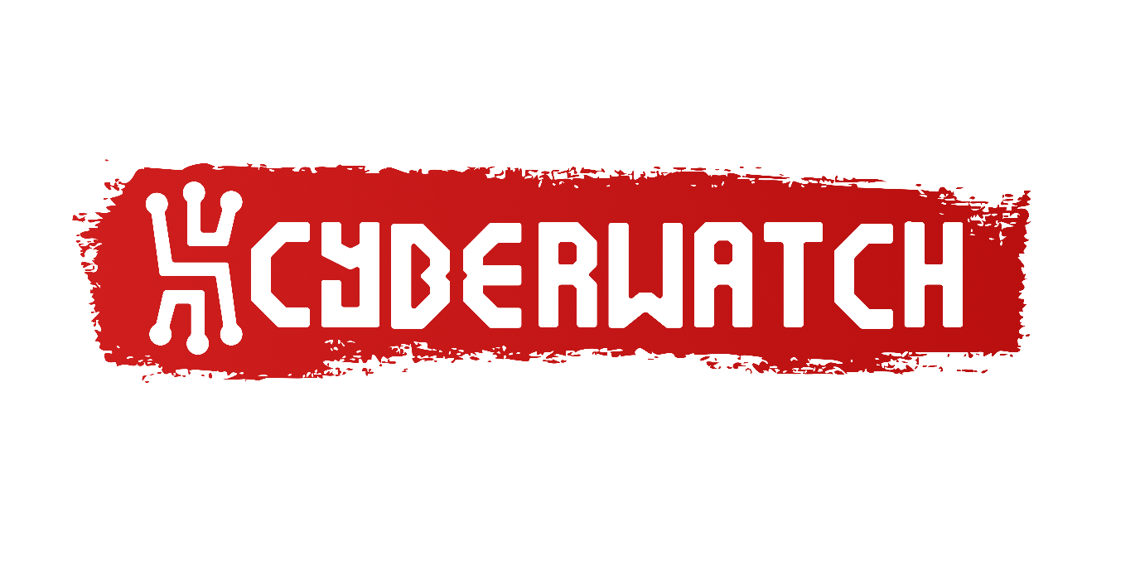

0.0 Introduction
Cyberwatch is a simple, versatile smartwatch with its own operating system called “Cyan”, for custom-made apps and tracking time. It is to a smartwatch what a “cyberdeck” is to a computer: open ended and reprogrammable.
A cyberdeck or cyber deck is a custom-built, portable personal computer, often one designed for a particular individualized purpose and usually with a cyberpunk aesthetic.[1] These devices are typically individually crafted, powered by laptop motherboards or single-board computers (SBCs), such as Raspberry Pis, and include a display and keyboard
A coloured 1.69-inch LCD display shows the time, date and battery charge. The device is designed to operate for at least 24 hours on a single charge, and be recharged through a USB-C connection. A custom-built real time operating system called “Cyan” is responsible for managing hardware and the user interface. User interaction is facilitated by three physical buttons and a rotary crown, which can also be pressed as a button. The device measures x-mm by y-mm by z-mm. Cyberwatch began as an embedded systems project and a way to demonstrate my engineering ability. The longer-term ambition is more personal: to build a watch I genuinely want to wear, understand, repair and improve for as long as I am able. It is meant to work as a stand-alone device rather than an extension of a smartphone. It is not designed to track you or harvest your data. It is designed to be a useful tool, dependable and arguably more importantly: joyful.
Cyan is designed to target an ESP32 microcontroller, but is designed with platform abstraction in mind. This allows parts of the software to run on a PC for faster development and iteration, while the Cyberwatch hardware remains its primary platform for deployment.

0.1 Executive Summary
standalone one-page summary…

0.2 Index
Table of Contents
0.0 Introduction 1
0.1 Executive Summary 1
0.2 Index 1
1.0 Technical Overview 2
1.1 Functional Requirements 2
1.2 Non-Functional Requirements 2
1.3 System Architecture 2
2.0 Hardware Design 3
2.1 Power System 3
2.2 Electronic Components 3
2.3 PCB Design 3
2.4 Structural Design 3
2.5 Mechanical Design 3
3.0 Software Design 3
3.1 Cyan 3
3.2 User Interface 4
3.2.1 Cyan Watch-Face Tab 4
3.2.2 Cyan App Catalogue Tab 4
3.2.3 Cyan Timer Tab 4
3.2.4 Cyan Stopwatch Tab 5
3.3 Application System 5
3.4 Hardware Abstraction 5
3.5 PC Platform 6
3.6 Settings & Configuration 6
3.7 Remote Shell 6
4.0 Testing and Verification 6
5.0 Development History 6
5.1 Hardware Decisions 6
5.2 Software Decisions 7

Technical Overview

All requirements are assigned a reference number in the format of FR/NFR for Functional Requirement or Non Functional Requirement respectively, followed by a dash, then a category, then a number that is unique inside it’s given category.
Requirement Categories:
- A: User Interaction
- B: Display
- C: Application Handling
- D: System Management
- E: Platform Agnosticism
Change this to:
FR:
- A: Application Handling
- B: User Interaction
- C: System Management
- D: Display
NFR:
- P: Performance - rendering rate, input latency, response times
- W: Power & Endurance - battery life, charging, sleep current
- R: Reliability - graceful degradation, crash recovery, watchdog behaviour, app isolation
- M: Maintainability - platform abstraction, build separation, testability
- U: Usability - legibility at a glance, button feel, one-handed operation

1.1 Functional Requirements

Reference | Requirement Name | Description | Acceptance Criterion | Verification Method | Status
FR-A001 | Button Input | Cyberwatch shall accept input from three physical buttons.
FR-A002 | Rotary Input | Cyberwatch shall accept rotational input from the rotary crown.
FR-A003 | Crown Button | Cyberwatch shall detect presses of the rotary crown.
FR-B001 | Time Display | Cyberwatch shall display the current time.
FR-B002 | Date Display | Cyberwatch shall display the current date.
FR-B003 | Battery Status | Cyberwatch shall display the current battery charge level.
FR-B004 | Watch Face | Cyan shall provide a watch-face interface.
FR-B005 | Timer | Cyan shall provide a timer function.
FR-B006 | Stopwatch | Cyan shall provide a stopwatch function.
FR-C001 | Lua Applications | Cyan shall support applications written in Lua.
FR-C002 | Application Storage | Applications shall be stored on the hardware implementation’s SD card.
FR-C003 | Application Catalogue | Cyan shall provide an application catalogue from which installed applications can be selected.
FR-C004 | Application API | Cyan shall provide applications with access to supported display and input functionality.
FR-C005 | Application Manifest | Each application shall provide a manifest containing its required application information and services.
FR-D001 | Hardware Initialisation | Cyan shall initialise available hardware during system startup.
FR-D002 | Service Registration | Cyan shall identify available hardware capabilities and register the corresponding services.
FR-D003 | System Status | Cyan shall display the status of subsystems during startup.
FR-D004 | Reduced Capability Operation | Cyan shall continue operation with reduced capabilities when supported hardware or services are unavailable.
FR-E001 | PC Platform | Cyan shall be capable of operating on a PC platform for development and iteration.
FR-E002 | Platform Abstraction | Cyan shall separate platform-specific hardware implementations from platform-independent software functionality.

1.2 Non-Functional Requirements
…

1.3 System Architecture
layered model: hardware -> data/display -> service -> OS -> app
##Create a graphic here##
┌─────────────────────────────┐
│ Applications │ Lua, sandboxed, via App API
├─────────────────────────────┤
│ Cyan OS │ Shell UI, tabs, app lifecycle
├─────────────────────────────┤
│ Service Registry │ Time, Power, Input, Storage…
├─────────────────────────────┤
│ Hardware Abstraction │ Display, data, platform entry
├─────────────────────────────┤
│ Hardware │ ESP32-S3, ST7789, MCP23017…
└─────────────────────────────┘

Services are used to abstract across platform differences and provide a wrapper for the capabilities of the system which can be inspected during runtime. They may be only indirectly related to the underlying hardware, for example: notifications are purely a system capability, whereas storage may be unavailable if a component is missing or faulty – meaning .
Service | ID | Description | Criticality
Time | SERVICE_TIME | Provides current date and time from the platform RTC or system clock | HIGH
Power | SERVICE_POWER | Battery level, charge state, sleep and shutdown control | HIGH
Display | SERVICE_DISPLAY | Reports display dimensions to platform-independent code | HIGH
Input | SERVICE_INPUT | Polls physical buttons and rotary crown events | HIGH
Input Display | SERVICE_INPUT_DISPLAY | Pointer input for touchscreen or mouse | LOW
Storage | SERVICE_STORAGE | File read/write via the platform’s storage medium | HIGH
Network | SERVICE_NETWORK | WiFi connectivity and signal strength | MED
Bluetooth | SERVICE_BLUETOOTH | Bluetooth connection state | MED
Notifications | SERVICE_NOTIFICATIONS | Pending notification count from paired device | MED
Location | SERVICE_LOCATION | (reserved) | LOW
Audio | SERVICE_AUDIO | (reserved) | LOW
Vibration | SERVICE_VIBRATION | (reserved) | LOW

2.0 Hardware Design
…

2.1 Power System
…

2.2 Electronic Components
…

2.3 PCB Design
…

2.4 Structural Design
Enclosure/case etc…
2.5 Mechanical Design
- dial: bearing, magnet, tolerances

3.0 Software Design
…

3.1 Cyan
Cyan is the home-brewed operating system, custom built for the Cyberwatch hardware. On startup, Cyan will display a splash-screen and exhibit the Cyan logo.


It will then load hardware capabilities and register services, checking the health of each system step by step. Cyan is designed to run with reduced capabilities, meaning it is robust against failure when hardware does not meet full expectations (see §1.3 System Architecture for details on Service handling). Displaying each sub-system’s status during boot. Once startup is complete, the user is taken to the watch-face - the first of four tabs Cyan provides: (1) Watch-face, (2) App Catalogue, (3) Timer, (4) Stopwatch. (elaborated on in §3.2 User Interface).

3.2 User Interface
A crucial library chosen for Cyan is Nic Barker’s Clay. A lightweight real time, and importantly, platform agnostic layout engine. The UI is first laid out using Clay and is then passed on to the renderer - which is implementation specific. During native targeting the rendering engine used is SDL3, whereas Arduino GFX supports hardware on the ESP32. The user interface is recalculated each updated, meaning it is event driven. This works well with Clay’s immediate mode architecture as recalculating the entire layout from scratch is very simple, but this can be slightly more intensive than persistent UI elements allowing the rendering loop to skip a portion of the screen altogether. Fortunately, immediate mode UIs also have the added benefit of robustness: because everything is recalculated from scratch each time, there are no miscalculations that can survive across frames. After layout calculations are complete, the list of render commands is interpreted by either the SDL3 Clay backend or a custom-built receptacle for ArduinoGFX, converting layout commands into draw commands.
Sometimes for avoiding complexity, Clay is bypassed as the primary mode of display-management. For example: during app execution…

3.2.1 Cyan Watch-Face Tab

The watch-face is a simple UI for showing the current time in a format of the user’s choice, stored as setting #xthe day of the week and current date, also configurable using settings #y and #z respectively.
This is achieved by storing a time object and character buffers which are written to each update.
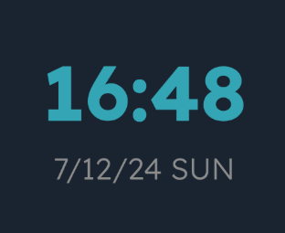

Allowing Cyan to retrieve the date and time from the current platform and produce a string which is then displayed on screen using Clay’s in-built String object.

3.2.2 Cyan App Catalogue Tab
…

3.2.3 Cyan Timer Tab
…

3.2.4 Cyan Stopwatch Tab
…

3.3 Application System
Cyan provides support for applications written in Lua. These applications, on the hardware implementation, are stored on the SD card, inside of the root folder “apps/”. Each app has its own folder, containing a Lua script, a thumbnail image and a manifest file also written in Lua – this allows for a simpler implementation than writing an additional interpreter for a JSON manifest. During startup, Cyan scans through all subdirectories inside of the apps/ folder and spins up a temporary Lua instance to read manifest files into an app object, storing information such as the name of the app, the file address to the app thumbnail and the services the app will require (e.g. WiFi).
Once an app has been selected to launch from the app catalogue, a new Lua instance is created to interpret the app’s script in real time. To exit an application, the user can press button one.
An API is exposed to the application, allowing draw calls and input events to be transacted between the operating system and a running application. All visuals produced by the application are rendered to a surface target abstraction, allowing the app to display inside of the pre-existing UI by converting the in-app coordinates to global screen coordinates after the layout step is completed.
API Draw Calls
Name | In App  Signature | Backend Signature | Effect
Draw Rectangle | draw.rect  (x, y, w, h, r, g, b) | AppHandler _draw_rect  (lua_State *L) | Draws a rectangle using specified quad and colour.
Draw Text | draw.text  (x, y,  text,  font_size,  r, g, b) | AppHandler_draw_text  (lua_State *L) | Prints text on screen at the given coordinate
Draw Width |  | AppHandler _draw_rect  (lua_State *L)
Draw Height

3.4 Hardware Abstraction
…

3.5 PC Platform
SDL etc

3.6 Settings & Configuration
- standalone, no Lua dependency

3.7 Remote Shell
- serial now, WiFi later

4.0 Testing and Verification
retrospective: hardware bring-up discipline
prospective: planned Unity tests

5.0 Development History
…

5.1 Hardware Decisions

MCU
- ESP32-S3 over C3 for primary target; C3 kept as reduced-capability build
- XIAO ESP32-S3 Plus over base S3 and Waveshare S3-Zero
- module, not bare IC (V1) - isolates RF risk to V2
DISPLAY
- Waveshare 1.69" ST7789V2, 240x280 SPI
- JST GH 1.25mm 8-pin - custom symbol built, no Plus-specific footprint found
I/O EXPANSION
- MCP23017 for I2C GPIO (buttons + display RST/BL)
- SOIC (-SO) over QFN (-ML) - hand-solderability
RTC
- DS3231 family - free built-in temp sensor
- DS3231MZ (SOIC-8) over DS3231M (SOIC-16) - same specs, smaller
- RV-3028-C7 rejected for V1 (leadless) - deferred to V2
- CR1220 over CR2032 - smaller, shorter but replaceable backup life
- no trickle-charge circuit - real fire-risk finding, deliberately omitted
ROTARY INPUT
- AS5600 (Hall-effect I2C) over mechanical encoder - sealed, contactless
- SOIC-8 footprint verified against real datasheet dims
- footprint sourced from KiCad's own library, not unverified SnapEDA
- MLX92213 rejected - wrong sensor category (binary latch, not angle)
- ADA4570BRZ rejected - needs external ADC, wrong complexity for use case
- bearing material - still open, deferred to empirical test

STORAGE
- bare microSD socket, not breakout module
- SPI mode over SDIO - fewer pins
- SCK/MOSI shared with display bus, each device own CS
POWER
- AO3401 P-MOSFET for isolation - raw switch undersized for WiFi burst current
- MAX17048 fuel gauge - simple, proven, official Espressif driver
(MAX17055 deferred to V2 - more accurate, more complex)
- JST-PH 2.0mm 2-pin for main battery
PASSIVES
- I2C pull-ups: 4.7k, per AS5600 datasheet
- SD pull-ups: 10k, per Espressif ESP-IDF docs

5.2 Software Decisions
…

