**adnasjkdkhajdhkjadnsk**

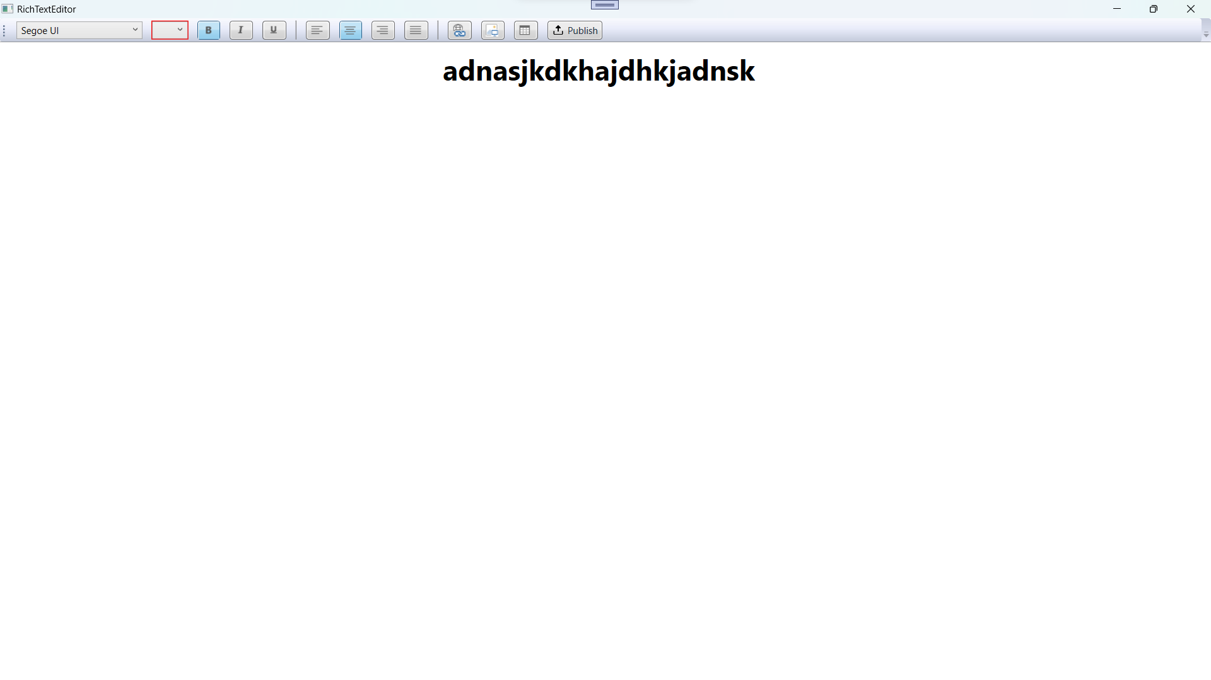

**adnasjkdkhajdhkjadnsk**



**adnasjkdkhajdhkjadnsk**



**adnasjkdkhajdhkjadnsk**



**adnasjkdkhajdhkjadnsk**

