\section{Introduction}
\subsection{Problematic}
\subsubsection{Current Status of Infectious Diseases}
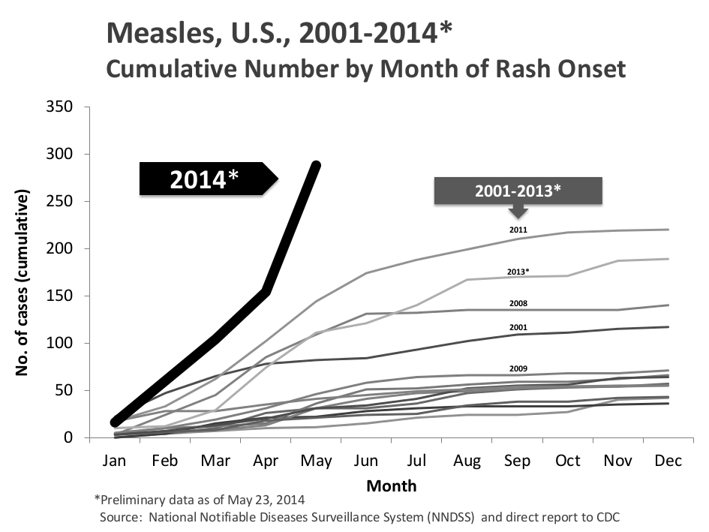
According to the 2004 Global Burden of Disease report of the world Health Organization, infectious disease is the leading cause of death of children and adolescents, and one of the main causes in adults. Infectious disease brings for six of the top 20 leading causes of death worldwide. In low-income countries, infectious disease represents six of the top 10 most common causes of death. This thesis is proposed in the context when the world started struggling with a global recession and in the same time, many public health serious events have occurred in the world : SRAS in 2003, avian influenza in 2004 or swine flu in 2009, etc. Besides, we had to face up to “re-emerging” infectious diseases that were thought to be waning. For example, particularly and quite surprisingly one of the vaccine-preventable diseases is measles that returned backs in all the world and much stronger than before. At the start of 2014, the World Health Organization (WHO) officially stated global measles epidemic outbreak. In the first three months of the year 2014, there were about 56,000 cases of measles infections in 75 countries, particularly in southeast Asia and in Vietnam. More specially, in the United States, measles cases significantly rose in 2014, 14 years after national leaders stated that the disease had been disappeared within the country. There were 288 cases of measles reported in the U.S between Jan. 1 and May 23, 2014 as in figure \cite{fig:measlesUS20012014}. To explain this sudden outbreak of the measles, epidemiologist found out that the reasons are strongly relative to international travel by unvaccinated people (particularly U.S. residents), and incomplete vaccination that the American government doesn't control.

Moreover, the world has to face up new infectious diseases that were once unknown or already known in past but totally to be waning, such as Ebola epidemic, in the same year to the measles. The Ebola epidemic is the largest in human history, affecting almost all countries in West Africa. To date, the WHO have reported a total of 28,575 suspected cases and 11,313 deaths. However, it is numbers in documents understated for the magnitude of the outbreak. Now, in Liberia, the government was officially stated Ebola-free in May 2015, however new cases were found in late June and early July. The world suffered two large epidemics in the same year, this has stressed the importance of the epidemiological phenomena anticipation when diseases occur. Many studies proposed by the WHO, the Pasteur Institute and the Inserm in the field of environmental security have tried to understand disease phenomena and spread of disease over a territory, to better manage when diseases occur.
Hence, infectious diseases is becoming more complex, and more variant. We are difficult to well control the spread of infectious diseases even vaccine-preventable diseases as meals.

With the current epidemic state of the world, the main reasons to explain the reemergence of old communicable diseases and the emergence of new ones as follows :
- changes of environment where we live in :
  - (1) Increased movements of people,
  - (2) expansion of international trade in foodstuffs and medicinal biological products,
  - (3) social and environmental changes linked to urbanization,
  - (4) deforestation,
→ these four reasons change rapidly the nature of the world where we live in, but our human is not becoming to. However, the main agents of infectious diseases such as bacterial, fungal, parasitic, and viral already rapidly adapt to new environment.
- Evolution of drugs that is used for the curative treatments of infectious disease, have become less effective and developed less slowly than the adaption of parasites.
Hence, we are preceding two great challenges :
- we keep on promoting the evolution of antimicrobial resistance for infectious disease.
- It is necessary to understand the environmental factors that contribute to the emergence and re-emergence of infectious diseases and the process of disease spread to develop tools that will enable detecting and monitoring of how diseases spread, so that they can be identified and controlled before these infectious disease become pandemics.
Because the evolution of drugs is always slower than the adaption of parasites in environmental changes, thus now we focus on tools that will enable detecting and predicting diseases spread before they become pandemics.

\subsubsection{Disease control}
http://www.pnas.org/content/107/50/21701/F1.expansion.html

Pathogenic microorganisms such as bacteria, viruses, parasites or fungi are key factors causing infectious diseases. The diseases can be spread directly or indirectly from one person to another, through a mediate environment or contaminated tools. As far as directly infectious diseases are concerned, meaning diseases directly transmitted from one person to another, we have some normal policies to prevent the spread of diseases such as vaccines, anti-viral medications, and quarantine.

Quarantine:
Quarantine is a policy to protect the public of disease by separating and restricting the movement of people in community who have or may have a contagious disease.
Advantages:
- Quarantine can be applied to humans as well as animals to protect the spread of disease.
- Quarantine simply is a precautionary measure that breaks the line of transmission from infected individuals to others. This method allows health authorities to prevent further spread of a disease in the case the quarantined individual develops clinical symptoms of the disease of concern.

Disadvantages:
- The main method of the quarantine is to separate and restrict the movement of people in community. This method really is effective in a public health to prevent spread of a disease. However it has to face adverse consequences for civil liberties (ethical and human rights) and economic status (border closures and travel restrictions). Big challenge is proposed how we can guarantee tradeoffs between personal freedom and public good in preparing for a pandemic. \cite{choffnes2007ethical}
- In the case, disease has a long incubation period and do not have highly evident symptoms. Everything needs to be checked for suspected cases,
so can be quite time consuming.
- Quarantine is only effective as a PHYSICAL barrier to disease. Hence, it is not effective for disease of animal, particularly wild birds.
anti-viral medications:
Antiviral medications usually are called drugs used specifically for treating viral infections. Antiviral drugs are medicines in form (pills, liquid, an inhaled powder, or an intravenous solution) that makes the ability of viruses decrease to reproduce. So, these drugs may help reduce the duration of symptoms caused by virus.
Advantages :
- Antiviral drugs are recommended for both treatment and prevention of virus replication. For example, for influenza, within 48 hours of onset of flu symptoms, antiviral drugs work best, but they may still offer benefits when taken later. These medications may reduce the duration of flu by one to two days and prevent severe flu complications. Moreover, when you get the flu, the antiviral drugs is a best choose.
- Current antiviral drugs now are designed to help deal with HIV, herpes, viruses, the hepatitis b and C viruses, and influenza A and B viruses.
Disadvantages:
- Designing safe and effective antiviral drugs is difficult, because viruses use the host's cells to replicate.
- Antiviral drugs sometimes are serious, particularly for children and newborn babies. It is necessary to speak with doctor before making any decisions about medications.
- Antiviral drugs only work best within when taken within 48 hours of onset of flu symptoms. It is not good to prevent diseases before taking diseases. For some diseases that have vaccines, antiviral drugs are a second method of defense to treat diseases if you get it. Vaccines are still the first and best way to prevent diseases.

Vaccination:

A vaccine is understood as a biological preparation that provides active acquired immunity to a particular disease for our body. After having been vaccinated, we transport microorganisms in weakened or killed form of the microbe into our body. The body's immune system produces the right antibodies to recognize the germs as a threat, destroy them and keep a record of them. Because of that, when the disease occurs, our immune system can recognize and destroy with a better chance of success any of these germs that it later encounters. In past, vaccination has greatly helped human beings. The vaccination of influenza, Human Papillomavirus (HPV) and chicken pox have been particularly appreciated. Smallpox is a particular example. It was a big black point in human history during the closing years of the 18th century. Smallpox killed an estimated 400,000 Europeans annually and among the people that luckily survived, a third had been blinded by the disease. However, the WHO officially stated the eradication of smallpox in 2011 \cite{tognotti2010SmallpoxErad,fenner2001SmallpoxErad}. Many infectious diseases are clearly restricted such as influenza, polio, measles and tetanus from much of the world.

Advantages:

- The biggest benefit of vaccine is individual immunity: It provides long-term, sometimes lifelong protection against a disease. The vaccines recommended in the early childhood immunization schedule protect children from common infectious diseases worldwide (measles, chicken pox and other illnesses). As children grow older, additional vaccines protect them from diseases that affect adolescents and adults, as well as for diseases they may encounter during travel to other regions.
- The secondary benefit of vaccination, is herd immunity (or called also community immunity). When vaccination rates in a community is high, so herd immunity can protect people who are unable to receive vaccinations (including newborns and individuals with chronic illnesses) from diseases. Hence, it’s difficult for the disease to gain an outbreak in the community. Vaccination has greatly reduced the burden of infectious diseases.
- Vaccination is different from giving medicine to an unwell child to make them better. The benefits of vaccination are invisible.
Disadvantages:
- The ability of disease outbreak strongly depends on community vaccination rates. Widespread disease outbreaks can occur if the vaccination rates drop below the threshold of herd immunity. Thus, the problem about the vaccination rates is a big problem for countries that have complex geographic system.
- Deciding not to vaccinate children puts them at risk of catching a range of potentially serious, even fatal, diseases.
- Expensive.

In short, we find that among three policies to prevent spread of diseases, the vaccination policies bring more benefits than two methods left. The vaccination policies build a complete immune system against diseases for children in long-term or lifelong. Moreover, vaccines can prevent spread of disease in an entire community. Due to two strong benefits, the vaccination programmes have been deployed in the world. However, according to the U.S. childhood vaccination schedule for children between birth and six years, 14 different diseases are recommended for immunizations. 14 base vaccines must vaccinate children in an obligatory age is a very difficult financial problem for governments as well as parents in low-income countries. To solve the financial problem and at the same time to prevent the disease outbreak in the world, WHO always try to provide more free vaccines for poor countries. But nowadays, no infectious disease is completely eradicated.
One question is posed why the human is still facing up to infectious diseases when most of common infectious disease have vaccines. It is obvious that the thorough knowledge of the disease is essential in order to implement large-scale proper infection control measures and prevention campaigns. The disease transmission methods depend on the characteristics of each disease and the nature of the microorganism that causes it. However, as mentioned above, vaccination rates strongly influences the ability of disease outbreak in the community. If in a community, the rate of vaccinated individuals is more than 80%, so this community is completely protected from a disease. But, in fact, it is very rare to have a community of 80% vaccinated individuals, and more rarely in pour countries.
Our current mass policy (for example the routine measles vaccination policy for measles) that vaccinates the maximum number of children before a certain age, is the oldest (started from the 1950s in the rich countries) and is now the most used. The policy has obtained main result that is a clear decrease of the incidence in most countries. However, due to the nature of this mass policy
the problem of this vaccination policy is too expensive, really ineffective and quite impossible to implement in poor countries, especially in Africa because of both financial and logistical problems. (e.g. the WHO project "Extended Program on Immunization" in Vietnam for the measles extinction before 2012 failed).
Hence, the challenge is posed that there is a way that can help us predict the effective of a vaccination policy before we place it. Because, in fact when a vaccination policy is performed in a country, there is only one policy deployed. One single policy is placed in a community and after a couple of years we can start evaluating the effective of the policy. This is very expensive and loses time.
Need a tool new optimal vaccination policies in artificial intelligence in order that these policies may become more effective, less expensive, and take into account the spatial dimension for all popular infectious diseases. Modeling tools are proposed to simulate disease transmission dynamics of vaccine-preventable diseases and to investigate and predict the effect of vaccination policies on the spread of diseases in the entire world.

\subsection{Current Modeling Tools}
As we know, increased movements of people world-wide is the leading factor of the ability of spread of infectious disease. Recent works have shown that infectious diseases can spread and outbreak in space [9, 15, 35, 37]. There are many factors that affect the spread in space such as: local factors (demographic including population size [19], growth rate and death rate [7], sociological such as school period of children, work tendency from rural to urban, environmental and climatic comprising seasonal variations in seasonality [8, 17], temperature and rainfall, immunological for diseases, etc...), and global factors (the connections between the different populations (i.e. spatial structure) [40] such as distance [19], coupling rate, number of individuals between populations, etc....). Hence, knowledge of these factors is very difficult, but extremely essential to inform models and computational efforts. It is the reason why there are few empirical studies available that provide estimates of the number and duration of contacts between subpopulations in a metapopulation. Moreover, the role of the infectious disease modeling has a big signification for us. For examples, due to these, we can simulate the spread of infectious diseases in subpopulations, the interaction among subpopulations. We can observe and understand the emergent dynamics of epidemics. Then, we can predict and anticipate the scales of infectious disease dynamics. Thus, we can give proper policies to minimize the infected number and better manage when diseases occur. Hence, there are already some packages in R that support us doing simulations, such as : “adaptivetau”, “GillespieSSA” and “EpiDynamics”. These packages allow us to simulate dynamics of epidemics. However, they have many disadvantages: (1) simulation in R is naturally slow, (2) these packages don't perform modeling for a meta-population of many subpopulations, so simulating the dynamics of a meta-population is very difficult, and the time to implement simulations is very big, (3) R uses virtual memory to hold objects, this causes design limitations on great objects, hence users see always issues in R memory, specially anyone who works with large datasets.
Therefore, challenge to us is to create a tool that permits us to model infectious disease dynamics in a metapopulation, to hurry up simulations, and become a useful tool to support decision of public healthy policies used by health professionals.

\subsection{Motivation of the thesis}
This thesis is proposed in epidemic context where many infectious diseases such as measles, dengue in Asia and most countries of southeast Asia are more and more seriously occurring in incidence and geographic range; and there are emerging infectious diseases such as Ebola, Zika. Besides, the mass policy, the oldest and still most widely used in the world, is to vaccinate a maximal number of children before a certain age. This policy is already obtaining a significant decrease about the incidence in many countries. However, it is too expensive, ineffective and absolutely impossible to implement in many poor and low-income countries, in particular in Africa, Southeast Asia because of financial and logistical problems. (ex. the project of the WHO about the extinction of measles in Vietnam before 2012 is failed). On the other hand, the number of the tool supporting prediction of disease spread is still limited. Hence, there are many challenges pointed to this thesis. The first urgent request is to propose an efficient algorithm for optimizing vaccination policies evaluated by spacial and stochastic simulation. More urgently, we must have an informatics tool supporting decision of vaccination policies used by health professionals available in the form of an R package that can integrate R and C++ to speed up simulations.

JJJJ
In this thesis, we will investigate popular infectious diseases with transmission by direct contact. This transmission requires a close contact between an infected person and a susceptible person, such as touching an infected individual, kissing, sexual contact with oral saliva, or contact with body lesions. Therefore, these diseases usually occur between members of the same household or close friends and family. In particular, this thesis will mostly focus on measles. Because measles is a highly contagious, serious disease caused by a virus. It is a typical infectious disease with direct transmission. In 1980, approximate 2.6 million people was killed each year before we had the widespread vaccination policies. It spreads very fast by coughing and sneezing in human communities via close interpersonal contact or direct contact with secretions. Its main symptoms consist of high fever, cough, runny nose and red eyes. These first symptoms usually take from 10 to 12 days after exposure to an infectious person, and lasts 4 to 7 days \cite{panum1988observations}.
In fact, now there is no proper treatment for measles to totally prevent the spread of measles except routine measles vaccination policy for children. According to the report by the WHO, since 2002 measles was eradicated from U.S. However, today measles vaccination has not been extensively popularized in the entire world. Beside the obtained results, for example, in 2013, there was about 84\% of the world's children having received one dose of measles vaccine, and during 2000-2013, measles vaccination prevented an estimated 15.6 million deaths; we have had to face up about 145700 measles deaths globally-estimated 400 deaths every day or 16 deaths every hour in 2013. Measles becomes one of the leading causes of death among young children in the world, although now we are having a big stock of safe and readily available measles vaccines.

Mass policy (or the routine measles vaccination policy for measles) that vaccinates the maximum number of children before a certain age, is the oldest (started from the 1950s in the rich countries) and is now the most used. The policy has obtained clear results : a clear decrease of the incidence in most countries. However, the problem of this vaccination policy is too expensive, really ineffective and quite impossible to implement in poor countries, especially in Africa because of both financial and logistical problems. (e.g. the WHO project "Extended Program on Immunization" in Vietnam for the measles extinction before 2012 failed). In addition, when a vaccination policy is performed in a country, there is only one policy deployed, but in modeling, we can realize many policies and assess their results.

In short, measles is still a common and often fatal disease in the world. We still very much need to model the transmission dynamics of measles and investigate the effect of vaccination on the spread of measles in the entire world. More largely, we need to give new optimal vaccination policies in artificial intelligence in order that these policies may become more effective, less expensive, and take into account the spatial dimension for all popular infectious diseases.

- For poor countries with dense population, finance for vaccination policies over entire countries is a big problem of governments.

Thus, one big question proposed is why many infectious diseases still exist in the world though we have produced vaccines for most infectious diseases. In order to answer this question, first of all, we have to answer to some following small questions:

Inf | Dizzys | GillespieSSA | adaptivetau | EpiDynamics
Title | Simulating SEIR/SIR models in metapopulation | Gillespie's Stochastic Simulation Algorithm (SSA) | Tau-leaping stochastic simulation | Dynamic Models in Epidemiology
Definition | This package permit us to simulate infectious diseases by using the SIR/SEIR models. To do that, we implement the direct algorithm of Gillespie in 1977 as described in the book Keeling and Pejman Rohani (2008), and the adaptive tau leaping to approximate the trajectory of a continuous-time stochastic process as described by Cao et al. (2007).  The package integrates R and C++. The C++ language is used to write code and simulate epidemic models. The R language is used to show interface of obtained results.  - Algorithms implemented:  - Gillespie's exact stochastic simulation algorithm (Direct method)  - Approximate method: adaptive tau leaping method.  - Models simulated :  - Deterministic and stochastic SIR and SEIR models with births and deaths for one population or one metapopulation. | The GillespieSSA builds a simple, intuitive, and extensible interface to several stochastic simulation algorithms for generating simulated trajectories of finite population continuous-time model.  - Algorithms implemented:  - Direct method of Gillespie  - Several approximate methods (Explicit tau-leap, Binomial tau-leap, and Optimized tau-leap)  - Models simulated :  - Decaying-dimerization reaction set.  - Linear chain system.  - Logistic growth model.  - Lotka predator-prey model.  - Rosenzweig-MacArthur predator-prey model.  - Kermack-McKendrick SIR model.  - Metapopulation SIRS model | The 'adaptivetau' package implements 'adaptive tau leaping' method to approximate the trajectory of a continuous-time stochastic process as described by Cao et al. (2007)  1. Algorithms:  - the exact solution of Gillespie  - the adaptive explicit-implicit tau-leaping method with automatic step size selection | The 'EpiDynamics' package simulates mathematical models of infectious diseases in humans and animals. It can implement and plot both deterministic and stochastic models.
Advantages | - The simulation runs faster than any R package.  - We can directly plot 2D or 3D figures for simulation results by using the function “plot” of this package.  - We can simulate deterministic and stochastic models by using exact methods or approximate methods.  - We can simply place simulations for a population or a metapopulation of multi-subpopulation. | - The chief advantage of GillespieSSA is that you will be up and running in a whiff.  - Many epidemic models can be implemented in GillespieSSA. | - The used adaptive tau method really is a flexible algorithm for accelerated stochastic simulation of chemically reacting systems.  - This method is particularly useful for systems that change its dynamical behavior over time in the sense that they behave well in some time periods but possess stiffness in other time periods.  - The basic functionality in adaptivetau package is similar to the functions in GillespieSSA R package [Pineda-Krch, 2008]. however, their new implementation is much faster, due in art to its underlying implementation in C++. | - Understand the complexity and evolution of disease spread through epidemic models is a difficult problem for new student who not experienced in writing code and simulation techniques. The EpiDynamics package provides pre-built epidemiological models to help students understand the evolution of disease spread through R language by implementing , from basic to more complex models in the well-known book written by Matt J. Keeling and Pejman Rohani.  - Models :  - SIR model with births and deaths  - SIR model with disease induced mortality and density dependent transmission  - SIS model with n risk groups  - SEIR model with n age groups and yearly aging  - SIR model with partial immunity  - SIR model for mosquito vectors  - SIR model with sinusoidal forcing  - We can plot directly simulation results by using functions in this package.
Disadvantages | - The packages can simulate SIR and SEIR models with births and deaths for human infectious diseases. | -In GillespieSSA, the propensity vector is simpler to define and maintain throughout the simulation. Thus, although “manually” update the state vector, time variable and collect the output data is very simple but takes many time.  - Simulation will be running slow. Because, not only will any R code be inevitable slower than the same code in C, in particular very slow for big population.  - We can not plot directly simulation results by using functions in this package.  - We must create models that we want to simulate. | - The obtained result is an approximate trajectory of a continuous-time stochastic process. In the case, we are interested in the exactitude of the trajectory at each time. So the adaptive tau leaping method is not chosen.  - We can not plot directly simulation results by using functions in this package. | - The epidemic models in this package are implemented in R. Hence, simulation time is slow and is limited in R memory.
Rapidity | Simulating SEIR model for a single population. We implement 10 different imitation timeS.  #simulation duration = 10years  # Population size N=1e+05  # Birth rate = death rat = 3.913894e-05  # Rate of infection beta=1000/365  #sigma=0.125  #gamma=0.2  #
 | # 10 different iterations:  user system elapsed  2.720 0.004 2.744 | # 10 different iterations:  user system elapsed  342.285 1.954 344.717 | # 10 different iterations:  user system elapsed  35.828 0.021 35.933
 | 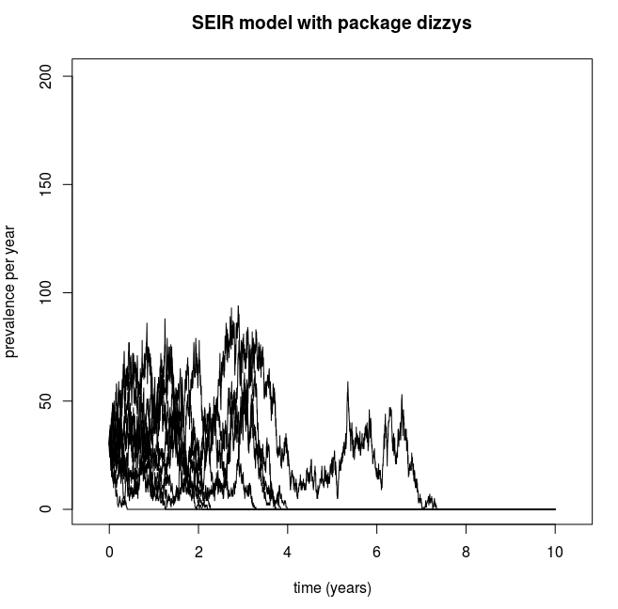 | 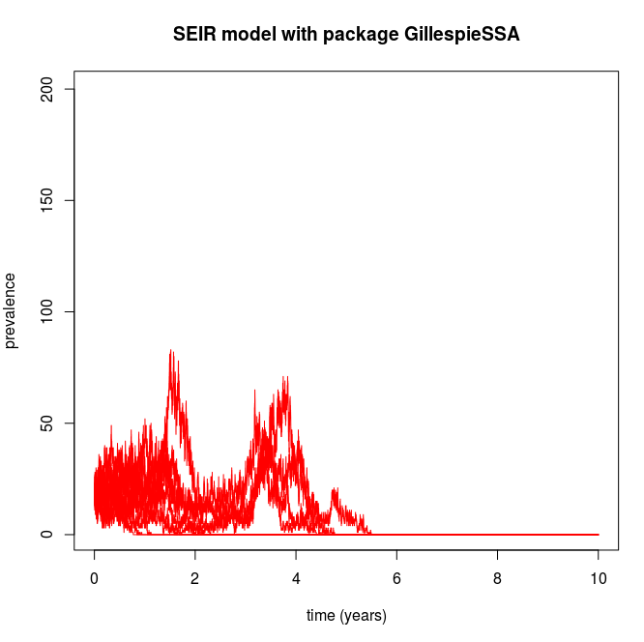 | 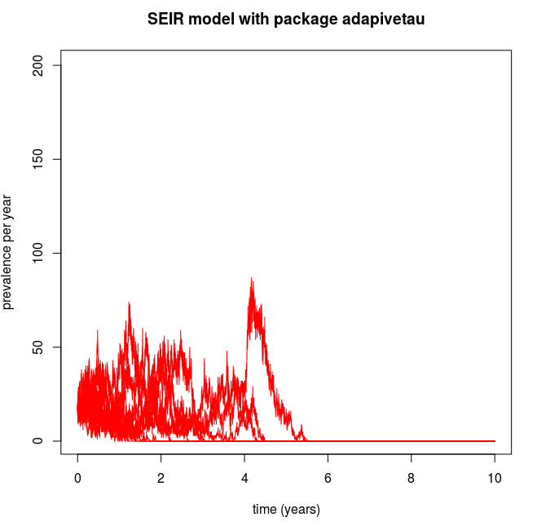

htyghghh

