Regarder l'effet des trois paramètres p1, p2, p3
Parce que quand on utilise la valeur de “seed”. Ça influence directement les valeurs de p1, p2, p3.
Quand p1, p2, p3 sont ensemble changé, on trouve toujours un méli-mélo (đống lộn xộn) des dynamics ( avec 100 simulations différentes). Si on voit l'effect de chaque paramètre, on peut comprendre le dynamics de modèle.
#srand()
p1 = rand()/(double)RAND_MAX;//probability for time
p2 = rand()/(double)RAND_MAX;//probability for time
p3 = rand()/(double)RAND_MAX;//probability to choose event
remove.packages("dizzysNEWYANN")
system("R CMD build dizzysNEWYANN")
install.packages("dizzysNEWYANN_0.3.tar.gz")
library(dizzysNEWYANN)
plot.seir(seir.stochYANN(seed=3,disSTAT=rep(1,1),nbVilles=1,duration = 5000),col="red")
for(sed in 1:10) plot.seir(seir.stochYANN(seed=as.numeric(sed),disSTAT=rep(1,1),duration = 5000,nbVilles=1),col=sed,add=T)

SENARIO 1
P1 | P2 | P3 | Figure | Commentaire
0 | 0 | 0 → 1 | 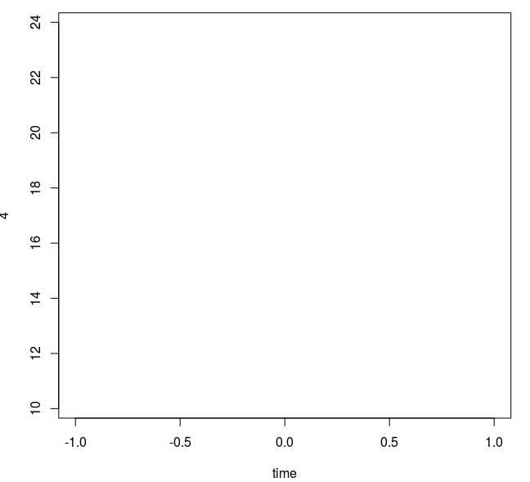
0.1 | 0.0 | [0,0.001] | 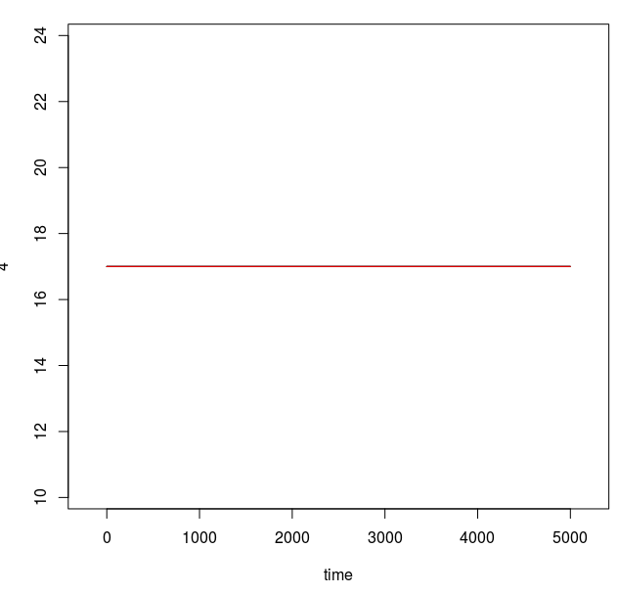
0.1 | 0 | [0.001, 0.01] | 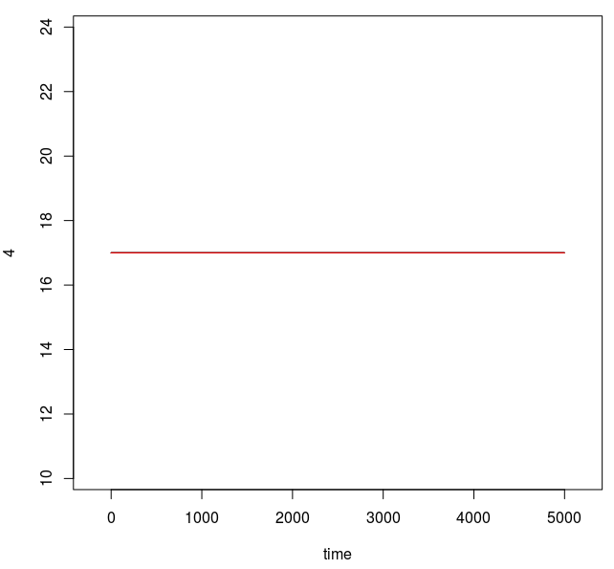
0.1 | 0 | [0.01, 0.1]
0.1 | 0 | [0.1, 0.5] | 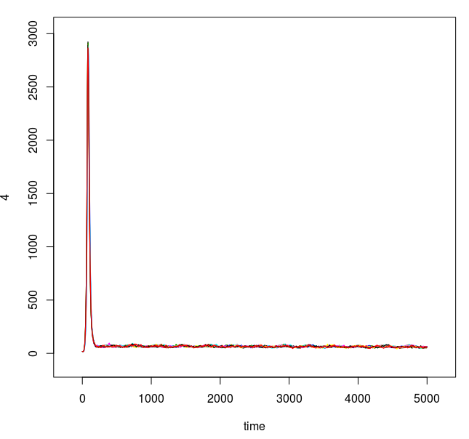
0.1 | 0 | [0.5,1.0] | 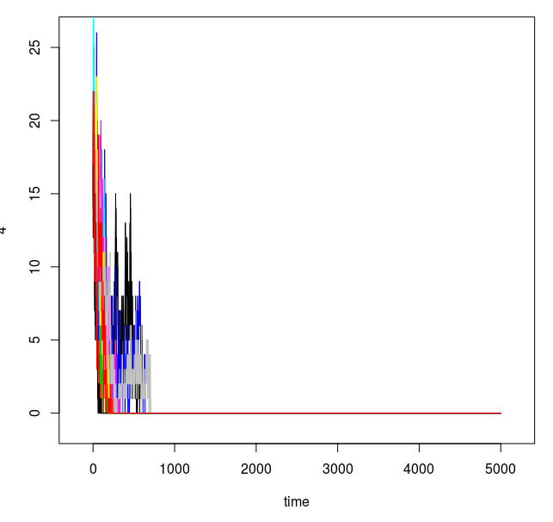
[0,0.001] | [0,0.001] | [0,0.001] | 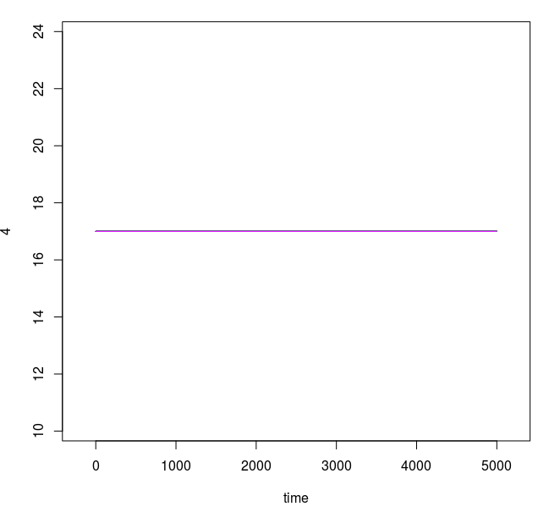
[0,0.001] | [0,0.001] | [0.001,0.01] | 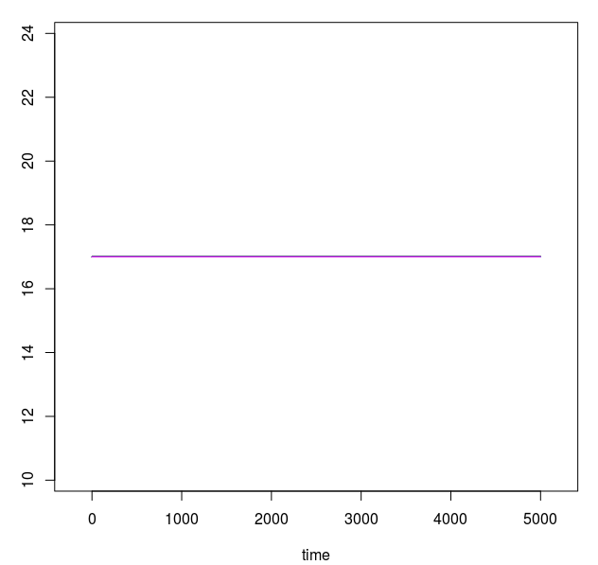
[0,0.001] | [0,0.001] | [0.1,0.5] | 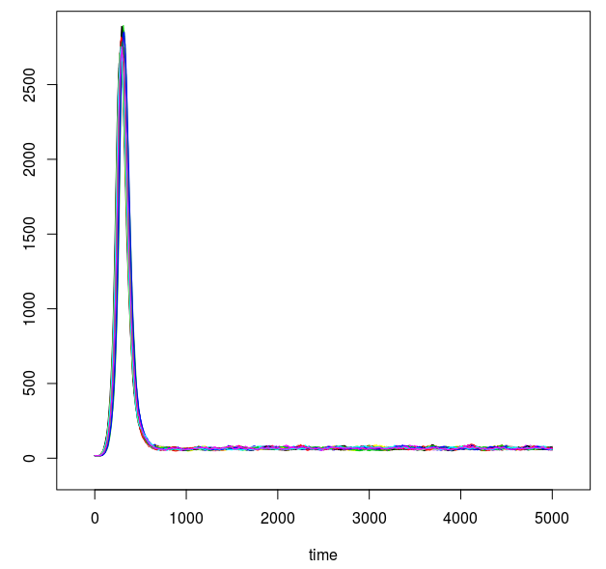
 |  | [0.5,0.8] | 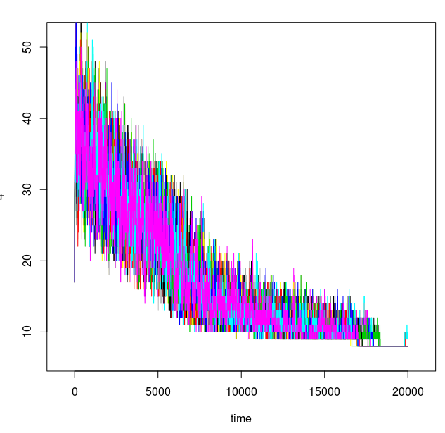
[0,0.001] | [0.001,0.01] | [0,0.001] | 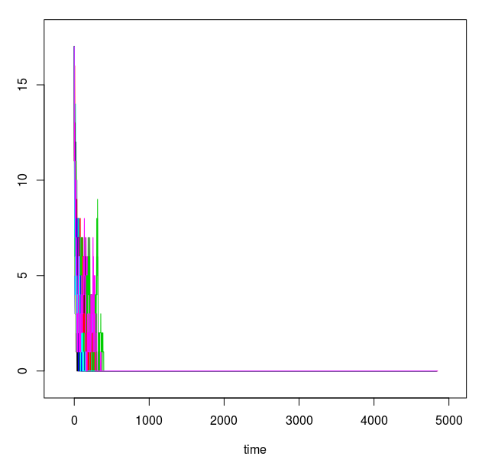 | P2 ko co y nghia vi nbVilles=1  P1 cung ko anh huogn gi den kqua vi chi lam thay doi tstep cua buoc thoi gian
 |  | [0.001,0.01] | 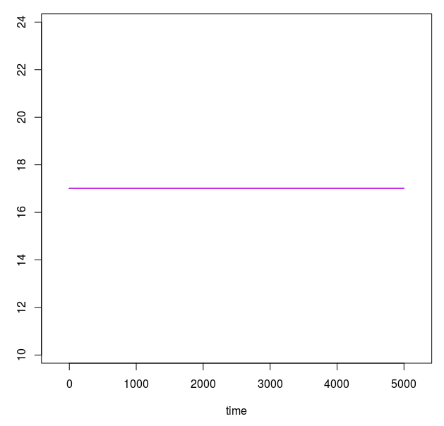
 |  | [0.01,0.1] | 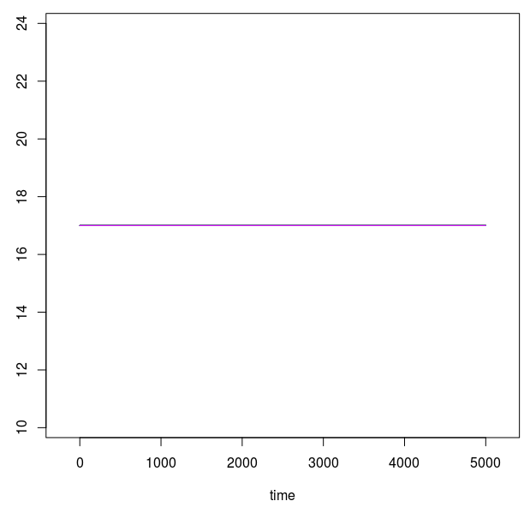
 |  | [0.1,0.5] | 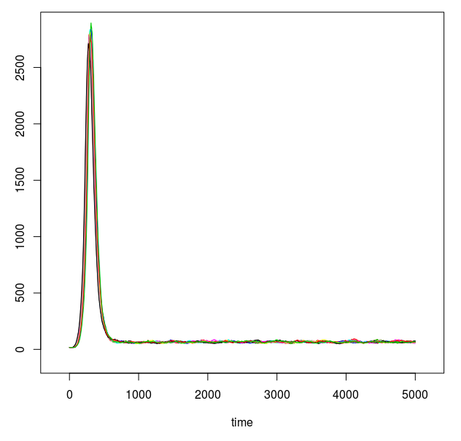
 |  | [0.5,0.8] | 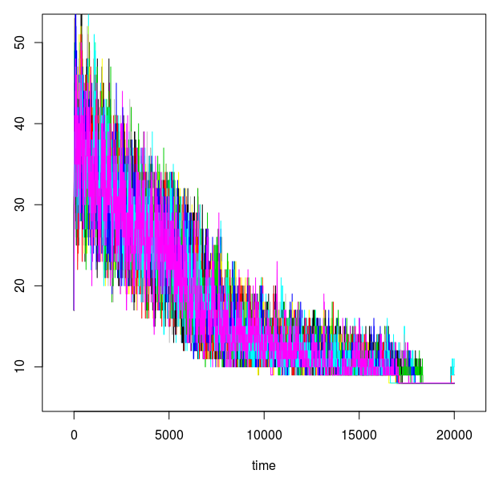
 |  |  | 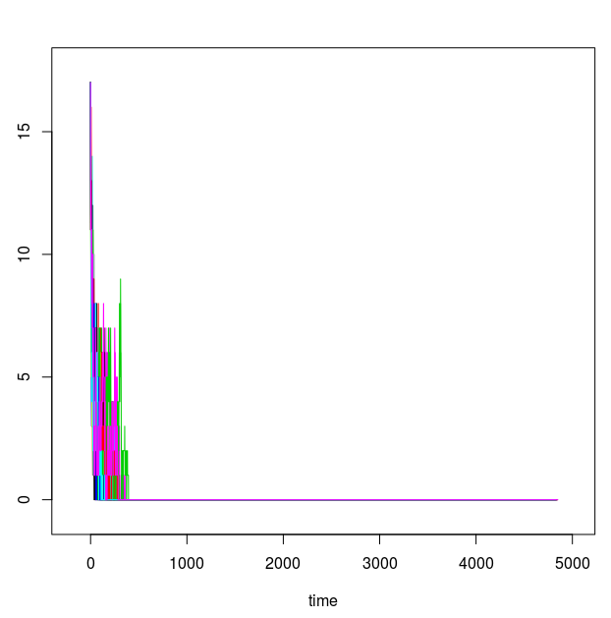
 |  | NbVilles=2,3,5,10  N=1e5,5e5,1e6  phiMAX=0,pi  [0,0.001]  [0.01,0.001]  [0.1,0.01] | 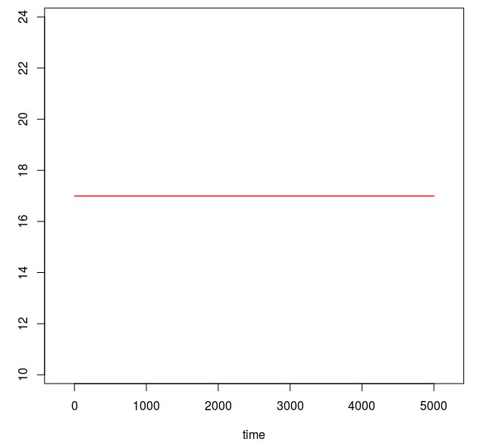
 |  | [0.5,0.8] | 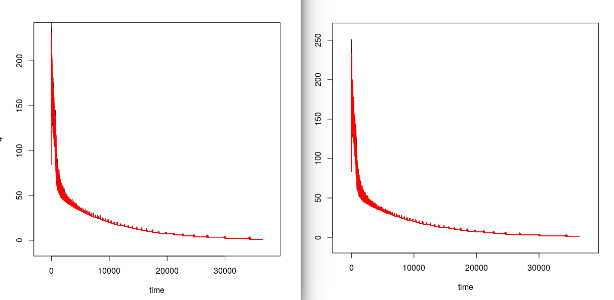
 |  | [0.8,1.0] | 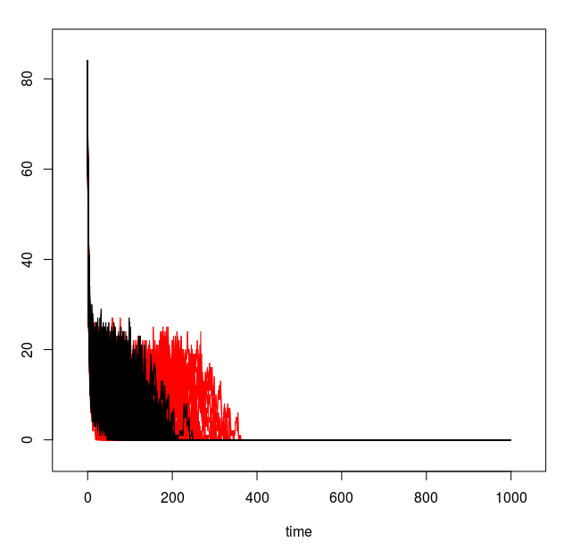  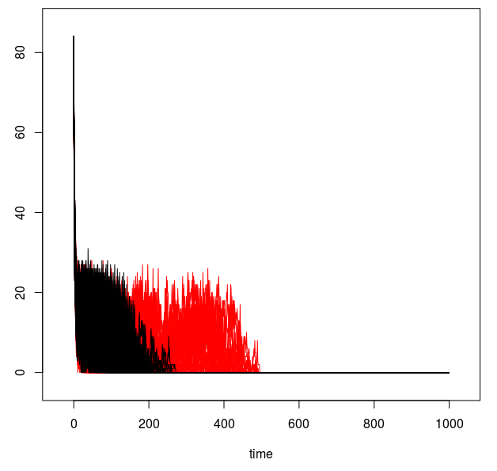
 |  | [0.1,1.0]  nbVilles=3 | 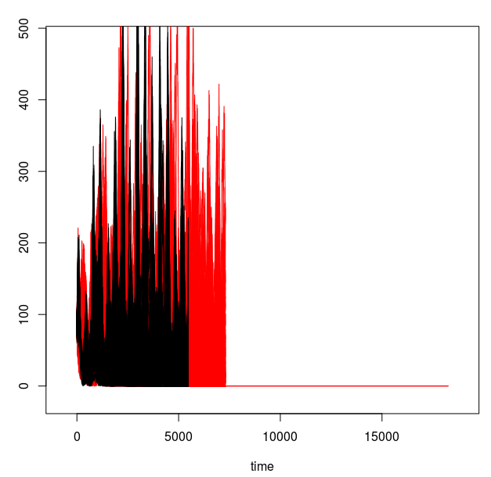
Utiliser la fonction “uniforme distribution” to créer les p1,p2,p3
random | random | Utiliser la méthode de random de YANN,  p3=[0.1,1.0]  nbVilles=2,  phiMAX=[0,pi] | 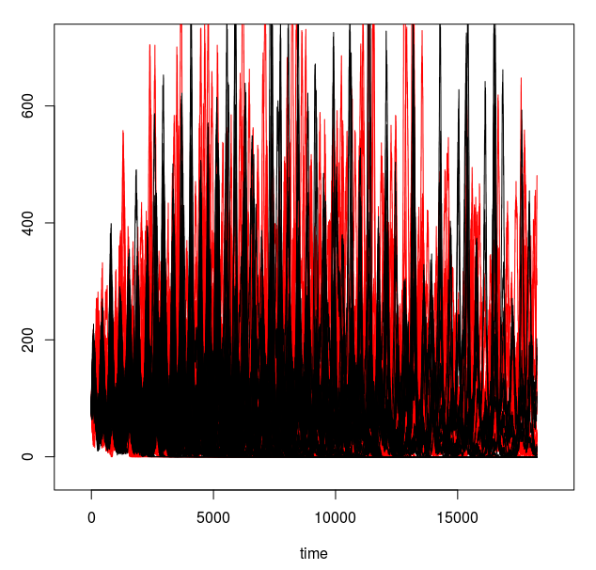
 |  | Utiliser random() C++  nbVilles=2,  [0.1,1.0] | 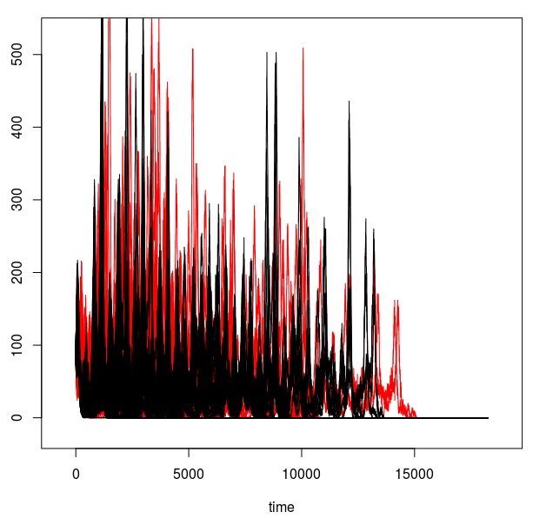
 |  | C++,  [0.5,1.0] | 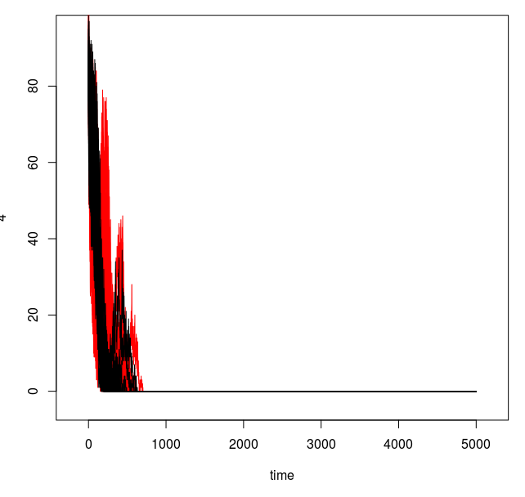 | Gieo co ve nhu y, nhung neu nhu vay thi chugn ta dang dkien p3
 |  |  | 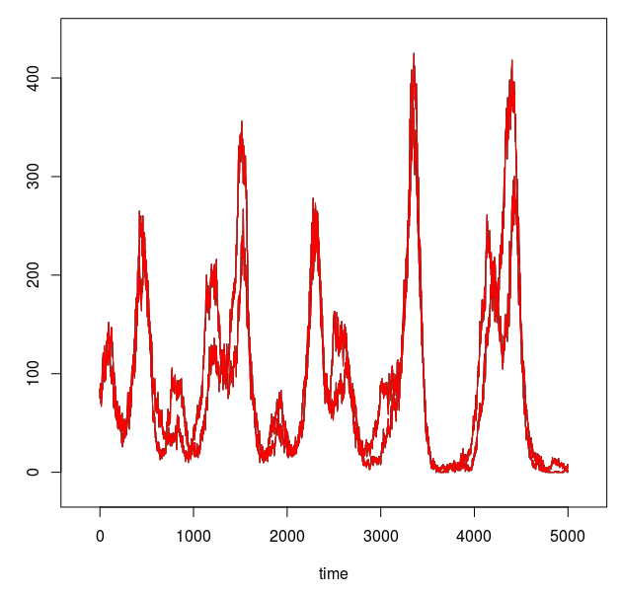 | Dua hàm srand(seed) ra ngoai hoam chinh seir.stoch  Voi cung seed thi luon thu dc cung gia tri
 |  |  | 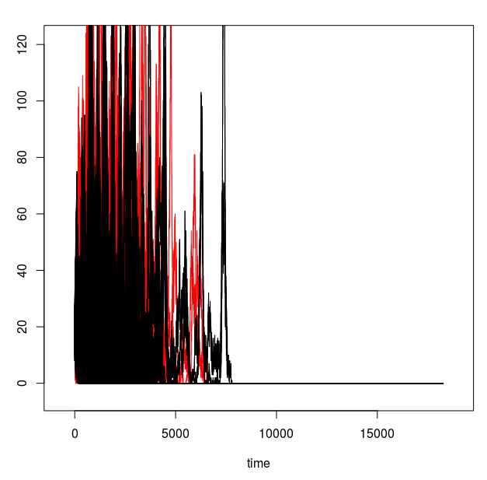 | seed=runif(1,0,100)  nbREP=100  nbVilles=2

SENARIO 2
http://stackoverflow.com/questions/11641629/generating-a-uniform-distribution-of-integers-in-c

rand() in C++ is not goo, don't provide a good randomness
SENARIO 3

SENARIO 4

SENARIO 5

