We implemented six different scenarios to check the influence of the number of subpopulations in a metapopulation on the rates of local extinction, of recolonization and global extinction.
We divided simulations into two main parts : (I) metapopulation with coupled subpopulations and (II) metapopulation with independent subpopulations without connection. In each part, we executed three main scenarios : (1) we set the amplitude of the number of contacts \kappa_1 per unit of time to zero, it means that we set the metapopulation in the absence of seasonal forcing; (2) we placed simulations for the metapopulation in the seasonal synchronization of epidemics between connected subpopulations; (3) we set the metapopulation in the seasonal asynchronization of epidemics.

Results:

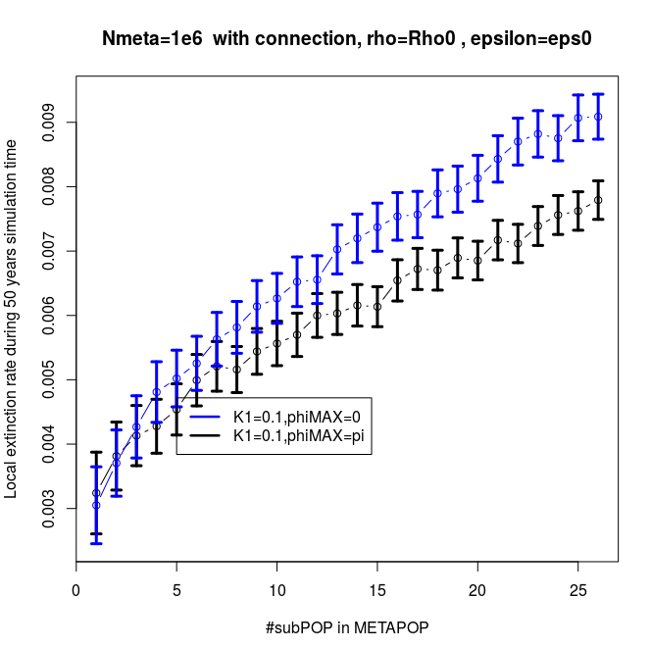 | 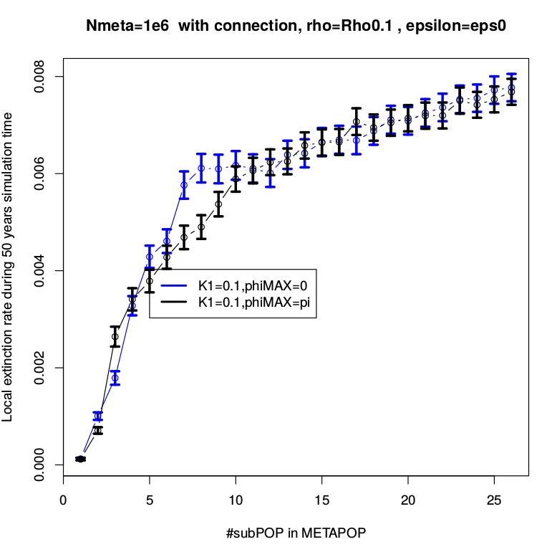
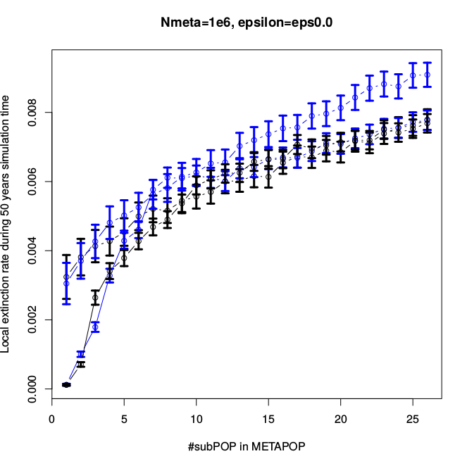
Analyse:
Influence of the number of subpopulations on the local extinction rate
As shown in Fig 3.1, there is a good agreement between simulations and analytic results for the synchronization and phase lag between subpopulations in the metapopulation. We implemented the simulation for the SEIR metapopulation model of subpopulations coupled by individual movement with time-varying periodic contact rate.
The result shows that the local extinction rate of non-seasonal model is always the highest, it is higher than the rate of the model of the seasonal synchronization that is also greater than the rate of the model of the seasonal asynchronization in the independent metapopulation as well as in the coupled metapopulation. Moreover, the local extinction rate of the metapopulation of independent subpopulations is larger than the one of the metapopulation of coupled subpopulations, and the number of subpopulations in the metapopulation strongly affects the local extinction rate.

In order to investigate the dependence among subpopulations, we use a parameter ρ that is referred to the coupling interaction. Increasing the value of \rho means that we increase the strength of connection among subpopulations in a metapopulation. Besides, φmax is an important parameter which clearly reflects the difference between subpopulation’s phases. With the decreasing of φmax, we increase the similarity between sub-populations, but we limit the chances of re-colonizations.

In the model of isolated subpopulations no immigration, the subpopulations fluctuate totally independently. The rescue ability of disease among subpopulations is zero. It is why the probability of disease persistence is smaller than the case of the metapopulation of coupled subpopulations. Decreasing the probability of disease persistence leads an increase of the rates of global extinction as well as of local extinction. These extinction rates of the metapopulation without connection is greater than the metapopulation with connection.
Moreover, by fitting the seasonality amplitude of the average contact rate \kappa_1 at which a susceptible will have when visiting city i per unit of time, so as to describe more exactly the variation in contact rate due to the opening and closing of schools, to term-time forcing and more further, to an age-structure. In the case of the non-seasonal model, \Kappa_1 is set to zero at all time. Inversely, in the case of the model with forcing, we make \Kappa_1 be greater than zero, the average number of contacts per unit of time \kappa of each subpopulation will be a sinusoidal function. The results in the Fig... shows that the rates of local extinction and of global extinction of the unforced model are bigger than those of the forced model.

To obtain the synchrony in the metapopulation, we set φmax≠0. The subpopulations are grouped into pairs based on their interactions, and particularly their disease phases are in-phase. All the subpopulations are in synchrony. So the ability of rescue effect among subpopulations are small, they simply get extinct. Consequently, the local extinction rate when equal 0 is higher than the rest. On the other hand, the asynchrony is presented by φmax≠0 . The disease phases in the coupled subpopulations are out of phase, the synchrony is interrupted. With φmax=pi , the decreased similarity between sub-populations leads an increase of the chance of recolonization among sub-populations. A sub-population has even reached the local extinction, but the disease comes easily back due to the recolonization among sub-populations. Hence, the local extinction rate in the case φmax≠0 is lower. Briefly, the local extinction rate of the synchrony is better than that of the asynchrony.

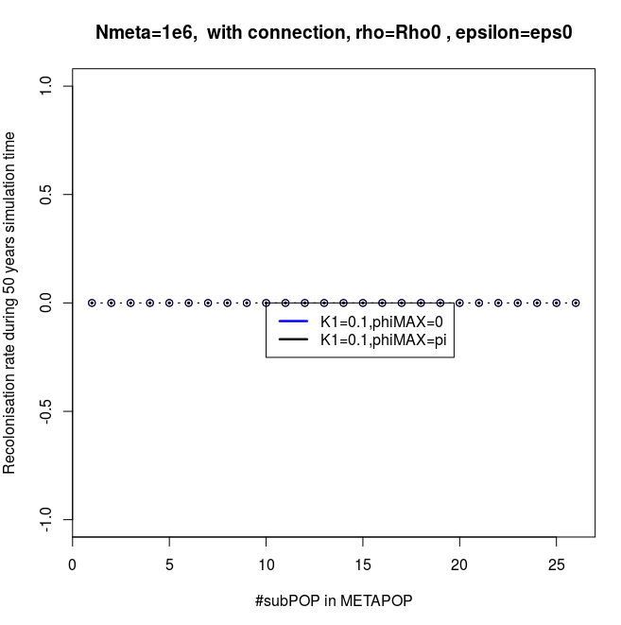 | 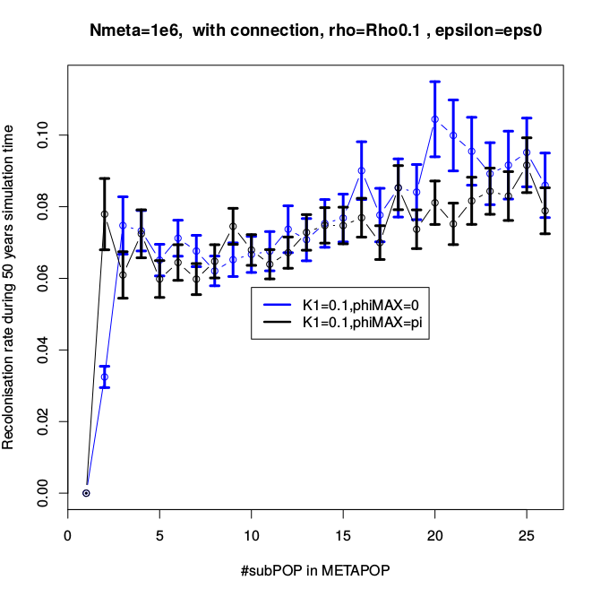
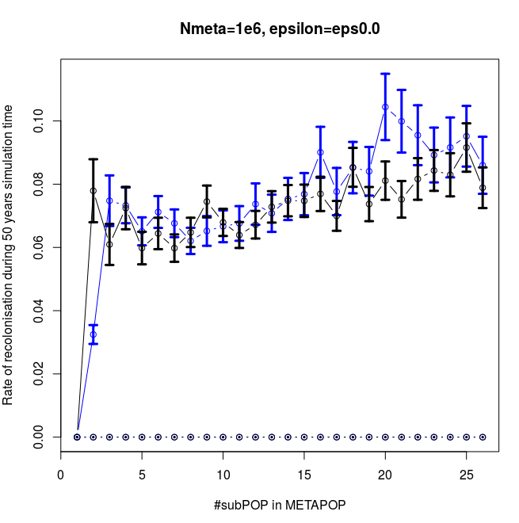

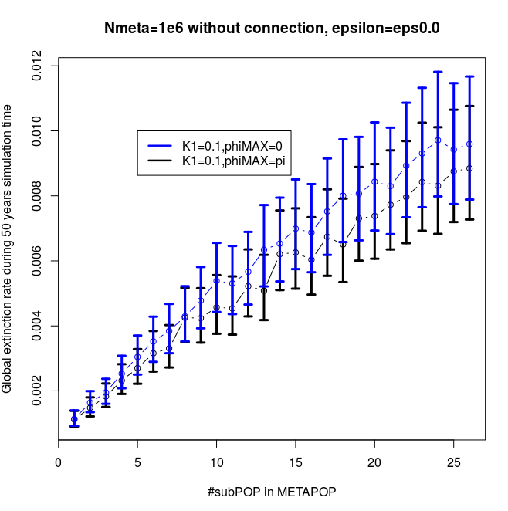 | 