We implemented six different scenarios to check the influence of the number of subpopulations in a metapopulation on the rates of local extinction, of recolonization and global extinction.
We divided simulations into two main parts : (I) metapopulation with coupled subpopulations and (II) metapopulation with independent subpopulations without connection. In each part, we executed three main scenarios : (1) we placed simulations for the metapopulation in the seasonal synchronization of epidemics between connected subpopulations; (2) we set the metapopulation in the seasonal asynchronization of epidemics.

Results:

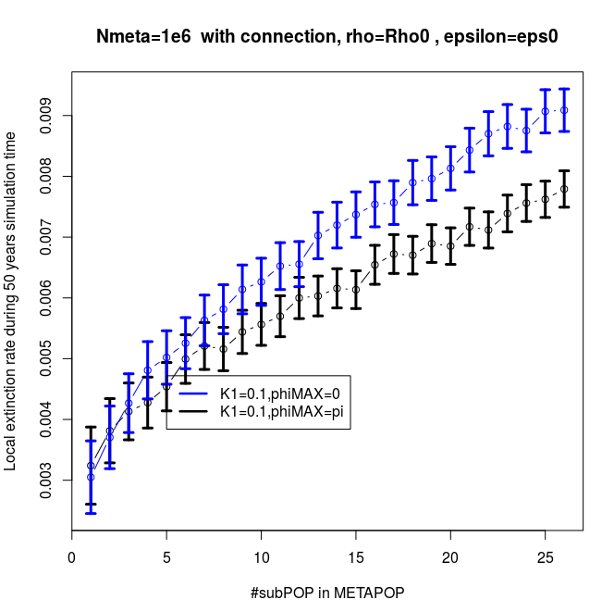 | 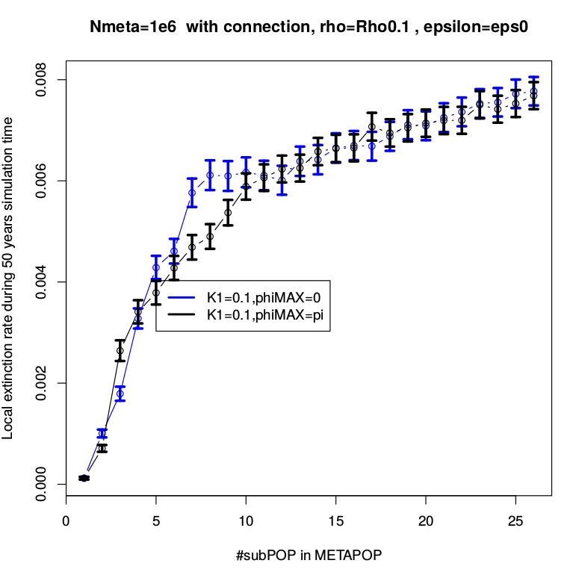
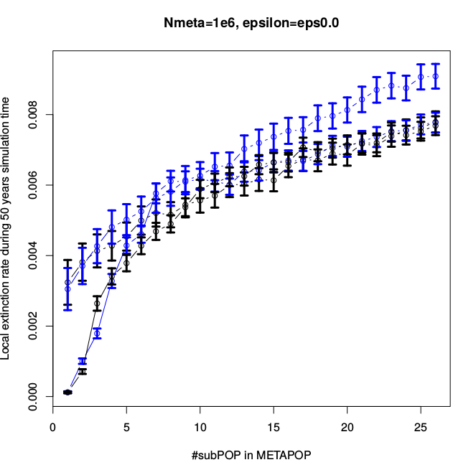

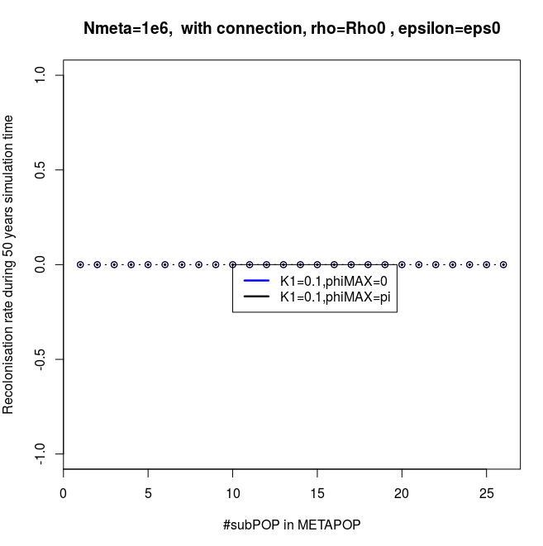 | 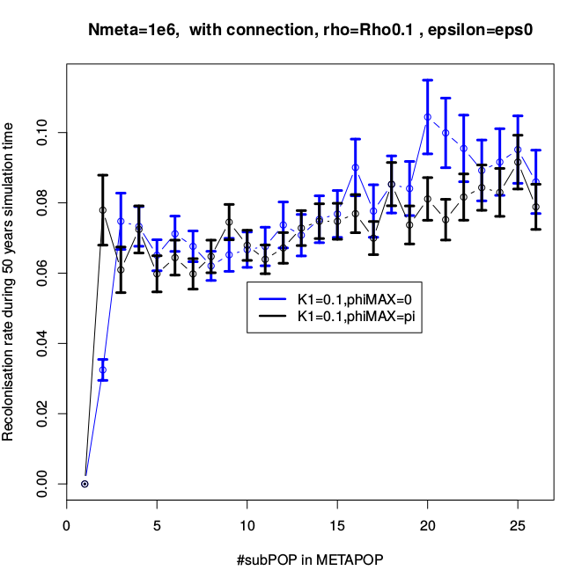
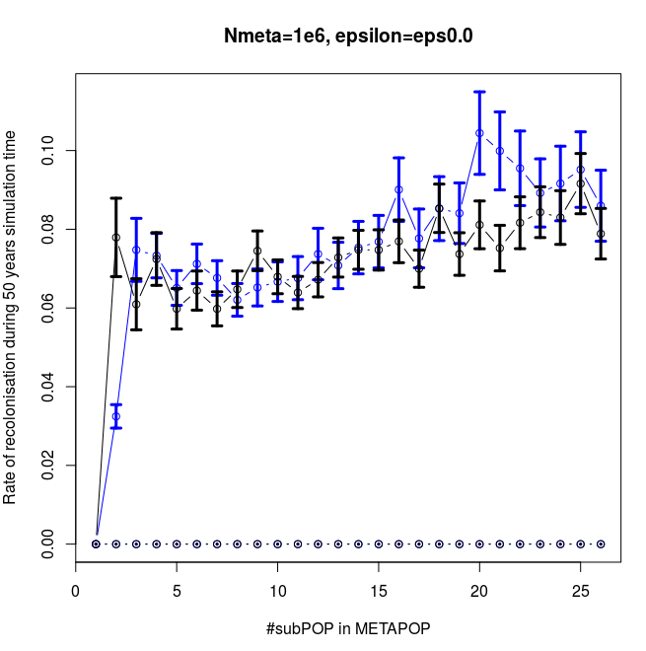

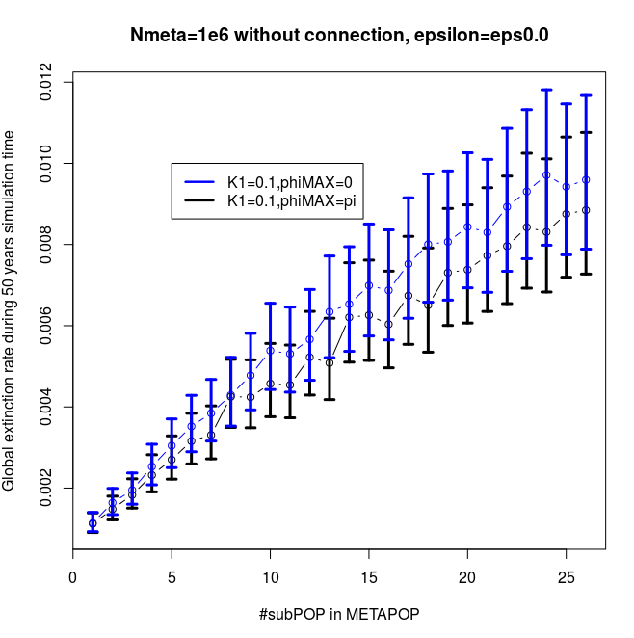 | 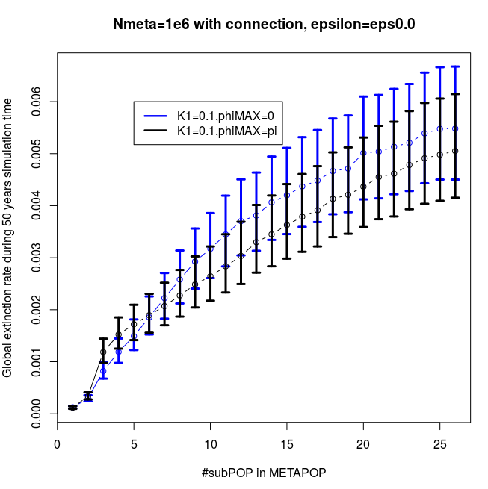
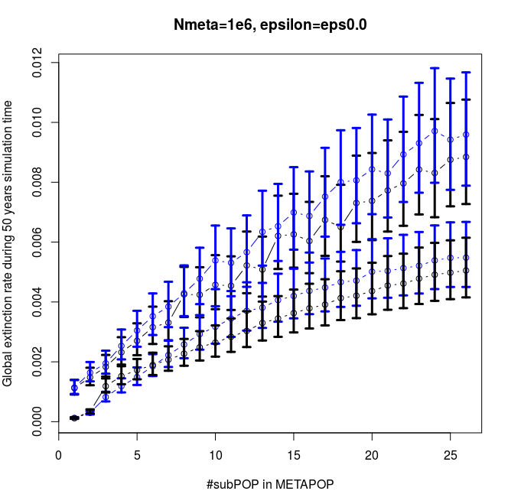

Analyse:
Influence of the number of subpopulations on the local extinction rate
As shown in Fig 3.1, there is a good agreement between simulations and analytic results for the synchronization and phase lag between subpopulations in the metapopulation. We implemented the simulation for the SEIR metapopulation model of subpopulations coupled by individual movement with time-varying periodic contact rate.
The result shows that the number of subpopulations in the metapopulation strongly affects the extinction rates, increasing the number of subpopulations leads an increase of the rates of local extinction as well as global extinction. The extinction rates of the synchrony is always higher than that of the asynchrony in the independent metapopulation as well as in the coupled metapopulation. Moreover, the extinction rates of the metapopulation of independent subpopulations is larger than the one of the metapopulation of coupled subpopulations.

In order to investigate the dependence among subpopulations, we use a parameter ρ that is referred to the coupling interaction. Increasing the value of \rho means that we increase the strength of connection among subpopulations in a metapopulation. Besides, φmax is an important parameter which clearly reflects the difference between subpopulation’s phases. With the decreasing of φmax, we increase the similarity between sub-populations, but we limit the chances of re-colonizations.

In the model of isolated subpopulations no immigration, the subpopulations fluctuate totally independently. The rescue ability of disease among subpopulations is zero. It is why the probability of disease persistence is smaller than the case of the metapopulation of coupled subpopulations. Decreasing the probability of disease persistence leads an increase of the rates of global extinction as well as of local extinction. These extinction rates of the metapopulation without connection is greater than the metapopulation with connection. Due to no immigration among subpopulations, the rate of recolonization is zero in all cases, it means that the disease can not turn back when a subpopulation did find the local extinction. However, a model of isolated subpopulations no immigration is impossible in our world, so this result is only significant for theory, but non-significant for reality.

Moreover, by fitting the seasonality amplitude of the average contact rate \kappa_1 at which a susceptible will have when visiting city i per unit of time, so as to describe more exactly the variation in contact rate due to the opening and closing of schools, to term-time forcing and more further, to an age-structure.

A forcing model well appear, we make \Kappa_1 be greater than zero, the average number of contacts per unit of time \kappa of each subpopulation will be a sinusoidal function. Besides, to describe the seasonal phase difference among subpopulations, we use the parameter φmax to adjust the phase difference of disease between seasonal air-temperature variations in a metapopulation.

To obtain the synchrony in the metapopulation, we set φmax=0. The subpopulations are grouped into pairs based on their interactions, and particularly their disease phases are in-phase. All the subpopulations are in synchrony. So the ability of rescue effect among subpopulations are small, they simply get extinct. Consequently, the local extinction rate when φmax is equal to zero, is higher than when φmax is different from zero. On the other hand, the asynchrony is presented by φmax≠0. The phase variation in disease dynamics of the coupled subpopulations are out of phase, the synchrony is interrupted. With φmax=pi, the decreased similarity between sub-populations leads an increase of the chance of recolonization among sub-populations. A sub-population has even reached the local extinction, but the disease comes easily back due to the recolonization among sub-populations. Hence, the rates of local extinction as well as of global extinction in the case φmax≠0 is lower. Briefly, the extinction rates of the synchrony is better than that of the asynchrony.
Moreover, in the coupled model, when the number of subpopulations increase, we can see that the the local extinction rate of the synchrony goes closer to that of the asyschrony. Because, first we increase the number of subpopulation, we increase the similarity among subpopulations, we decrease the ability of the recolonization among subpopulation, one more plus point, increasing the number of subpopulation in the case of the fixed metapopulation size makes the subpopulation size decrease.
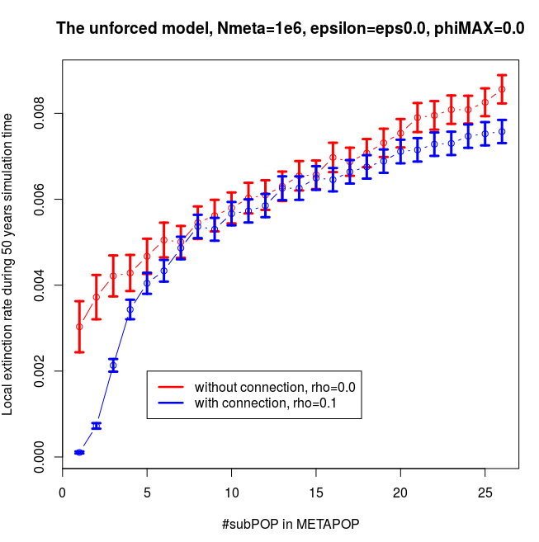 | 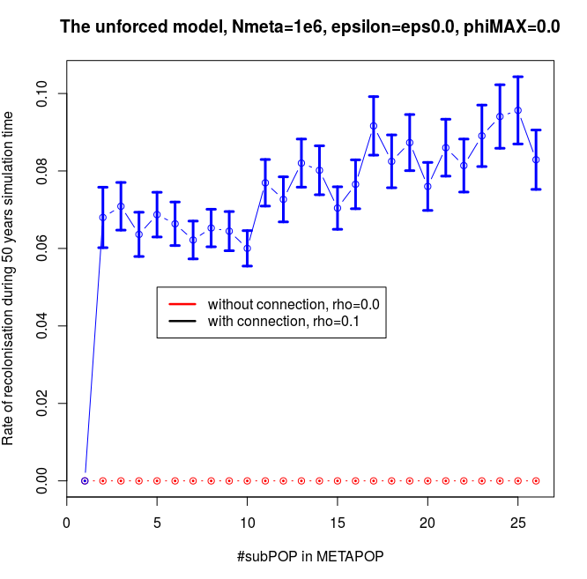

In this experience, we are interested in the influence of the number of subpopulations on the local extinction rate for the standard SEIR model without forcing. This simple metapopulation model just investigates subpopulations connected by individual movement without environmental transmission. In the non-seasonal model, the average number of contacts per unit of time of a susceptible when visiting another subpopulation is set as a constant. The strength of connection ρ is set to 0 for the model of isolated subpopulations (island model) and different from 0 for the model of coupled subpopulations (coupling model). Hence, in this case, the main factor affecting the extinction rate is the migration of individuals rather any environmental factor.
The result shown in the Fig figInfNbPOPIslandModel_a points out that in the isolation model with the fixed metapopulation size, the increased number of subpopulations leads to a decrease of the subpopulation size. This limits the ability of the rescue effect to ensure locally extinct subpopulations become recolonized. Hence the local extinction rate rises significantly, and is greater than that of the coupled model without forçing. Besides that, due to the disjunction among subpopulations in the metapopulation, a subpopulation will obtain the global extinction immediately after it get the first local extinction, so any there won't be any recolonization occurs in this island model. The recolonization rate is zero in all cases as shown in the Fig figInfNbPOPIslandModel_b.
Inverse to the coupled model, the strength of interaction between the two subpopulations have clearly demonstrated its influence on the extinction ability in metapopulation. The curve of the coupled case will be increased notably when the number of subpopulation extends in the range from 1 to 26. As explained in above obtained results of the Fig figInflNubPOP, although the number of subpopulation augments but is still small, the number of native individuals in a subpopulation is much larger than the number of tourists in any specific time. Thus, for the fixed metapopulation size, the increased number of subpopulations draws a decline of the subpopulation size. The disease of subpopulation easily get extinct, whenever the local extinction rate augments. However, when the number of subpopulation becomes a large number, then the subpopulation size becomes really small. The ability of disease persistence significantly decreases, then the rates of extinction augments. As pointed out in the Fig figInfNbPOPIslandModel_b, the recolonization rate has the same form to the local extinction rate.

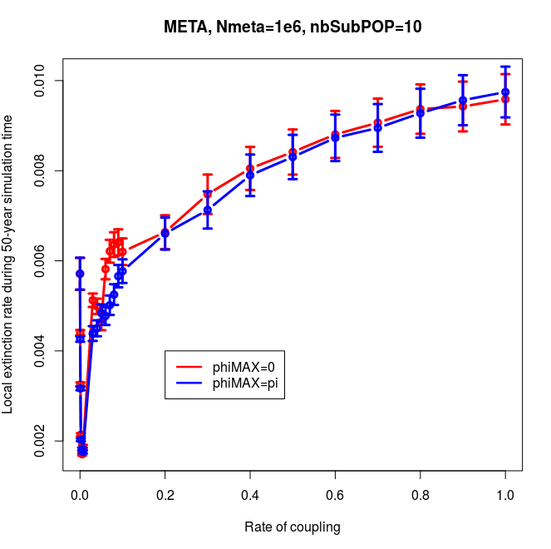 | 