1) Figure 1: Global Extinction rate

Independent populaiton rho=0  Nmeta=1e6, without connection, rho=0.0 | Connected population rho >0,  Nmeta=1e6 with connection, rho=0.1
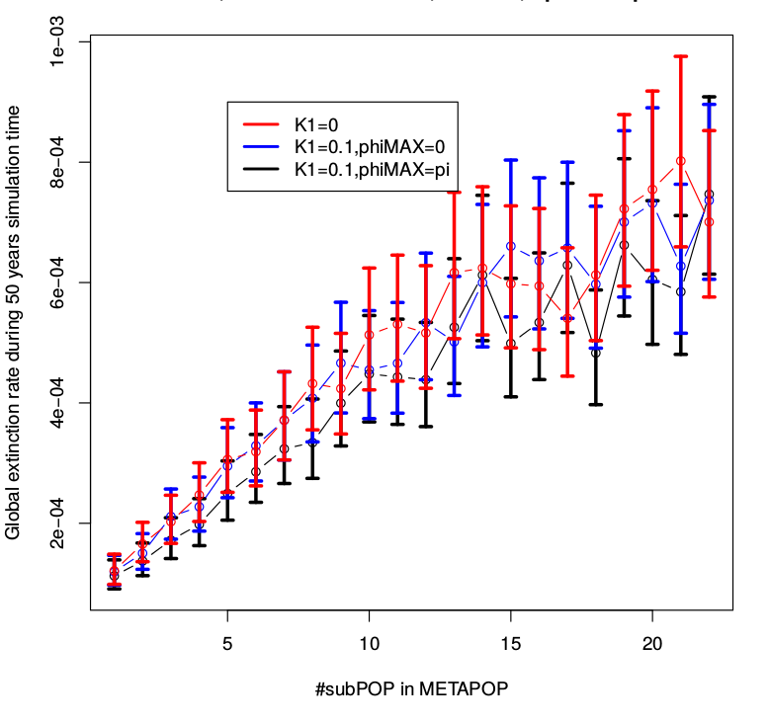 | 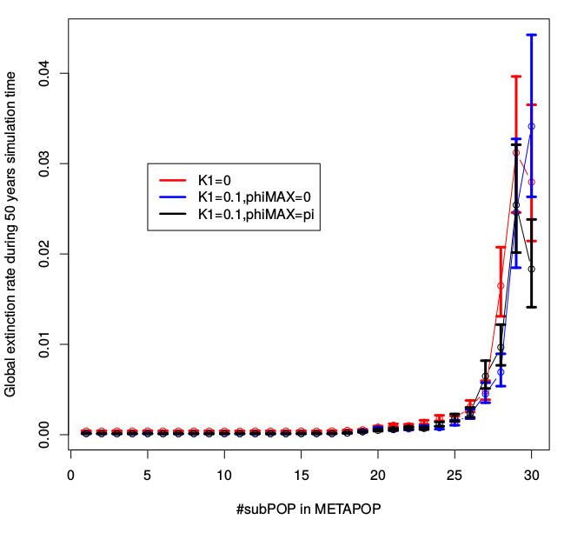

2) Local extinction rate
Independent populaiton rho=0  Nmeta=1e6, without connection, rho=0.0 | Connected population rho >0,  Nmeta=1e6 with connection, rho=0.1
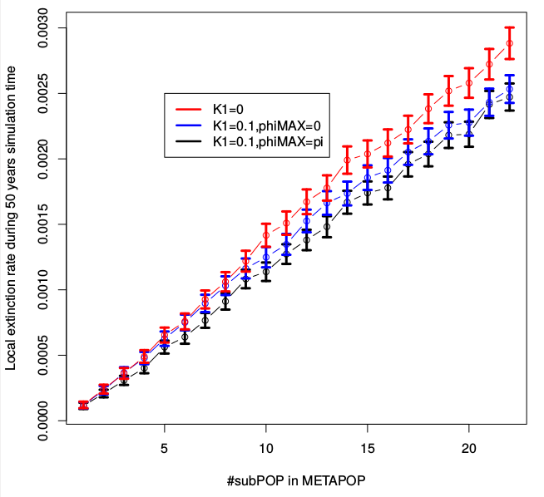 | 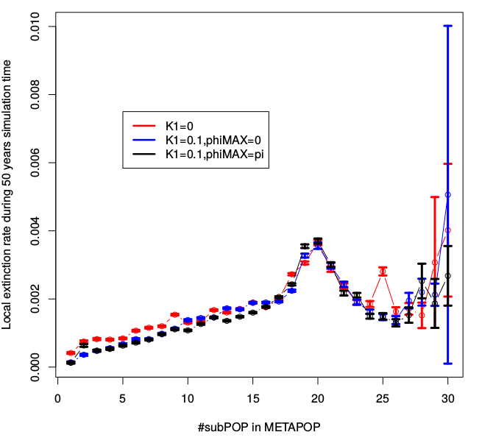

3) Recolonization rate

Independent populaiton rho=0  Nmeta=1e6, without connection, rho=0.0 | Connected population rho >0,  Nmeta=1e6 with connection, rho=0.1
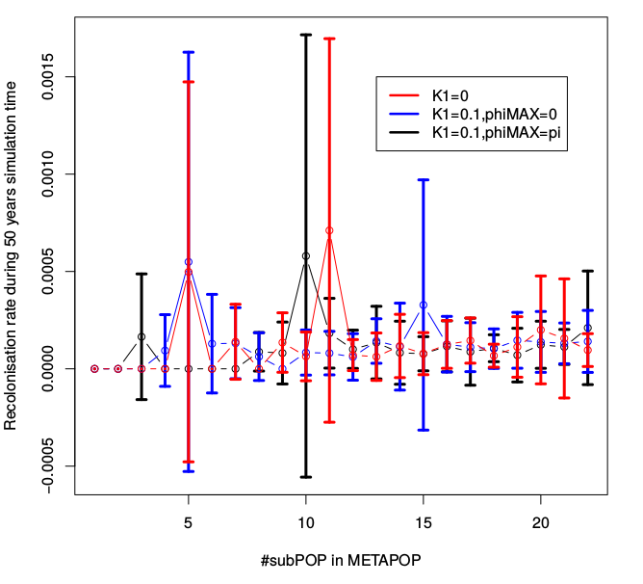 | 